APRIL 2019

The April birthstone, the diamond, is a symbol of everlasting love, and was once thought to bring courage. The April birth flowers are the Daisy and the Sweet Pea. The Daisy conveys innocence, loyal love, and purity. Yet, it is also a flower given between friends to keep a secret; the daisy means “I’ll never tell.” Sweet Peas signify blissful pleasure, on the other hand they are also used to say good-bye.
SUNDAY MONDAY TUESDAY WEDNESDAY THURSDAY FRIDAY SATURDAY
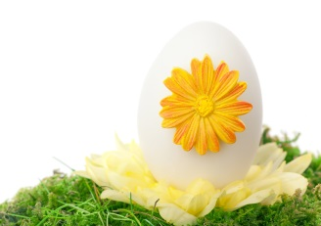 | 1  PM MUSIC CLASS | 2  AZ MERIT  WRITING 3/4  8:30 AM  BOOK MOBILE  SCHOOL BOARD MEET 5:45PM  PM PE CLASS | 3  AZ MERIT  WRITING 5/6  8:30AM | 4  AIMS SCIENCE  4TH GRADE 10:30 AM  AM ART CLASS | 5 | 6
7 | 8  AIMS SCIENCE  9:30 4TH  PM MUSIC CLASS | 9  AZ MERIT  READING 1  8:30 3/4  10:00 5/6  PM PE CLASS | 10  AZ MERIT  MATH 1  8:30 3/4  10:00 5/6  PM ACTIVITY | 11  AM ART | 12  AZ MERIT WRITING CLOSES | 13  THOMAS JEFFERSON'S BIRTHDAY
14 | 15  STONE SOUP PERFORMANCE 11AM  PM MUSIC | 16  AZ MERIT  READING 2  8:30 3/4  10:00 5/6  PM PE | 17  AZ MERIT  MATH 2  8:30 3/4  10:00 5/6  PM ACTIVITY | 18  PAPA MURPHY'S FUNDRAISER  mustang market  AM ART | 19  AIMS SCIENCE CLOSES | 20
21  Easter Sunday | 22  SPRING HOLIDAY  NO SCHOOL | 23  SPRING HOLIDAY  NO SCHOOL | 24 | 25 | 26  AZ MERIT CLOSES | 27
28 | 29  PM MUSIC | 30  BOOK MOBILE LAST ONE FOR S/Y  TURN IN LIBRARY BOOKS  AM PE | PM ACTIVITY |  | SWEET PEA | DAISIES
