

# Summer 2018 Season

# Week 4 – 18.04.18

# Singles League Report

# 

# End of Season Meal – Sat 28th April 2018

# Jersey Bowl - £17.50

# Please email club if you wish to attend

**Remember if you cannot play on the scheduled fixture date; please try to play in advance. You must email club confirming date match will be played.**

Well the early season front runners after three weeks are Matt Pinel and Matt Buesnel in the Premier League

Matt Pinel was hoping for three wins in a row but was up against Andrew Bellamy-Burt, a tough match that could go either way. Well that is what you would have thought, especially given Andrew’s excellent record against Matt. However, a dip in form saw Andrew beaten and one game resulting in a certificate, yes a 13 – 0 for Andrew. Matt with 100% record.

Geoffroy Buffetrille was hoping to recover from his defeat against David Ibitson was up against Brian Harris who lost his first match to Alice. Despite winning the first game, Geoffroy was heavily beaten in the second 13 – 4 for a draw. Geoffroy then drew a catch up match with Alice but was lucky in the first game as Alice blew a big lead 13 – 11 and a valuable 3 points.

Alice Ibitson was looking for back-to-back wins though in her scheduled match, this time against Callum Stewart. Another draw for both. Alice sits in third place now.

Ross Payne was up against Keith Pinel, with both players hoping for their first win of the season. Ross played really well catching Keith off guard to record a much-needed win.

David Ibitson came up against Toby Northern who was looking for his first win and David looking to build on his win over Geoffroy. A very close first game with David leading all the way and 12-10 up fired his own boule out of the way and drop his third shot short to gift Toby three points to take the first game 13 – 12. Despite this, David changed terrain but this only resulted in a heavier defeat 13 – 2 for Toby’s first win of the season.

David then drew a catch up match with Paul Le Moine.

Neil Selby was hoping his cup form translated into league form against Jonny Hill but Neil is fast becoming the draw master with Jonny proving hard to beat.

Matt Buesnel played Paul Le Moine and was looking at a draw losing 9 – 0 in the second game Matt came back to win 13 – 11 and take 3 valuable league points sitting in second place in the league.

Division 1

Harrison Marie played Paul Bell and a close second game 13 – 11 gave Harrison a point in a good draw.

David Le Gresley played Brigitte Ibitson after his Easter holidays, playing his first match. Another very close match saw Brigitte take three points winning 13- 12, 13 – 11.

Jean Stewart played Stephen Stoneman and Stephen almost won his first match, just losing the first game 13 – 12 before winning the second game for a draw. Playing his first ever season is already improving.

Matt Hutchings played John McGaw with both players hard to beat, there was only ever going to be one result. A draw.

Alex Stewart played Joey Le Clech with Alex on two wins from two, would have been confident, especially as Joey had failed to win either of his first two matches. Joey though performed well taking the first game 13 – 1 before going onto win his first match of the season.

Mo De Gruchy played Cassie Stewart and Brigitte Ibitson and although improving all the time two defeats on the day. Brigitte in second place on seven points from three matches.

Richard Williams played Laurent Pellaton; these two battled it out for the Winter Division 2 title, before Laurent won the league. The Summer season isn’t going as well as Laurent lost heavily 13 -4, 13-4 to Richard and now as only two points from three matches, whilst Richard sits on 7 points and top spot.

Best of Luck to everyone who is playing in the Island Triples Championship at Quennavais this weekend.

Super 6 - Statistics

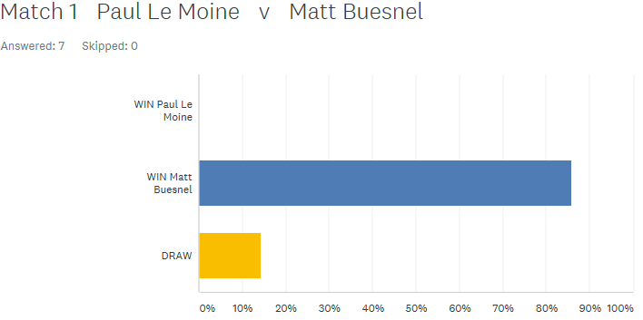

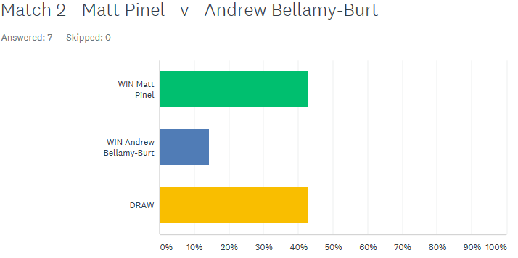

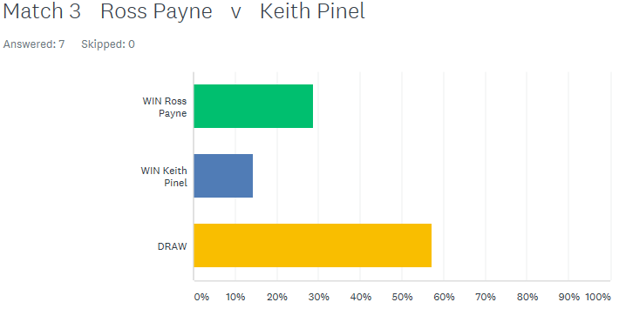

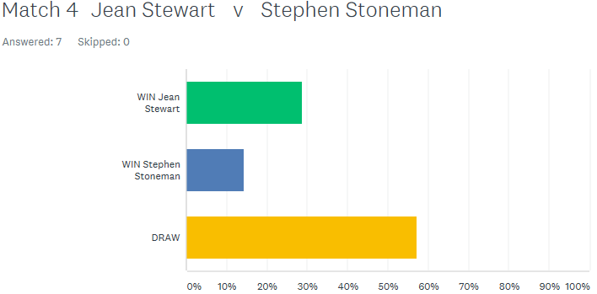

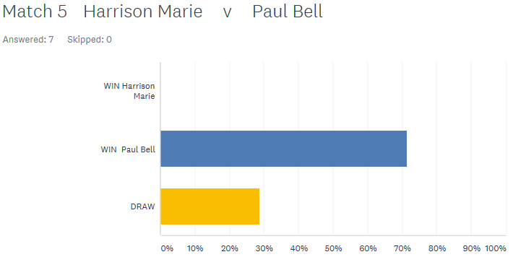

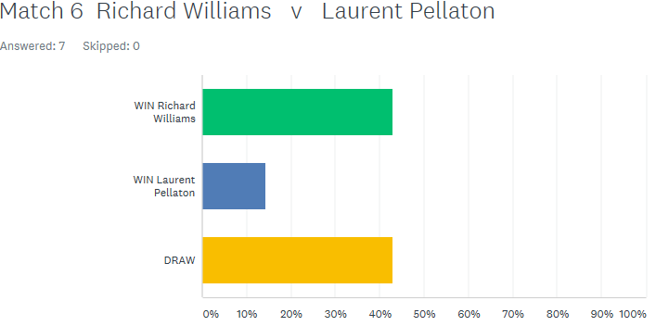

***NEXT WEEK***

**25th April – Triples Mini League – Week 1**

**(If you not playing a change to catch up on outstanding matches)**

**WEBSITE** [**www.liberationpetanque.co.uk**](http://www.liberationpetanque.co.uk)

**EMAIL** [**liberationpc@gmail.com**](mailto:liberationpc@gmail.com)

**Kind Regards**

**Toby Northern**

**Chairman**

**Liberation Petanque Club**

# SPONSORED BY

# http://nebula.wsimg.com/135a1bd6338e1b589a50cdec98bd84d1?AccessKeyId=C6E923731F1A482DD910&disposition=0&alloworigin=1