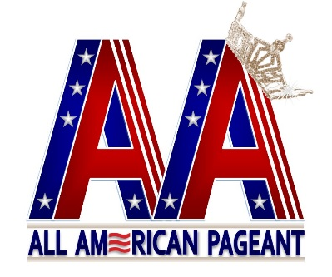
All American Pageant/Mrs. All American Pageant

Official Application 2019
(Please print)
Name: _____________________________________________________________ Address: ___________________________________________________________
City: _________________________State: ________ Zip Code: _______________ Home Telephone __________________ Mobile Telephone. __________________ Email: _____________________________________________________________
What is the best way to reach you: (Check all that apply)
Facebook ________ Texts _______ Phone ________ Mail ______
Age: _______________ D.O.B. ________________ Birthplace: ______________
State you wish to represent ____________________________________________
Division you are competing in: _________________________________________
T-shirt Size ________________________ Shoe Size ________________________
What makes you a good candidate for this pageant? _________________________ __________________________________________________________________ Recent Honors/Awards: ______________________________________________ ____________________________________________________________________________________________________________________________________

FOR RETURNING DELEGATES ONLY:
I would like to use my current sash. _______
I would like to order a new crown _______
Please include a $100 (non-refundable) application fee – per state title you are applying for – along with an application for each title. Please send a recent 5x7 photo of yourself (headshot preferred) along with your application.
____________ (Initial and Date)

- I am enclosing a money order with my application. _________ (initial)
- I am sending fees via PayPal _________ (initial)
They can be sent through PayPal to allamericanpageants852@gmail.com.

By signing this application, I am certifying that all information is true and correct to the best of my knowledge.
__________________________________ Signature ___________________ Date

All American Pageant/Mrs. All American Pageant

If I am competing in both pageants, why do I need to pay two application fees?
Each pageant is independent from one another.

All American Pageant Divisions
All American Pre-teen 11-13
All American Junior Teen 14-16
All American Teen 17-19
All American Miss 20-29*
All American Ms. 30-39*
All American Woman 40-49*
All American Lady 50-Over*
All American Classic Ms. 25-39 (Size 16 up)*
All American Woman 40-Over (Size 16 up)*

*Married, Widowed, or Divorced

Mrs. All American Pageant Divisions
Mrs. All American 21-40*
Mrs. All American Woman 40-49*
Mrs. All American Lady 50-Over*
All American Classic Mrs. 25-Over (Size 16 up)*

*Married or Widowed

ALL Delegates-Age determined as of September 1, 2018.

Selection of State Delegates: Delegates can choose to represent any state or region based on residency, birthplace, work, or any special tie to the state. All states are awarded At-Large on a first come, first serve basis.
National Competition Judging Criteria:
Delegates are judged individually, never as a whole.
Scoring areas and weight:
- Interview 50%
- Runway/Fashion Wear 25%
- Evening Gown 25%

National Entry Fee:
The pageant entry fee is $495.00 for nationals. Qualifying delegates may compete in both pageants. The second pageant entry will be an additional $250.00 for second pageant entry. ) Preteen, Jr. Teen, and Teen division are $200.00 for national entry fee. All entry fees are due on or before the pageant deadline date of September 11, 2018. No application will be reviewed or accepted, until the application fee is received.

All American and Mrs. All American Pageants
c/o Patricia Sullivan
249 East Taylor Avenue
Wildwood, New Jersey 08260

Please direct any email correspondence to the pageant office email at aacontestant@gmail.com.

