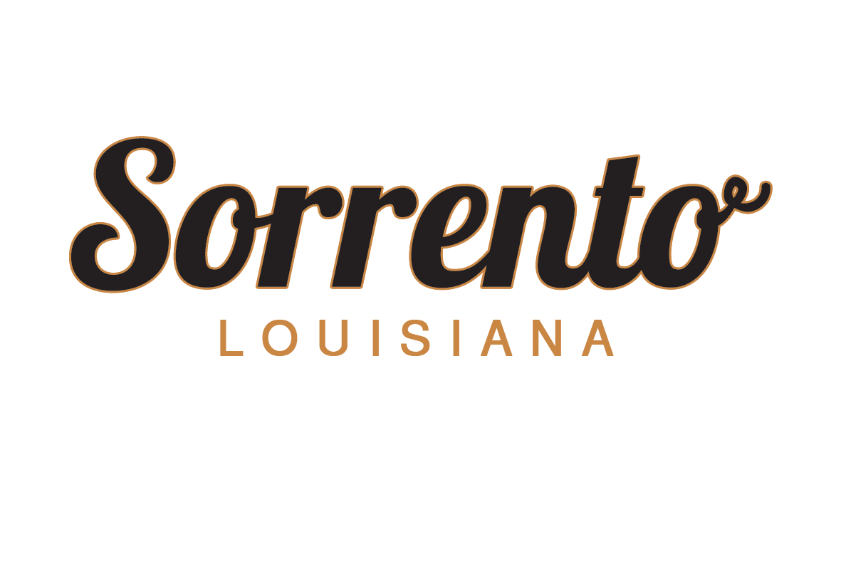

PO Box 65
Sorrento, Louisiana 70778
225-675-5337

***Important Information –Please Read***

- A deposit of $84 is required to open a garbage account.
- A deposit of double the sewer rate is required to open a commercial sewer account.
Commercial Sewer Rates per month:
- 1” water line and smaller $65
- 1 ½ “ water line $100
- 2”-3” water line $125
- Larger than 3” water line $175
- A deposit for each service is required to open both a garbage and commercial sewer account.

Utility bills are due on the 26th day of each month. If payment is not made by the 26th of the month, a late fee will be added to the outstanding balance for each service. If payment is still not received after 90 days from billing, the service will be cut off. After 120 days, if payment is not collected, the account will be sent to either: a.) a collection service, b.) Town legal counsel or c.) Parish constables in small claims court for collection.

If collection is not made within 90 days, service will be cut off and
the customer deposit will be applied to the utility customer’s account.

A $25 service fee will be charged to restore service for each non-payment offense for Garbage.
A $75 fee will be charged to restore service for each non-payment offense for Sewer.

If a customer pays the late fee, service fee and outstanding balance to account, the customer may reconnect and receive future utility services. Also, the customer must maintain the proper amount of deposit on hand to resume services.

If a customer has an outstanding balance after applying the deposit and has service discontinued, they will be turned over by the Town of Sorrento, in no particular order, to either: a.) a collection service b.) Parish Justice of the Peace in small claims court, or c.) Town legal counsel

Ordinance Article V. Sec 3-35

I am applying for utility service from the Town of Sorrento at the above address. I agree to follow and abide by all rules for utility service and to pay charges in effect as stated on each monthly bill. I understand that non-payment of my account will result in discontinuation of service. I also understand it is my responsibility to either send it in writing or come in person to the Town Hall to disconnect any service to avoid further charges on my account.

_________________________ __________________________ _______________
Signature Printed Name Date

Town of Sorrento
Application for Utility Service
Commercial
Garbage / Sewer

Account No. ______________
Name on Account _____________________________________________
Daytime Phone ___________________ Cell Phone __________________
Email Address ________________________________________________
Driver’s License St. & # ____________ Social Security # ____________
Date Service to Begin _______________ Deposit Amount $__________

Service Address
Street _______________________________________________________
City ______________________ State _________ Zip ___________

Mailing Address (if different from Service Address)
Street ______________________________________________________
City _______________________ State ________ Zip ___________

Are you the:
Property Owner or Renter

If Renter, please provide Property Owner Information
Name ___________________________ Daytime Phone ______________
Address ____________________________________________________
City _________________________ State _______ Zip ___________

Employment
Employer________________________ Phone No. _________ Ext. _____
Address ____________________________________________________
City ________________________ State _______ Zip ___________

