

Internal Training: Capital Campaign JOb AIds

Table of Contents

Setting Up Captial Campaigns 3

Locating Captial Campaigns 4

Search for a Campaign 5

Capital Campaign Home Overview 6

Edit Campaign 7

Goals tab 8

Hierarchy tab 9

Priorities tab 10

Designations tab 11

Fundraisers tab 12

Teams tab 13

Major Giving tab 14

Naming Opportunities tab 15

How to Create a Naming Opportunity 16

Documentation tab 17

Snapshots tab 18

Adding Purposes/Designations 19

Manage Fundraising Hierarchies 21

Adding Teams 23

Configuring KPIs 25

Add KPIs 25

Setting up a KPI Dashboard 30

Creating Pages on a KPI Dashboard 33

Creating Tabs on a KPI Dashboard 34

Reports: Campaign Level 35

Campaign recognition credit report 36

Campaign priority report 37

Campaign summary report 38

About Report Explorer 39

Access Report Explorer 39

Run Campaign Reports in Report Explorer 40

Take a snapshot in Report Explorer 41

# 

Setting Up Captial Campaigns

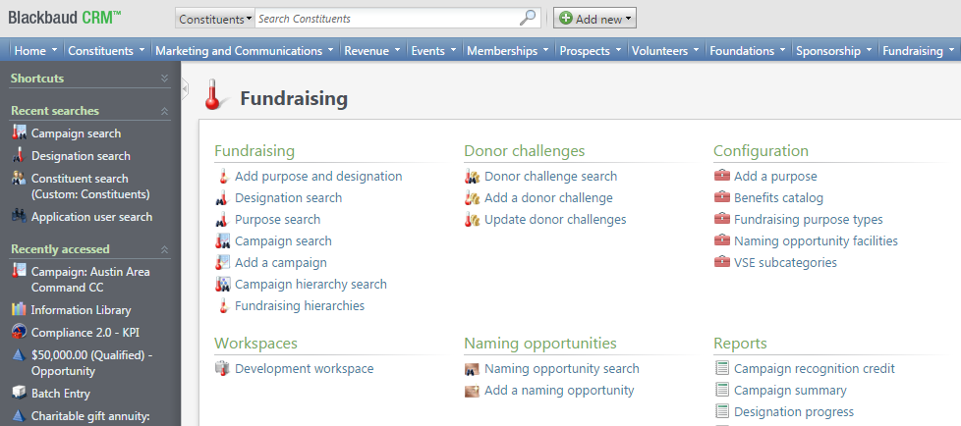

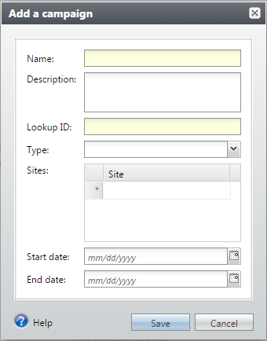

* The SST will be setting up Capital Campaigns for the fields based on the information provided to you (in an Intake Worksheet or otherwise.) To set up a Capital Campaign, go to the Fundraising tab, click on the ‘Add a campaign’ hyperlink, and fill out the relevant fields. Click Save and your campaign will be added to the list of Campaigns.

Locating Capital Campaigns

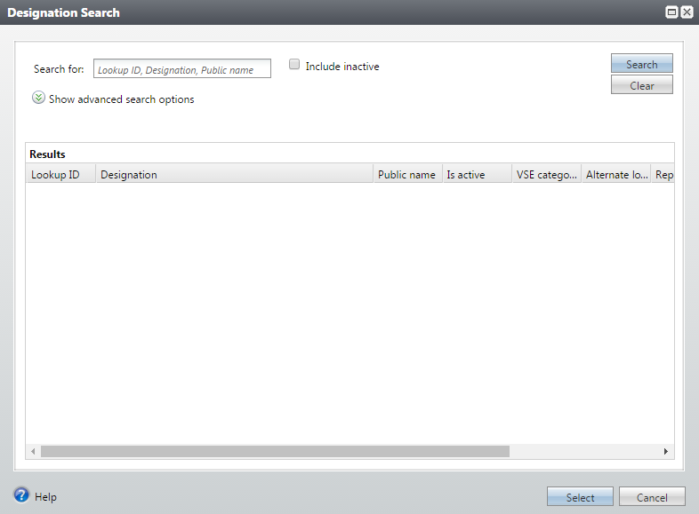

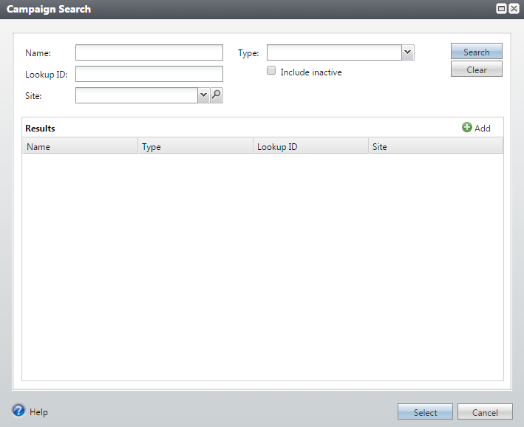

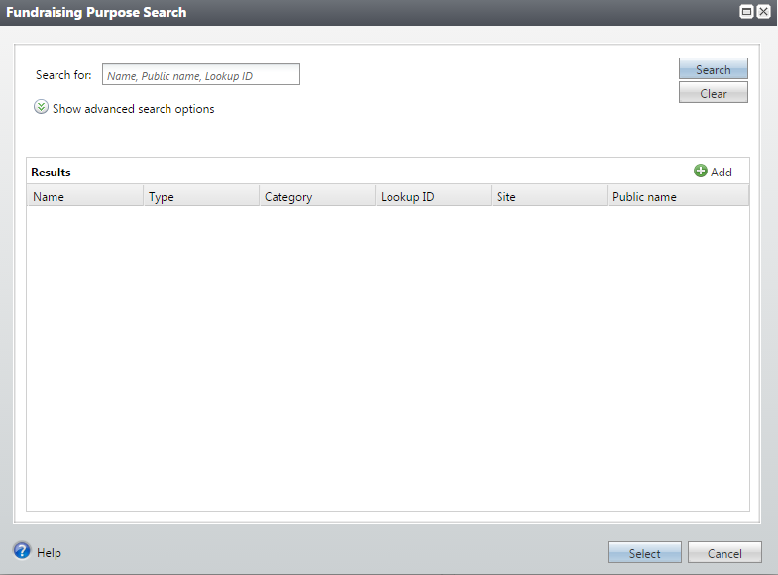



* Once you set up a Campaign, you can search for it by its name (as it won’t yet have any purposes or designations set up yet). To search for your Capital Campaign, go to the Fundraising functional area and click ‘Campaign Search’. (Later, once purposes and designations have been established, you can search these as well from the Fundraising functional area).

Search for a Campaign

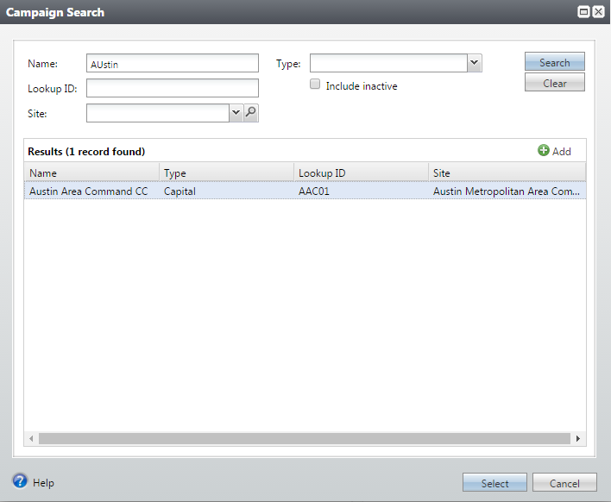

* The Campaign(s) that matched your search criteria will appear in the Results box as a hyperlink. Click on the hyperlink name to take you directly to the Capital Campaign’s Home Page.

Capital Campaign Home Overview

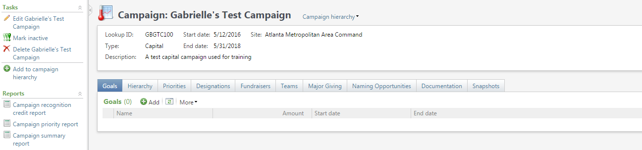

**3**

**4**

**1**

**2**

* This is what a Capital Campaign Home Page looks like. There are several areas that you’ll want to be aware of:

1. This is where basic information about the CC can be located (this is what you created when you set up the campaign).
2. Here one can edit basic information about the CC (site, start and end dates, etc.) *See Edit Campaign for more information. One can also mark the Campaign as inactive, or add to the Campaign Hierarchy. *See Hierarchy Tab for more information.
3. Here is where one can run various reports. *See Reports for more information.
4. Here is where one will see the various tabs that allow them to manage the relevant elements of their CC. To learn more about each tab, click on the respectively-named parts of this manual.

Edit Campaign

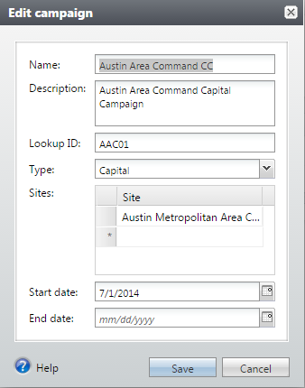

* Once you click the ‘Edit Campaign’ hyperlink, the Edit Campaign box will appear. Here one can modify the Capital Campaign’s:
* Name
* Description
* Lookup ID
* Type
* Sites
* Start and End dates

Goals tab

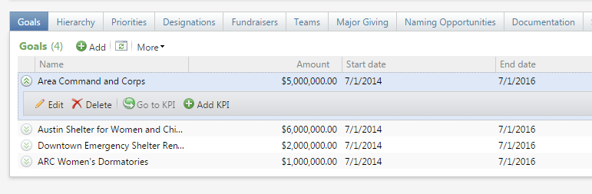

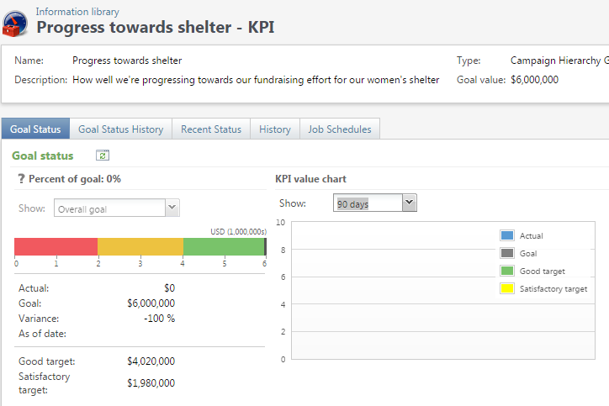

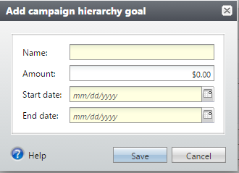

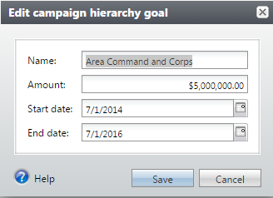

* Under the Goals tab one can:
* Add in a new fundraising goal (called a campaign hierarchy goal) for the Campaign
* Edit an exisiting fundraising goal (called a campaign hierarchy goal) for the Campaign
* Go to a KPI (Key Performance Indicator) that the SST set up for the field.

Hierarchy tab

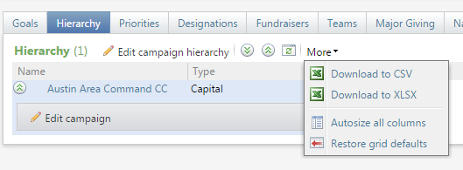

* The Hierarchy tab is shown ***only*** on top-level campaigns (Not sub-campaigns nestled inside another Campaign)
* Under the Hierarchy tab one can:
* Edit the Campaign Hierarchy
* (Beneath the actual Campaign) Edit basic information about the CC. See Edit Campaign for more information.
* Download the Hierarchy to a CSV or Excel document by choosing an option from the drop-down menu under More. *Please note, the ‘More’ drop-down appears under several tabs, contains the same options pictured here and thus, will not be documented for the other tabs in this reference guide.

Priorities tab

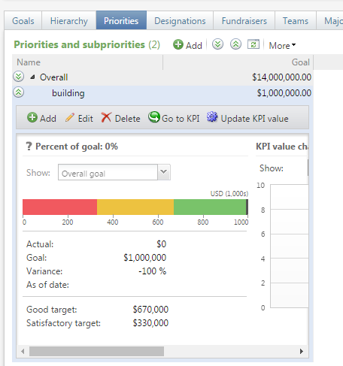

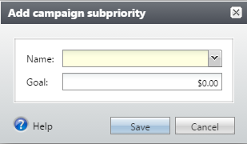

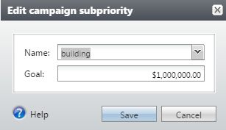

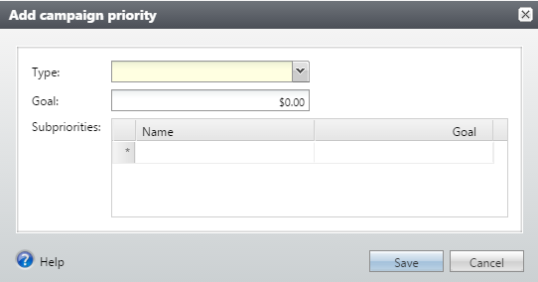

* Under the Priorities tab one can:
* See the priorities and subpriorities that have been established for this CC
* Add and Edit priorities and subpriorities by clicking on the respective buttons located in the drop-downs
* Access KPIs for priorities and subpriorities that have been created (by the SST).

Designations tab

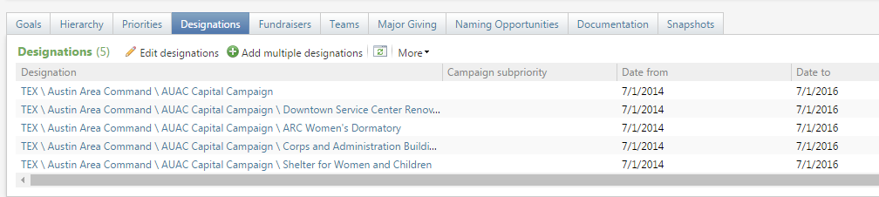

* Under the Designations tab one can:
* See the designations that have been established for this Capital Campaign

*See Adding Purposes/Designations for more information on how to create these.

Setting up Designations

You cannot set up new designations under the Designations tab; you can only view and edit ones that have been created.

Fundraisers tab

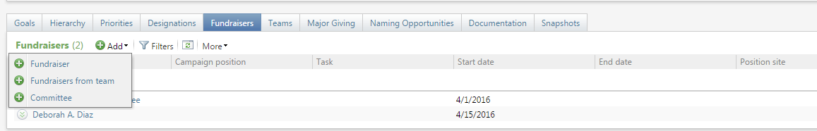

* Under the Fundraisers tab one can:
* See the Fundraisers who have been added to this Capital Campaign
* Add a Fundraiser, a Fundraiser from a team, or a fundraising Committee to this Campaign.

Keep in mind that when adding fundraisers…

…under this tab, you will be choosing fundraisers that have *already* been set up in InterChange. For example, when you choose to add a Fundraiser or a Committee to a Capital Campaign, you can only ***choose*** these entities. To make a constituent into a fundraiser, you’ll need to go to the Prospects functional area in InterChange. Committees can be created in the Constituent functional area in InterChange or can be added in from a search screen.

Teams tab

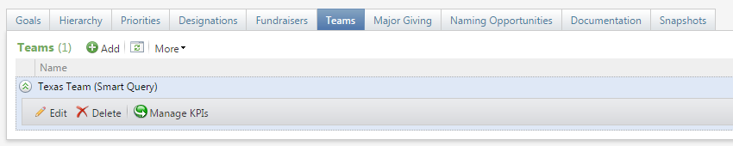

* Under the Teams tab one can:
* See the Teams of fundraisers who have been assigned to this Capital Campaign
* Manage KPIs that have been created for each Team
* *See Adding Teams to learn how to assign a fundraising team to a CC
* *See KPIs to learn how to set these up

Major Giving tab

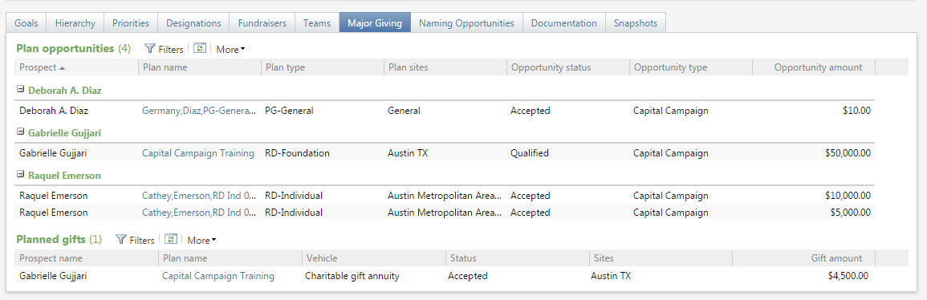

* Under the Major Giving tab one can:
* See all of the prospect plans that have been designated to this Capital Campaign (under Plan Opportunities)
* See all of the Planned Gifts that have been designated to this Capital Campaign (under Planned Gifts)
* Access the Prospect Plans and Planned Gift pages for this Campaign (by clicking on the Plan name, which is a hyperlink)

You can only view plans here

If you’d like to create a Prospect Plan for a Campaign, you’ll have to do so in the Prospect functional area by setting up an Opportunity that is connected to one of your Campaign’s Designations. If you’d like to create a Planned Gift for a Campaign, you’ll have to do so on the Prospect’s record, under the Prospect tab.

Naming Opportunities tab

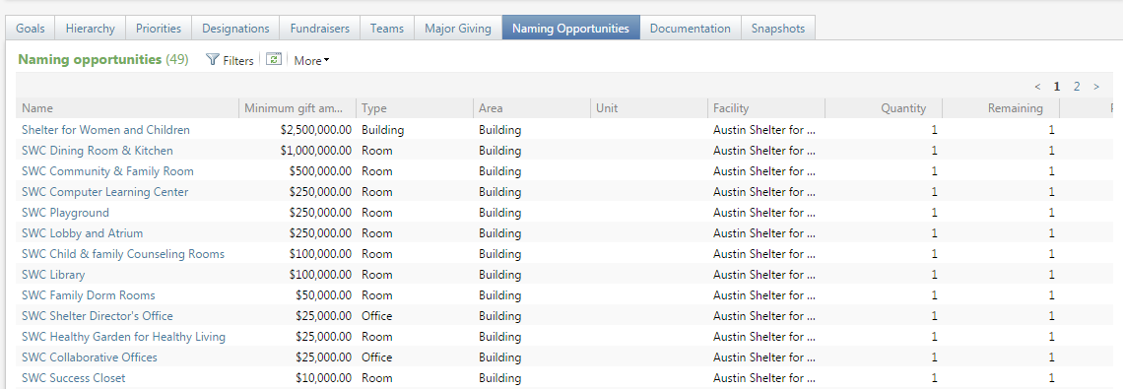

* Under the Naming Opportunities tab one can:
* See all of the possible naming opportunities for a Capital Campaign and information about each opportunity (ie: Gift amount required, type of opportunities, quantity, etc). *See How to Create a Naming Opportunity for more information about where and how these are created.

How to Create a Naming Opportunity

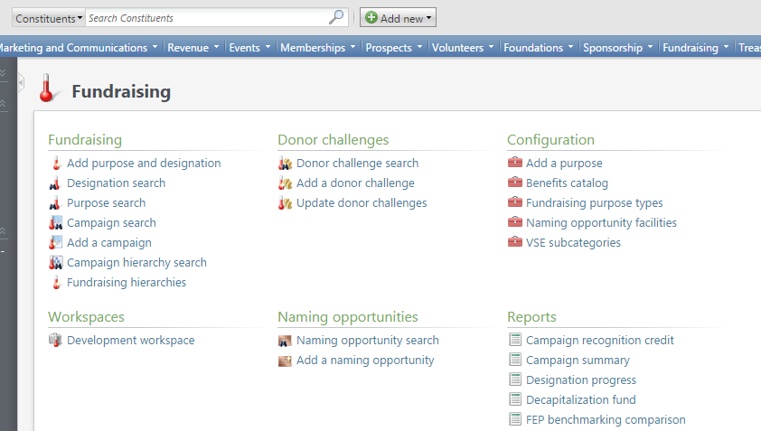

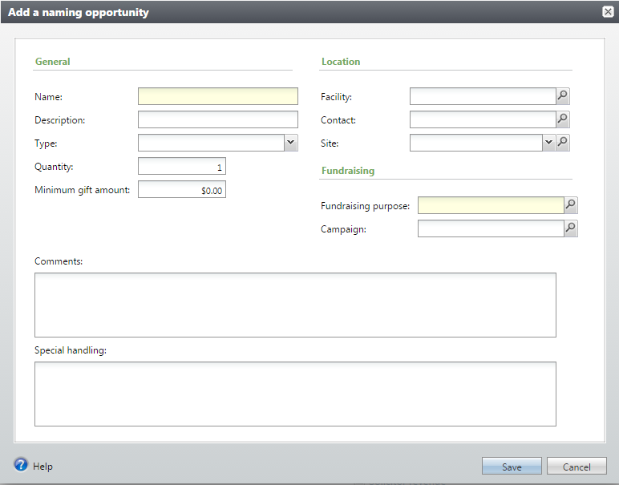

* Go to the Fundraising tab and, under Naming opportunities, click ‘Add a naming opportunity’.
* Complete relevant fields, including Fundraising Purpose and Fundraising Campaign.
* Once you Save, this Naming Opportunity will appear under the Naming Opportunities tab on the Capital Campaign page specified.

Documentation tab

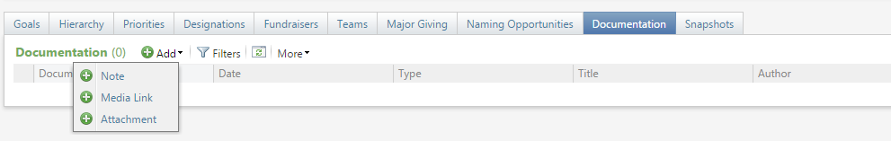

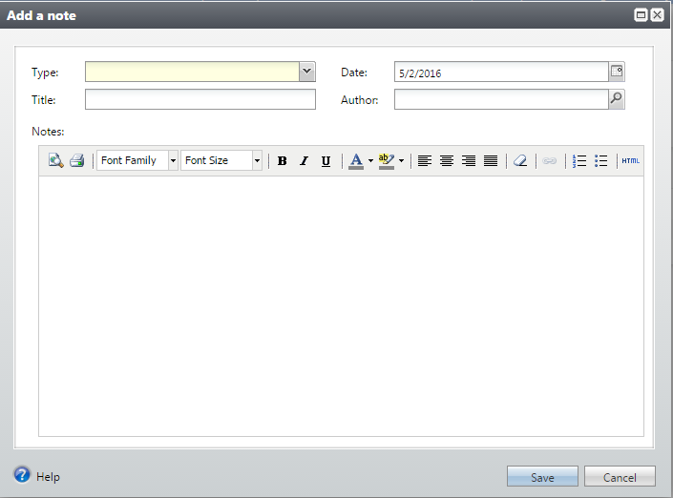

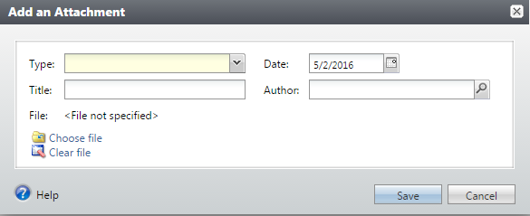

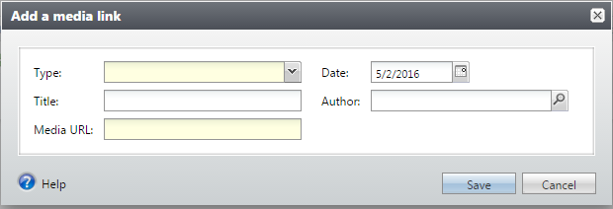

* Under the Documentation tab one can:
* See all notes, media links and attachments that have been created for your Capital Campaign
* Add and edit notes, media links, and attachments for a Capital Campaign

Snapshots tab

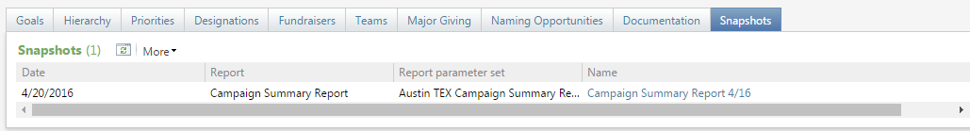

* Under the Snapshots tab one can:
* See any and all snapshots that have been created for this Capital Campaign. (*See Report Explorer for more information on how to create a Snapshot)
* Access the snapshot report by clicking on the report’s name, which is a hyperlink.

Adding Purposes/Designations



In order for donations to be allocated to their correct places, designations will need to be established for a Capital Campaign. Each Designation will also need to be connected to a Purpose, or a reason for the fundraising effort. The field will indicate which designations they need for which purposes and the SST will create these for the selected Capital Campaign. *Please note, a Capital Campaign can contain Purposes which have no assigned Designation (if the purposes don’t need to accept donations).

To add a purpose/designation, go to the Fundraising functional area and click ‘Add purpose and designation.’

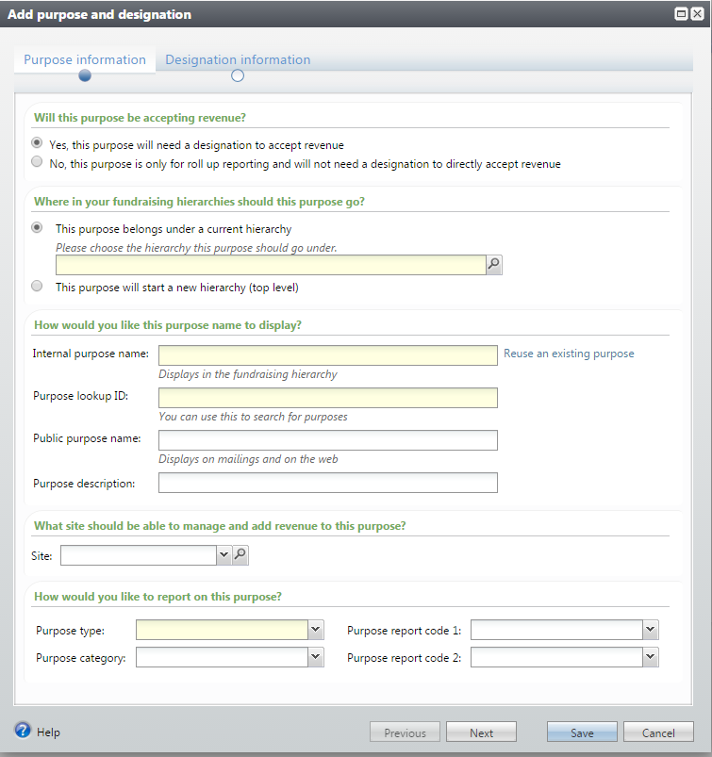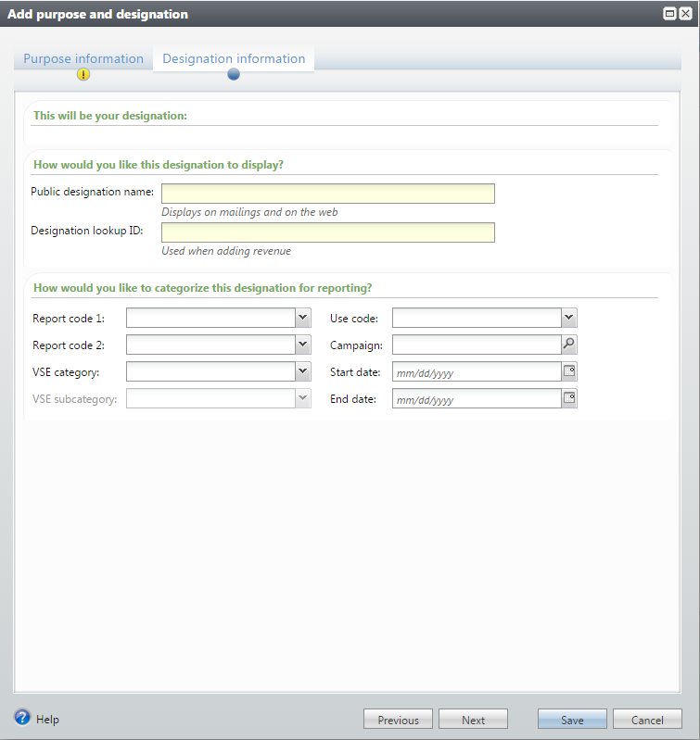

2

1

1. First, you’ll be asked to complete information about the Purpose. Note that you’ll have to determine whether or not the purpose needs to accept revenue (*If not, you won’t need to fill out the designation information*). You’ll also need to determine if the purpose/designation needs to start a new hierarchy (most likely it will be if you’re setting this up for the CC as the primary designation) or if it needs to roll up under another hierarchy that has already been established. (See Managing Hierarchies for more information on how to do this). You’ll also need to fill out the purpose’s name, description, ID, Type, Site, and Reporting Codes.
2. Next, you’ll need to complete information about the Designation, such as Name, Lookup ID and Reporting Codes. Clicking Save will save the Purpose and Designation.

Manage Fundraising Hierarchies



At times, the SST may be asked to nest sub-campaigns (with their own designations) into a larger campaign. To set up and manage fundraising hierarchies, go to the Fundraising functional area and click ‘Fundraising hierarchies’.

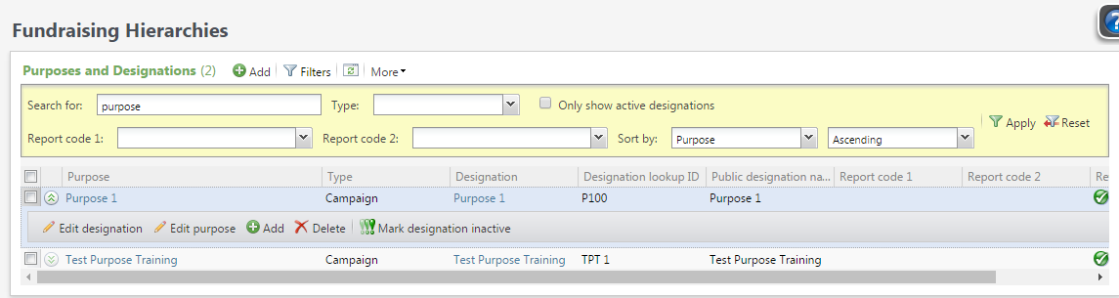

1

2

3

4



# 

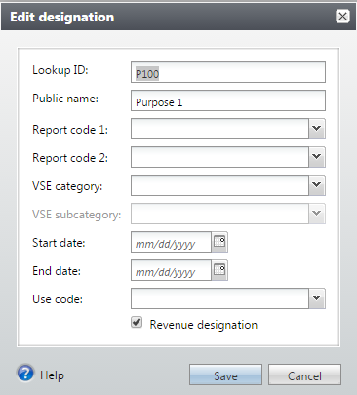

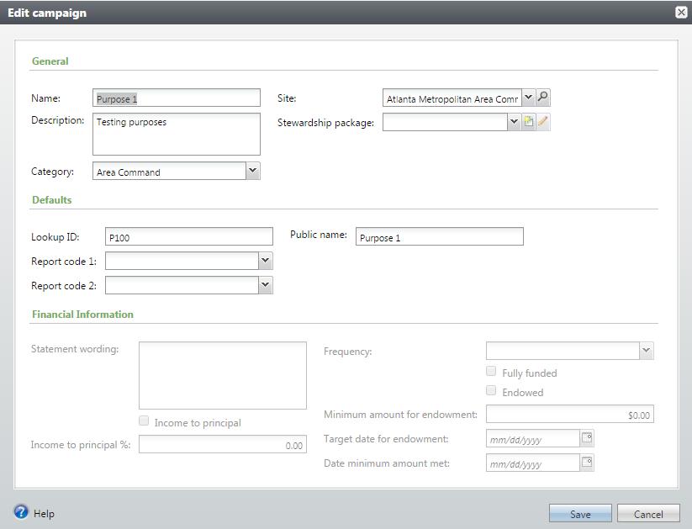



From the Fundraising Hierarchies area, you can:

1. Set up a brand new purpose and designation.
2. Set up a subcampaign by adding in a purpose and designation under the ‘parent’ or main campaign.
3. Edit a purpose.
4. Edit a designation.

Adding Teams

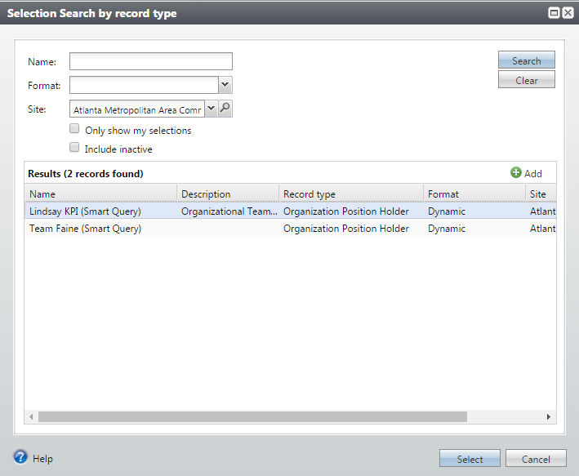



1

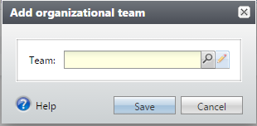

To add a fundraising team to this Capital Campaign, click the Add button. You have several options here:

1. You can search for a team that has already been created via a Smart Query and Select that particular team.

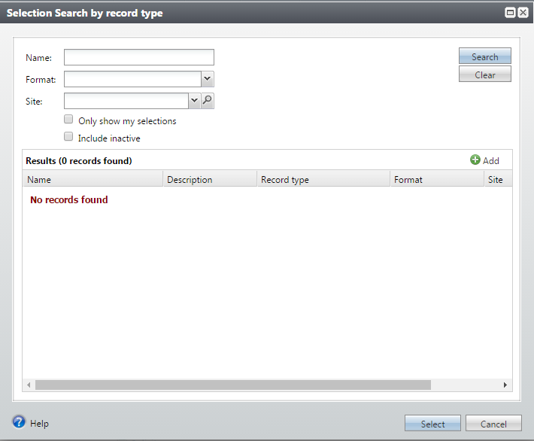

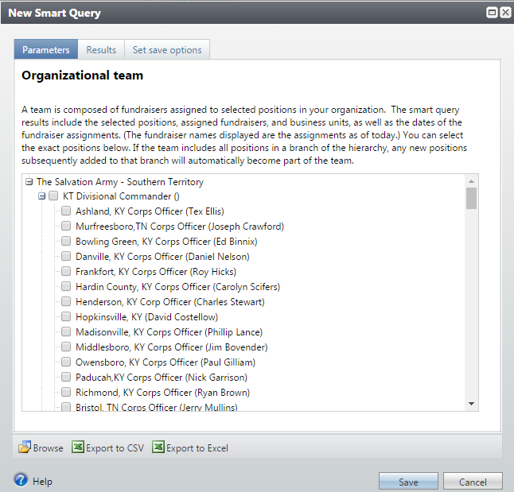

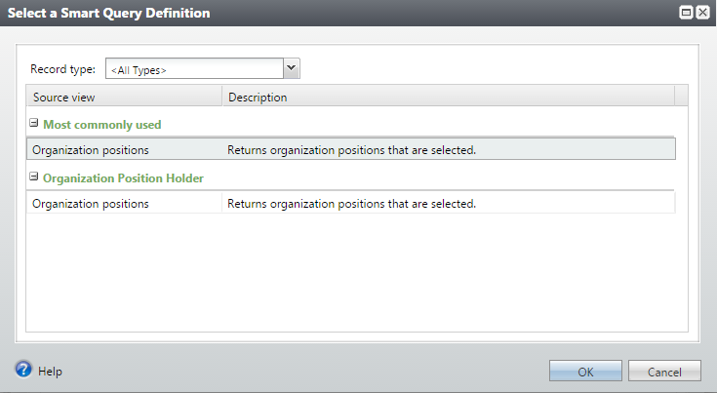

2

1. You can Add a Smart Query Definition from the Search screen and then you can choose the members of the team by checking the appropriate checkboxes.



3a

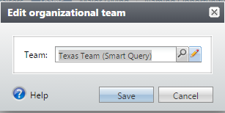

3a. You can also edit the people that are on a Team. If the Team has already been entered onto the Capital Campaign, you can click the Edit button beneath the Team name and click the Edit option (pencil icon).

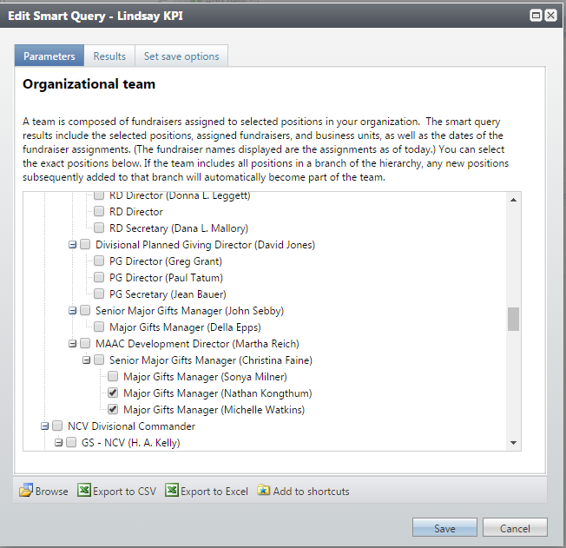

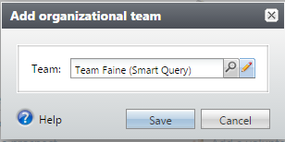

3b

3b. Or, you can Search for the Team and click on the Edit option (pencil icon).

Both ways will take you to a Smart Query box where you can choose the people you’d like to place on a team by checking the boxes next to their positions/names. (*These hierarchies are configured in the Administration functional area in InterChange).

Configuring KPIs

A KPI (Key Performance Indicator) is a way for users to see how well they’re progressing towards their fundraising goals. When you set up a KPI, what you’re doing is creating a ‘reporting’ feature that allows others to access the information defined without them having to go and write or run their own reports and you’re also giving them a tool that shows them both visually and with statistics where they are in relation to their defined goals.

Add KPIs

There are several ways that you can set up a KPI. From the options on a CC, you can choose either “Add KPI” or “Manage KPIs” to be taken to the KPI area in the Information Library.

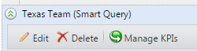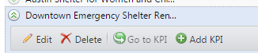

You can also add a KPI by going to the Analysis Functional Area, clicking on Information Library and then clicking on the KPI tab but if you choose this way to create a KPI, then you’ll have an additional step (see next page).

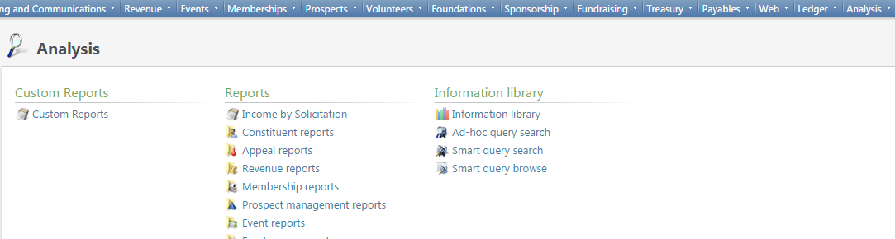

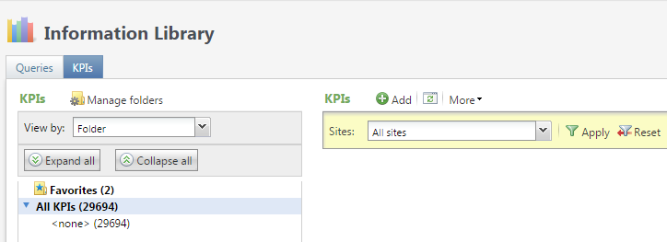

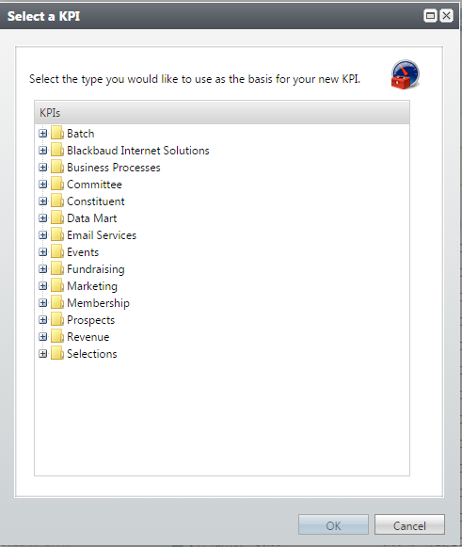

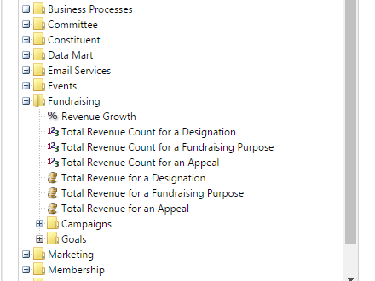

If you choose to add in a KPI from the Information Library (rather than from the Capital Campaign), you will also need to select the type of KPI you’d like. Click on the + sign to open up the folders to see which KPIs are available and click on the KPI type you’d like to create.

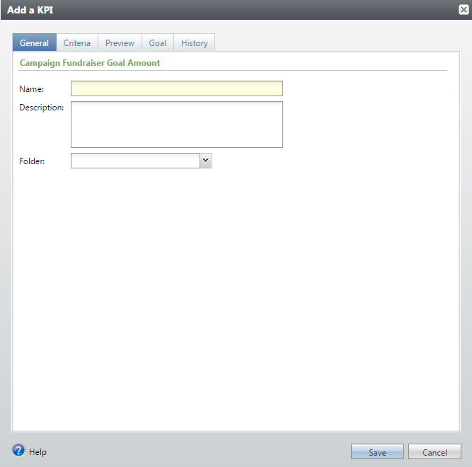 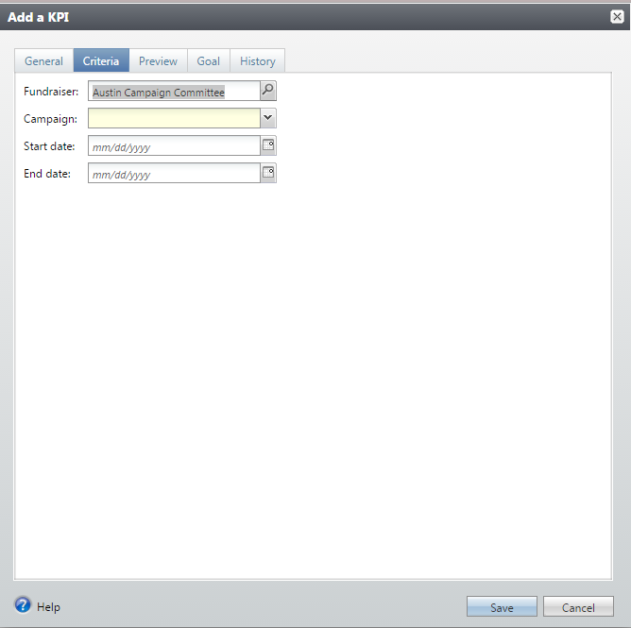

You will now see the ‘Add a KPI box’ open up. There are 5 tabs in this box that you will need to complete before saving the KPI.

* The first tab is entitled “General” and asks you to fill in the name and description of the KPI.
* The second tab is “Criteria” and here is where you set up the criteria for the specific KPI. (*Please note, the fields in the Criteria tab may vary based on the KPI you’ve chosen to create. The visual above is intended as an example only).

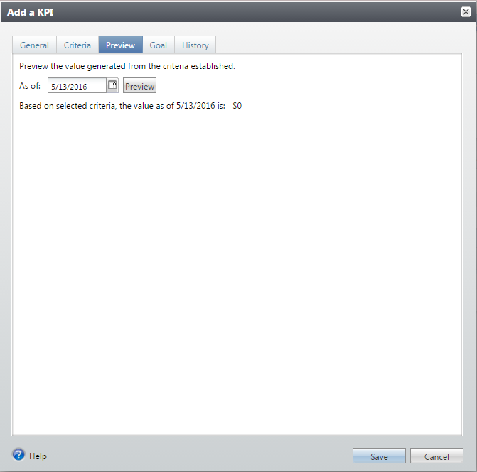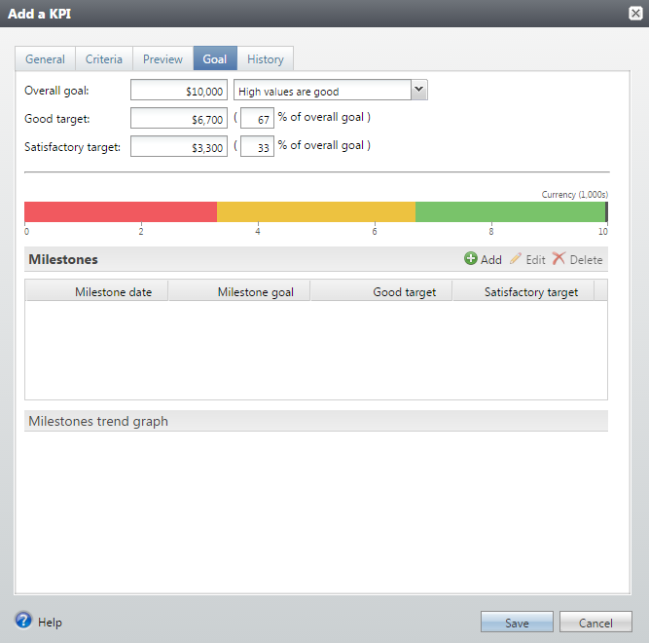

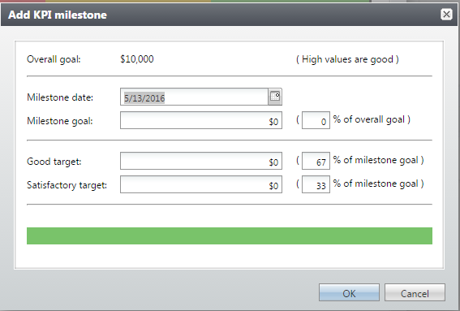

* Under the “Preview” tab, you can run the parameters of the KPI that you established in the second tab to see the results. (This is kind of like running a query to see if you chose the correct parameters).
* Under the “Goal” tab, you can set up the overall goal, a ‘good target’ and a ‘satisfactory target.’ When the KPI is run, the person running it can then have a visual of how well they are doing.
* There is also the option to add a milestone under this tab. You can set targets for milestones as well.

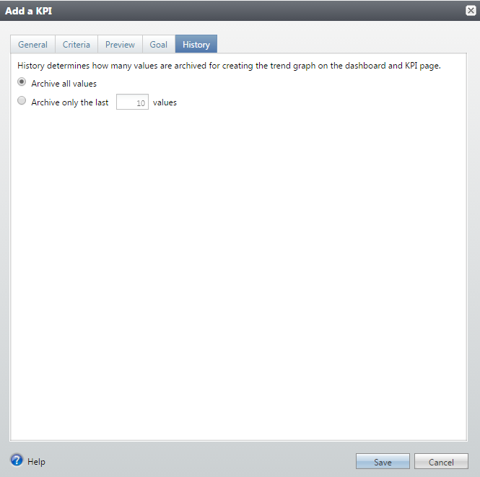

* Under the “History” tab you can determine how many of the KPI instances you want to store here. Once done, clicking Save will save your KPI.

Setting up a KPI Dashboard

There may be times when you’d like to access several KPIs at one time. Rather than locate and then run each of them, you can set up a KPI Dashboard which houses all of the KPIs you’d like to see in one, centralized place. Your KPI Dashboard is connected to your login, so that your Dashboard is yours and yours alone. You can place any KPIs that you have security permission to view and run onto your Dashboard. Here’s how to set one up:

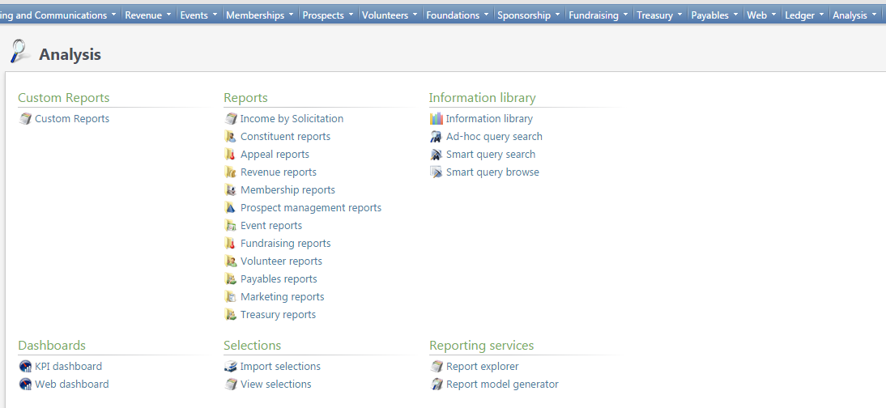

1. Go to the Analysis functional area, and in the Dashboards area, click on the hyperlink ‘KPI Dashboard’.

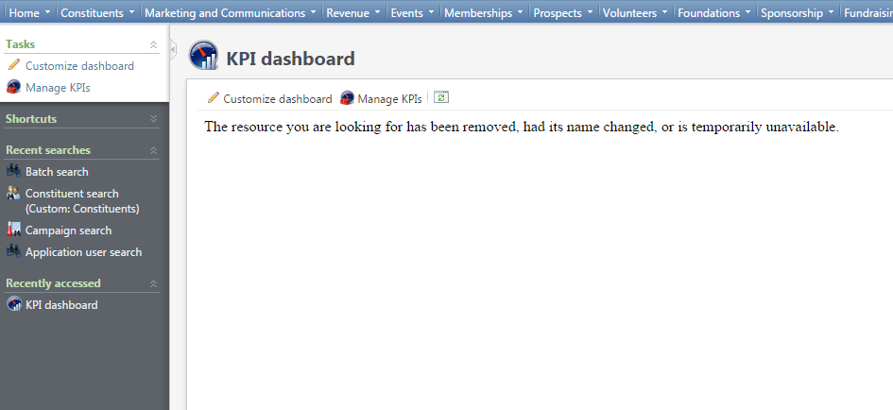

1. You’ll then be taken to the KPI Dashboard area. (You won’t have any KPIs listed because you haven’t set up your Dashboard yet.) Click ‘Customize dashboard’.

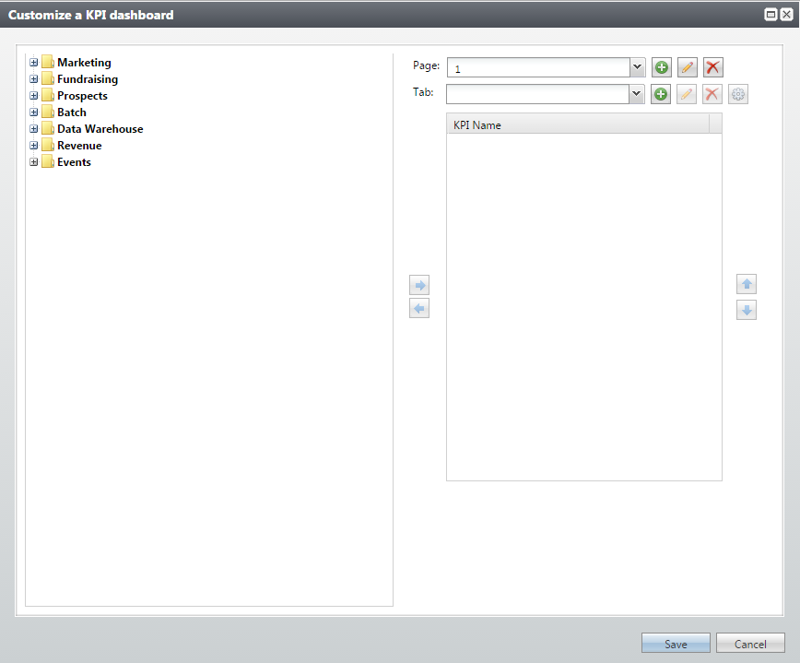

Use these arrows to move KPIs onto or off of your Dashboard.

Here are the folders where all of the KPIs that you have access to are located.

Here is where you manage the Tabs of your KPI.

Here is where you manage the Pages of your KPI.

1. You will then see the Customize a KPI Dashboard box appear. In this box, you can choose all of the KPIs you’d like on your Dashboard and organize them into Pages and Tabs. (See the following pages for more information on this). Make sure to Save your Dashboard when you’re done.

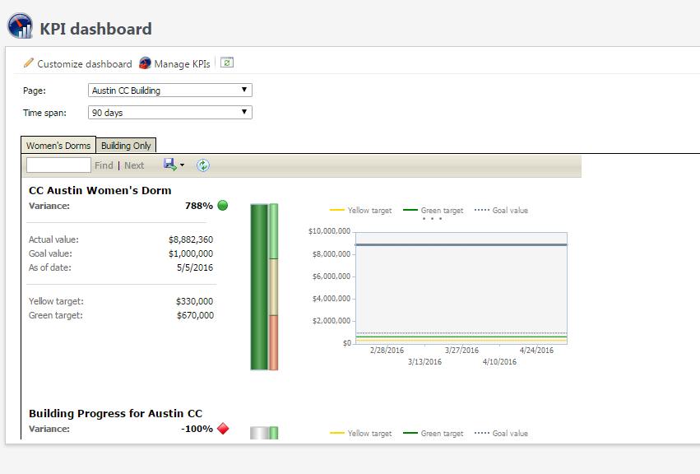

1. Now, every time you access your KPI Dashboard, you will see all of your KPIs by toggling through the Pages and Tabs that you created.

Creating Pages on a KPI Dashboard

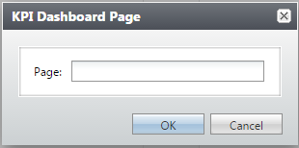

1

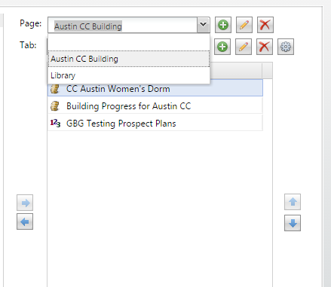

2

3

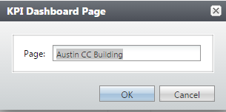

Tabs are housed on Pages in the KPI Dashboard. Therefore, it’s best to first create the Page you want, then add and modify the Tabs that will live on it.

1. You can access the various Pages you’ve created for your KPI Dashboard by clicking the drop-down menu next to the Page field.
2. You can add Pages by clicking the  button and entering a name for your Page. Clicking the OK button saves the Page.
3. You can edit Page names by clicking the  button. Clicking the OK button updates your Page name.
4. The  button will delete your entire Page and any and all Tabs that are on it.

Creating Tabs on a KPI Dashboard

Because Tabs live on Pages in a KPI Dashboard, before modifying or configuring your tabs, you’ll first need to make sure you are on the correct page.

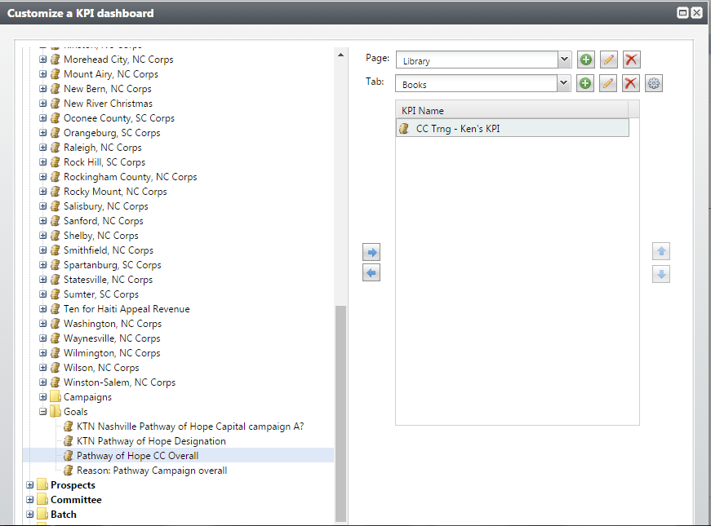

1

3

2

1. You can access the various Tabs you’ve created for your KPI Dashboard by clicking the drop-down menu next to the Tabs field. *Remember, make sure that you are on the correct Page.
2. You can add Tabs by clicking the  button and entering a name for your Tab. Clicking the OK button saves the Tab.
3. You can edit Tab names by clicking the  button. Clicking the OK button updates your Tab name.
4. The  button will delete the Tab and any KPIs associated with it.
5. You can add KPIs to tabs by highlighting the KPI and then using the  to move it onto the tab.
6. You can use the  or  buttons to reorder your Tabs.

Reports: Campaign Level

* There are many different places in InterChange where you can run reports to access data on various aspects of your Capital Campaigns.
* You can run reports on purposes, designations, fundraising hierarchy, and progress of any of the aformentioned.
* There are three reports you can run to gather data at the Campaign Level. They are Campaign recognition credit report, Campaign priorty report, and Campaign summary report.

Use Report Explorer

You can also run reports at the Campaign level and capture their data for future convenient access by using the Report Explorer tool. See Report Explorer for more information.

Campaign recognition credit report

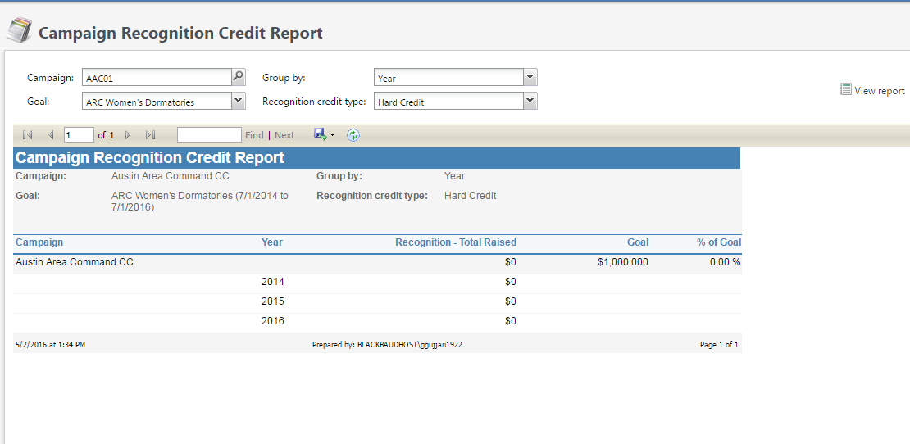

This report shows progress towards a specific goal, including total recognitions credit, and percent of goal for the campaign.

* To run the Report:
* Populate the fields at the top of the report on which you’d like to extract data
* Click View Report
* Click the floppy disk icon to download the file to your computer in a certain format (excel, pdf, etc)

Campaign priority report

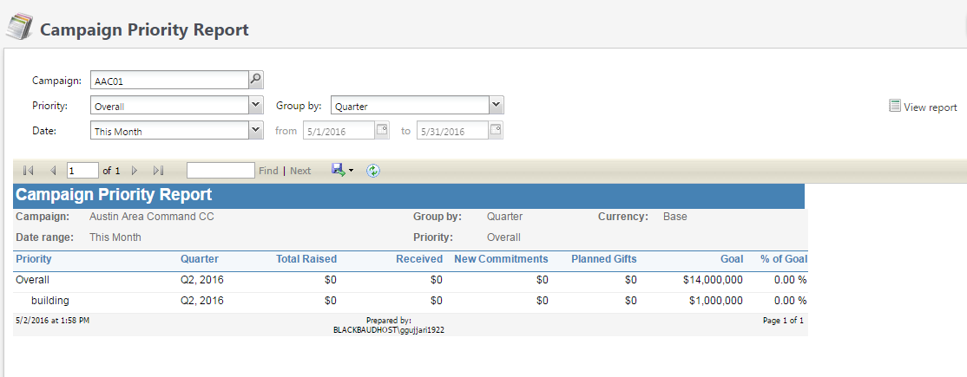

This report shows progress towards specific priority goals, including total raised, total received, new committements, total amount of planned gifts and percent of goal for the selected campaign.

* To run this report:
* Populate the fields at the top of the report on which you’d like to extract data
* Click View Report
* Click the floppy disk icon to download the file to your computer in a certain format (excel, pdf, etc)

Campaign summary report

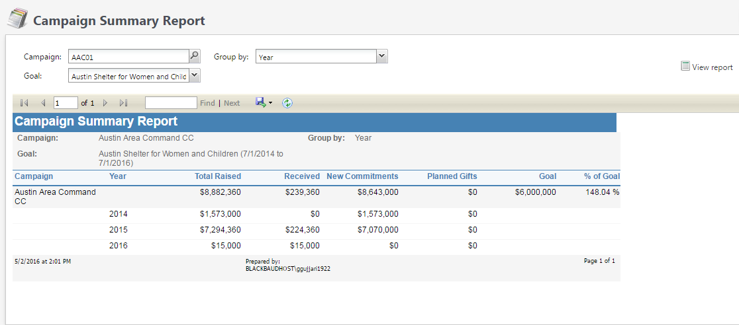

This report shows progress towards specific goal, including total raised, total received, new commitments, total amount of planned gifts and percent of goal for the campaign.

* To run this report:
* Populate the fields at the top of the report on which you’d like to extract data
* Click View Report
* Click the floppy disk icon to download the file to your computer in a certain format (excel, pdf, etc)

About Report Explorer

* The Report Explorer tool can be used to run reports on your Capital Campaigns
* You can ‘snapshot’ reports run in Report Explorer. These snapshots will show up under the Snapshots tab on your Campaign.

Access Report Explorer

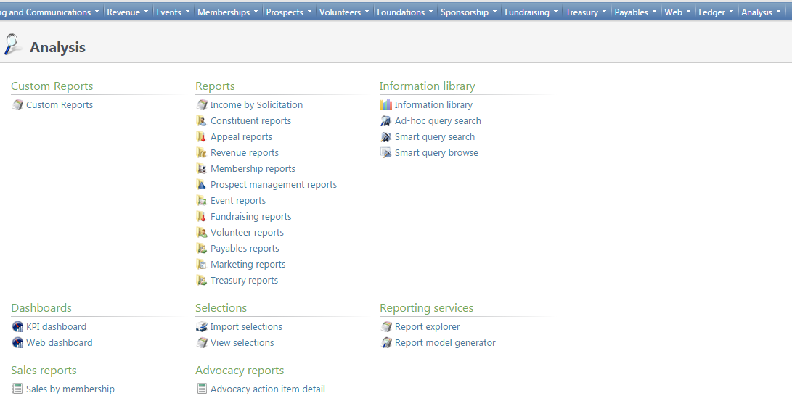

* First, go to the Analysis Functional area.
* Under Reporting Services, click on the ‘Report explorer’ hyperlink.

Run Campaign Reports in Report Explorer

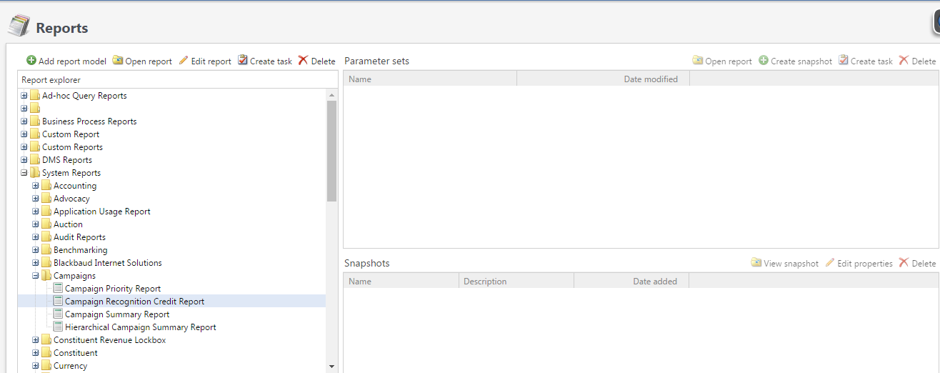

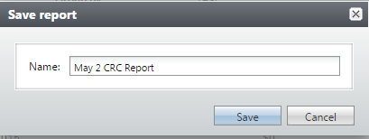

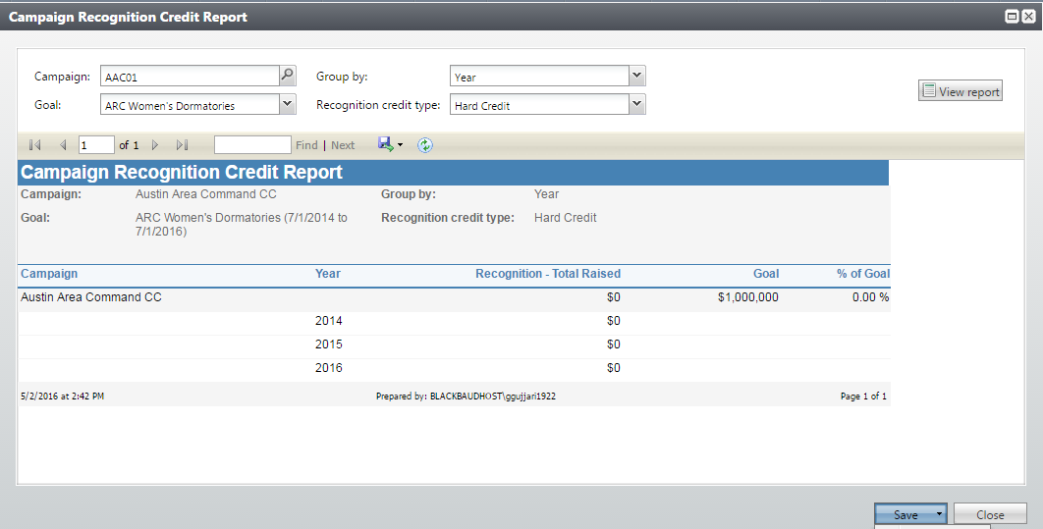

* You’ll see a series of folders on the left-hand side of your screen.
* Click the System Reports folder to open up its subfolders.
* Then click the Campaigns folder to open up its possible reports.
* Click on the report you’d like to run. *You have to choose your report to see icons appear above the left-hand side of the screen.
* Click the Open report icon to set up your reporting parameters.
* Set your parameters by filling in the fields, click View Report.
* Once done, Save the report by giving it a name.

Take a snapshot in Report Explorer

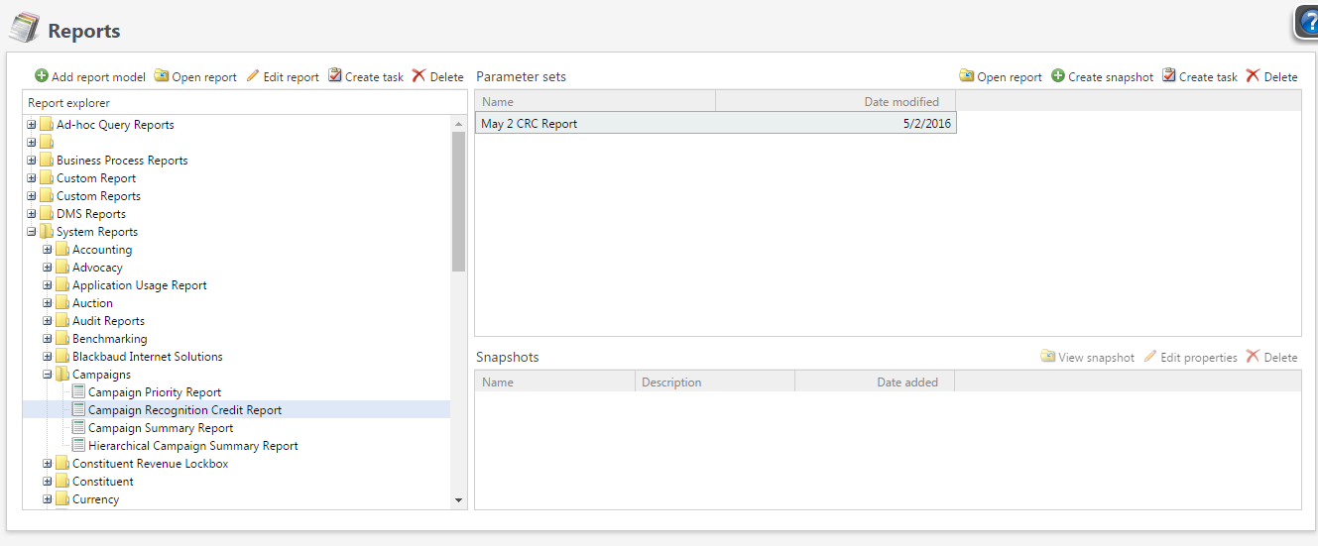

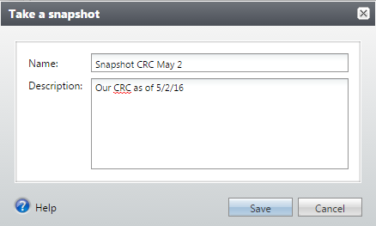

* Click on the report you’ve saved on which you’d like to capture a snapshot.
* Click the Create a snapshot button.
* Give your snapshot a name and description.
* Once you Save your snapshot, it will appear under the ‘Snapshots’ tab in your Capital Campaign.