Location
Three Dairies in Ohio and Indiana

Facility Type
Dairy Farms

Client
Irish Acres Dairies

Services Provided
- ODA and IDEM Expansion Permit Applications
- Regulatory Agency Compliance Assistance
- Subsurface and Siting Investigations
- Manure and Contaminated Storm Water Storage Pond Design
- Septic System Design
- Construction Storm Water Pollution Prevention Plan
- Construction Certification

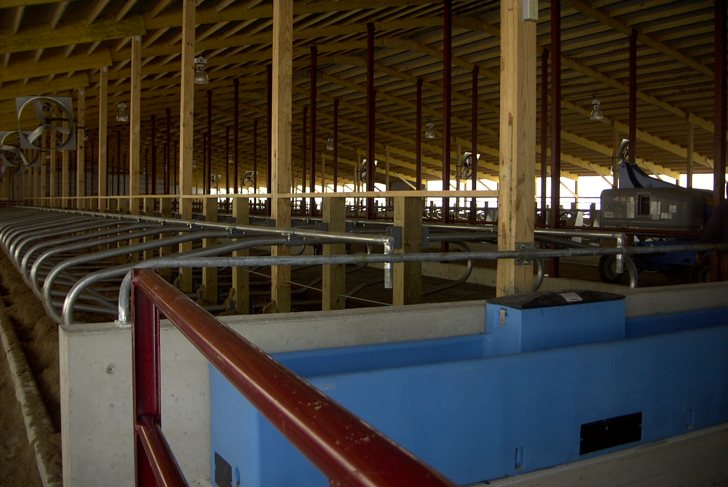

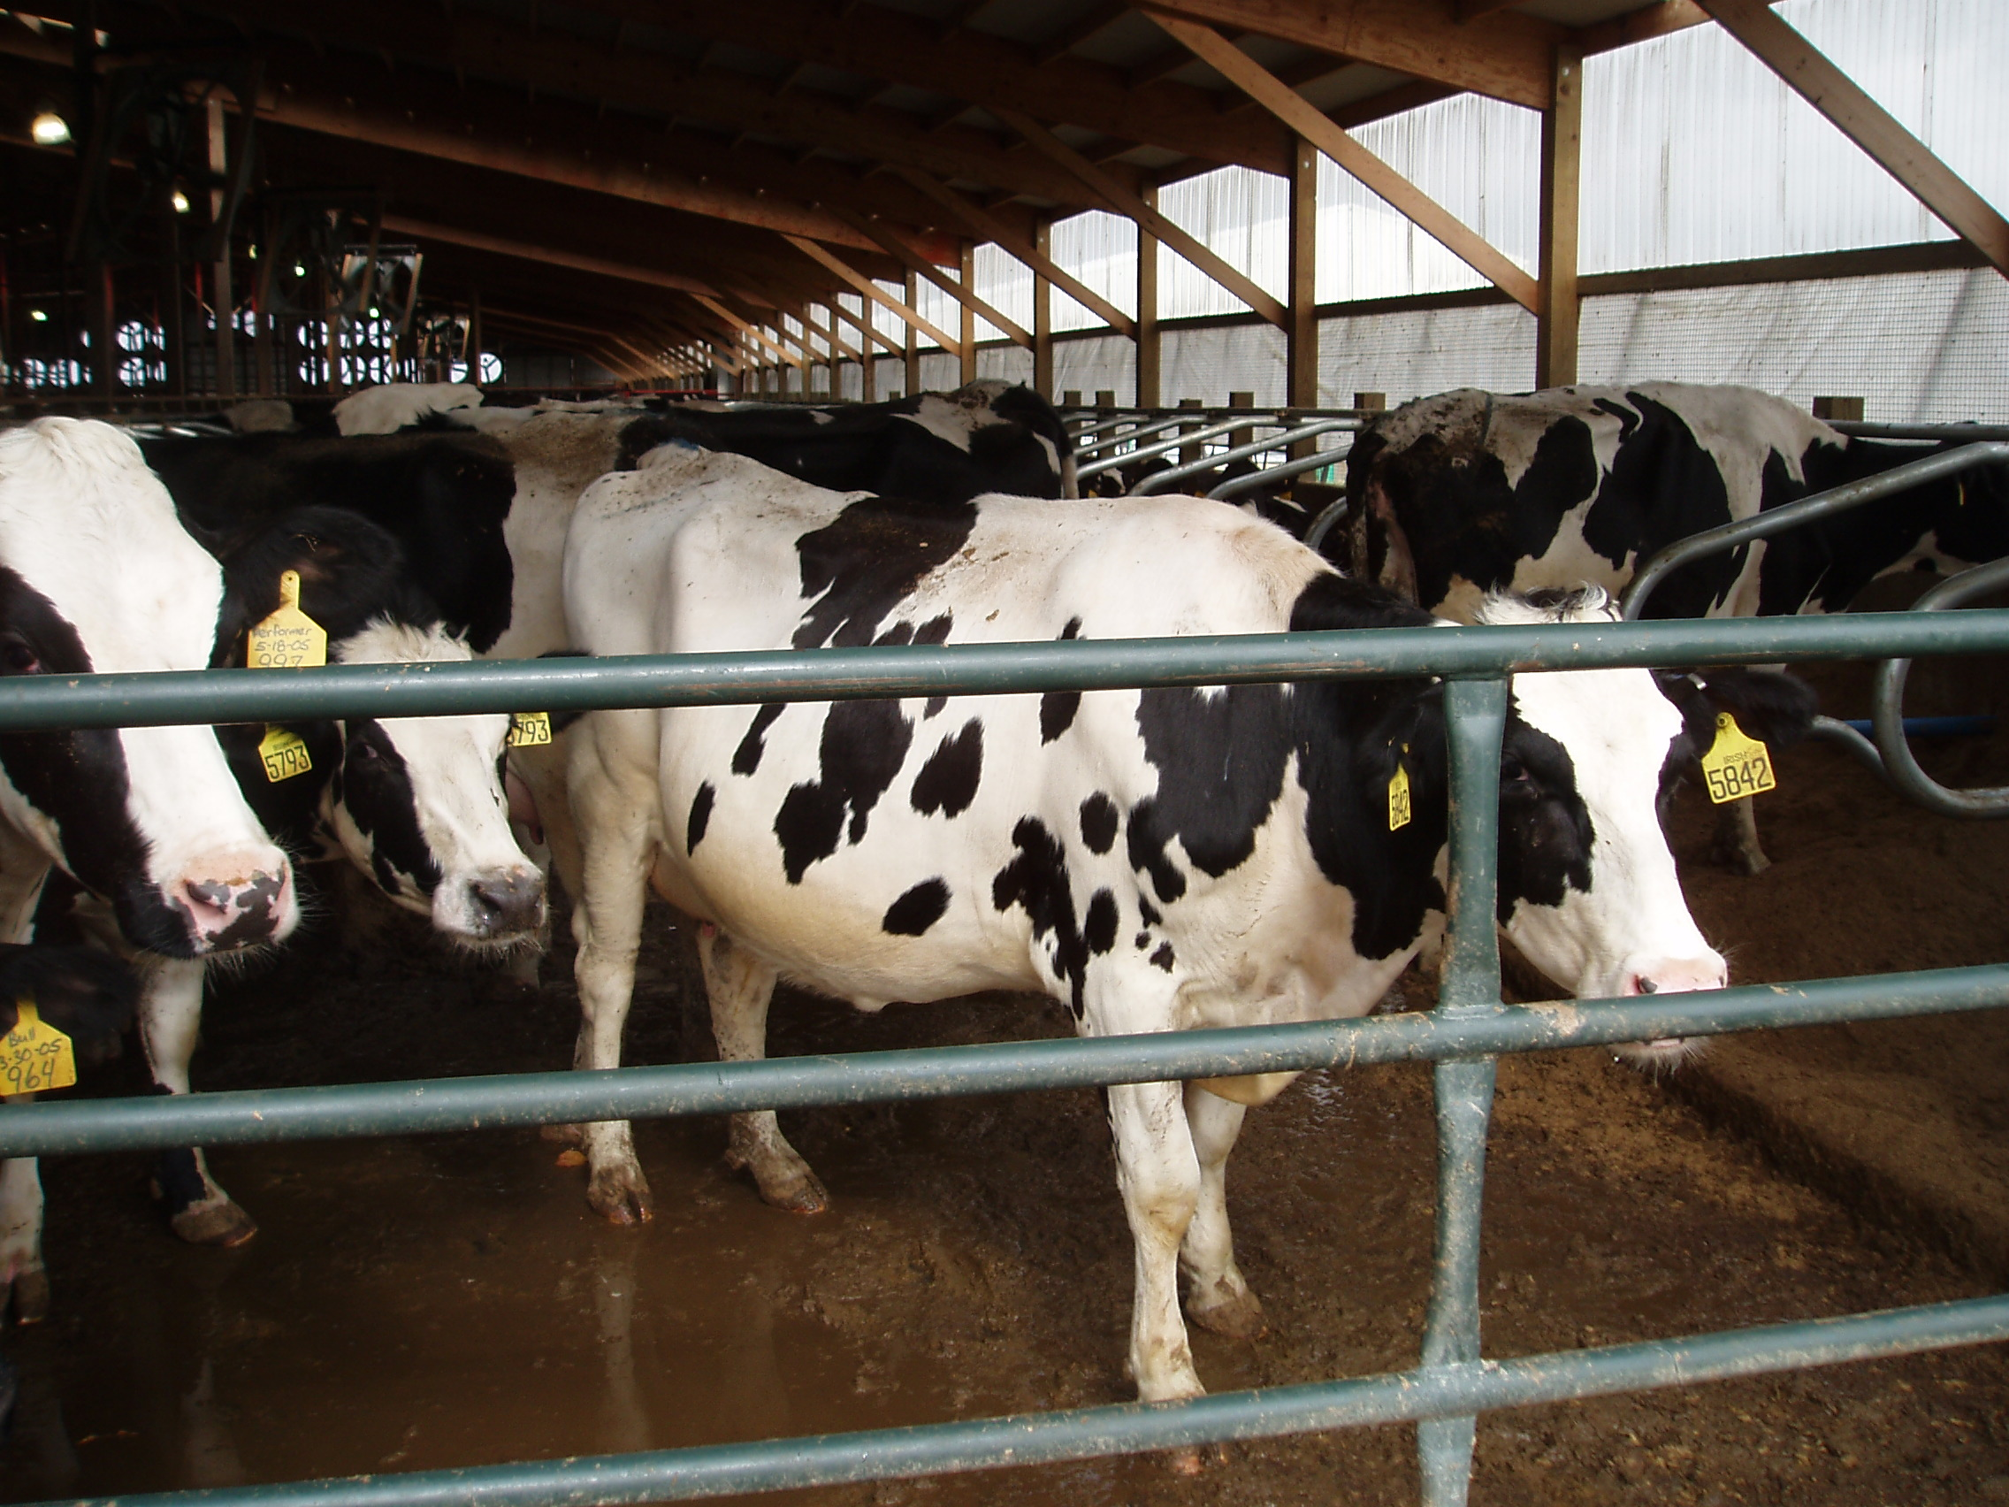

Project Profile
North Point Engineering has been the technical consultant for Irish Acres since 2003 and has performed the following services:

- Dairy Expansions (2004 - 2009) Three permit expansions, two in Indiana and one in Ohio, of existing farms
- Construction documentation and certification for several manure and storage ponds for the expansion of the three dairies (2005 -2008)
- Nutrient Management Plans
- Operating Record Assistance



