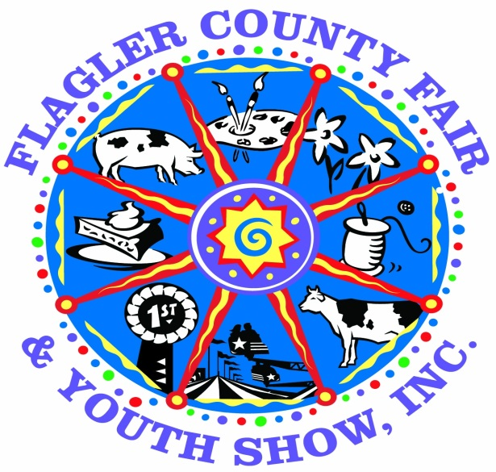

4H and FFA HORTICULTURE SHOW
Flagler County Fair and Youth Show Dates:
Wednesday April 4th, 2018 to Sunday April 8th, 2018

*Open to all 4H and FFA exhibitors in Flagler County*

GENERAL RULES:
- All plants will be provided by the fair. You can pick up your plants at the mandatory meetings in January. Those dates are as follows: January 11th, 2018 @6:00 PM
- All plants will be grown by the exhibitor.
- Horticulture projects will be accepted at the Cattlemen’s Hall on
April 2nd (10am-8pm)
- All specimens must be clean, free of insects and disease and be well groomed.
- Containers must be clean and near in appearance & shall not exceed three (3) gallons in size. No food cans or broken containers will be accepted.
- Exhibitors will be limited to one entry in their age division
- All entries may be removed on Sunday April 8th after 6 pm and Monday April 9th, 2018 between 5 pm to 7 pm
- Any 4H member that will be participating in the 4H Youth Potato Project will be allowed to enter their potato plants

AGE DIVISIONS: As of September 1st, 2017

Cloverbud – Age 5-7 Junior 8-10 Intermediate 11-13 Senior 14-18

JUDGING: Plants will be judged on the following criteria
* General Appearance * Size & Color of Leaves * Free of deficiencies/insects * Free of disease

PLACING & AWARDS: Each age division
1st Place – Blue Ribbon & $15.00 Cash Reward
2nd Place – Red Ribbon & $10.00 Cash Reward
3rd Place – White Ribbon & $5.00 Cash Reward
Best Decorated Pot (Each Age Division) – Rosette & $20.00
Overall Best of Show – Rosette & $25.00 Cash Reward
*Overall Best of Show will be based on a combination of both the plant and decorated pot*

