April 2017 At a glance
Full descriptions of activities in bulletin.

Sun | Mon | Tues | Wed | Thurs | Fri | Sat
9  Worship  11:15  Open Hearts Jar | 10  AA 7:30 pm  Meditation  7 pm | 11  Cards  9:30  TOPS  6:30 | 12  Community Study Night  8 pm | 13  Teaching Seder at LSC 7 pm | 14  Good Friday Memorial Wake  7 pm | 15  Easter Vigil at St. Paul’s Cathedral 10 pm
16  Sunrise Service and potluck breakfast  5:45 am Worship  11:15 | 17  AA 7:30 pm  Meditation  7 pm | 18  Cards  9:30  TOPS  6:30 | 19  Faith Expl. 7:30 pm | 20  Craft/Study  1:30  LT Meeting  7 pm | 21  Film and Faith | 22  IMCF Breakfast  9 am to 12
23  Worship  11:15  Transfer of Membership  POTLUCK  Cong. Care  Speaker | 24  AA 7:30 pm  Meditation  7 pm | 25  Cards  9:30  TOPS  6:30  Russell at Inhabit Conference | 26 | 27  Craft/Study  1:30 | 28 | 29
30  Worship  11:15 | 1  AA 7:30 pm  Meditation  7 pm | 2  Cards  9:30  TOPS  6:30 | 3  Faith Expl. 7:30 pm | 4  Cong. Care  10 am  Craft/Study  1:30  Family Dinner 6pm  Prayer Writing Workshop  7 pm | 5 | 6
7  Worship  11:15  Communion  Remit 3 | 8  AA 7:30 pm  Meditation  7 pm | 9  Cards  9:30  TOPS  6:30  Russell at Sexual Abuse Prevention | 10 | 11  Craft/Study  1:30 | 12 | 13  Women’s  Breakfast  8 to 10 am

TOPS = Take Off Pounds Sensibly
AA = Alcoholics Anonymous

ANNOUNCEMENTS
April 9, 2017

306-761-0556 eastsideunited@sasktel.net
Like us on facebook (Eastside United Church)
Follow us on Twitter @Eastside_united
www.eastsideunited.ca

W
elcome to Eastside United. May our opportunities of ministry offer you rest, challenge and peace on your Christian journey.

Ministers:
Minister: Russell Mitchell-Walker
Greeting: Alma Pockrandt and Diana Ingham
Congregational Care Greeter: Barb Rio
Prayers: Linda Fowler
PowerPoint: Steph Banks
Piano:Josh Hendricksen
Attendance last week:

Russell’s e-mail address: russell.eastside@sasktel.net

Office Hours:
Tuesday through Friday from 8:30 am to 3:30 pm
Brewed Awakening Office Hours, Wednesday afternoons from 2 to 4:30 pm. At Woodhams Drive location for the month of April.

Scripture Readings: Luke 19: 35-40; Luke 19: 41-47; Luke 20: 7-23; Matthew 26: 36-44; Matthew 26: 45-56; Luke 22: 54-62; Luke 22: 63- 23:25

Songs:
All Who are Thirsty MV #4
Hosanna, Loud Hosanna! VU #123
O Beautiful Gaia MV #41 vs 2
Were You There VU #144 (repeated throughout service)
Called by Earth and Sky MV #135 chorus
Don’t Be Afraid MV #90

Arcola East Senior Bridge Club: Looking for a fun way to get out and socialize with other seniors? The Arcola East Senior Bridge Club gathers for social bridge each Monday at 1 pm at the Living Spirit Centre (3018 Doan Drive). No prize money; weekly fee is $1. For more information, please contact Bill Jeske at 306-789-2430 or Alma Pockrandt at 306-789-5981 or apockra@yahoo.ca.
Join us for Easter
Worship

April 9 Palm Sunday
A Walk through Holy Week All Ages Service
11:15 am

April 13 Maundy Thursday
Teaching Seder with Bread of Life
7 pm

April 14 Good Friday
Memorial Wake with IMCF
Featuring Creator’s Sacrifice Paintings
7 pm

April 15 Easter Vigil
At St. Paul’s Anglican Cathedral
with St. Philip Anglican
10 pm

April 16 Easter Sunday
Sunrise Service 5:45 am at LSC
Easter Worship 11:15 am

LSC Meditation Group: The Meditation Group gathers at 7 pm Monday evenings in the East Sanctuary. Feel free to bring a friend, and dress comfortably.

St. Philip Senior Ministry Outreach card playing program,Tuesday mornings at 9:30 am in the East Sanctuary at the Living Spirit Centre. Whist and lessons to those that would like to learn. Come out and enjoy fellowship, coffee and card playing. If you need a ride call Rod 306-789-1388. Everyone is welcome.

Eastside’s Craft/Study Group Thursdays at 1:30 pm in the Multipurpose Room! Join us as we share in discussion, handiwork and coffee time following. We are reading Grounded by Diana Butler Bass. This is a fun time of study, crafting, and refreshments following. NO GATHERING APRIL 13.

Community Study Night, Wednesday, April 12, from 8 to 11 pm. Coffee, tea and snacks supplied! Come for a quiet space to get some studying and homework done. Plug-ins for laptops available! See Taylor Balfour if interested and follow our Facebook event page: https://www.facebook.com/events/157007284815470/

A Night for St. Andrew’s Gala Dinner and Fundraiser, Tuesday, April 18, 2017 at the Wascana Country Club, 6500 Wascana Parkway. Gathering 5 pm, dinner 6:15 pm. Tickets $110 (partial tax receipt), ticket deadline April 10. See Leona Martin or contact the church office if interested. This year’s fundraiser includes an address by Right Reverend Jordan Cantwell, UCC Moderator, and music by Lori Erhardt and Corinne Groff!

GARAGE SALE at Broadway United Church, 105 Broadway Avenue: Friday, April 21, 4 pm to 8 pm; Saturday, April 22, 9 am to 1 pm. Lunch Available! Come and Find Treasures Galore!!
We’d love you to join our family! We are planning a Transfer of Membership service Sunday, April 23. If you are interested in being included or have questions, please let Russell know.

TIME OUT FOR BLESSINGS: A Christ-centred yoga retreat presented by Connie Moker Wernikowski of Big Fish Yoga. Friday, April 28 at 6 pm to Saturday April 29 at 5 pm. At the living Skies Retreat Centre in Lumsden, SK. This retreat will offer both active and restorative yoga; meditation; some free time for walking, resting, visiting; Christian chanting; and an intro to the First Ignation Spiritual Exercise. Cost is $193. Please complete a registration form found on any of the LSC bulletin boards, or by emailing mokerw@sasktel.net.

Regina Philharmonic Chorus invites you to celebrate Canada’s 150th Anniversary at their Spring Concert "Canada 150 - Musical Celebration" Saturday, April 29, 2017 - 8 pm at Knox-Metropolitan United Church. Music includes Canadian folk songs and other Canadian compositions as well as John Rutter’s “Mass of the Children”. Living Spirit Centre’s accompanist, Joshua Hendricksen, will be one of the vocal soloists featured at the concert. Tickets: $30 available online at reginaphilharmonic.com. $15 Student and $5 Children’s tickets available from RPC members, Bach & Beyond, or at the door.
The P3 Garage – an original play – a comedy. Written by Wesley United’s Norman Bray and associates, the play touches on the Public and Private Partnerships in wide use to finance public facilities such as highways, sewage plants and schools. Tickets are available at Wesley United Church office or may be obtained at the door prior to performances: Friday, May 5 at 7:30 pm Saturday, May 6 at 7:30 pm; and Sunday, May 7 at 2:30 pm. Tickets Adults $20, Children under 12 $10 (includes refreshments).

Prayer Writing Workshop, Thursday, May 4 at 7 pm: Join us as we reflect on the power of prayer in worship and in devotional practices, and explore the benefits that writing a prayer can offer as a path to mindful and compassionate living. Workshop facilitator, Ray McGinnis, offers tips for helping anyone who is asked spontaneously to lead a group in prayer. Drawing on a splendid range of examples of prayer from scripture and recent prayers written by adults and children, Ray helpfully provides a step-by-step template for you to write opening prayers, prayers of thanksgiving and intercessory prayers. There is time for discussion and time for prayer and reflection on how praying together can strengthen the church and help us be there for each other when it counts. No previous writing experience needed. Older children, youth and adults all welcome! Suggested donation to attend is $20. To register, call 306-761-0556.
Since 1999, Ray McGinnis is has taught a range of writing workshops to over 15,000 participants across Canada and internationally. From 1986-95 he served as national staff for Youth and Young Adult Ministries with the United Church of Canada. He is author of Writing the Sacred: A Psalm-inspired Path to Appreciating and Writing Sacred Poetry. For more information on Ray visit www.writetotheheart.com.

Signs of Spring Supper at Lakeview United Church, Saturday, May 6 at 5:30 pm.
Entertainment by Band-Its Jazz Band; meal will be baked ham, scalloped potatoes, kernel corn, fresh salads, French bread, homemade desserts, tea, coffee, juice. Wine for purchase by the glass. Tickets: Adults $15, Children 6-12 $10, kids 5 and under free.

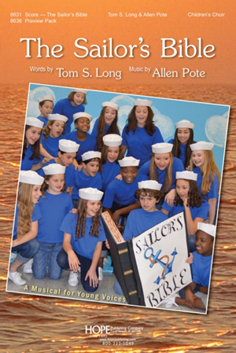
Join us for another LBC Musical
Cast members needed! May gathering intro with fall
rehearsals and performance in November.
Let Russell know if interested!
Maundy Thursday Service with Rabbi Jeremy Parnes. April 13 at 7 pm at the LSC
Maundy Thursday Service with Rabbi Jeremy Parnes. April 13 at 7 pm at the LSC

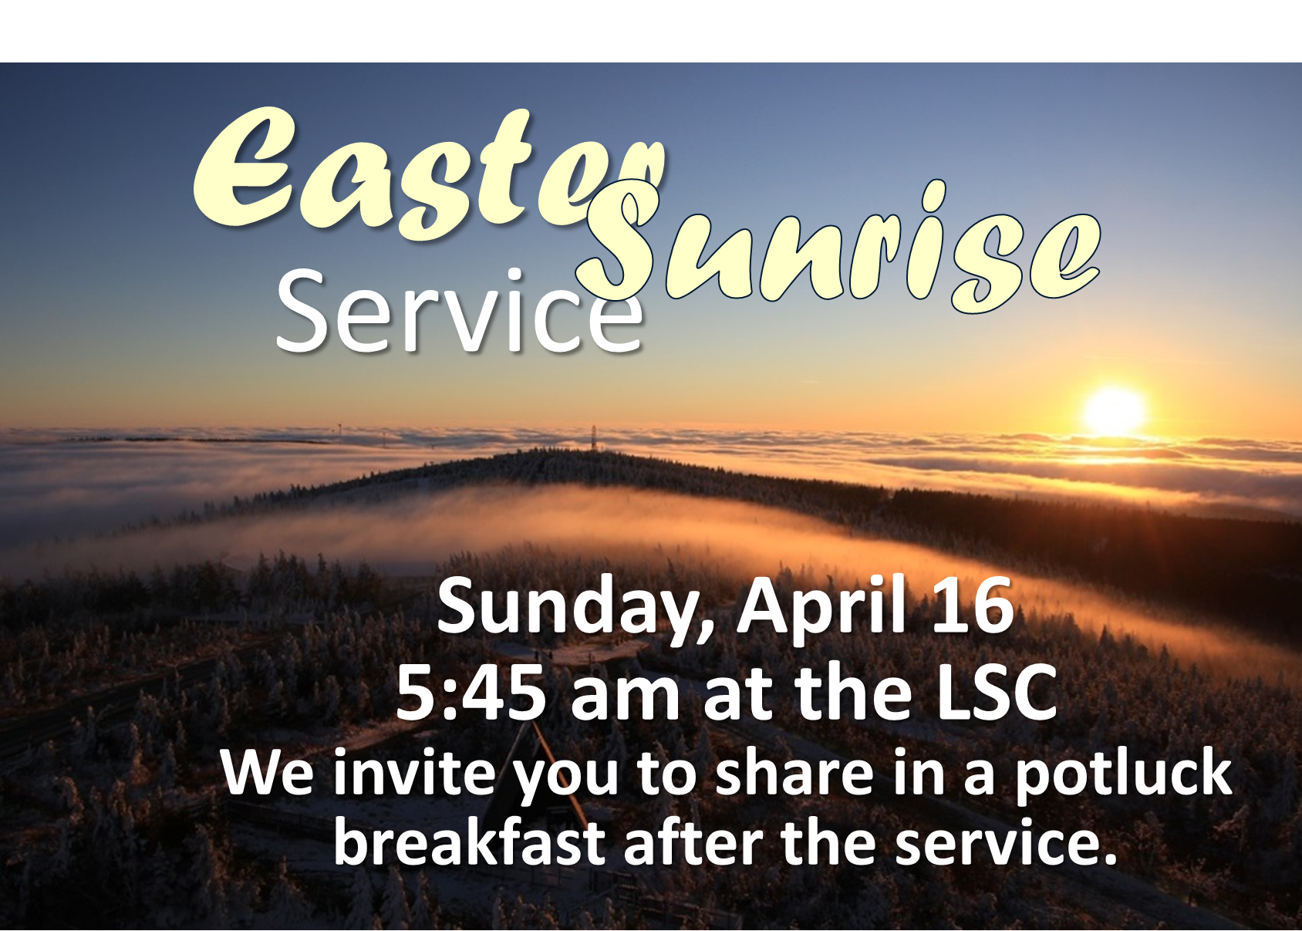
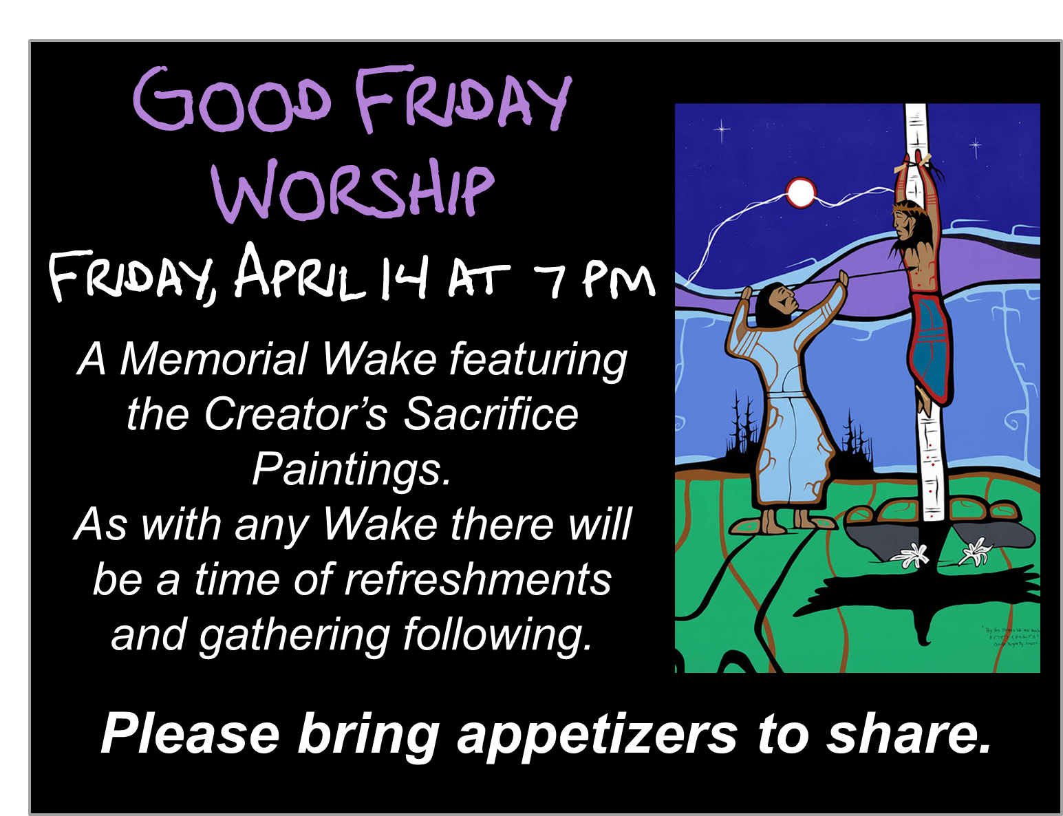
Regina Philharmonic Chorus invites you to celebrate Canada’s 150th Anniversary at their Spring Concert "Canada 150 - Musical Celebration" Saturday, April 29, 2017 - 8 pm at Knox-Metropolitan United Church. Music includes Canadian folk songs and other Canadian compositions as well as John Rutter’s “Mass of the Children”. Living Spirit Centre’s accompanist, Joshua Hendricksen, will be one of the vocal soloists featured at the concert. Tickets: $30 available online at reginaphilharmonic.com. $15 Student and $5 Children’s tickets available from RPC members, Bach & Beyond, or at the door.
The P3 Garage – an original play – a comedy. Written by Wesley United’s Norman Bray and associates, the play touches on the Public and Private Partnerships in wide use to finance public facilities such as highways, sewage plants and schools. Tickets are available at Wesley United Church office or may be obtained at the door prior to performances: Friday, May 5 at 7:30 pm Saturday, May 6 at 7:30 pm; and Sunday, May 7 at 2:30 pm. Tickets Adults $20, Children under 12 $10 (includes refreshments).

Prayer Writing Workshop, Thursday, May 4 at 7 pm: Join us as we reflect on the power of prayer in worship and in devotional practices, and explore the benefits that writing a prayer can offer as a path to mindful and compassionate living. Workshop facilitator, Ray McGinnis, offers tips for helping anyone who is asked spontaneously to lead a group in prayer. Drawing on a splendid range of examples of prayer from scripture and recent prayers written by adults and children, Ray helpfully provides a step-by-step template for you to write opening prayers, prayers of thanksgiving and intercessory prayers. There is time for discussion and time for prayer and reflection on how praying together can strengthen the church and help us be there for each other when it counts. No previous writing experience needed. Older children, youth and adults all welcome! Suggested donation to attend is $20. To register, call 306-761-0556.
Since 1999, Ray McGinnis is has taught a range of writing workshops to over 15,000 participants across Canada and internationally. From 1986-95 he served as national staff for Youth and Young Adult Ministries with the United Church of Canada. He is author of Writing the Sacred: A Psalm-inspired Path to Appreciating and Writing Sacred Poetry. For more information on Ray visit www.writetotheheart.com.

Signs of Spring Supper at Lakeview United Church, Saturday, May 6 at 5:30 pm.
Entertainment by Band-Its Jazz Band; meal will be baked ham, scalloped potatoes, kernel corn, fresh salads, French bread, homemade desserts, tea, coffee, juice. Wine for purchase by the glass. Tickets: Adults $15, Children 6-12 $10, kids 5 and under free.

Join us for another LBC Musical
Cast members needed! May gathering intro with fall
rehearsals and performance in November.
Let Russell know if interested!
Maundy Thursday Service with Rabbi Jeremy Parnes. April 13 at 7 pm at the LSC
Maundy Thursday Service with Rabbi Jeremy Parnes. April 13 at 7 pm at the LSC

