Two-Way Virtual Programming
Pre-Meeting Settings for Zoom Two-Way, including YSF Child-Safe Security Controls
YMCA OF SAN FRANCISCO
__________________________________________________________________________

Purpose of this guide: To provide instruction for enabling and disabling user settings in Zoom Meetings, including YSF Child-Safe Security Controls

Before you enable Zoom Security Controls
- Read Best Practices for Securing Your Zoom Meetings

When you’re ready to enable pre-meeting Security Controls (for child-safe):
- Sign-in to your zoom.us account
- Select Settings from the left-side menu
- Align each of the Security Controls below to your Zoom Account

Note: Each feature with an * can be manually changed once inside the meeting
- Host video – enable*
- Participants video – disable*
- Audio type – telephone and computer audio
- Join before host – disable
- Use Personal Meeting ID (PM) when scheduling a meeting – disable
- Use Personal Meeting ID (PM) when starting an instant meeting – disable
- Only authenticated users can join meetings from Web Client – enable
- Require a password when scheduling new meetings – disable
- Require a password for instant meetings – disable
- Require a password for Personal Meeting ID (PMI) - disable
- Embed password in meeting link for one-click join – enable
- Require password for participants joining by phone – disable
- Mute participants upon entry – enable*
- Upcoming meeting reminder – user's choice
- Require Encryption for 3rd Party Endpoints (H323/SIP) - disable
- Chat – enable
- Private chat – disable
- Auto saving chats – enable
- Play sound when participants join or leave – user's choice
- File transfer – enable
- Feedback to Zoom – user's choice
- Display end-of-meeting experience feedback survey – user's choice
- Co-Host – enable
- Polling – enable
- Always show meeting control toolbar – user's choice
- Show Zoom Windows during screen share – user's choice
- Screensharing – all participants* (Hosts should disable the feature in-meeting to prevent unwanted sharing during meetings. Hosts can enable the feature if a student needs to share screen)
- Disable desktop/screen share for users – disable
- Annotation – enable
- Whiteboard – enable
- Remote Control – enable (if possible)
- Nonverbal feedback – enable
- Allow removed participants to join – disable
- Allow participants to rename themselves – enable (but recommend it be disabled in-meeting to prevent students from naming themselves inappropriately. The Host can change student and Co-Host names manually in-meeting)
- Show participant’s profile picture – disable
- Give hosts option to report participants to Zoom – enable
- Breakout room – enable
- Remote support – enable (if possible)
- Closed captioning – enable
- Save captions – user's choice
- Far end camera control – disable
- Group HD video – disable
- Virtual background – enable
  - If a participant is found to be using an inappropriate virtual background in meeting, they should be “removed” from the meeting
- Identify guest participants in the meeting/webinar - disable
- Auto-answer group in chat – user's choice
- Only show default email when sending email invites – disable
- Use HTML format email for Outlook plugin – disable
- Allow users to select stereo audio in their client settings – disable
- Allow users to select original sound in their client settings – disable
- Select data center regions for meetings/webinars hosted by your account – disable
- Waiting room – enable
- Show a “join from your browser” link – enable
- Allow live streaming meetings – disable
- Email notification settings – user's choice
Limitations of Zoom Meeting
- Zoom does not allow Co-Hosts to start a meeting. If a Host is unable to start the meeting, he/she/they can assign an Alternative Host.
- Zoom does not allow a user to host multiple meetings at the same time.
If Participants try to join a meeting that the Host hasn't started, they will receive the message:
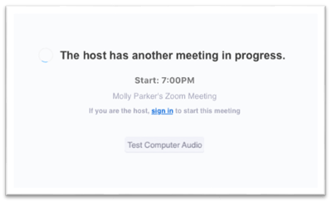
If the Host tries to start a new meeting at the same time another meeting is in-progress, the Host will be prompted to end the meeting in-progress:
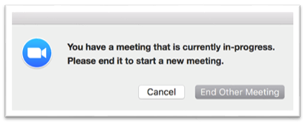
If the Host ends the meeting, Participants in that meeting will receive the following message:
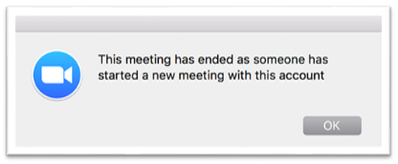

Chrome Books and Zoom Functionality
Zoom functionality on Chrome Books is unique – if you are a Chrome Book User, review these resources:
- Getting Started on Chrome OS
- Configuration for Chrome OS
- New Updates for Chrome OS
- Zoom Rooms on Chrome OS

