***October 2018 Newsletter***

**First Congregational Church**

**An Open & Affirming Congregation of the United Church of Christ**

**300 Central Street, Saugus, MA 01906**

**781-233-3028**

**Rev. Martha Leahy, Pastor Rebecca Harrold, Music Director Carolyn Davis, Church Secretary**

[**https://www.Facebook.com/uccsaugus**](https://www.Facebook.com/uccsaugus)

**“Go and make disciples of all nations, baptizing them in the name of the Father, and of the Son, and of the Holy Spirit, and teaching them to obey everything I have commanded you. And surely I am with you always, to the very end of the age.” *Jesus, Gospel of Matthew 28:16-20***

**REV. MARTHA’S MESSAGE**

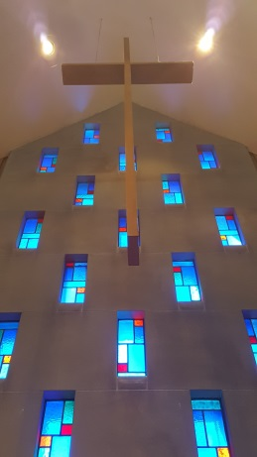**When I first walked through the doors** of this church 10 years ago to meet with the Pastoral Search Committee, I immediately felt this was the place for me. I had been on several other interviews, but the interior of those other places just didn’t feel right to me. I was surprised to discover what my mentors had told me about a “sense of call” was true – that I would know it when I felt it. And I felt called here right away. The warm welcome by the committee the frank discussions we had, and the good feeling I had, only affirmed by first impression – this was the church God was calling me to.

**I will be leaving Saugus soon**, as God has called me to other places. I will carry the memories of all we accomplished together for the sake of God’s love: outreach through Saugus Faith Community events like the Lenten Seder and Good Friday Walk; outreach to families experiencing substance abuse and attempting recovery; and outreach to children through the Healthy Students – Healthy Saugus initiative.

**Notice the keyword** in all these endeavors is “outreach.” I believe this is the primary purpose of church – to reach out into the community to show people we care about them, and that God cares about them. It is now your turn to raise new leaders to keep building on the solid foundation that’s been created for doing the work the Saugus community needs us to do.

Before I leave, I would like to **personally visit** with all of you. Please call me to set up a time to talk on Wednesdays or Thursdays when I am in the office.

**May God bless us** all on our separate journeys of life and faith and keep us reaching out to God, one another, and our community, wherever it is God calls us next.

**\*\*\*\*\*\*\*\*\*\*\*\*\*\*\*\*\*\*\*\*\*\*\*\*\*\*\*\*\*\*\*\*\*\*\*\*\*\*\*\***

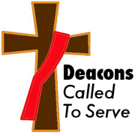**FROM THE DEACONS**

**Deacon of the Month** is Barbara Davis.

Has anyone noticed new **wax candles** in the sanctuary? These are in place of the oil candles that we used for many years. Many of the old candles were slowly leaking oil and needed to be replaced. The wax candles are easier to work with and will be more efficient.

**We have been working with Rev. Leahy** tying up loose ends before she leaves. There are many responsibilities that she has done over the years that technically should be done by Deacons or other church members. I’m sure we will find even more after she leaves.

We hope the congregation and friends of the church are **savoring our last weeks with Rev. Leahy**. We believe she is enjoying stories and remembrances that people are sharing with her. She has been an effective leader for our church over the last 10 years. We can agree that one of her many strengths is that she has helped us become much **more visible and relevant to our community**. We, the Deacons, and we hope others, are committed to continue this after her departure.

From your Deacons,

Barbara Davis, Susan Dunn, Terri Leander, Mike Mascovitz, John Gilmore, Rick Florentino

**\*\*\*\*\*\*\*\*\*\*\*\*\*\*\*\*\*\*\*\*\*\*\*\*\*\*\*\*\*\*\*\*\*\*\*\*\*\*\*\***

**Interim Pastor Selection Committee**

**Invites us to a Farewell Luncheon & Open House**

**Sunday, Nov. 4 @11:30-2 for Rev. Martha Leahy**

Dear Members and Friends of the First Congregational Church,

On September 9, 2018 Rev. Martha Leahy gave our Church her resignation letter which we accepted with a great amount of regret. Her 10 years among us have been very significant in our congregation. These next 6 weeks will be a precious time, and on Sunday, November 4, 2018, from 11:30-2 p.m. the Church will have **a Farewell Luncheon – Open House** for all members and friends to come and celebrate Rev. Martha’s ministry with us. Her last Sunday will be November 11, 2018.

**We want to assure you that we have met with our Conference Minister, Rev. Wendy Vander Hart, about the process of seeking new ministerial leadership.** During the meeting with Rev. Vander Hart and key members of the Church leadership, she went over the procedure of selecting a new part/time pastor. Five members volunteered to be on the Interim Selection Committee: Linda Anderson, Barbara Davis, Susan Dunn, Terri Leander, and Brenton Spencer. We will start this intense process by searching for the right Interim Minister for our Church. The more in depth search for our permanent part/time minister could take up to a year and a half to two years.

During this time if you have any questions or concerns, please feel free to speak to any of us on the Committee. We will keep you informed on a regular basis as we move toward God’s future for us as a congregation.

For now, let’s express our gratitude for Rev. Martha’s ten plus years of ministry and friendship with us and enter into a time of celebration and prayer with her.

In Christ’s name

The Interim Selection Committee

### ******************************************

**Sunday School is Open!**

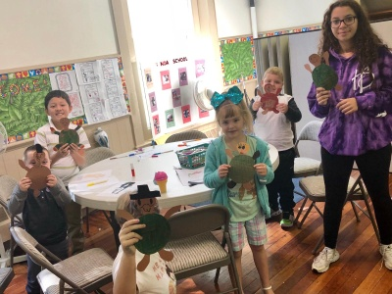

We are open and ready for your child this new Sunday School year! We are focusing on learning the Lord’s Prayer, reading Bible stories, and making fantastic crafts that reflect the story themes. For **Native American Sunday**, we made turtles to illustrate Rev. Martha’s message about **Turtle Island**. So, come see what we have to offer you and your child. We’ll be so happy to see you!

### ******************************************

****THE HEALING CIRCLE**

**1st & 3rd Wednesdays**

**7-8PM**

***“The Root of Healing is in the Power of the Circle”***

Come and join us at our Sacred Circle, for an hour of prayer and meditation that will soothe your soul.  We gather on 1st and 3rd Wednesdays for an hour.  We will be continuing with Deepak Chopra's "Hope in Un-Certain Times. Private, one-on-one healing prayer is offered at the end of the Circle. You can also make appointments for additional conversation. Find us on Facebook!

[www.facebook.com/healingcirclesaugus](http://www.facebook.com/healingcirclesaugus)

**Healthy Students – Healthy Saugus**

**Food Donations Needed**

**HS²**

*Healthy students require healthy food. For some families, food insecurity is a reality they must deal with. This is where HS² comes in. Our goal is to support those families and students by providing supplemental nutritional support. Organizations and individual citizens are encouraged to collect certain items and contribute them to the overall effort. Whitsons Food Service, the food service provider for the Saugus Public School system, has compiled this list of nutritionally balanced foods. Items have been carefully chosen for their high vitamin and nutrient content, so we ask that donations come only from this list.*

*Thank you for your support!*

**Proteins**: canned tuna, chicken, and salmon; peanut butter, and canned and dry beans.

**Vegetables:** canned corn, peas, green beans, chopped tomatoes, and mixed vegetables.

**Fruit**: canned fruit, mixed fruit cups, fruit snacks, applesauce, bottled juice, and shelf stable juice boxes.

**Carbohydrates**: whole grain pasta, tomato sauce, whole grain cereal low in sugar, individual oatmeal packets, small boxes of whole grain rice, and macaroni and cheese.

**Other**: jelly, granola bars, individual packages of whole grain graham crackers, pretzels, Goldfish crackers, peanut butter crackers, and popcorn.

**Canned Meals:**  stews, soups, chili, mac & cheese

**Toiletries:** toothpaste, toothbrushes, soap, shampoo, toilet paper, paper towels, deodorant.

*To make monetary donations, send your check made out to “Saugus Clergy Association” with “HS2” in the memo section to First Congregational Church, 300 Central Street, Saugus MA 01906.*

*You will receive a receipt for tax purposes. And thanks!*

*To make grocery donations,*

*please drop off at any one of the following local sites. If you can volunteer to help bag groceries,*

*see the days and times listed below.*

*Thanks for joining hands and hearts*

*to feed hungry kids in Saugus!*

**St. John’s Episcopal Church**, 8 Prospect St., Saugus. 781-233-1242

*Bagging groceries 1st Thursdays at 7 p.m.*

*Pickup by Whitsuns on Friday morning.*

**Cliftondale Church of the Nazarene**, 60 Essex St., Saugus. 781-233-2886

*Bagging groceries 2nd Thursdays at 4 p.m.*

*Pickup by Whitsuns on Friday morning.*

**First Baptist Church of Saugus**, 105 Main St., Saugus. 781-231-1690.

*Also bagging groceries 2nd Thursday at 7 p.m.*

*Pickup by Whitsuns on Friday morning.*

**Blessed Sacrament Church**, 14 Summer St., Saugus. 781-233-2497.

*Bagging groceries 3rd Thursdays at 7 p.m.*

**First Congregational Church UCC**, 300 Central St., Saugus. 781-233-3028

*Bagging groceries 4th Thursdays at 4 p.m.*

*Pickup by Whitsuns on Friday morning.*

**New Hope Assembly of God**, 9 Assembly Drive, Saugus. 781-233-6384.

*Bagging groceries 5th Thursdays at 7 p.m.*

*Pickup by Whitsuns on Friday morning.*

*Will also be a back-up site in case another church cannot host on their day.*

**On Friday mornings, Whitsuns Food Service will also pick up whatever food donations have been collected from the public when they collect the filled grocery bags at these sites.**

**Thanks for being part of HS2!**

***Note: We are still waiting for a launch date of the program (tent. 10/25.) We will let you know very soon! Also, will you volunteer to be the person to supervise our packing site?***

**\*\*\*\*\*\*\*\*\*\*\*\*\*\*\*\*\*\*\*\*\*\*\*\*\*\*\*\*\*\*\*\*\*\*\*\*\*\*\***

**2nd DELIVERY OF PUMPKINS ARRIVES**

**SAT., OCT. 13 @1 p.m.**

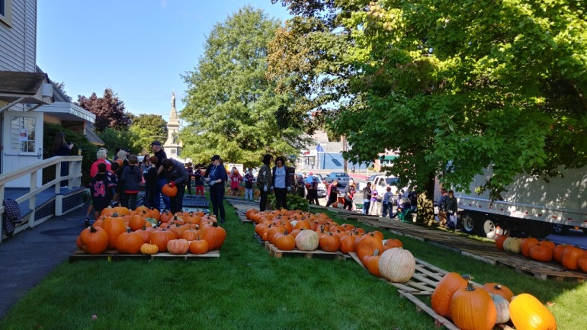

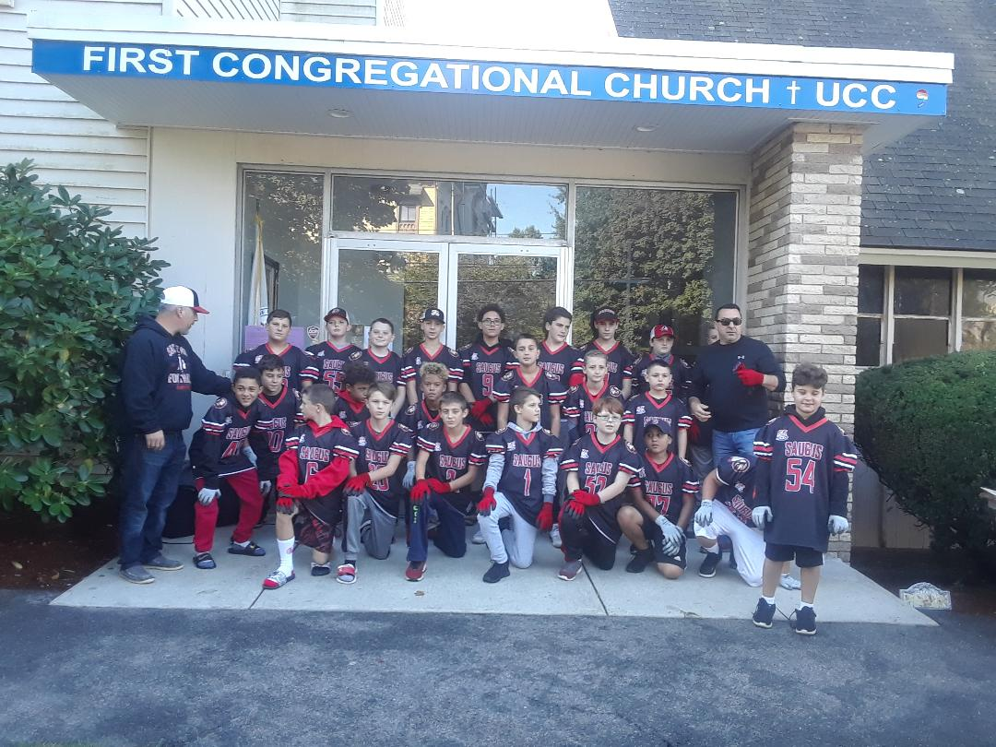

Thank you to all who helped unload the pumpkins on Sept. 29.  Special thanks to the Saugus Pop Warner football team. Job well done! **Let's not forget 2nd truck** **Saturday October 13 at 1 pm.** Please come. We need everyone's help.

Thanks, Carolyn Davis & Marilyn Panico

**SEE YOU THERE!!!!!!!!!!!!!!**

**\*\*\*\*\*\*\*\*\*\*\*\*\*\*\*\*\*\*\*\*\*\*\*\*\*\*\*\*\*\*\*\*\*\*\*\*\*\*\***

**\*\*\*\*\*\*\*\*\*\*\*\*\*\*\*\*\*\*\*\*\*\*\*\*\*\*\*\*\*\*\*\*\*\*\*\*\*\*\***

**“FALL FOR ALL”**

**Pumpkin Decorating for All Ages**

**On the Lawn at Town Hall**

**Sunday, Oct. 21, 2-4 p.m.**

*(Rain location: our Community Hall)*

Inspired by our generosity in giving out three $500 Pumpkin Patch scholarships this year, the Waybright School PTO is hosting **“Fall for All,”** with pumpkin decorating fun for all ages.

**Tables** will be set up outside at Town Hall for the decorating projects. Participants will buy our pumpkins and then take them back across the street to work on them. There will be a **food truck** and a **DJ** for entertainment.

So come on down and join in the festivities. Our Pumpkin Patch is truly a Saugus town-wide event, one that puts a smile on everyone’s face!

******************************************

**BACK TO SCHOOL COLLECTION DELIVERED**

Ann Kennedy delivered to the Superintendent’s office the backpacks and school supplies we collected this summer. Community members brought in supplies at our Christmas in July event and we continued through the month of August to increase the collection. We hope these gifts bring good luck to the Saugus students who receive them.

******************************************

**CHARLOTTE DAVIS CHRISTMAS PARTY**

**Wed., Dec. 5 @6:30PM**

This annual party for the women of the church and their guests features food, fun, and gift-giving. Please bring a covered dish to share, or an appetizer, main dish, salad, or dessert. We also need rolls and beverages. There will also be a Yankee Swap, so please bring a wrapped gift with a $10 value. Questions? Call Marilyn Panico @781-233-1454 or Cheryl Panico @781-231-5125.

**\*\*\*\*\*\*\*\*\*\*\*\*\*\*\*\*\*\*\*\*\*\*\*\*\*\*\*\*\*\*\*\*\*\*\*\*\*\*\***

**\*\*\*\*\*\*\*\*\*\*\*\*\*\*\*\*\*\*\*\*\*\*\*\*\*\*\*\*\*\*\*\*\*\*\*\*\*\*\***

**PRAYER SHAWLS WORK!**

**Calling All Knitters & Crocheters!** Our prayer shawl ministry continues to grow and reach far beyond our community. Jessie Allison delivered a supply of pocket prayer shawls to **Salem Hospital** and the chaplain told her a wonderful story. When a patient received a shawl, he said he hadn’t been able to pray for a very long time. But he held the tiny square to his face and was able to pray again.

**We have need of more shawls** – big and pocket sized – to fill our inventory. Please bring them in as you complete them. And if you know anyone who knits or crochets, invite them to join us in this important ministry. Thank you for sharing our blessings with others.

******************************************

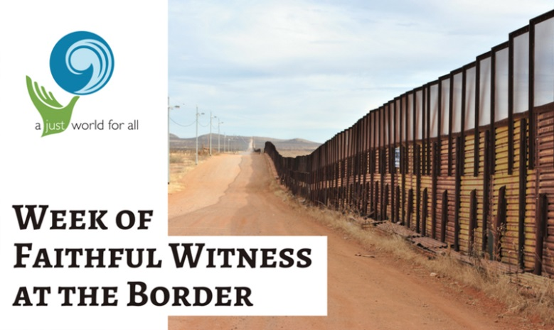

**FAITHFUL WITNESS AT THE BORDER**

**UCC Team here on Sunday, Oct. 28**

More than 100 people from seven UCC conferences across the country, including ecumenical partners, recently attended a 4-day Faithful Witness at The Border immersion and education event in August 2018, hosted by The Good Shepherd UUCC in Sahuarita, AZ near Tucson.

The event was organized through the Southwest Conference of the UUCC, in collaboration with Justice and Witness Ministries and Global Ministries.

Some of those who made this trip include members of Main Street Congregational Church UCC in Amesbury, Mass. They will be present in worship with us on Sunday, Oct. 28 to speak about what they saw at the border of the US and Mexico.

Highlights of what participants bore witness to were:

• Sponsoring of asylum families

• Border patrol activities at the border wall

• A desert walk to a migrant’s memorial site, showing the treacherous conditions migrants have to traverse, and the site where one died

• Crossing the border to visit the ministry of migrant shelters

• Holding a Communion Service on the Mexican side of the border wall

• Panel discussions of what the responsibilities are of faith communities in regards to migrant, border patrol and government policy issues

• Peaceful demonstration at the Border Patrol headquarters in Nogales, AZ promoting border justice for migrants.

The supplies that were brought to Arizona in August, 2018 and being sent to the UCC Southwest Conference through the Faithful Witness for the Border campaign met some of the needs of the 150 families currently camped at the port of entry, waiting for authorities to appropriately process their applications - according to the law. Emergency shelters are being reopened, and the Neighbors in Need grant sent to the Southwest Conference is helping to finance their ministries.

Our UCC friends from Amesbury were deeply affected by what they saw at the US-Mexico border. They will share their reflections with us and participate in our worship service. They will bring photos and share more stories at coffee hour.

Please plan to attend this very special Sunday with us. In the meantime, if you would like to watch a video recapping this trip, go to:

<https://www.youtube.com/watch?v=Ze2LmTBUCTk>

|  |  |  |  |  |  |  |
| --- | --- | --- | --- | --- | --- | --- |
| **OCTOBER 2018 – Pumpkin Patch Daily until Halloween!** | | | | | | |
|  | **Monday** | **Tuesday** | **Wednesday** | **Thursday** | **Friday** | **Saturday** |
|  | **1**  Trustees 5:45 | 2  Chair Yoga 9:30AM  Yoga 6:30PM | **3**  Office Open 12-5  Healing Circle 7pm | **4**  Office Open 10-3  Staff 10AM | **5** | **6** |
| 7  Worship & Communion 10AM  Sunday School | **8**  Labor Day  N.A. 7PM | **9**  Chair Yoga 9:30AM  Yoga 6:30PM | **10**  Office Open 3-6PM  Saugus Faith noon  HS2 1:30 @Roby  Into the Mystic 7-8  Divorce Support 7-10 | **11**  Office Open 10-3  Staff 12:30PM | **12**  Hall rental 4-8PM | **13**  Pumpkins Arrive 1PM |
| 14  Worship & Baptism 10AM  Sunday School | **15**  N.A. 7PM | **16**  Chair Yoga 9:30AM  Yoga 6:30PM | **17**  Office Open 12-5  Healing Circle 7PM | **18**  Office Open 10-3  Staff 12:30PM  Masons Night | **19** | **20** |
| 21  Worship & Baptism 10AM  Sunday School  “Fun in the Fall” Pumpkin Crafts @Town Hall 2-4PM | **22**  N.A. 7PM | **23**  Chair Yoga 9:30AM  Yoga 6:30PM | **24**  Office Open 10-3PM  Into the Mystic 7-8  Divorce Support 7-10 | **25**  Office Open 10-3  Staff 12:30PM  **Healthy Students Food Packing 4PM**  **(tent.)** | **26**  **Healthy Students Food Pickup Time TBD** | **27** |
| 28  Worship 10AM  Sunday School  Special guests UCC Witness at the Border Team | **29**  N.A. 7PM | **30**  Chair Yoga 9:30AM  Yoga 6:30PM | **31**  Office Open 12-5PM  Into the Mystic 7-8 |  |  |  |