Hocking Township Fire Department
1175 Cincinnati – Zanesville Road SW
Lancaster, Ohio 43130
P: 740.654.5615 F: 740.654.5463

2021 Annual Report

Curtis Golden
Fire Chief

Steve Kilbarger
Assistant Fire Chief

Table of Contents
Mission Statement……………………………………………………………………………………………………………………1
Core Values………………………………………………………………………………………………………………………………1
Department Organizational Chart…………………………………………………………………………………………….2
Department Members……………………………………………………………………………………………………………..3
Department Vehicles……………………………………………………………………………………………………………….4
Run Data…..……………………………………………………………………………………………………………………………..6
Major Department Accomplishments………………………………………………………………………..…………….7
Mission Statement
The mission of the Hocking Township Fire Department is to serve the citizens of Hocking Township with professional rapid emergency response and other services that save lives and protect property.
Core Values
Safety
In striving to protect the lives and well-being of our community and our co-workers.

Professionalism
In people who are dedicated, compassionate, trustworthy, and who act with honesty and integrity.

Respect
For our community and ourselves, while consistently exhibiting courtesy and compassion for those in need.

Innovation
Via an environment that allows new ideas and positive change to better serve our community.

Department Organizational Chart
Fire Chief
Curtis Golden

Assistant
Fire Chief
Steve Kilbarger

Captain 652
Nick Philiopoulos

Lieutenant 651
Kyle Parlier
Fleet Maintenance Coord.
Lieutenant 652
Dylan Wamsley
SCBA/Turnout Gear Coord.
Lieutenant 653
OPEN Position
Lieutenant 654
Owen Brewer
EMS Coordinator

Lieutenant 655
Eric Keener
Fire Inspector
Fire Training Coord.

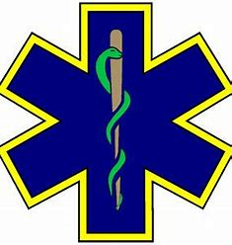
Dave Cramer
Asst. EMS Coord. (EMS Reports/Billing)

Member | Unit # | FF Cert | EMS Cert
Heilman, Chris | 5 | FF | EMT
Kilbarger, Dave | 6 | FF
Kirby, Will | 7 |  | EMR
Mohler, Ashley | 8 | FF
Copeland, Ryan | 9 | FF
Perry, Geoffrey | 10 | FF | EMT
Thaxton, Dylan | 11 | FF
Schultz, Leah | 12 | FF | EMT
Oren, Miranda | 13 | FF
Nye, Dakota | 14 | FF | EMT
Neighbarger, Harley | 15 | FF | EMT
McKibben, Christopher | 16 | FF
Remington, Mark | 17 | FF | EMT
Malone, Brian | 18 | FF | EMT
Hopper, Tyler | 19 | FF | EMT
Pryor, Mathew | 20 | FF | EMT
Gillespie, Steve | 21 | FF
Reed, Douglas | 22 | FF
Cramer, David | 23 | FF | AEMT
Bowman, Janee | 24 | FF | MEDIC
Shields, Cullen | 25 | FF | EMT
Bell, Michael | 26 | FF | AEMT
Cruikshank, Kara | 27 | FF | EMT
Breneman, David | 28 | FF | EMT
Armstrong, Ashley | 30 |  | RN
Stewart, Grant | 31 | FF | MEDIC
Flint, Amber | 33 | FF | MEDIC
Stone, Brandon | 35 | FF
Smith, Ryan | 36 | FF | MEDIC
Simpson, Aaron | 40 | FF | EMT
Bolin, Jeffrey | 41 | FF | EMT
Swartz, Connor | 42 | FF
Department Member List

Total Membership at the end of 2021 = 40 members

Station 650
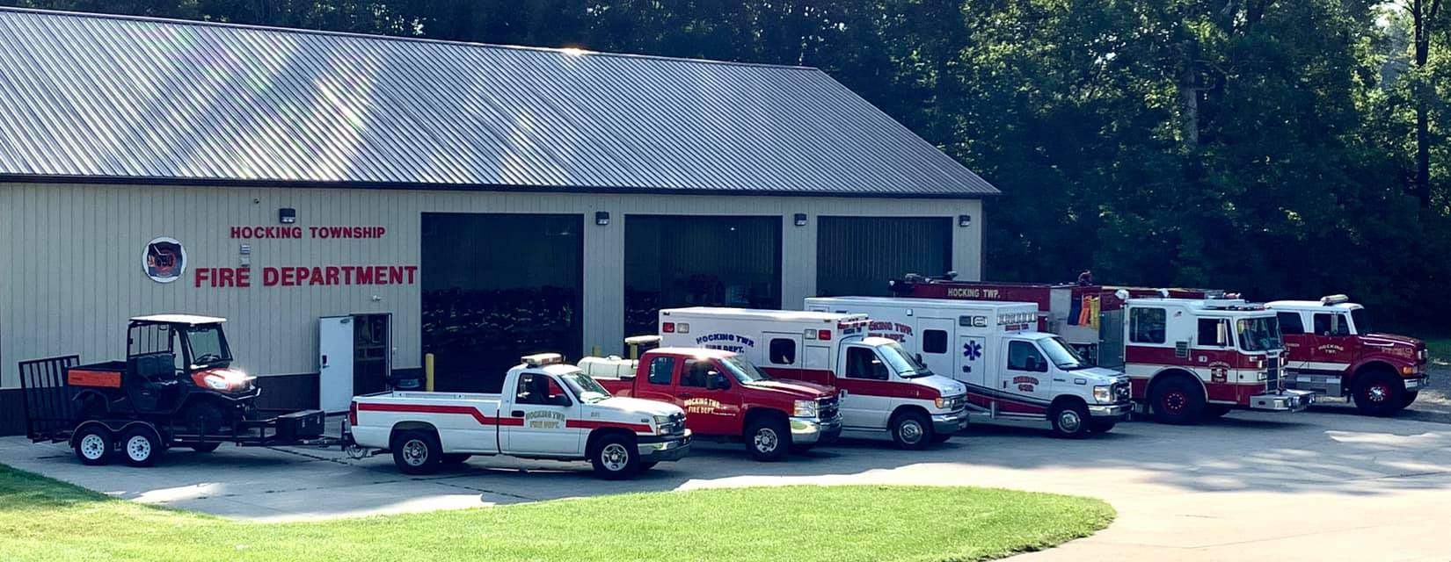
Department Vehicles
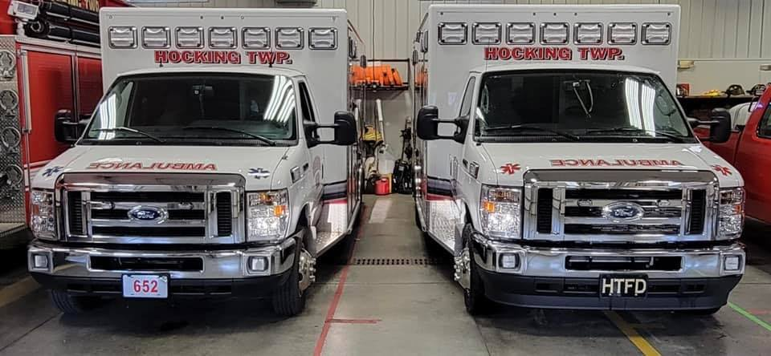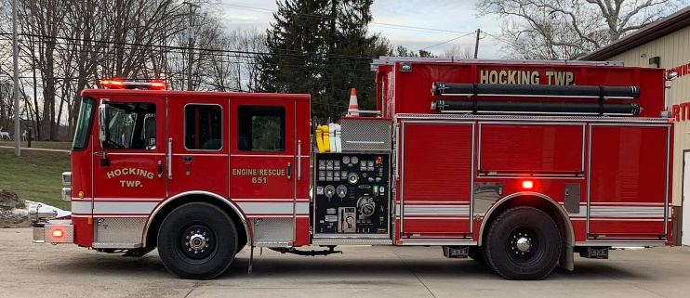
Medic/Squad 651 & 652 Engine/Rescue 651
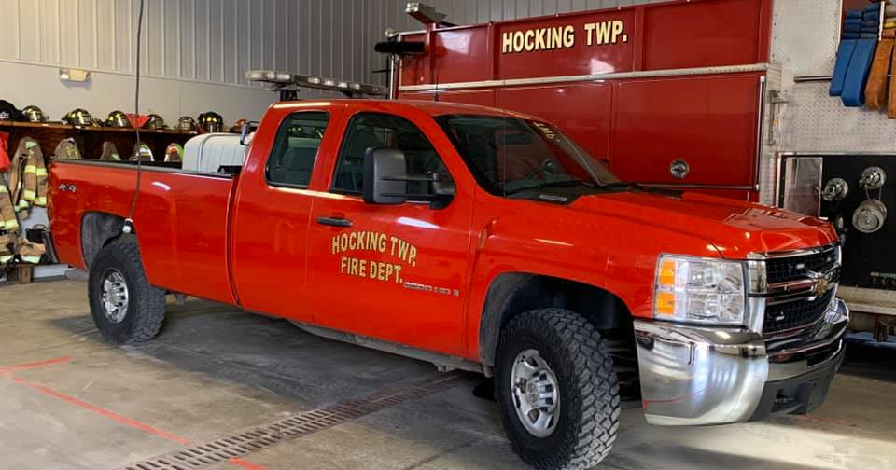
Grass 651 Engine/Tanker 652
UTV 652 Station Truck 652

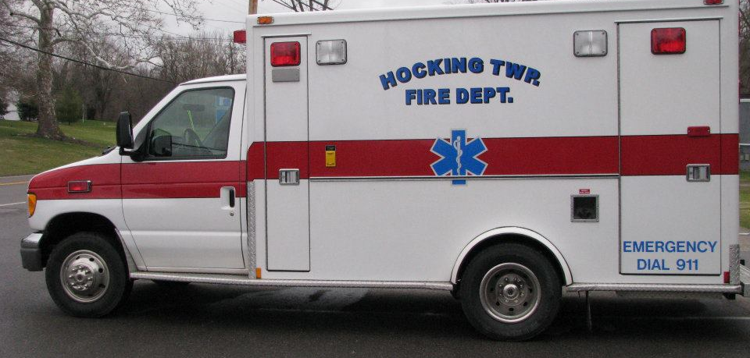
Reserve Medic/Squad

Run Volume
Year | EMS Calls | Fire Calls | Year Total
2021 | 659 | 218 | 877
2020 | 611 | 223 | 834
2019 | 460 | 020 | 712
2018 | 496 | 187 | 681
2017 | 497 | 174 | 671
2016 | 488 | 168 | 656
2015 | 515 | 168 | 666
2014 | 485 | 112 | 597
2013 | 412 | 118 | 530
2012 | 302 | 120 | 422

Major Department Accomplishments 2021

- Department decreased ISO (Insurance Service Office) rating to a 4/4y. This has the potential to decrease insurance costs to residents and businesses in the township.

- Engine/Rescue 651 was placed in-service, replacing old Engine 651 which was a 1990’s unit.

- Medic/Squad 652 was placed in-service, replacing a 1990’s unit.

- Fire Inspection program was implemented for all township business. These inspections provide education to business on fire codes to decrease the risk of fire and injury with in their establishments.

- We were awarded the following grants:
  - Ohio EMS = $3,960.58
  - Ohio Division of Forestry = $2,141.30
  - 2021 MARCS Radio Grant = $3,480.00
  - COVID Relief funding

