REGULAR MEETING
SEPTEMBER 20, 2018

A Regular Meeting of the Town Board of the Town of Hampton, County of Washington and the State of New York was held at the Town Hall, 2629 State Route 22A, Hampton, New York on the 20th day of September 2018.

PRESENT: David K. O’Brien------------Supervisor
Tamme Taran----------------Councilwoman
Donald Sady-----------------Councilman
Andrea Sweeney------------Councilwoman
Roger Weeden---------------Councilman
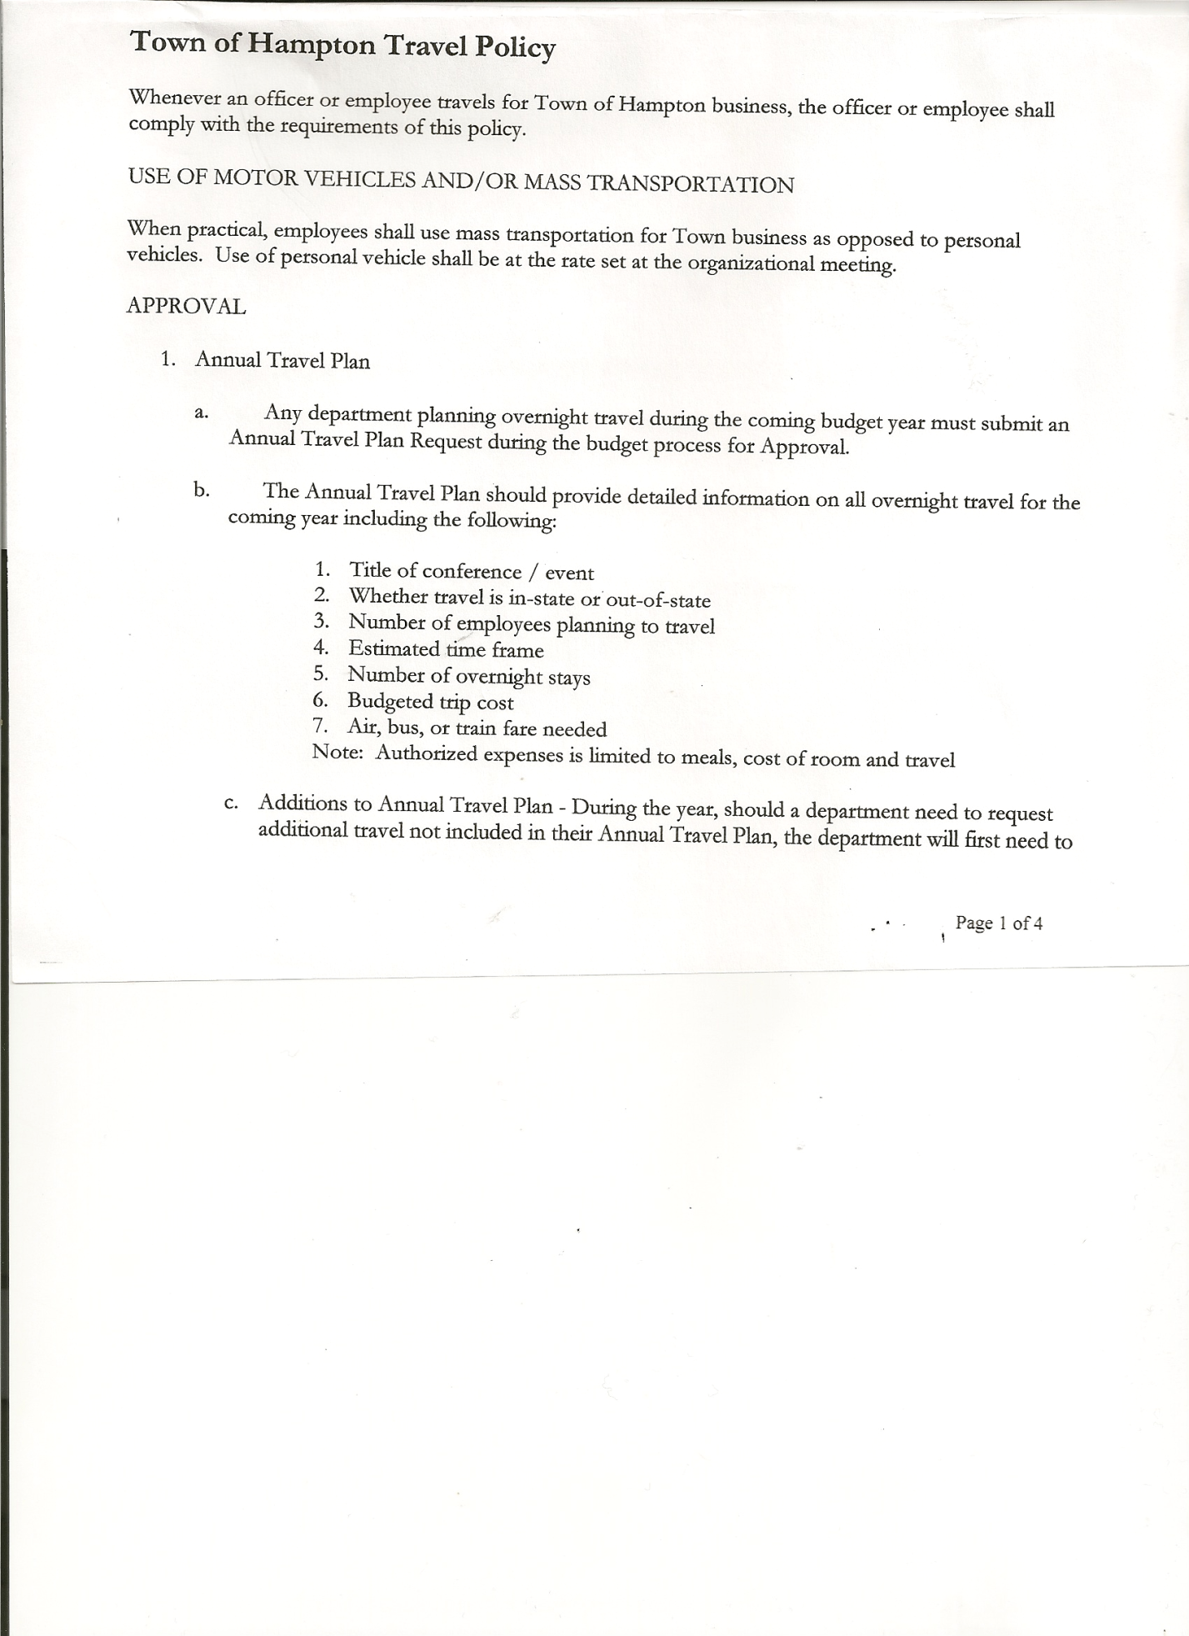
Rebecca Jones---------------Town Clerk
Camilla Shaw----------------Tax Collector/Deputy Town Clerk
Herbert Sady, Jr.-------------Highway Superintendent
Kim Perry---------------------Budget Officer

Planning Board Member(s): Bonnie Hawley, Chair, Ginny Kinsey, Renee Rountree and Matthew Pratt

Also present: See attached sheet.

The Regular Meeting was called to order by Supervisor O’Brien at 7:30pm, followed by the Pledge of Allegiance. Location of Fire Exits were given. Quorum of board members present.

Supervisor O’Brien asked for a moment of silence in memory of Terry Carmichael.

RESOLUTION NO. 58-2018
APPROVAL OF THE MINUTES
On a motion of Councilman Sady, seconded by Councilwoman Sweeney, the following resolution was ADOPTED: Ayes 5 O’Brien, Taran, Sady, Weeden, Sweeney
Nays 0
RESOLVED, that the Regular Town Board Minutes for August 16th, 2018 are approved.

RESOLUTION NO. 59-2018
AMEND MINUTES - NAME CORRECTION
On a motion of Councilman Sady, seconded by Councilwoman Taran, the following resolution was ADOPTED: Ayes 5 O’Brien, Taran, Sady, Weeden, Sweeney
Nays 0
RESOLVED, to correct the minutes of August 16th, 2018, the correct name to use is the Hampton Fire Company not Hampton Fire Department.

Camilla Shaw, Tax Collector- Zero balance. Submitted Bank Statement to the Board for review and signatures.

Larry Carman, Dog Control Officer submitted his report, which was read by Supervisor O’Brien, copy of report is attached for 8/14/18-9/16/18. Discussion followed as to procedure/protocol to follow if an injured/dead dog is found.

Planning Board…Bonnie Hawley, Chairperson
- William Barsalow is moving his business from Fair Haven to his home on
Manchester Road, Hampton. Site Plan application was approved.
- Next meeting will be October 10, 2018 @ 7:00pm at the Town Hall

TOWN BOARD MEETING
SEPTEMBER 20, 2018 PAGE 2

Herbert Sady, Jr., Highway Superintendent submitted his report, copy of which, is attached.

Additional paperwork regarding the Grant for the Highway Truck has been submitted.

Supervisor O’Brien handed out for informational purposes only “Vehicle Replacement Plan”

RESOLUTION NO. 60 -2018
APPROVAL OF SUPERVISOR’S MONTHLY REPORT
On a motion of Councilman Taran, seconded by Councilman Weeden, the following resolution was ADOPTED: Ayes 5 O’Brien, Taran, Sady, Weeden, Sweeney
Nays 0
RESOLVED, that the Supervisor’s Monthly report be accepted as submitted for AUGUST 2018.
07/31/18 08/31/18
ACCOUNT BALANCE RECEIPTS DISBURSEMENTS BALANCE
General Fund $ 70,948.88 $ 2.96 $ 6,185.63 $ 64,766.21
Highway Fund $ 46,154.67 $ 1.79 $ 14,638.31 $ 31,518.15
Equipment Reserve $ 94,128.64 $ 4.00 $ 0.00 $ 94,132.64
Fire #1 $ 20,400.00 $ 0.00 $ 0.00 $ 20,400.00
Fire #2 $ 2,703.00 $ 0.00 $ 0.00 $ 2,703.00
Cemetery $ 1,705.88 $ 1.05 $ 0.00 $ 1,706.93
Totals $236,041.07 $ 9.80 $ 20,823.94 $215,226.93

All Board Members present signed Supervisor’s Report.

County Budget is being worked on, hoping to not go over tax cap.

The Town Clerk’s report for August 2018 was submitted to the Board. The Town Clerk had Board Members review and sign bank reconciliation statements for the Town Clerk Account and Special Town Clerk Account dated August 31st, 2018.

Public Comments/Council Comments:
September 29th, Cemetery Work Day….starting at Warren Cemetery, may split into groups for
Hooker Cemetery and Burdick Cemetery.

Looking for one person to serve on the Board of Assessment Review.
Looking for two people to serve on the Ethics Board.

Charles Rountree, Treasurer for the Hampton Volunteer Fire Company, Inc. handed out a Three (3) Year Projection Budget.

Bonnie Hawley asked about a Sign Board at the Firehouse in Low Hampton to be used for Public Notices.

Reminder….Community Pig Roast will be held on October 13th, 2018 at the Firehouse.

The Tentative Budget for 2019 was presented to the Town Board.

TOWN BOARD MEETING
SEPTEMBER 20, 2018 PAGE 3

RESOLUTION NO. 61-2018
BUDGET WORKSHOP
On a motion of Councilman Sady, seconded by Councilwoman Sweeney, the following resolution was ADOPTED: Ayes 5 O’Brien, Taran, Sady, Sweeney, Weeden
Nays 0
RESOLVED, to set a Special Meeting for a Budget Workshop to be held on Thursday, September 27th, 2018 at 7:30pm.

RESOLUTION NO. 62-2018

AUDIT OF CLAIMS
On a motion of Councilman Sady, seconded by Councilman Weeden, the following resolution was ADOPTED: Ayes 5 O’Brien, Taran, Sady, Weeden, Sweeney
Nays 0
RESOLVED that the bills have been reviewed by the Town Board and are authorized for payment in the following amounts.
General Fund No.101 through No.107 $ 1,931.73
Highway Fund No.93 through No. 104 $ 6,077.66
Total both funds $ 8,009.39

On a motion of Councilwoman Taran, seconded by Councilwoman Sweeney, the meeting adjourned at 9:12pm. All in favor Aye.

Respectfully submitted,

Rebecca S. Jones, RMC
Town Clerk

