WEEK 6

BIBLE PROJECT
Genesis 3, cont.

DISINTEGRATION
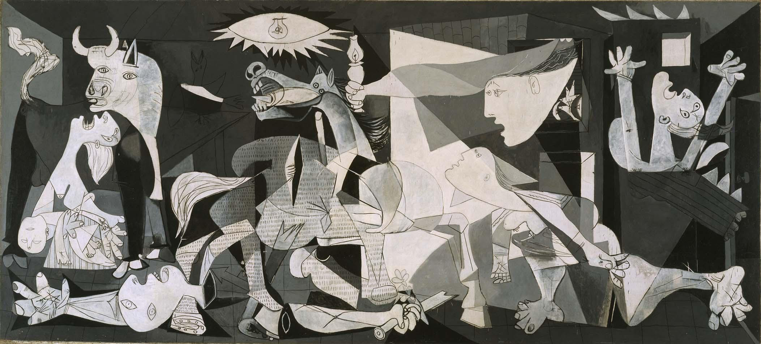
DISINTEGRATION
Guernica, Picasso

OVERVIEW:

THE LARGEST OVERALL PURPOSE OF THIS SECTION OF GENESIS (1-11) IS TO ADDRESS THE QUESTION: HOW DID THE WORLD GET INTO ITS PRESENT STATE OF DISINTEGRATION?

God’s project to create a world where His will is done and all creatures live in blessedness /paradise and in fellowship with their Creator appears to come apart. HOW DID THIS HAPPEN?

THE Bible right at the beginning addresses the problem of evil. Evil is a problem. It’s God’s problem. It’s consequences fall on all of creation. Genesis 3 is the starting point.

BIG IDEAS GENESIS 3: DISINTEGRATION—GOD HAS A PROBLEM

Order of the Garden Plot
a) Trees good for food.
b) Delight for eyes
c) Fruit desired for wisdom/insight
d) EAT—this is the climax
c) Only physical sight opened
b) Saw nakedness
a) Trees now good for cover (leaves)

Rationalization: So when the woman saw that the tree was good for food, and that it was a delight to the eyes, and that the tree was to be desired to make one wise, she took of its fruit and ate, and she also gave some to her husband who was with her, and he ate.

List the “reasons” Eve and Adam give themselves for obeying the serpent. What do they omit to mention? Note: They are in this together. What does the Tree of the knowledge of good and evil stand for? Human finitude. Adam and Eve reject their limits and seek to be “like God.” We have a word for that PRIDE.

SIN IS REVOLT, MUTINY AGAINST GOD AND GOD’S ORDER

Consequences: Then the eyes of both were opened, and they knew that they were naked. And they sewed fig leaves together and made themselves loincloths.
8 And they heard the sound of the Lord God walking in the garden in the cool of the day, and the man and his wife hid themselves from the presence of the Lord God among the trees of the garden. 9 But the Lord God called to the man and said to him, “Where are you?” 10 And he said, “I heard the sound of you in the garden, and I was afraid, because I was naked, and I hid myself.”

What died that day?

Relationship with God dies:

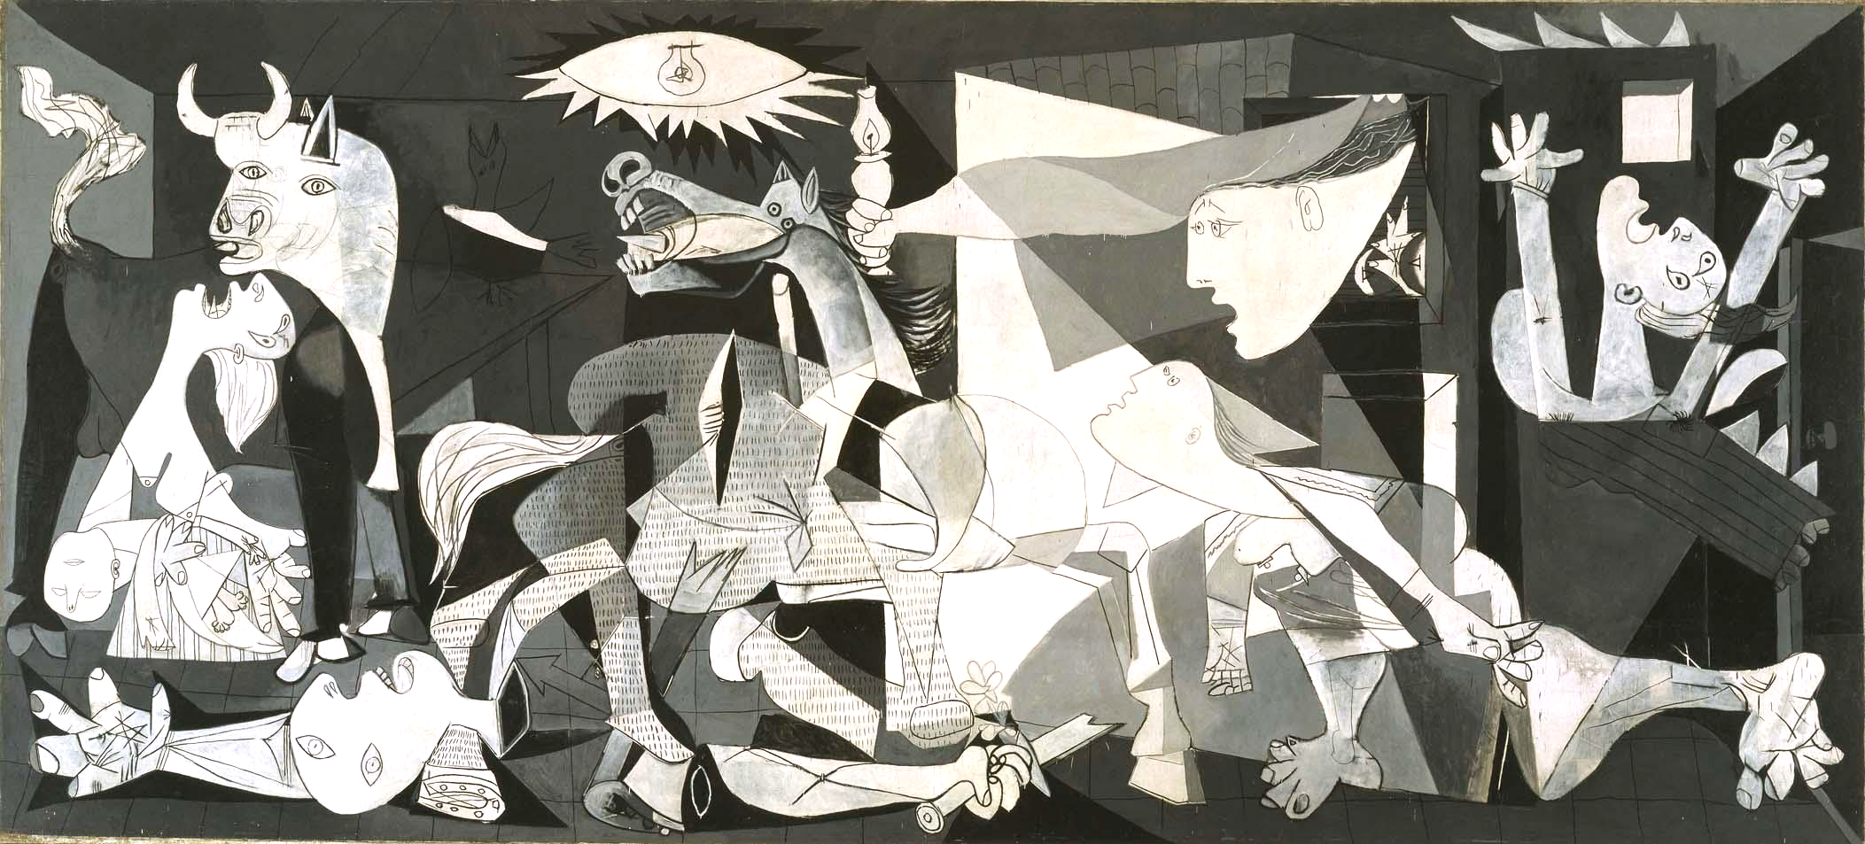

- Fig leaves and hiding. I was afraid…
- Refuses to answer God’s question. Where are you? Who told you that you were naked? Have you eaten…?
- Blames God. The woman whom You gave to be with me…
- Estrangement—Cast out of the garden
- Revolt makes God the enemy…
- Freedom to obey completely dies that day. Before it was possible for man NOT to sin. From then on it becomes impossible for man not to sin. Non posse non peccare

Relationship with Eve —others—dies:

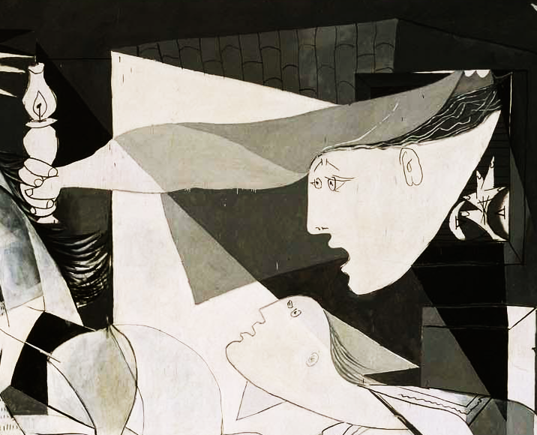

- Blame—the woman …. And later Cain.
- Secrets
- Masks
- Deception
- Hypocrisy
- All manner of anti-social behavior up to and including murder.
- Competition—desire for domination—replaces partnership.
- “To leave and to cleave” becomes “to desire and to dominate.”

Relationship with self dies.

Guilt and guilt feelings
Definitions:
Real Guilt is the result of breaking God’s revealed will, or nature’s objective moral law.
GUILT FEELINGS are what humans feel when they break God’s law or what they believe to be God’s law.

IN a sane person real guilt and a sense of guilt go together and are good—kind of like feeling pain is that comes from touching something hot: it keeps us from going further into trouble.

Doing wrong with no guilt and doing no wrong and feeling guilty are both forms of insanity.

What are common human efforts to deal with sense of guilt which have the effect of minimizing the seriousness of real sin?

- Eliminate God/moral law
- Everybody’s doing it.
- By comparison
- The scales method Good deeds balance bad ones
- Excuse for environment
- Keeping busy
- Anesthesia
- Define all guilt as illness

Shame
Secrecy
Fear—anxiety—paranoia—always looking over his shoulder to see if God is stalking him.
Doubt
Integrity lost
Image defaced

Relationship with natural order dies. Garden becomes jungle.

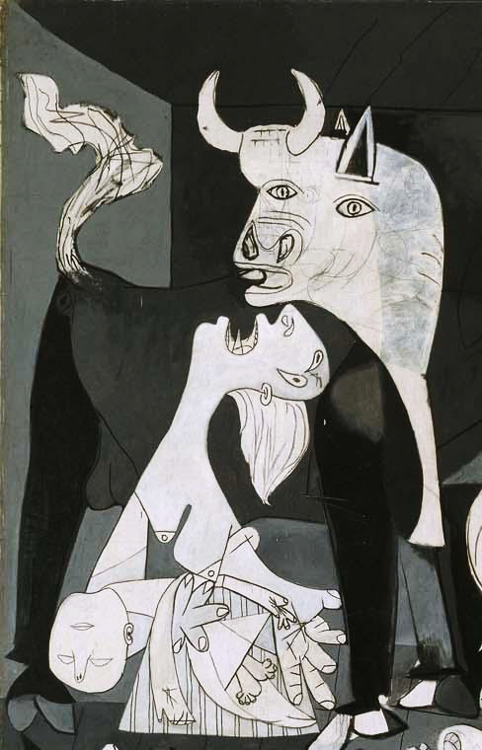

“Cursed is the ground for your sake;
In toil you shall eat of it
All the days of your life.
Both thorns and thistles it shall bring forth for you,
And you shall eat the herb of the field.
In the sweat of your face you shall eat bread
Till you return to the ground,
For out of it you were taken;
For dust you are,
And to dust you shall return.”

Everyone agrees that DISINTEGRATION is the current state of the world.
WHOSE fault is a world in a state of disintegration?

Three possible kinds of answers:

- Stuff happens—but in the happening these are at least some of the explanations:

- Dualism: disintegration comes from the degrading effects of the material world. Existence is matter and spirit. Disintegration comes from the mix in humans when matter taints spirit. Hence rise above matter through transcendental meditation. Be “spiritual.”
- Wrong thinking: education is lacking. If only humans could be taught to think right. Philosophy straightens out the world. Right thoughts: mind over matter.
- Human finitude—man is “coming of age”. He will grow into sufficient knowledge and experience. It’s his present limits that are the problem: Utopia is coming. So in the 19th century, it was thought that everything was progressing. Hence Darwinism, Hegelianism and Marxism. Make the master race and man will outgrow disintegration.
- Heredity and environment—the gene pool is corrupted and the environment gives the wrong signals. Humanity is pre-conditioned to fail by the conditions in which he finds himself.

- God’s fault—He made the world wrong.

- ADAM’s Revolt—puts the world including nature in a mutiny. Jack on the island mutinies and eventually burns the island down in Lord of the Flies. Well-intentioned Ralph, wise Piggy and even spiritual Simon can’t stop it. Only intervention can stop it and rescue the island culture. William Golding, no Christian theologian, writes: Lord of the Flies.

GOD’S PROJECT apparently collapses in every way:
Remember: God’s PROJECT IS To create a world where His will is done and all creatures therefore live in blessedness/paradise and in fellowship with their Creator.

But God does not quit: God rescues Adam and Eve from his own Sanction.

Note the box is blank—no category for this in Guernica.

God kills animals to provide covering for Adam & Eve—fig leaves are not enough.

Also for Adam and his wife the Lord God made tunics of skin, and clothed them.
Gen 3:21
Two principles established:
Substitution
Without the shedding of blood there is no forgiveness of sin.
Lev 17:11--it is the blood that makes atonement for one’s life.

- God still seeks out ADAM & EVE.
- It’s mercy as well as consequence that leads to their expulsion from the Garden.
- And he clothes them in rescued life.

And God promises a rescuer:

To the serpent he declares:

I will put enmity
between you and the woman,
and between your offspring and hers;
he will crush your head,
and you will strike his heel.”

Promise of the Rescuer to come: Disintegration will not win. Rescue will cost, but the serpent will be destroyed.

God’s PROJECT will create a world where His will is done and all creatures therefore live in blessedness/paradise and in fellowship with their Creator.

ADDENDUM

How do we get what we know of prehistorical paleontology to fit with the biblical idea of an early progenitor of the human race? This may be a Greek-think question. Nevertheless, it is raised for us by the biblical insistence that God created humanity in his image, not in continuity with the rest of the animals.
WE NEED TO THINK OF THE IMPLICATIONS OF THAT THOUGHT FOR APPLICATIONS AND CONTRASTS TO THE MATERIALIST/NATURALIST VIEW OF CREATION.

But first, how do we relate our historical facts with the biblical interpretation?

GAP theory – we know that the Bible omits great sections of details: Jesus the son of David, the son Abraham (Matthew 1.1) Therefore, gap between Gen 1.1 and Gen 1.2.

Investiture theory: Made in the image of God occurs at a particular juncture in the evolutionary process and precipitates what some have called the “Neolithic revolution” so that the creation of man is reality God’s investing humanoid animals with the dignity of his own image, the consciousness of self-exitence, and the mandates of creation.

But the truth is that the writer of Genesis is not at all interested in the question of the quantity of man’s existence, but in its quality. That is, not how long man has been around, but whether there is something uniquely human, as contrasted with the rest of the creatures and imbued with dignity and worth, based on the essential human qualities.

Only in the modern west has the pursuit of the quantity of time been substituted for an understanding of the quality of human nature. The question raised by the image of God discussion whether the meaning of being human is something that exists from before his creation or whether his worth is a consequence of his own self-evaluation. Does humanity have intrinsic value or is the value of human life that is a function of its own determination? Does existence precede essence? Or does essence precede existence. Is our worth given or earned? Does man exist before he has meaning? Or is his existence the consequence of purpose?

The materialist/naturalist view of origins indicates that things exist and develop for no apparent reason and on no demonstrable lines. Thus, for the materialist, there is only description. Things are. What they mean is not connected with their existence. Thus, man exists before he has value, worth, meaning, purpose.

The Biblical view is that humanity is the consequence of God deliberate plan; that humans individually and together have God-given image/dignity/meaning/purpose/ responsibility. Psalm 139.13 ff. And that meaning is not related to the quantity of time in which humanity has existed.

WEEK 7

Assignment for week 7—

Be prepared to raise questions on what you have heard/read so far.

Read: Job—note the role of Satan at the beginning of Job.

Seek to discern big picture in Genesis 4-11

Carefully review Genesis 12-17

MARKERS:

Job 1: Satan in heaven

Exodus 2: Birth of Moses
Exodus 4: Moses’ excuses
Exodus 7-11: Plagues
Exodus 12: Passover
Exodus 14: Crossing Red Sea
Exodus 19: Kingdom of Priests

