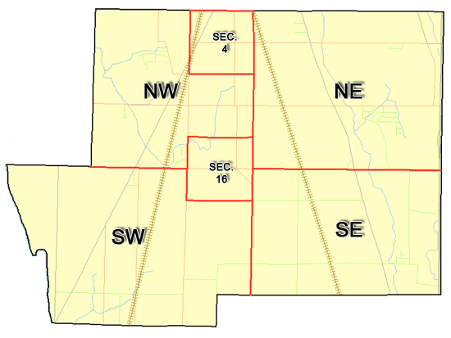 | Pleasant Township  Zoning Commission Minutes  1035 Owens Rd W.  Marion, Ohio 43302
Meeting called by: | Scheduled | Type of meeting: | Regular Monthly
Chairperson: | Mr. Holler | Secretary: | Stephanie Barkley
Timekeeper: |  | Date: April 20th,2023 | Time 7:30 pm
Call to Order by: | Mr. Holler Moment of silence followed by the pledge to the flag.
Roll Call: | Jack Dean, Harry Holler, Tom Leib, Dwight Williams, Joe Thompson, Tyron Canterbury  Stephanie Barkley
Minutes: | Read and approve minutes from previous meeting.  Motion to approve minutes by: Mr. Williams Seconded by Mr. Leib: All approved
Attendees Address Board: Have sign in sheet on desk by door.
Type in attendees and addresses: see attached
.
----- Agenda Topics -----
Business
Zoning Reports: | Zoning Inspector goes over reports and provides copy to board.
Unfinished:
New:
Announcements: | Next meeting will be May 18th ,2023
Adjournment: | Motion to adjourn by: Mr. Williams and seconded by Mr. Canterbury all in favor all approved

Pleasant Township
Zoning Commission Minutes

1035 Owens Rd W.
Marion, Ohio 43302
Business Notes:

 | Discussion:
 | Conclusions:
 | Action items: |  | Minutes signed by: | Date approved:
 | Provide copy of approved minutes to Zoning |  | Chairperson:
 | Inspector. File original in township office. |  | Secretary:
Other Information
Trustees Present: |  | Mr. Schrote, Mr. Lust, Mr. Creasap
Zoning Inspector: |  | Mr. Baker
Special Guests: |  | Clint Canterbury, Rick Roe, Brion Bauer, Ken Lengieza, Scott Bickley, Evelyn Warr-Omness

Minutes
The Pleasant Township Zoning Commission met for their regularly scheduled monthly meeting April 20th,2023 at the Pleasant Township Senior Centre Zoning Commission Board Members were present: Mr. Dean, Mr. Leib, Mr. Thompson, Mr. Williams, Mr. Canterbury and Mr. Holler, and Secretary Miss Barkley and trustee Mr. Schrote , Mr. Lust, Mr. Creasap and Zoning Inspector Mr. Baker and Fire Clint Canterbury was present.
- Minutes were read from the March16th,2023 regularly scheduled Zoning Commission meeting. There were no corrections to be made. A motion to approve the minutes was made by Mr. Williams and seconded by Mr. Canterbury. All members present agreed to passage of the minutes.
- Mr. Tom Baker Pleasant Township Zoning Inspector present the report for March. There were 11 permits and 1 violation and 1 new home to report. There was 3 appeals for April 2 of the 3 appeals passed by the appeals board. Mr. Brion Beaver from Foundations Health Solutions went over the proposed plan for the new Marion Rehab and Skilled nursing facility. The facility will be 70,000 square feet, 99 beds, with 90 employees. The building will be on a 14-acre lot, 27 ft and 8 inches tall. It will have a building to store vehicles. After the presentation Mr. Leib made a motion to accept the proposed plan and Mr. Thompson second the motion. The motion passed by the zoning board. The next plan is to take this to the appeals board for conditional use to get approved.
- The next meeting going to start placing zoning items in sections of the book. There being no additional business for discussion Mr. Williams made motion to adjourn, seconded by Mr. Dean all Members in attendance agreed and the meeting was adjourned. The next Board Meeting will be held on May 18th ,2023 at 7:30 PM.

