REGULAR MEETING
FEBRUARY 16, 2023

A Public Hearing and the Regular Meeting of the Town Board of the Town of Hampton, County of Washington and the State of New York was held at the Town Hall, 2629 State Route 22A, Hampton, New York, on the 16th day of February 2023.

PRESENT: David K. O’Brien------------Supervisor
Donald Sady----------------- Councilman
Tamme Taran----------------Councilwoman
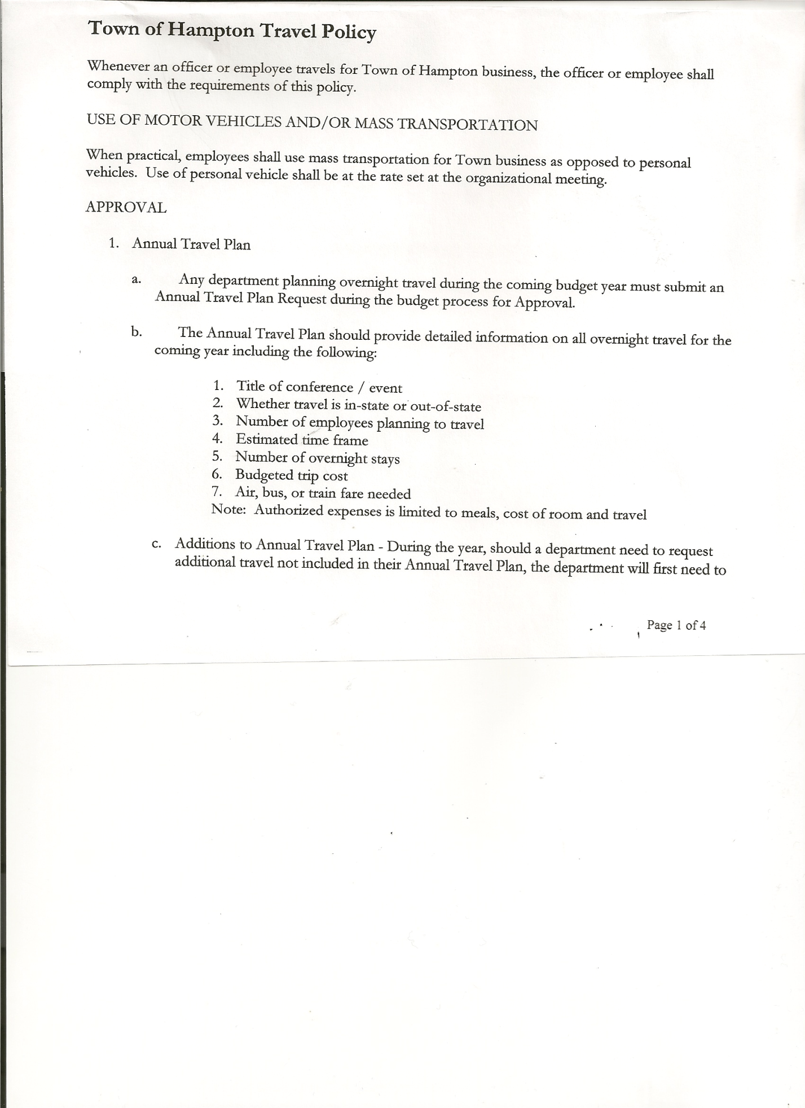
Michael Pietryka------------Councilman
Andrea Kugler---------------Councilwoman-absent
Rebecca Jones---------------Town Clerk
Camilla Shaw----------------Deputy Town Clerk-absent
Tyler McClure---------------Highway Superintendent

Planning Board Member (s):…Bonnie Hawley, Chair; Matthew Pratt and Richard Cole
Others present at the Town Hall: see attached sheet

The Public Hearing was called to order by Supervisor O’Brien at 7:16pm

Town Clerk Jones read the Legal Notice of Public Hearing (copy attached), which was published in Manchester Newspapers on 2/2/23 regarding the adoption of a proposed Local Law providing for a partial real property tax exemption for volunteer firefighters and volunteer ambulance workers.

Supervisor O’Brien went over the details of the proposed Local Law.

All persons desiring to be heard, having been heard, the Public Hearing was closed at 7:30pm.

REGULAR MEETING
The Regular Meeting was called to order by Supervisor O’Brien at 7:30pm, followed by the Pledge of Allegiance. Location of Fire Exits were given. Quorum of board members present.

RESOLUTION NO. 19-2023
APPROVAL OF THE MINUTES
On a motion of Councilwoman Taran, seconded by Councilman Sady, the following resolution was ADOPTED: AYES 4 O’Brien, Sady, Taran, Pietryka
NAYS 0
ABSENT 1 Kugler
RESOLVED, that the Regular Town Board Meeting Minutes for January 19th, 2023 are approved.

PERMITS/SUBDIVISION
Kevin Perry, 2750 State Route 22A, Hampton came before the board regarding a subdivision of Yorkmont Farm Inc. to Kevin and Penny Perry consisting of 3.29acres.

TOWN BOARD MEETING
FEBRUARY 16, 2023 PAGE 2

RESOLUTION NO. 20-2023
PERRY- SHORT ENVIRONMENTAL ASSESSMENT FORM/NEGATIVE DECLARATION
On a motion of Councilman Sady, seconded by Councilwoman Taran, the following resolution was ADOPTED: AYES 3 Sady, Taran, Pietryka
NAYS 0
ABSTAIN 1 O’Brien
ABSENT 1 Kugler
RESOLVED, that the Short Environmental Assessment Form for Kevin and Penny Perry is complete and to adopt a negative declaration and finding that there will be no adverse environmental impacts and to consider it a minor subdivision, therefore waving the public hearing.

RESOLUTION NO. 21-2023
APPROVAL OF SUBDIVISION
On a motion of Councilman Sady, seconded by Councilwoman Taran, the following resolution was ADOPTED: AYES 3 Sady, Taran, Pietryka
NAYS 0
ABSTAIN 1 O’Brien
ABSENT 1 Kugler
RESOLVED, to approve Perry’s subdivision.

Richard Cole, Dog Control Officer gave his report…
- No new complaints
- William Jones, Low Hampton….both dogs are finally licensed
- Had a 6 month inspection with Ag & Markets on 2/10/23

Tax Collector Report for Dec/January was given and a copy is attached.

Planning Board…copy of the minutes of their meeting held February 8th, 2023 are attached. Next Planning Board meeting is planned for March 8th, 2023.

Tyler McClure, Highway Superintendent submitted his report, copy of which, is attached.
Discussed One-Ton Truck vs 5500 Truck…Tyler will get more info for next board meeting.
Also discussed closing Staso Road.

SUPERVISOR’S REPORT/ COUNTY UPDATES/ COMMUNICATIONS

RESOLUTION 22-2023
BUDGET AMENDMENTS-GENERAL FUND
On a motion of Councilman Sady, seconded by Councilman Pietryka, the following resolution was ADOPTED:
By Roll Call Vote: Supervisor O’Brien AYE
Councilman Sady AYE
Councilwoman Taran AYE
Councilman Pietryka AYE
Councilwoman Kugler ABSENT

RESOLVED that, the following Budget Amendments to the General Fund are approved:
TOWN BOARD MEETING
FEBRUARY 16, 2023 PAGE 3

EXPENSES:
Increase Central Printing & Mailing CE Account A1670.4 in the amount of $2,876.07
Increase Justice CE Account A1110.4 in the amount of $3,922.00
Increase Tax Collector CE Account A1330.4 in the amount of $410.70
Increase Personnel Personal Service Account A1430.1 in the amount of $1,055.00
Increase Unallocated Insurance Account A1910.1 in the amount of $1,340.25
Increase Superintendent of Highways CE A5010.4 in the amount of $260.00
Increase Garage CE Account A5132.4 in the amount of $7,907.79
Increase Historian Personal Service Account A8510.4 in the amount of $40.00
Increase Cemeteries CE Account A8810.4 in the amount of $916.81
Increase State Retirement Account A9010.8 in the amount of $298.00
Increase Social Security Account A9030.8 in the amount of $156.95
Increase Employee Training Account A9189.4 in the amount of $16.80
Decrease Contingent Fund Account A1990.4 in the amount of $19,200.37

RESOLUTION 23-2023
BUDGET AMENDMENTS-HIGHWAY FUND
On a motion of Councilman Sady, seconded by Councilwoman Taran, the following resolution was ADOPTED:
By Roll Call Vote: Supervisor O’Brien AYE
Councilman Sady AYE
Councilwoman Taran AYE
Councilman Pietryka AYE
Councilwoman Kugler ABSENT
RESOLVED that, the following Budget Amendments to the Highway Fund are approved:
EXPENSES:
Increase Capital Outlay Account DA5112.2 in the amount of $4,895.90
Increase Machinery CE Account DA5130.4 in the amount of $5,375.28
Increase State Retirement Account DA9010.8 in the amount of $297.00
Decrease General Repairs CE Account DA5110.4 in the amount of $10,568.18

RESOLUTION NO. 24-2023
APPROVAL OF SUPERVISOR’S MONTHLY REPORT
On a motion of Councilman Sady, seconded by Councilwoman Taran, the following resolution was ADOPTED: AYES 4 O’Brien, Sady, Taran, Pietryka
NAYS 0
ABSENT 1 Kugler
RESOLVED that, the Supervisor’s Monthly report be accepted as submitted for DECEMBER
11/30/22 12/31/22
ACCOUNT BALANCE RECEIPTS DISBURSEMENTS BALANCE
General Fund $ 59,789.76 $ 12,034.94 $ 17,068.73 $ 54,755.97
Highway Fund $ 17,388.78 $ 94,209.02 $ 27,200.81 $ 84,396.99
Equipment Reserve $114,952.65 $ 2.91 $ 0.00 $114,955.56
Fire #1 $ 22,081.50 $ 0.00 $ 22,081.50 $ 0.00
Fire #2 $ 5,202.00 $ 0.00 $ 5,202.00 $ 0.00
Cemetery $ 1,765.33 $ .54 $ 0.00 $ 1,765.87
Totals $221,180.02 $106,247.41 $ 71,553.04 $255,874.39
All Board Members present signed Supervisor’s Report.

TOWN BOARD MEETING
FEBRUARY 16, 2023 PAGE 4

RESOLUTION 25-2023
BUDGET AMENDMENTS-GENERAL FUND
On a motion of Councilman Sady, seconded by Councilwoman Taran, the following resolution was ADOPTED:
By Roll Call Vote: Supervisor O’Brien AYE
Councilman Sady AYE
Councilwoman Taran AYE
Councilman Pietryka AYE
Councilwoman Kugler ABSENT
RESOLVED that, the following Budget Amendments to the General Fund are approved:
INCOME:
Increase Unexpended Balance in the amount of $26,179.44
Increase Contingent Fund Account A1990.4 in the amount of $26,179.44

RESOLUTION 26-2023
BUDGET AMENDMENTS-HIGHWAY FUND
On a motion of Councilwoman Taran, seconded by Councilman Sady, the following resolution was ADOPTED:
By Roll Call Vote: Supervisor O’Brien AYE
Councilman Sady AYE
Councilwoman Taran AYE
Councilman Pietryka AYE
Councilwoman Kugler ABSENT
RESOLVED that, the following Budget Amendments to the Highway Fund are approved:
INCOME:
Increase Appropriated Fund Balance in the amount of $5,607.04
Increase General Repairs CE Account DA5110.4 in the amount of $5,607.04

RESOLUTION NO. 27-2023
APPROVAL OF SUPERVISOR’S MONTHLY REPORT
On a motion of Councilman Sady, seconded by Councilman Pietryka, the following resolution was ADOPTED: AYES 4 O’Brien, Sady, Taran, Pietryka
NAYS 0
ABSENT 1 Kugler
RESOLVED that, the Supervisor’s Monthly report be accepted as submitted for JANUARY
12/31/22 01/31/23
ACCOUNT BALANCE RECEIPTS DISBURSEMENTS BALANCE
General Fund $ 54,764.44 $ 114,271.41 $ 8,691.98 $ 160,343.87
Highway Fund $ 84,396.99 $ 334,287.03 $ 16,733.42 $ 401,950.60
Equipment Reserve $114,955.56 $ 2.93 $ 0.00 $ 114,958.49
Fire #1 $ 0.00 $ 0.00 $ 0.00 $ 0.00
Fire #2 $ 0.00 $ 0.00 $ 0.00 $ 0.00
Cemetery $ 1,765.87 $ .04 $ 0.00 $ 1,765.91
Totals $255,882.86 $ 448,561.41 $ 25,425.40 $ 679,018.87
All Board Members present signed Supervisor’s Report.

Regarding the proposed Local Law for Partial Real Property Tax Exemption for Volunteer Firefighters and Volunteer Ambulance Workers, the following resolution was introduced:

TOWN BOARD MEETING
FEBRUARY 16, 2023 PAGE 5

RESOLUTION NO. 28-2023
MOTION BY: Councilman Donald Sady
SECONDED BY: Councilwoman Tamme Taran

RESOLUTION ADOPTING PROPOSED LOCAL LAW PROVIDING FOR A PARTIAL REAL PROPERTY TAX EXEMPTION FOR INCORPORATED VOLUNTEER FIRE COMPANY, FIRE DEPARTMENT OR INCORPORATED VOLUNTEER AMBULANCE SERVICE MEMBERS AND THEIR SPOUSES

WHEREAS, the State of New York legislature enacted Real Property Tax Law Section 466-a which permits a municipality to adopt a local law providing for a partial tax exemption for enrolled members of an incorporated volunteer fire company, fire department or incorporated voluntary ambulance service, or their spouses; and

WHEREAS, a local law providing for such partial tax exemption has been drafted, and the Town Board scheduled and held a public hearing thereon whereat members of the public were permitted to appear and be heard; and

WHEREAS, the Town Board wishes to proceed with the adoption of said local law.

NOW, THEREFORE BE IT

RESOLVED, that the Town Board finds that the adoption of the proposed local law to be in the best interests of the residents of the Town; and be it further

RESOLVED, that said local law is hereby adopted as Local Law 1 of 2023; and be it further

RESOLVED, that this resolution shall take effect immediately.

DATED: February 16, 2023 Supervisor O’Brien AYE
Councilman Sady AYE
Councilwoman Taran AYE
Councilman Pietryka AYE
Councilwoman Kugler ABSENT

NEW BUSINESS
Appointment of Assessor

RESOLUTION NO. 29 of 2023
MOTION BY: Councilman Donald Sady
SECONDED BY: Councilwoman Tamme Taran

RESOLUTION APPOINTING AREK GORDON AS THE TOWN ASSESSOR FOR THE TOWN OF HAMPTON

WHEREAS, The Town of Hampton is in a joint agreement with Washington County Department of Real Property Tax Services for Assessing Services,

TOWN BOARD MEETING
FEBRUARY 16, 2023 PAGE 6

NOW, THEREFORE BE IT

RESOLVED, that the Town of Hampton appoints Arek Gordon as Town Assessor starting January 1, 2023 to December 31, 2023 based on Agreement RPTL 1537.

DATED: February 16, 2023 Supervisor O’Brien AYE
Councilman Sady AYE
Councilwoman Taran AYE
Councilman Pietryka AYE
Councilwoman Kugler ABSENT

PUBLIC COMMENTS/COUNCIL COMMENTS
Richard Cole, President of the Hampton Fire Co spoke regarding the donation of one of the Town’s Fire Trucks. This truck was received approximately 15 years ago from the Fort Edward Fire Co. Hampton wanted to “pay it forward” by selling this said Fire Truck for $1.00 to a Fire Co. that truly needed it, with the provision that it would be put into service. The following is an email that Supervisor O’Brien sent out.

Donation of Fire Truck
daveobrien hamptonny.org
Dave O'Brien - Hampton Supervisor <hamptonsupervisor@roadrunner.com>
Background
Fifteen years ago the Hampton Volunteer Fire Company received a donation of a 1986 Pierce Arrow Fire truck from a local fire department I believe it was Fort Edward. This truck has served them well but they have acquired a couple newer vehicles and are looking to pay it forward by providing this to a fire department who will keep it in service for one dollar.
They have found a fire department who is badly in need of a truck. There is a very poor Indian Reservation in South Dakota who is badly in need of a fire truck with these capabilities. Below you will see a message from the Fire Chief of the Pine Ridge Indian Reservation.
Basically through the efforts of the President and member of the Hampton Volunteer Fire Company they are trying to help raise funds to transport this truck to the Indian Reservation. They have also received commitments from local fire companies to donate other much need equipment to accompany the truck from air packs to hoses to nozzles and other equipment.
You can check out their website: www.alphaonedefense.org

There has been a gofundme site setup for anyone would like to donate to help this worthy effort by our fire company to help arrange transportation costs. If you can please consider helping. Here is the link to the gofundme.

TOWN BOARD MEETING
FEBRUARY 16, 2023 PAGE 7

https://gofund.me/7761dbf2
Any help or equipment that can be given would be greatly appreciated.
Thank you all for your time and consideration.
Richard D. Cole, President HVFC

From their Fire Chief, TJ Plume:
"Our tribal reservation spans 3,467 sq. miles or 2.1 million acres, in fact our reservation spans 3 counties, Oglala Lakota, Bennett, & Jackson. Our county is considered the poorest county in the United States with poverty at 53.75% vs the United States average of 15.6%. Per capita income for American Indians living on the Pine Ridge Indian Reservation is about $3,000 per year while the United States average is $27,599. In the U.S. census bureau, two (2) of the top five (5) poorest communities are located on the Pine Ridge Indian Reservation, Allen, SD (#1) Wounded Knee, SD (#4).

Our department is all volunteer based with 17 active firefighters with hopes of growing to 25 this year when we can establish another pumper in another community that is 1 hr 30 mins away from us. Attached you will see a diagram of our Reservation and where we can respond in adequate time. It is our hope that your fire department and/or board of directors will consider our department this incredible opportunity to put your pumper back into immediate service for the Eagle Nest District in Wamblee, SD. Once we can establish a truck there, we will be covering 67% of the Reservation which is a huge milestone for us. We fundraise all of our operating costs, we have 3-5 firefighters conducting fundraisers each weekend so no one gets overly worked.

It would be a great honor for us to be given a chance for this truck you have up for consideration. As we have done with all of our trucks, your truck would receive a blessing from a traditional medicine man and be given a Lakota name so that our ancestors will provide a safe journey for the truck and firemen & firewomen.

From June to December 2022, we had 729 calls for service ranging from structural, wildland, search and rescue, highway rescue (automobile accidents). 118 of those calls came from the Eagle Nest District, 11 structural, 72 wildland, 16 highway rescue, 6 false reports, 13 search & rescue."
--

RESOLUTION NO. 30-2023
AUDIT OF CLAIMS
On a motion of Councilwoman Taran, seconded by Councilman Sady, the following resolution was ADOPTED: AYES 4 O’Brien, Sady, Taran, Pietryka
NAYS 0
ABSENT 1 Kugler
RESOLVED that the bills have been reviewed by the Town Board and are authorized for payment in the following amounts.
General Fund No.10 through No. 22 $ 12,838.37
Highway Fund No. 8 through No. 20 $ 14,476.62
Total both funds $ 27,314.99

TOWN BOARD MEETING
FEBRUARY 16, 2023 PAGE 8

The Town Clerk’s report for January 2023 was submitted to the Board. The Town Clerk had Board Members review and sign bank reconciliation statements for the Town Clerk Account and Special Clerk Account dated January 31st, 2023.

RESOLUTION NO. 31-2023
MEETING ADJOURNED
On a motion of Councilwoman Taran, seconded by Councilman Sady, the following resolution was ADOPTED: AYES 4 O’Brien, Sady, Taran, Pietryka
NAYS 0
ABSENT 1 Kugler
RESOLVED that the meeting adjourned at 8:41pm.

Respectfully submitted,

Rebecca S. Jones, RMC
Town Clerk

