OUR HISTORY
The Roy I. Rhodes Chapter 306, Inc. of the Vietnam Veterans of America, located in Morgantown, WV has been established as a Chapter for over 25 years. During those years, our numbers have increased and decreased but our Members and our Associate Members have worked together for many causes, fundraising events and support to each other while remaining “in service to America” and our community.

OUR MEETINGS
The Roy I. Rhodes
Chapter 306 meets
the first Monday of every month at 7:00 PM at:
The Elks Lodge #411
1138 Chestnut Ridge Road Morgantown, WV 26508

OUR WEBSITE
For more information please visit our newly updated
website at:

www.VVA306.org

An R & R Event was planned to visit the Sight and Sound Theater in Lancaster, PA. on October 1st and 2nd

This was a Chapter co-sponsor event which included bus transportation, two shows, shopping, dinner and a hotel room. Those who attended report that it was an outstanding adventure!
A very special thank you to Cindy S. and others for making this trip possible!!

WEST VIRGINIA STATE COUNCIL MEETING

Next meeting will be held on
November 4, 2018.

We are looking for Chapter Members who would like to attend these meetings.
Please let the Chapter 306 leadership know you would like to be involved!

VVA Chapter 306
Monthly Meeting
October 16, 2018

The October meeting held at Shoney’s Restaurant in Sabraton this morning with 9 VVA Members and 7 AVVA Members gathering for breakfast.
AVVA member T.J. reported that the Buckwheat Festival was a success in fundraising for the Chapter this year. She also mentioned the Chapter is conducting a raffle on a Longaberger Basket packed full of West Virginia items. The winning ticket will be drawn on Veterans Day. If you are interested in tickets, please contact the Chapter leaders.

A lot of information was presented at this meeting,
please check your email for
upcoming events.

VETERANS TABLE PROGRAM

Third Friday of Every Month
10:00 a.m. to 12:00 p.m.
Freedom Shelter
in the VA Park

For those in need of food or a little extra help each month,
HELP IS AVAILABLE.

The Mountaineer Food Bank has started a program known as Veterans Table Program. This is in partnership with the Clarksburg VA Hospital.

There are no guidelines and you simply have to be a VETERAN.
The Mountaineer Food Bank will also be providing CSFP food boxes (senior food box) for those 60 years or older, and who meet income guidelines.

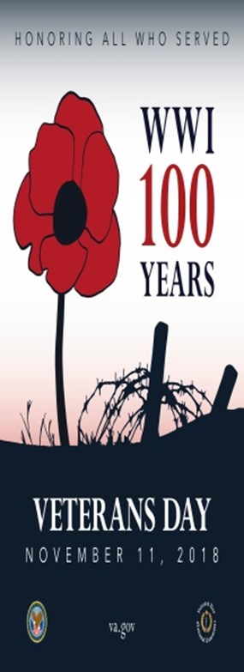

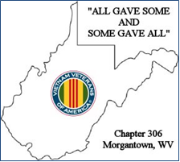

Veterans Day Parade
November 12, 2018
6:30 p.m.

The Chapter will participate in the Veterans Day Parade on High Street, Morgantown, WV on Monday, November 12th.

Please plan to join us!
We appreciate help carrying the Chapter Banner and the Colors.
You are welcome to ride along in a vehicle, too!

VVA Chapter 306
Monthly Meeting

November 13, 2018
9:30 a.m.

The VVA Monthly Meeting for November will be at Shoney's in Sabraton.
This will be a social gathering for breakfast with the Chapter meeting following. We will be making plans for the Chapter’s Holiday Thanksgiving and Christmas Chapter Dinner at this meeting.
See you there!

Christmas Shopping for Nursing Facility Veterans
Tuesday, November 27, 2018
6:00 p.m.

Once again during the Christmas season, our Chapter will partner with the VFW 548, providing gifts for all Veterans in the four area Nursing Homes. We have done this for many years and it is a fun time, very rewarding and emotional.

We have 38 Veterans that we will be shopping for gifts to provide a Happy Christmas Season for all.
For those desiring to assist, we will meet at the Hornbeck Road Walmart do shop.

On Sunday, December 16 at 1:00 p.m., for those who are able, we will meet at the VFW 548 Hall to load and distribute the gifts to the Nursing Facility Veterans.

Thanksgiving and Christmas Holiday Dinner

Monday
December 3, 2018
6:30 p.m.

A discussion at the October meeting was regarding the Thanksgiving and Christmas Holiday Dinner. The Chapter has reserved the Meeting Room at Shoney’s in Sabraton for this event.

Please watch your email for the cost and RSVP information.

Note: This event was attended by 18 couples. Everyone had an enjoyable evening. It was great to see everyone!

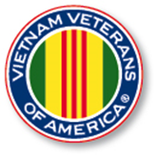

The Special Offer
of $100.00 for
LIFETIME
MEMBERSHIP
continues
for both the
VVA and AVVA
Members!

Sweetheart Christmas
Dinner and Show
St. Clairsville, Ohio

December 6th
Dinner at 6:00 p.m.
Show at 7:00 p.m.

The Chapter is co-sponsoring the event. Interested Members and their spouses will carpool to enjoy this show.

If you are interested, please contact the Chapter Leaders for a contact phone number.

REMINDER!

3rd Tuesday of Each Month 9:30 a.m.

We have started to hold unofficial/social breakfast events on the 3rd Tuesday of each month at Shoney’s in Sabraton at 9:30 a.m.

This is a great time to socialize and enjoy a good breakfast! We have had positive comments on these events that everyone is enjoying the food and the fellowship.

We also plan on having our Winter Monthly Meetings during these social events during December, January and February.

Please watch your email for upcoming details as we also plan on rotating the breakfast to other restaurants in the area.

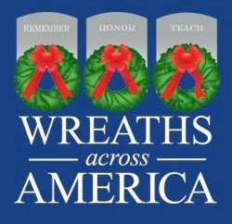

The National Wreaths Across America Day was held on

Saturday, December 15, 2018.

Programs were held and wreaths were laid at both WV Veterans Cemeteries.

Grafton National Cemetery (WVGNCG)
431 Walnut St
Grafton, WV 26354

West Virginia National Cemetery (WVNCGR)
42 Veterans Memorial Lane
Grafton, WV 26354

The wreath removal event
will be held in
January 2019.

For more information:
http://www.wreathsacrossamerica.org/

R & R EVENTS

Please bring your ideas for an
R & R event to the attention of the Leadership via email or at the next meeting.
We look forward to planning the 2019 R & R events with you. Please watch your email for updates.

The members of the VVA and the AVVA of Chapter 306 extend our deepest sympathy to
the Rudash Family in the loss
of their loved one,

Danny Rudash

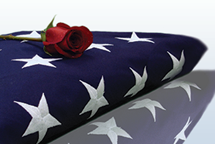

Respectfully Submitted by
VVA Chapter 306
Morgantown, WV

Janet. L. Finerfrock
Activities & Media Reporter
Gary W. Burch
President
Mike Harsh
First Vice President
Jamie Welch
Second Vice President
Doug Geary
Secretary
Don Davis
Treasurer

