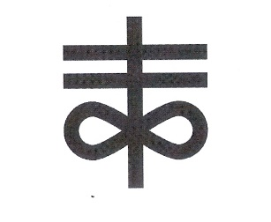
Saints TC
Parent Tops and T-Shirt order form

Polos Tops | Cost | Y SM | Y Med | YL | SM | Med | LG | XL | 2XL | 3XL
 | $25
T-Shirts
Parent of a Saint | $20
Track Mom | $25
Danger Track Mom | $25
The Real Mom of Track | $25
Pretty Girls Run Too | $25
I run like a girl keep up | $25
Run like a beast | $25
Head Band | $12

Name_____________________________________________
Total__________ Cash___ Credit Card_____ Check____

