0-

**GSPCI Newsletter Pointer Post April 10, 2014**

**German Shorthair Club of Indiana**

Presidents Message:

Dear Members,

Taking over President of the German Shorthair Club of Indiana has been very challenging, yet rewarding. A little about myself; 1 husband, 2 kids, 3 GSP’s. My family is my life. My goal is that my kids will have the opportunity to enjoy this club into and thru their adulthood as well. I have had a lot of focus already this year on new members. I look forward to encouraging everyone to do the same. If you get calls for pups, even if you don’t have a litter, there is an easy opportunity to introduce us to them. We have had 2 new members already from such a simple contact. I am looking forward to the year we have ahead. It has been a very busy start and the year will continue that way as well. Our yearly meeting was nicely received at Ponderosa this year. I have kicked off the year with website design work, making new member opportunities avail and the Spring Hunt Test. The website is off to a great start! We anticipate the change to happen very soon. The Hunt Test went very well. It was not our largest test, (36 entries) but, due to our extreme winter months this year…..there has been little time for the training. That said, Thank you to all our members who came to test and to help with the hunt test be the success that it was! I look forward to putting training days together in the upcoming days as well. I June we have our club picnic coming. At this time we have June 21st set aside for the picnic at Glenns Valley. We will have more information put out closer to that time.

Thank you all so much and I look forward to seeing you at the upcoming events.

Laura Getzen

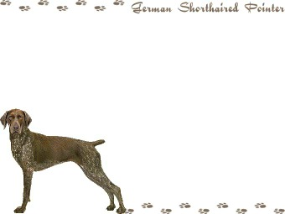

Indiana Hunting Seasons

UPLAND GAME HUNTING DATES DAILY LIMIT*

Pheasant (statewide-cock only) Nov. 1, 2014 – Dec. 15, 2014 2

Quail (North of Interstate 74)*** Nov. 1, 2014 – Dec. 15, 2014 4

Quail (South of Interstate 74)*** Nov. 1, 2014 – Jan. 10, 2015 8

Rabbit Nov. 1, 2014 – Feb. 28, 2015 5

Board Members

**President** – Laura Getzen

laura.getzen@yahoo.com

**Vice President –** Kirk Johnson

[kirk_johnson@iqest.net](mailto:kirk_johnson@iqest.net)

**Secretary/Treasurer** - Debra Moline

debramoline16@gmail.com

**Board of Directors**

Larry Harris Mark Holzinger Ron Ferris

Vince Guerrini Matt Cosgrove John Kennedy

Chris Weber Giles Hoyt Brittany Moline

**“B R A G G I N R I G H T S”**

Everyone has done a great job this year training and participating for the hunt tests. Congratulations to everyone who participated in a hunt test this spring. And as you can see we have a lot of new faces as well as some promising prospects to be proud of. A big thank-you goes out to all who helped and participated in this spring’s hunt test. If you haven’t participated in the past then “GET INVOLVED”. You can enter your dog or come watch and see for yourself what it is all about. Ask any of our club members who have participated in a hunt test and they will be glad to answer your questions.

C:\Users\Laura\AppData\Local\Microsoft\Windows\Temporary Internet Files\Content.IE5\9W9VH1NS\MC900329538[1].wmf

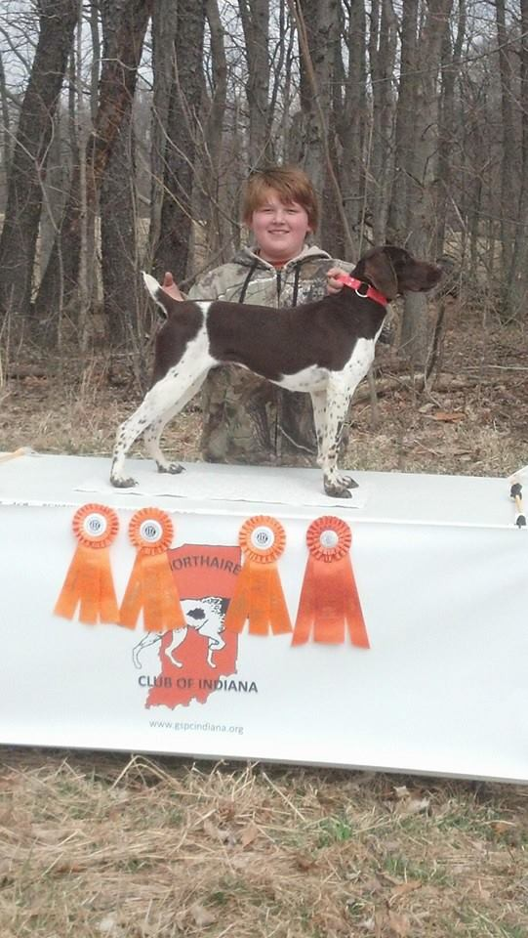

Congrats to Jake, Grandson of Mark Holzinger and his dog Athena for completing the last leg of their Junior Title. Great Job!!

GSPCI J.A. Lemcke with Butch & Sundance completing the first leg of their Junior Title!!!! 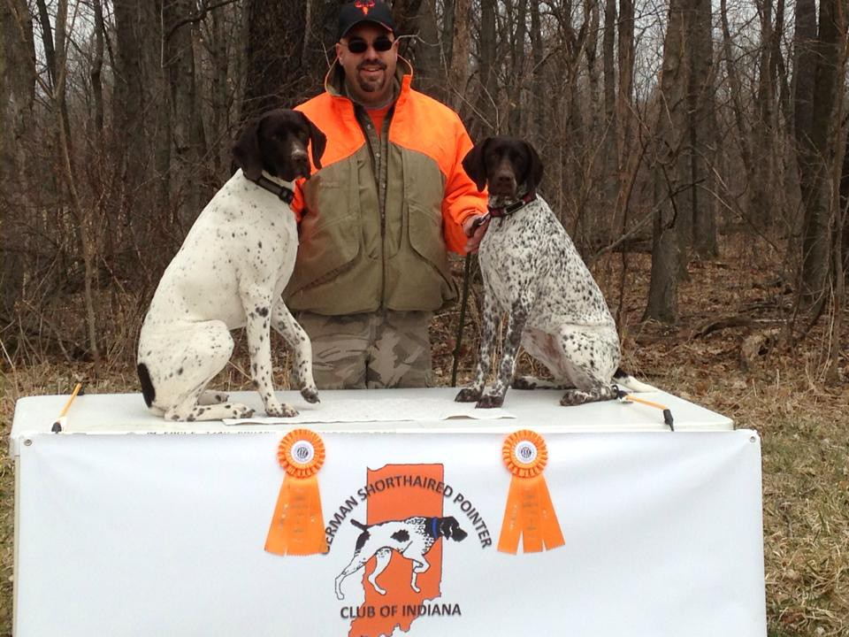

GSPCI Member J.A. Lemcke with Butch & Sundance completing their 1st leg of their Junior Title!!!

.

Matt Cosgrove’s New Pup “Enzo out enjoying the field together during the Spring Hunt Test

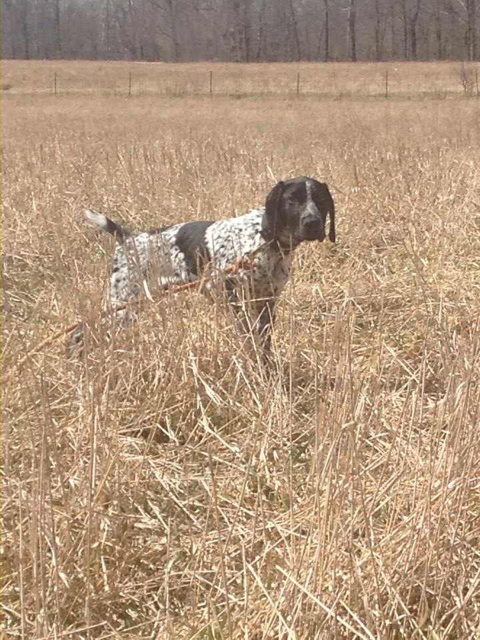

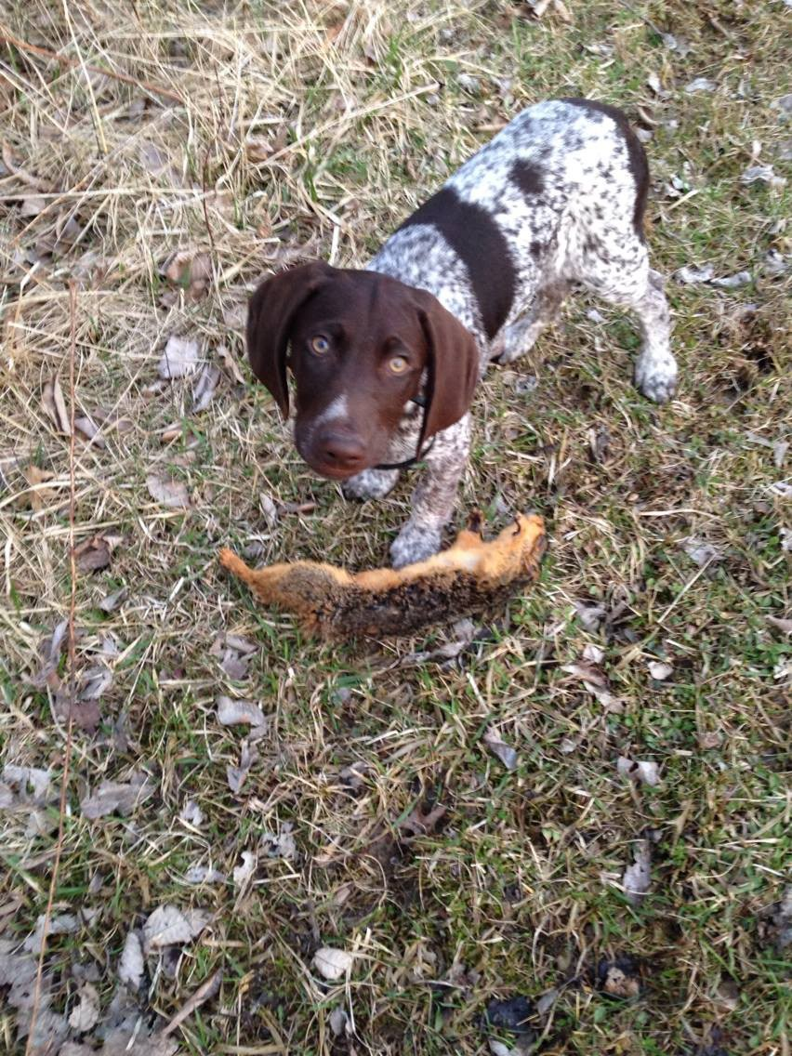

New Members Tom and Monica Meyers and their new hunting partner “Bart”

If you have a bragg that wasn’t included that doesn’t mean you were excluded. Please send any wins or Braggs you would like to have featured please email them to Laura Getzen, Newsletter Editor [markorlaura@comcast.net](mailto:markorlaura@comcast.net).

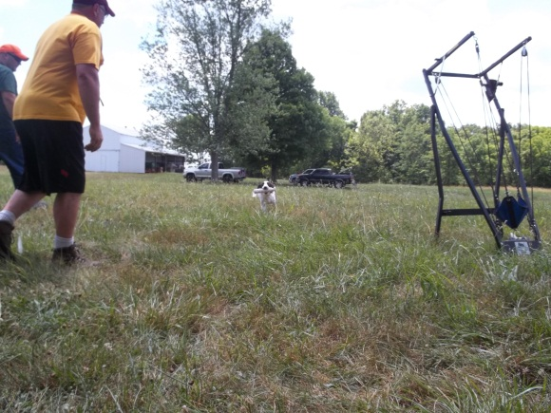

|  |
| --- |
|  |
|  |

Spring is a great time to usher in the warm weather and get out and experience the rebirth of nature. With the final close of a winter like we have experienced here I thought this might be a good opportunity to get introduce that new prospect to some spring time training.

1. **I** can't stress enough that puppies not properly socialized will never reach their full potential. In my experience, pups isolated from positive people contact prior to 12 weeks of age are a trainer's albatross.  
  
 2. **I** recently received a letter from an individual who had purchased a six-month-old dog. Since birth, the dog had been kenneled with its littermates, and when anyone approached the enclosure all pups had sought refuge in the doghouse. At eight months the pup was reticent and timid. I was sorry to have to tell the owner that because of this lack of socialization it would be almost impossible to make his dog into a first-rate hunting companion.  
  
 3. **D**uring your dog's first six months it is critical that the pup come to know and trust you and that you learn to understand the pup's developing personality. You will see the pup mature and its ability to concentrate increase. A key ingredient in training is to know when the dog is ready to learn as well as when it's ready to move on.  
  
 4. **T**o properly expose the pup, take it for walks where it will be introduced to new scents, people and other animals. Let strangers spoil it. Pup needs to see the world, not just your backyard.  
  
 5. **T**his is what it's all about-the button-popping pride of watching your pup develop into a world-class shooting dog. The more birds your dog is exposed to, the better bird dog it will become. But your dog will first need to learn to hunt. It won't learn this in the backyard sitting perfectly, holding a dummy in its mouth.

 6. **B**irds, birds, birds. This is the key to your dog learning to hunt. If you don't live in an area where Pup can find lots of wild birds, join a hunting preserve or lease a farmer's field and use pen-raised birds. The bottom line is that if your dog does not see birds, it will never become an accomplished bird dog.

7. **C**onsistent performance in response to your commands should be one of your training goals. This is accomplished through repetition, as a dog learns by rote, much as you did when learning the multiplication tables. Keep in mind that a dog's attention span is limited; therefore short, frequent training sessions are far more effective than longer but fewer lessons.  
  
8. **G**et into the habit of saying a command only once. Say the command, then make the pup comply. A well-trained dog performs the first time and will only do this if you command excellence. If your dog learns it does not have to obey "Here" the first time, you may just lose it to a speeding truck on a back road.

9. **I** tell clients in my dog training school, "If I wanted my son to be a plumber, I wouldn't give him a wrench on his first birthday." In other words, do not expect unrealistic feats from your pup. Too much early formal training may take style and pizzazz out of a youngster. It is wiser to err on the side of caution.  
  
10. **P**up will need to learn certain commands from a safety standpoint and for acceptable behavior in the house. For example, early on you will want to teach the pup "No" and that biting is intolerable. You can also start teaching "Here" by running away from the pup saying "Here, here, here." When the youngster gets to you, reward it with a treat, an "Attaboy" or a pat.  
  
11. **W**hen the dog is 10 to 12 weeks old, you can begin teaching, "Sit, Hup" or "Whoa." Don't make the dog comply for long periods. Your job at this stage is to show the pup what the command means, not demand that it respond like a pro. I don't like to teach "Sit" to the pointing breeds before I teach "Whoa," as pups that are taught "Sit" first have a tendency to sit when being taught "Whoa."  
  
12. **I**f you have a pointing breed, you can play "wing on a string," but don't over do it. This is a sight game and, if over done, may encourage creeping. I play this game only to bring out the pointing instinct in dogs up to 12 to 14 weeks old.  
  
18.**W**henever possible, hunt your dog into the wind. The dog will produce birds if the wind is blowing scent to its nose, rather than away from its scent gathering radar.  
  
19. **M**ake sure all of your dog's vaccinations, heartworm, and tick preventatives are up to date. Coyotes, foxes, rodents, and parasites are lurking out there. Be prepared.  
  
20. **M**ake hunting fun for you and your dog. Don't expect your dog to do things that you haven't trained it to do. Also remember that the dog doesn't understand the King's English. Don't expect excellence from a young dog in its debut or from a dog that is untrained. Give your pup the experience and make it a happy time.

Spring Training Tips

It’s Time to Get That New Pup Started!!

**SAVE THE DATES**

**Spring Hunt Test........March 22&23  Glenns Valley**

**Club Picnic TENTATIVLY.....June 21  Glenns Valley**

**Fall Hunt Test**......Sept. 21&22  Glenns Valley

**Youth & Ladies Hunt.....October 18     Ron's Farm**

**Steve Hammond Memorial** **Hunt**.......November 1  Ron's Farm

Closing Club Notes

GSPCI Hunt Test March 22&23

Put a couple of beautiful days together, some well trained dogs, a few good flying birds and what do you get? You get a hunt test! The hunt test was well received with a few die hard trainers risking the fact that they had little or no time in order to get ready. Some of our members where able to hit pay dirt and come away with a leg or two towards their Junior, Senior, or Master dog titles. The judging was fair and accurate and most entrants came away with a feeling of accomplishment. There was even one entrant from Michigan who felt that Hoosier Hospitality and promised to come back and bring some others. A big thank-you to all who helped organize and run this year’s Spring Test. Your work is very much appreciated by everyone. For those of you members who didn’t make it out to see this function come out and see for your self what you are missing!

Breeders

Please make sure you email Christy Featherson if you have any litters available or coming. Christy is listed on AKC website as a Breeder Referral.

Christy Featherston [artemisgsp@aol.com](mailto:artemisgsp@aol.com)

Volunteers

During the events we host or attend there is always room for help. May be it food, cleaning up, setting up or just offering. Contact is easy to make to offer any assistance where needed. There is no specific list for this, or maybe there is and were all on it!

Give where you can and lets all do our part to help things pull together. We have many members who already help and volunteer for the many things we do. So a BIG Thank You to them and lets continue to all support and help with our efforts!

**Information**

The club is in the process of updating our web-site so any one who has either an interesting article for training or raising birds or even a video in that category please e-mail one of the club officers to get it on the Web. Remember to we also on face book so look us up and remember to mark us in the “like” category.



Other informative sites;

http:// inddeptof natural re

<http://www.bdarn.com/calendar/> <http://www.nstra.org/> <http://www.gspca.org/> <http://www.centralindiananavhda.com/> <http://www.glennsvalley.org/>

FOR SALE

Any one with equipment or puppies please email me with the information and I will try to get into the next newsletter. Items such as training pigeons, quail, etc. will be helpful to other club members so let’s get me as much info as you can. E-mail [guerrini.vince@gmail.com](mailto:guerrini.vince@gmail.com)

UPCOMING LITTER: GSP PUPPIES DUE TO WHELP April 4/25, 2014

CONTACT: PERRY CLOYD

CELL: 812-431-0465

QUAIL: BOB QUIGLEY 317-650-5940 Web Site:

[www.indiancreekgamebirds.com](http://www.indiancreekgamebirds.com)

For the Do It yourself crowd here is some plans to make a Pigeon Hobble:

B

D

A C

**Material List:**

**A: 1”PVC (Length may vary depending on age/strength of pigeon) I recommend that you purchase a**

**4’ length to make multiple hobbles. Start with 12” lengths and test from there by shortening if**

**necessary or adding sand.**

**\* Shaded area is sand fill to vary or add weight so the pigeon will travel a shortened length. Your Choice**

**B: 1” PVC Caps (2 per hobble) Push caps onto PVC Main Body**

**C: 3/16 hole Drill through**

**D: 24” Nylon twine with (2) slip knots on the end that will attach to pigeons leg above the 2nd joint**

**on the birds leg. Attach each length of twine through the 3/16ths hole make sure distance is**

**even to the slip knot.**

**This device requires a little trail and error to get it the way you want it. You will get multiple chances at your birds thus increasing your dogs chances to point.**