**Pressure Treated Structural Lumber Coalition (PTSLC) Faulty Lumber Issue and Impact Report**

**June 2017**

**Introduction:**

Pressure Treated Structural Lumber Coalition, LLC (PTSLC), [www.ptslc.org](http://www.ptslc.org), has been created to provide a platform for those affected by the ongoing financial, emotional, physical and environmental consequences of deficient “Pressure Treated Wood Products”, to focus national attention on the far-reaching magnitude of damage surrounding this issue and to foster a unified voice for resolution.

**Coalition Leadership:**

Mike Lucht, Executive Director, Concerned citizen and personally affected by faulty lumber, resident of Michigan District 7

Sara Bowen, Communications Director, Concerned citizen, resident of Ohio District 5

**Coalition Support:**

Todd Roskin, American Wood Protection Agency (AWPA) Member and wood expert

Kevin Flynn, Flynn and Associates Inc, Forensic Wood Technologist

Mac McKinney, Energy Policy Advisor, Congressman Tim Walberg

Cletis Clendinen, Field Representative, Congresswoman Stacey Plaskett

_________________________________________________________________________

**Summary:**

2003 the lumber industry stopped selling CCA pressure-treated lumber for residential use.

2004 the lumber industry introduced new formulas to replace CCA pressure-treated lumber, however, these formulas were not tested for longevity.

2015 The Consumer Product Safety Commission released a report regarding the sudden increase in deck failures. Deck failures have resulted in 224,000 injuries and at least 6 deaths in this time frame.

2004-2017 Anyone who has used lumber for structural construction building purposes (such as decks) is at risk for premature lumber failure due to wood rot, fungal decay and/or termite infestation.

2017 The PTSLC asks the Digital Commerce and Consumer Protection Committee to consider regulation and remediation for those negatively impacted by faulty lumber acquired through deceptive trade and negligent processing.

**Background:** Discovery through a home addition project in the Virgin Islands

Mike Lucht started experiencing unexplainable, repetitive lumber damage to his home in the Virgin Islands. A pattern of faulty material emerged and he realized he was not alone as other Virgin Island residents were experiencing the same failures. Through further research, Mike discovered that there was a change in treatment chemicals used to produce Pressure Treated Lumber in 2003 that significantly impacted the life expectancy of the lumber. This change was industry wide which indicates that the issue is far reaching into all pressure-treated lumber use since 2003.

Timeline:

* Prior to 2003: Lumber industry treats pressure treated structural lumber with CCA – Chomated Copper Arsenate[1]
* 2003: EPA states there needs to be a reduction in Arsenic levels[2]
* 2004: Lumber industry changes their treatment formula from CCA – Chomated Copper Arsenate to copper rich formulas such as MCA – Micronized Copper Azole. This change occurred to satisfy the demand for Arsenic to be removed from the supply chain, but without testing on the impact of the product.[3]
* 2004-2017: Pressure Treated Lumber is being sold as it always has been sold, with a common understanding that it will last a “lifetime” which was 40-50 years with CCA Lumber. The life expectancy of pressure-treated lumber sold after 2004 was significantly reduced to less than 15 years, however there are no warranty’s supporting any specific time frame. Life expectancy tends to be stated as “limited lifetime warranty.”[4][5][6]
* 2004 – Current: Anyone who has installed pressure-treated structural lumber after 2004 is at risk for early and unexpected lumber failure.
* 2015: AWPA U1 standard developed and released. This standard acknowledges that different treatments work better in different applications, 11 years after the new formulas were introduced to consumers.[7]
* 2017: Pressure Treated Structural Lumber Coalition was formed. (www.ptslc.org)
* 2017: AWPA releases Use Category Guide[8]

**Lack of Consumer Education and Transparency Created Product Deception:** Changes made with little consumer warning and lack of impact testing while supporting market place assumptions

While the industry changed its formulas to meet the EPA recommendation of removing Arsenic, the industry has not effectively educated the consumers about the change and its impact. Since 2004, homeowners and builders alike have continued to use Pressure-Treated Structural lumber as if it was made in the familiar way, prior to 2004. This familiar pressure-treating formula used since the 1940’s, CCA, had an assumed minimum life expectancy of over 35 years for general use and 50 years for posts.[9]

Through interviews with Lowes, Home Depot, Menards and 84 Lumber, we have learned that today there is not any educational material representing the expectations of pressure- treated lumber use and/or life span, leading to consumer confusion regarding the term pressure-treated and product expectations prior to 2004. Although AWPA suggests that there are a variety of formulas available, retailers typically only offer either regular lumber or pressure-treated lumber. Just now in 2017 the AWPA released a Use Category Guide to better inform consumers of the different types of pressure-treated lumber and their recommended uses confirming a deliberate social experiment of confusion and failure since 2004, despite the fact there is no mention that the EPA never banned the use of CCA sawn cut dimensional lumber for residential structural purposes.[10]

If you look at websites today for consumer education and product descriptions, you see misleading information. Lowes says the pressure-treated lumber is “Safe for People, Pets and Plants”.[11] However, PTW-Safety Info document declares that you must wear gloves to handle it, you must wear a mask when cutting it, and other safety issues that are significant and counter that the wood is “Safe for People, Pets and Plants.”[12]

**Environmental Impact:** New wood fails faster and chemical composition is also dangerous.

The new formula of pressure-treated lumber negatively impacts the environment in 3 ways:

1. Premature failure is causing consumers to purchase more wood in order to repair damages. This rise in lumber use is depleting wood supply.
2. Copper is more likely to leech with the new formula. This is causing water and soil contamination. It is also detrimental to marine life.
3. The failed structural lumber materials are adding to landfill space depletion.

**Consumer Safety Issues:** 224,000 injuries and 6 deaths in recent years due to deck failures

The failure of the new formula came quickly to the Virgin Islands where the wood is exposed to the highest and most severe climate demands and environmental threats. This region is considered Zone 5 by the AWPA index (the highest of the decay regions).[13] However, wood failure issues have now been seen across the country at an accelerated pace.

Homeowners in all regions have experienced premature failure of pressure treated lumber. The most common form of failure experienced is collapsed decks. According to a five-year study by the Consumer Product Safety Commission (CPSC), there were 224,000 people injured due to a deck or porch failure.[14]

The most notable case of pressure-treated lumber failure in the continental US is the Berkeley Balcony Collapse. In 2015, 6 students were killed when their 5th floor apartment balcony collapsed. Overwhelming evidence shows dry rot as the main cause of the failure.[15],[16]

Mirroring the Dry Wall Safety Act of 2012[17], the PTSLC will encourage a remediation path form impacted consumers.

**Lack of Regulation:** Inconsistent labelling and lack of testing requirements in residential use applications

The AWPA is the overarching standard organization for the lumber industry. Within the lumber industry there are several specialized organizations[18] that support the specific process or use that the lumber will go through. While these standards producing groups make suggestions on treatments, none of them are regulators. The industry is self-regulated.

The standard communication tool in the industry today is the end tag. The ideal end tag should contain this information, according to the AWPA:

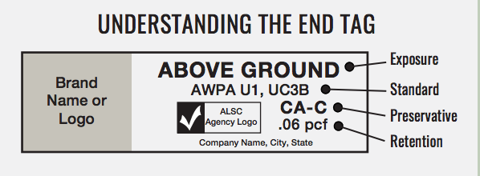

The use of end tags is suggested not regulated and therefore can end up looking like this:

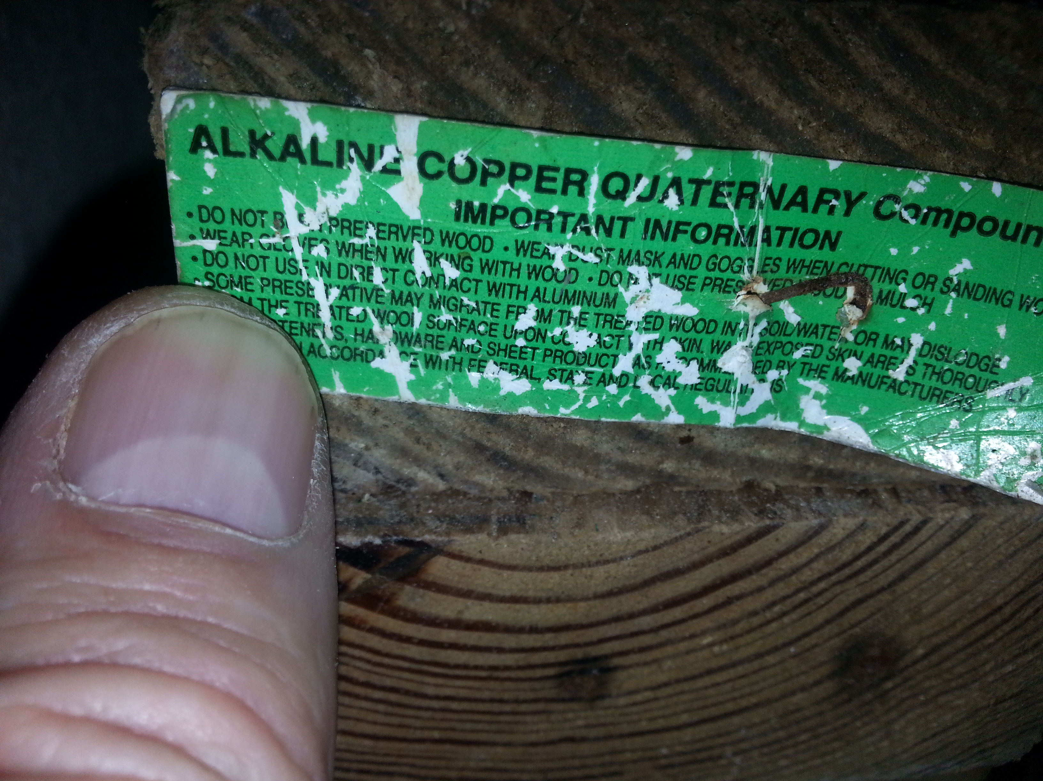

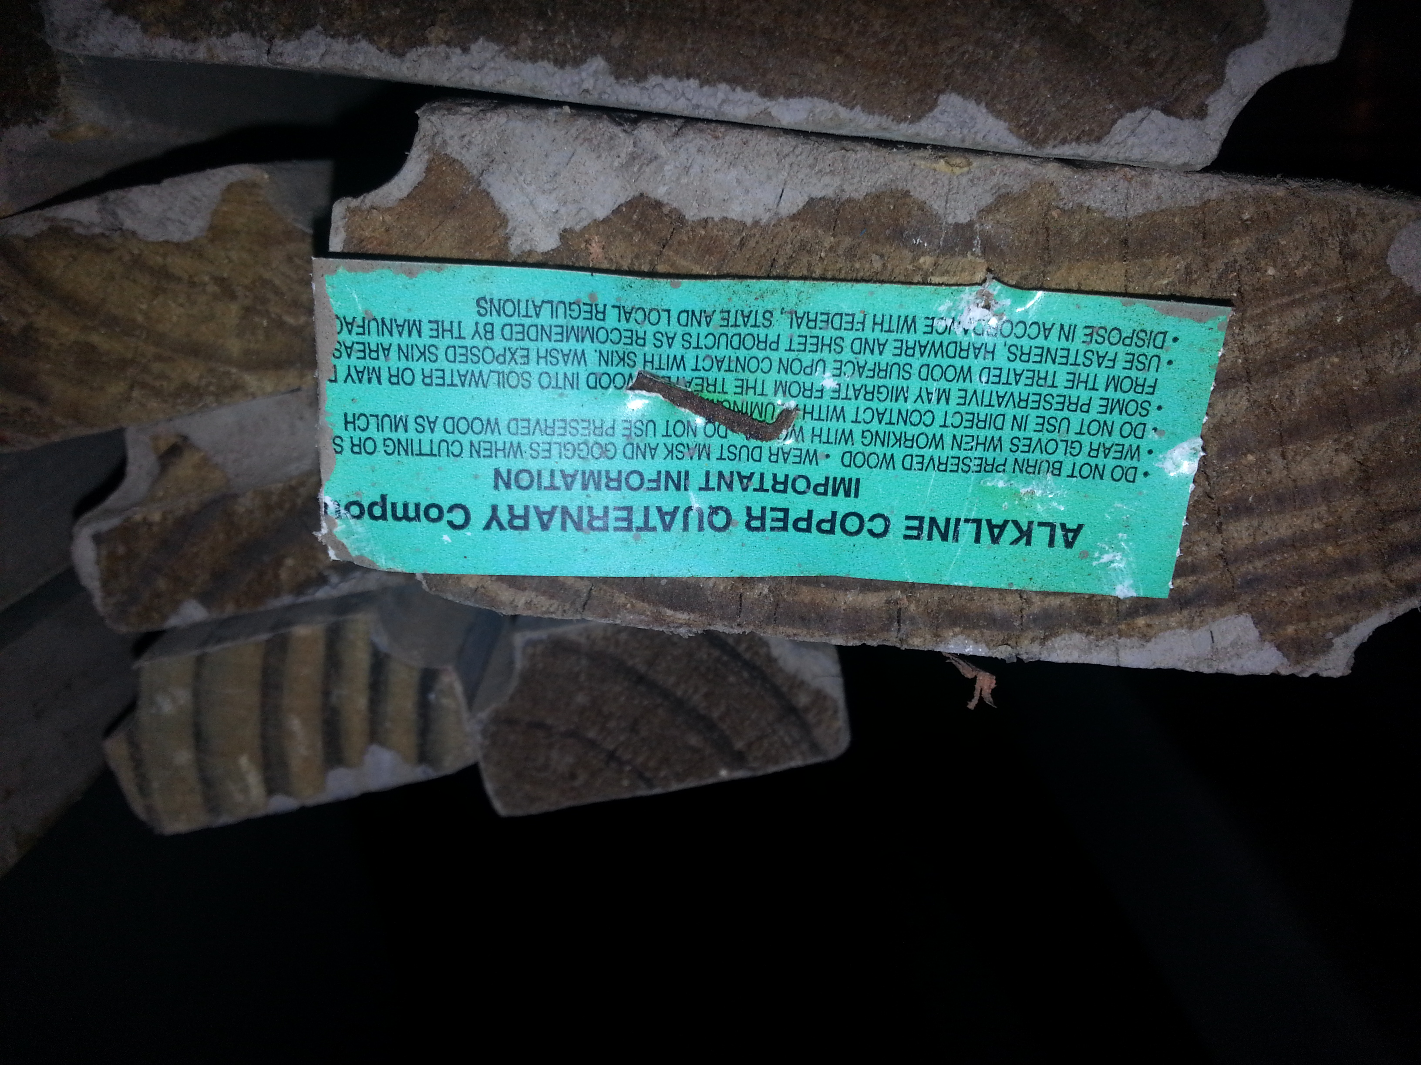

Virgin Islands Lumber Photo

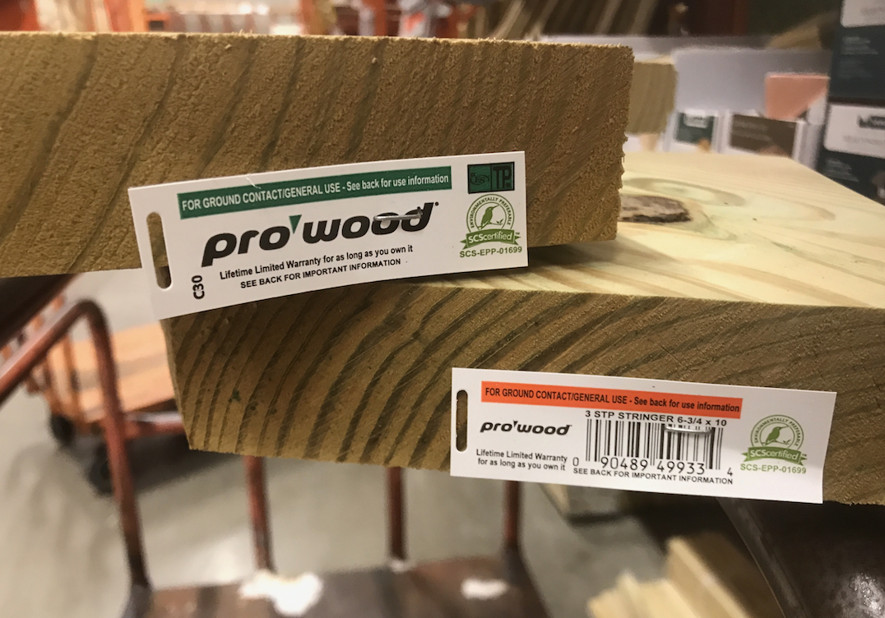

Home Depot Lumber Photo June 2017

In the USA as consumers of American products we have the luxury of government regulated consumer protection. As a result, we trust the system and generally think that those in charge are regulating our consumption in a way that is protecting our best interest. In this

case, while the EPA was making positive strides to rid Arsenic in the water, the lumber industry decided to remove Arsenic from its formulas. However, due to lack of regulation, the industry did not test the new formula for durability or consumer impact.

**Suggested Action:** Remediation and Regulation

The following actions are recommended to protect consumers of pressure treated structural lumber;

1. AWPA Standards should be enforced for every batch of pressure treated lumber produced and sold by retailers.
2. Each board should have a label identifying the manufacturer, month and year of manufacture, batch/bundle number, American Lumber Standards Committee (ALSC) Treated Wood Program accreditation, AWPA Use Category, and minimum guaranteed expected life span (in years) of the pressure-treated wood material.
3. Retailers should be required to clearly and properly inform consumers in writing of the expected life span (in years) of the pressure treated lumber material being sold and the proper fasteners to be used in construction.
4. Retailers should be required to maintain a warranty registry used to identify which batches of pressure treated lumber were sold to whom so when a consumer identifies defective material and alerts the retailer, other consumers of lumber from the same batch/bundle can be alerted in the spirit of consumer safety and transparency.

**Further Information and Contacts:**

[www.ptslc.org](http://www.ptslc.org)

[dklumber@ptslc.org](mailto:dklumber@ptslc.org)

1-202-505-4506

1. <http://npic.orst.edu/ingred/ptype/treatwood/ccareg.html>
2. <https://nepis.epa.gov/Exe/ZyNET.exe/P100AFIX.TXT?ZyActionD=ZyDocument&Client=EPA&Index=2000+Thru+2005&Docs=&Query=&Time=&EndTime=&SearchMethod=1&TocRestrict=n&Toc=&TocEntry=&QField=&QFieldYear=&QFieldMonth=&QFieldDay=&IntQFieldOp=0&ExtQFieldOp=0&XmlQuery=&File=D%3A%5Czyfiles%5CIndex%20Data%5C00thru05%5CTxt%5C00000027%5CP100AFIX.txt&User=ANONYMOUS&Password=anonymous&SortMethod=h%7C-&MaximumDocuments=1&FuzzyDegree=0&ImageQuality=r75g8/r75g8/x150y150g16/i425&Display=hpfr&DefSeekPage=x&SearchBack=ZyActionL&Back=ZyActionS&BackDesc=Results%20page&MaximumPages=1&ZyEntry=1&SeekPage=x&ZyPURL>
3. http://www.deckmagazine.com/design-construction/framing/treated-wood-update_o
4. http://www.koppersperformancechemicals.com/pdfgallery/pdfs/ag-warranty.pdf
5. https://www.midwestmanufacturing.com/MidwestManufacturing/web/docs/pdf/cms/AC2PressureTreated.pdf
6. http://pdf.lowes.com/warrantyguides/099796632007_warranty.pdf
7. <https://www.proremodeler.com/new-rules-pressure-treated-lumber>
8. http://www.awpa.com/references/documents_PDF/ResidentialInfographic2016.PDF
9. https://www.fpl.fs.fed.us/documnts/pdf2013/fpl_2013_lebow001.pdf
10. https://www3.epa.gov/pesticides/chem_search/reg_actions/reregistration/frn_G-22_2-Feb-02.pdf
11. https://m.lowes.com/pd/Severe-Weather-Common-4-in-x-4-in-x-8-Ft-Actual-3-5-in-x-3-5-in-x-8-ft-Pressure-Treated-Lumber/50261729
12. http://www.ptw-safetyinfo.ca/en/micronized-copper-azole-mca
13. https://www.fpl.fs.fed.us/documnts/rips/fplrip-4723-022-UW-Kirker-Hickey.pdf
14. <http://www.jerebeasleyreport.com/2015/03/recent-study-reveals-dramatic-increases-in-collapses-and-failures-of-decks-and-balconies/>
15. <https://en.wikipedia.org/wiki/Berkeley_balcony_collapse>
16. http://www.cnn.com/2015/06/23/us/berkeley-balcony-collapse-dry-rot/index.html
17. https://www.congress.gov/bill/112th-congress/house-bill/4212
18. http://www.awpa.com/other/organizations.asp