OUR HISTORY
The Roy I. Rhodes Chapter 306, Inc. of the Vietnam Veterans of America, located in Morgantown, WV has been established as a Chapter for 32 years. During those years, our numbers have increased and decreased but our Members and our Associate Members have worked together for many causes, fundraising events and support to each other while remaining “in service to America” and our community.

OUR MEETINGS
The Roy I. Rhodes
Chapter 306 meets
the second Monday of EVEN months at 7:00 PM at:
The Elks Lodge #411
1138 Chestnut Ridge Road Morgantown, WV 26505

OUR WEBSITE
For more information please visit our newly updated
website at:

www.VVA306.org

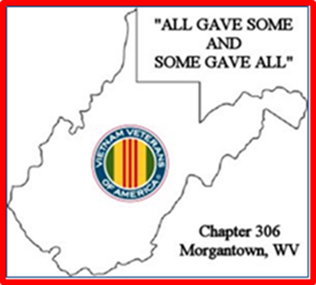

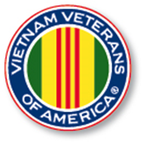

The Special Offer of $50.00 for LIFETIME MEMBERSHIP
continues for the
VVA Members.

The AVVA Membership is still
calculated by the person’s age.

The membership forms are available through our website:
www.VVA306.org

Please look for the LINKS tab to
VVA and AVVA.

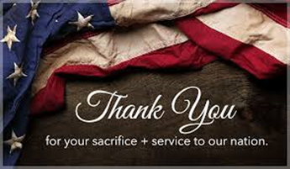

VVA Chapter 306
Monthly Social Brunch
2nd Monday EVERY Month
10:00 AM

Monday, February 14, 2022
CANCELLED

An email was sent from President Charles Harrington to cancel this meeting due to the continuing COVID-19 crisis and wanting to keep everyone healthy and safe.

Watch your email for upcoming information on the 2022 Election of Board Members. Please consider serving.

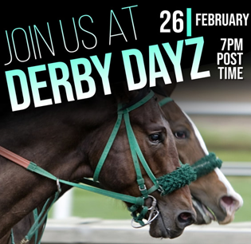

Saturday, February 26
Derby Days at the Elks Lodge

Over the years, we have had an agreement to man the ticket tables for the Derby. We need ten people to complete that task.
We need to be there at 6:45 PM.

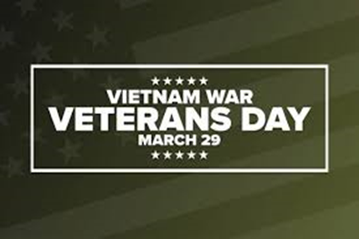

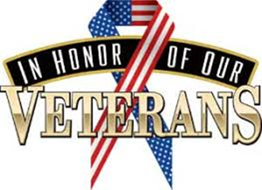

CHAPTER SOCIAL BRUNCH
2nd Monday EVERY Month

Monday, March 14, 2022
10:00 AM
We will fellowship and break bread at Denny’s on Hornbeck Road.
Our Nominations for Board of Directors will be held at this meeting. Please come with a desire to hold an office for the next two years.

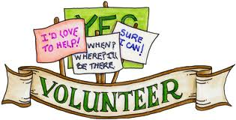

VVA Chapter 306
EVEN MONTH MEETING
Monday, April 11, 2022
at 7:00 PM Elks Lodge

This is the Election meeting.

Please come with a desire to hold an office for the next two years.

SPECIAL NOTE from APRIL 11th MEETING

Officer Nominations
None were received from the membership and none from the floor for new Officers.

Election
In lieu of not having a Board of Directors, all current Board Officers agree to serve another term.

Thank you all for
your dedication and service
to the Chapter!

The AVVA Members want to help the current VVA Board Members and Chapter as much as possible.
The AVVA Members want the Chapter to succeed.

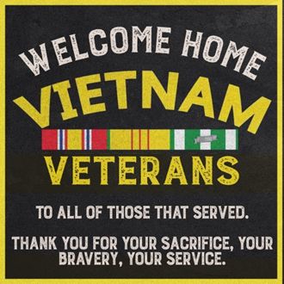

MEMBERSHIP NOTE:

IT WAS ALSO AGREED TO CHANGE OUR MEETING SCHEDULE. THIS WILL BE EFFECTIVE IMMEDIATELY AND REMAIN UNTIL SUCH TIME AS A CHANGE IS FURTHER NEEDED.

*** ODD Months ***
(Jan, Mar, May, Jul, Sep, Nov) We will meet as an Informal Social Brunch/Meeting setting on the SECOND MONDAY at 10:00 A.M. The meeting place may change but May’s Brunch will be at Denny’s on Hornbeck Road.

PLEASE MARK YOUR CALENDARS AND PLAN ON ATTENDING IF POSSIBLE. GREAT TIME TO ENJOY A MEAL AND SOCIAL TIME.

*** EVEN Months ***
(Feb, Apr, June, Aug, Oct, Dec) We will meet at the Elks Lodge in a formal setting on the SECOND MONDAY at 7:00 P.M. The time, etc. are subject to change.

THE FORMAL MEETINGS NEED MEMBERSHIP INVOLVEMENT.

CHAPTER SOCIAL BRUNCH
2nd Monday ODD Months

Monday, May 9, 2022
10:00 AM

The Chapter Social Brunch is held on the second Monday of ODD months at 10:00 a.m. The May social brunch will be held at Denny’s near Walmart on Hornbeck Road at 10:00 a.m. on Monday, May 9th.

Please watch your email for upcoming details on future breakfast meetings during the ODD months (Jan, Mar, May, Jul, Sep, Nov)!

Don’t forget to join us for Formal Meetings at the Elks Lodge during the EVEN months (Feb, Apr, June, Aug, Oct, Dec)! We look forward to seeing you very soon!

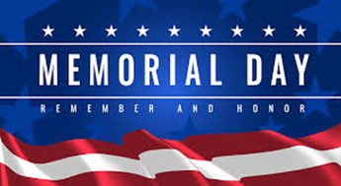

MEMORIAL DAY PARADE
Grafton, WV
Monday, May 30, 2022

VVA Chapter 306 voted to participate in the Grafton Parade. We are in Division One.

Report on the Parade:

- No one was available to pull the trailer in the parade.

- Members elected not to participate.

- Someone did show up and was the only one present for the parade.

- The parade was also delayed for a period of time due to a bomb threat.

BE SAFE OUT THERE!

REMEMBER FOREVER MEMORIAL DAY

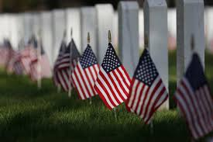

VVA Chapter 306
EVEN MONTHLY MEETING
Monday, June 13, 2022
at 7:00 PM, Elks Lodge

JUNE IS AN EVEN MONTH!
Our next meeting will be the second Monday, 13 June 2022, at 7:00 p.m., at the Elks Lodge.

All members are welcome.
Your ideas and input are welcome. THE MEMBERS ARE THE CHAPTER.

We will be discussing a picnic in lieu of our August Meeting. We are open for ideas.

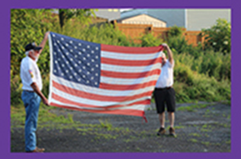

FLAG DAY CEREMONY
and FLAG BURNING
Tuesday, June 14, 2022
at 6:00 PM, Elks Lodge

The Elks will do their presentation inside at 6:00 PM, then we will have dinner and then we will move outside for the flag burning ceremony. Several Scouts are supposed to be in attendance. Anyone with flags, please bring them.
REMEMBER TO INVITE FAMILY AND FRIENDS, ESPECIALLY YOUNGER PEOPLE TO LEARN ABOUT THE HISTORY OF THIS COUNTRY’S FLAG HISTORY.

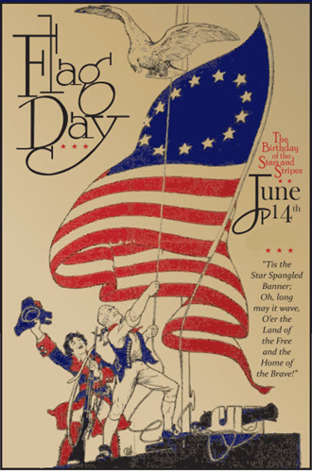

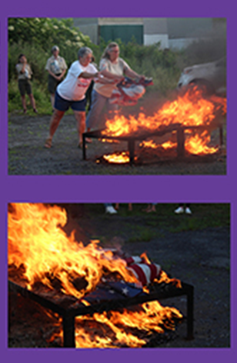

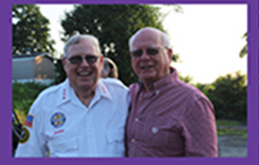

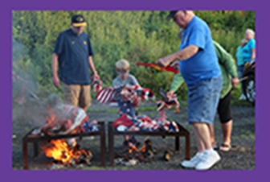

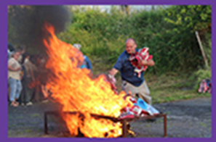

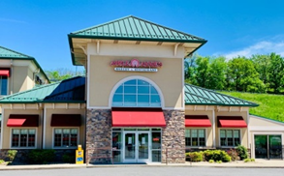

CHAPTER SOCIAL BRUNCH
2nd Monday ODD Month

Monday, July 11, 2022
10:00 a.m.
Our Social Brunch will be held at APPLE ANNIES in MORGANTOWN, 10:00 AM on the 11th of July.

Doug will need a headcount on who will be attending NLT Thursday, 7th of July.
PLEASE CONTACT BY EMAIL IF YOU PLAN ON ATTENDING.

VVA Chapter 306
PICNIC
Monday, August 8, 2022
at 6:00 PM

The Chapter will host a FAMILY PICNIC on the 8th of August in lieu of a formal meeting at the Elks Lodge.

The PICNIC will be held at the home of T.J. Burch on Kelly Road. If you need directions, please ask one of the Board Members.

The PICNIC will start at 6:00 p.m. The Chapter will buy the meat and drinks. Members are asked to bring a pass-around dish.

Please RSVP on attending to Doug Geary by email no later than July 31 with a headcount.

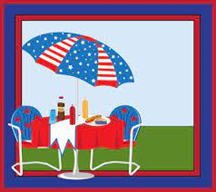

BLACK BEARS
MILITARY APPRECIATION
BASEBALL GAME
AUGUST 27th
6:00 PM

The Chapter has voted to attend a local Black Bears Baseball game. We will attend the game on August 27th. This date is MILITARY APPRECIATION
at the game.

THE CHAPTER WILL PURCHASE TICKETS FOR THOSE THAT RSVP NO LATER THAN AUGUST 15th
TO DOUG GEARY IF YOU PLAN ON ATTENDING,

YOU NEED TO MEET AT THE BLACK BEARS MAIN ENTRANCE GATE
NO LATER THAN 6:00 PM.

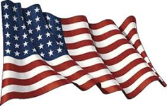

The members of the VVA and the AVVA of Chapter 306 extend our deepest sympathy to
the STRANG Family
in the loss of their loved one,

EARL B. STRANG, Jr.

Earl was one of the
Charter Members involved with getting the VVA #306 started.
Earl served on the Board,
and was a Life Member of
VVA Chapter 306.

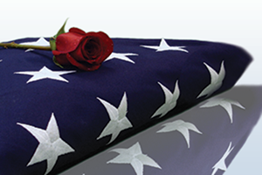

The members of the VVA and the AVVA of Chapter 306 extend our deepest sympathy to
the ROY Family
in the loss of their loved one,

ROGER D. “SARGE” ROY

Roger served with the US Army in Vietnam, earning three Purple Hearts and a Bronze Star.

The members of the VVA and the AVVA of Chapter 306 extend our deepest sympathy to
the BURCH Family
in the loss of their loved one,

GARY WILLIAM BURCH

Gary was a Life Member of
VVA Chapter 306.
Gary served on the Board as President for several years, and other Officer positions as well.

The members of the VVA and the AVVA of Chapter 306 extend our deepest sympathy to
the WILLIAMS Family
in the loss of their loved one,

HERSHEL “WOODY” WILLIAMS

Chief Warrant Officer 4
1st Battalion, 21st Marine Regiment, 3rd Marine Division

The last living Medal of Honor recipient from World War II.

A Friend to all Gold Star Families, Veterans and Active Duty Military Personnel.

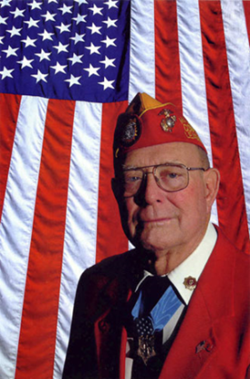

A Few Words from
Chapter 306 Leadership

We hope all are well, staying healthy and finding a way to stay active during the continuing Covid-19 issue.

Please keep in touch by email or phone.

Remember to watch your email for important Chapter 306 information and for upcoming events mentioned in this newsletter.

Please take care of yourself, stay healthy and well.

Please pray for Members on the Sick Call List. Keep the spouses in prayer as we all know they could use some prayers.

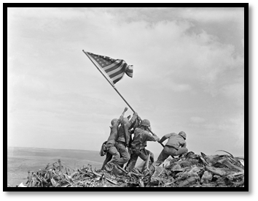

Respectfully Submitted by
VVA Chapter 306
Morgantown, WV

PRESIDENT
Charlie Harrington
VICE PRESIDENT
Robert Jamie Welch
SECRETARY
Doug Geary
TREASURER
Don Davis
ACTIVITIES & MEDIA REPORTER
Janet. L. Finerfrock

