9/20/2017 Joseph, Mary, and the Male Child

The Hebrew Day of Trumpets

We're currently (September 20, 2017) awaiting the Hebrew Day of Trumpets (Yom Kippur) on September 21 that will arrive at sunset in Israel tonight according to the Jewish Hillel calendar.

Those who keep the ancient Hebrew Karaite method of actually observing the New Moon by at least two witnesses in Israel will probably observe September 22 as the Day of Trumpets and the beginning of the 7th Hebrew month.

The Sign of the Birth of the Man Child on September 23, 2017

On September 23 there appears a sign in the heavens which many people believe to be the sign of the Woman travailing in birth mentioned in Revelation chapter 12. The Woman is giving birth to a man child (male child) who will rule all nations with a rod of iron.

We know that about 2021 years ago, around 4 or 3 BC, a man child who will rule all nations was born to Joseph and Mary in Bethlehem.

The Timely Culmination of Jose, Maria, and the Manchild

Atlantic Ocean hurricanes are named by the World Meteorlogical Organization. There are 6 lists of hurricane names, so the same names repeat every 7th year unless a name is retired from the list or the rules are changed for some reason.

Below is the Hurricane name list for 2017:

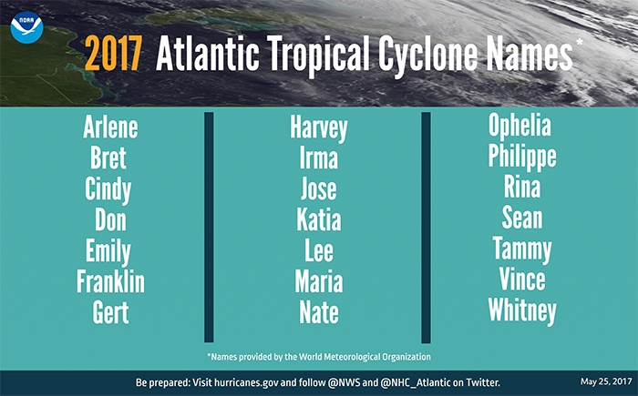
Image courtesy NOAA

The Veiled Signs from Our Creator

It is significant that the naming of hurricanes this year includes Jose and Maria.

Jose is the Spanish name equivalent of the English name Joseph.

Maria is the Spanish name equivalent of the English name Mary.

A reference to the biblical characters Joseph and Mary, the earthly parents of our Messiah, was present in the Atlantic ocean just several days prior to the sign in the heavens of the woman clothed with the sun travailing in birth of the man child on 9/23/2017.

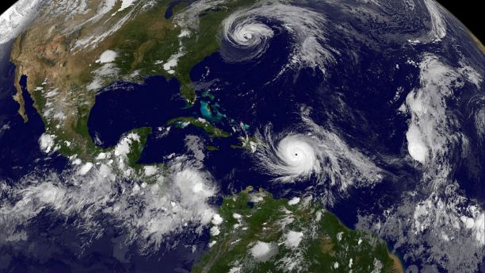
Image courtesy NOAA GOES East Satellite

In the image above from 9/19/2017 hurricane Jose appears as the cloud spiral near New York City and hurricane Maria appears north of South America.

Many were watching for the appearance of a Man Child event on or after September 23.

Our Creator Elohim has arranged the weather patterns of the earth and the naming lists of the hurricanes to coincide and accompany His sign to us of the Man Child in the heavens on September 23, 2017.

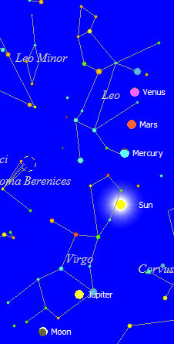

Above: A graphic showing the sign in the heavens on September 23, 2017, of the woman clothed with the sun travailing in birth mentioned in Revelation chapter 12. This arrangement of heavenly bodies was ordained to appear in the heavens by our Creator YaHuWaH Elohim when the heavens and earth were created.

The sign of the woman travailing in birth in the heavens will appear on September 23, 2017, as hurricanes Jose and Maria (Joseph and Mary) are ordained by our Creator to bear witness to us on earth of the Man Child's birth.

Note that few people (Anna and Simeon) were allowed to recognize the Man Child for who He was. His recognition by Anna and Simeon came 40 days after His birth when He was taken to the Temple for dedication.

What are the Odds?

What are the odds that the names Jose and Maria from the hurricanes list, which would appear once every 7th year, would accompany the sign of the woman travailing in birth in the heavens? There are 126 names on the 6 lists, 21 names on each list.

And what are the odds that both hurricanes would appear at the particular time to accompany the sign of the Woman clothed with the Sun in the heavens on 9/23/2017?

These complementary signs on earth and in heaven assure us who believe and trust in Him that everything is precisely under the control of our heavenly Father, YaHuWaH Elohim.

Prepare with Repentance

We all have free will. Each of us can freely choose our eternal destiny. Now is the time to turn to YaHuWaH Elohim in prayer and repentance.

