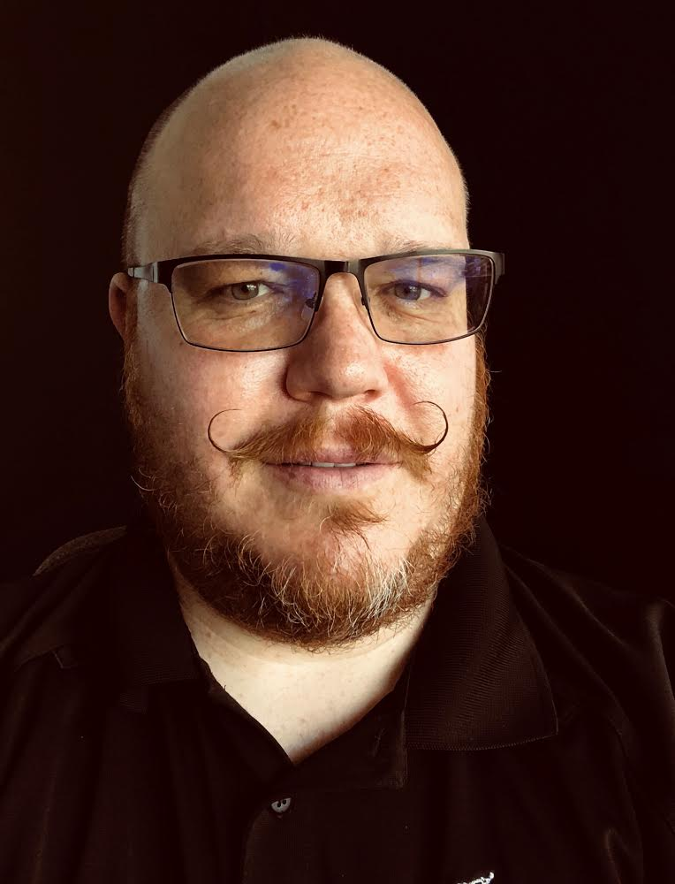
Jason Cole
Jason is a Technical Sales Specialist for Foster + Freeman.
Jason began his Law Enforcement career as a police officer for the Sandy City (Utah) Police Department. Later he was reassigned to the Investigations Division as the detective over juvenile crime and domestic violence crime. He also began receiving training in crime scene investigation and began to process major crime scenes for the department.
In 2001 Jason left the Sandy City Police Department and began working as a Forensic Investigator for the West Valley City (Utah) Police Department. In 2007 he was promoted to be the Forensic Director of the West Valley City Police Department Forensic Services Unit.
In 2010 Jason left the West Valley City Police Department and accepted a position as a Latent Print Examiner with the Henderson (Nevada) Police Department.
Jason served on the Board of Directors for the Utah Division of the IAI for over 10 years, including serving as President. He was awarded the Utah Division of IAI Outstanding Achievement Award in 2005. Jason has served on the Board of Directors for the Nevada State Division of the IAI since 2010, including 6 years as President. Jason works part-time as a Latent Print Examiner for the Loudoun County Sheriff’s Office. Jason serves on the Board of Directors for the International Association for Identification. Jason is a member of DMORT region IX.

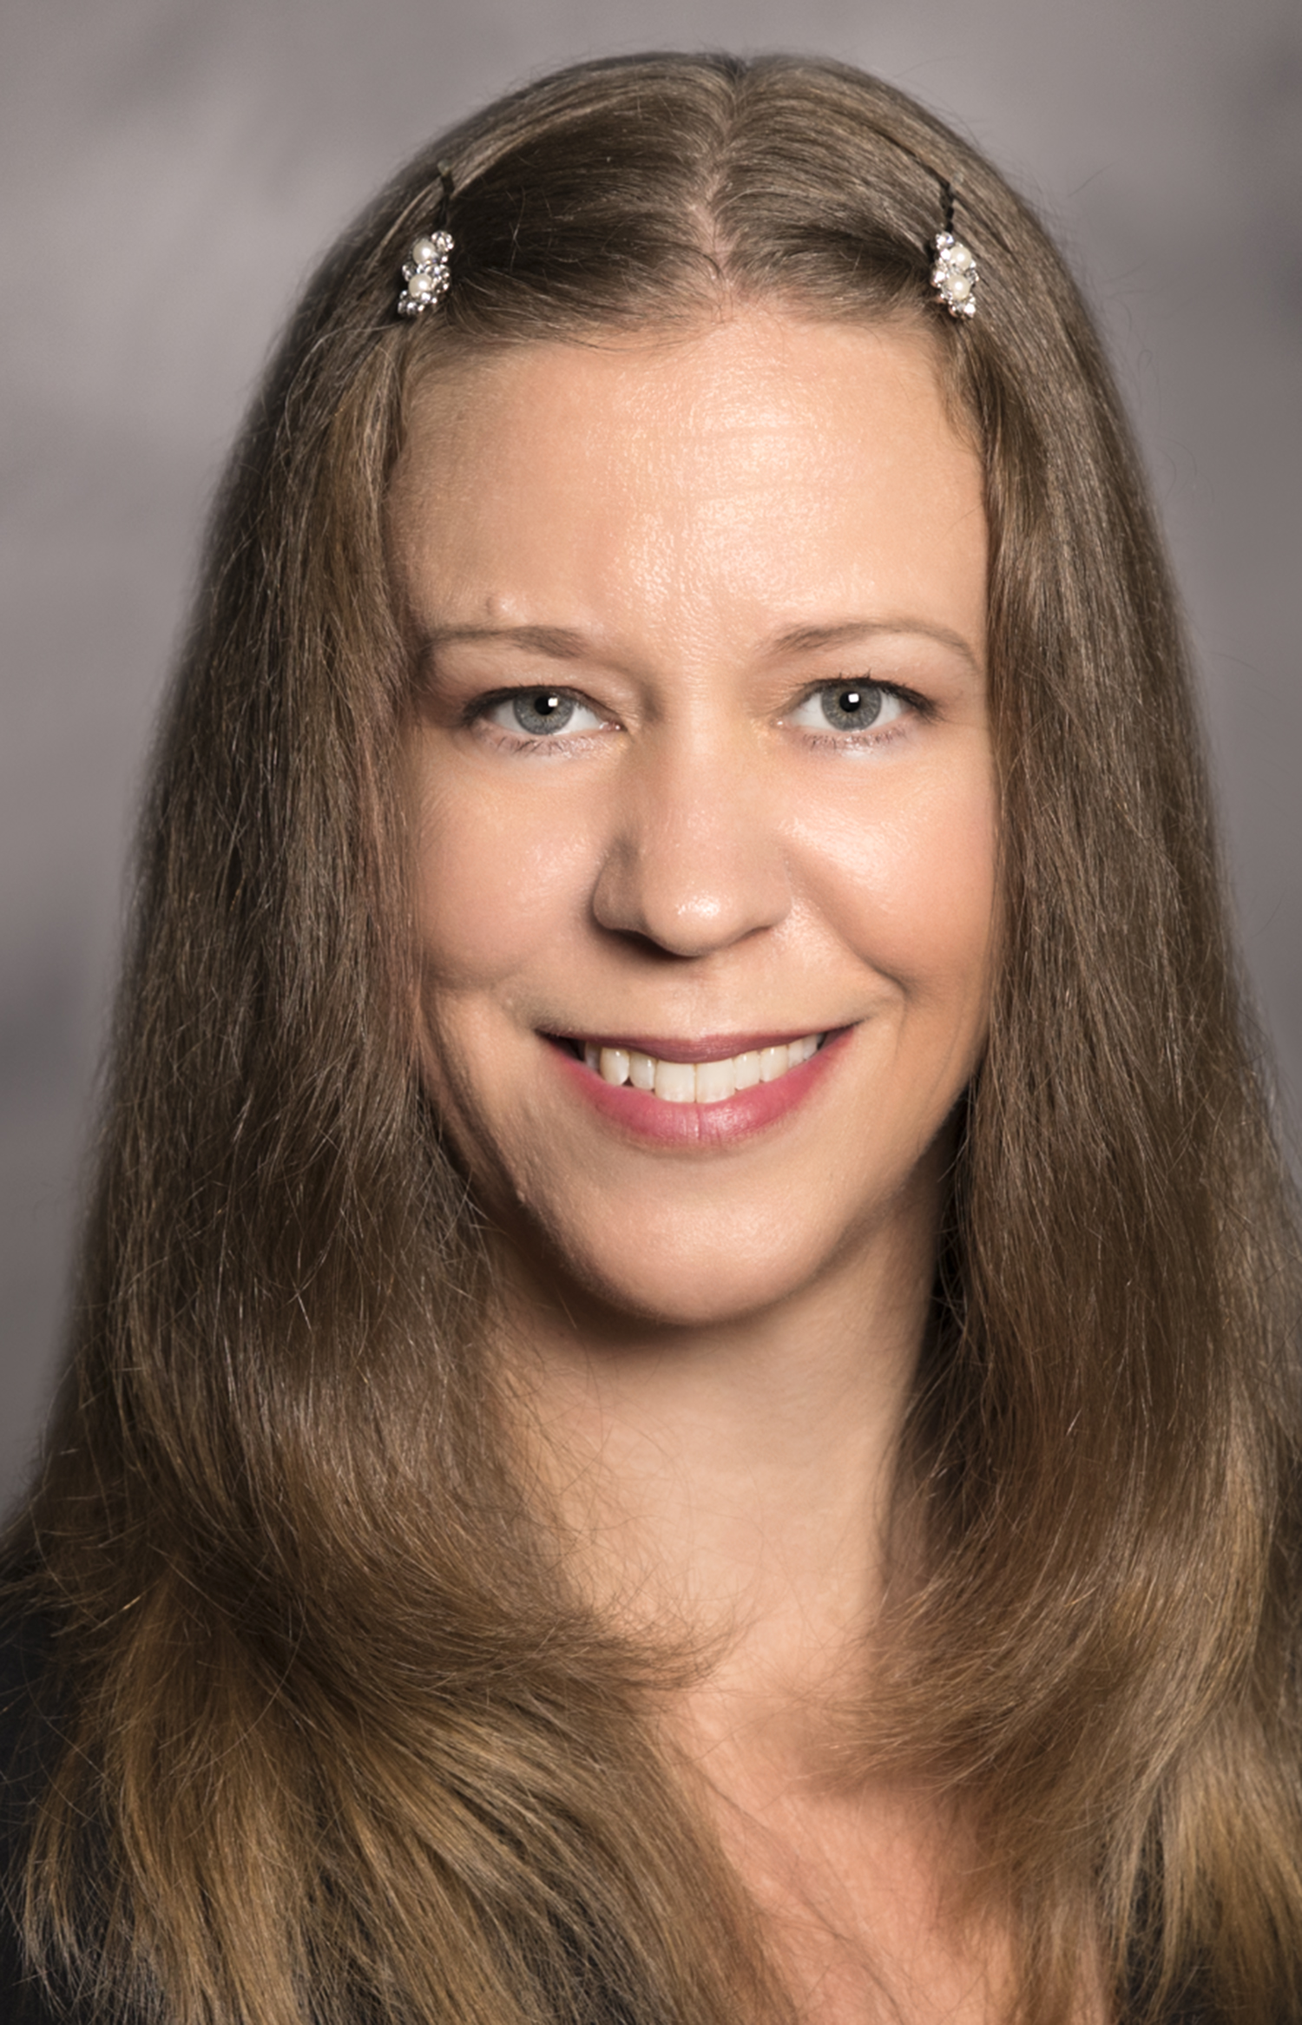
Heidi Eldridge
Heidi Eldridge has been a latent print examiner for over 12 years. Heidi is a CLPE and Board of Directors member with the IAI, sits on the JFI Editorial Board, and was a member of SWGFAST until its dissolution. She is now a member of the Friction Ridge Subcommittee of the OSAC and Vice-Chair of the Academy Standards Board friction ridge consensus body. Heidi has been teaching latent print testimony for more than 7 years and is a PhD candidate in Forensic Science at the University of Lausanne. After 11 years as a practitioner, she is now a Research Forensic Scientist with RTI International.

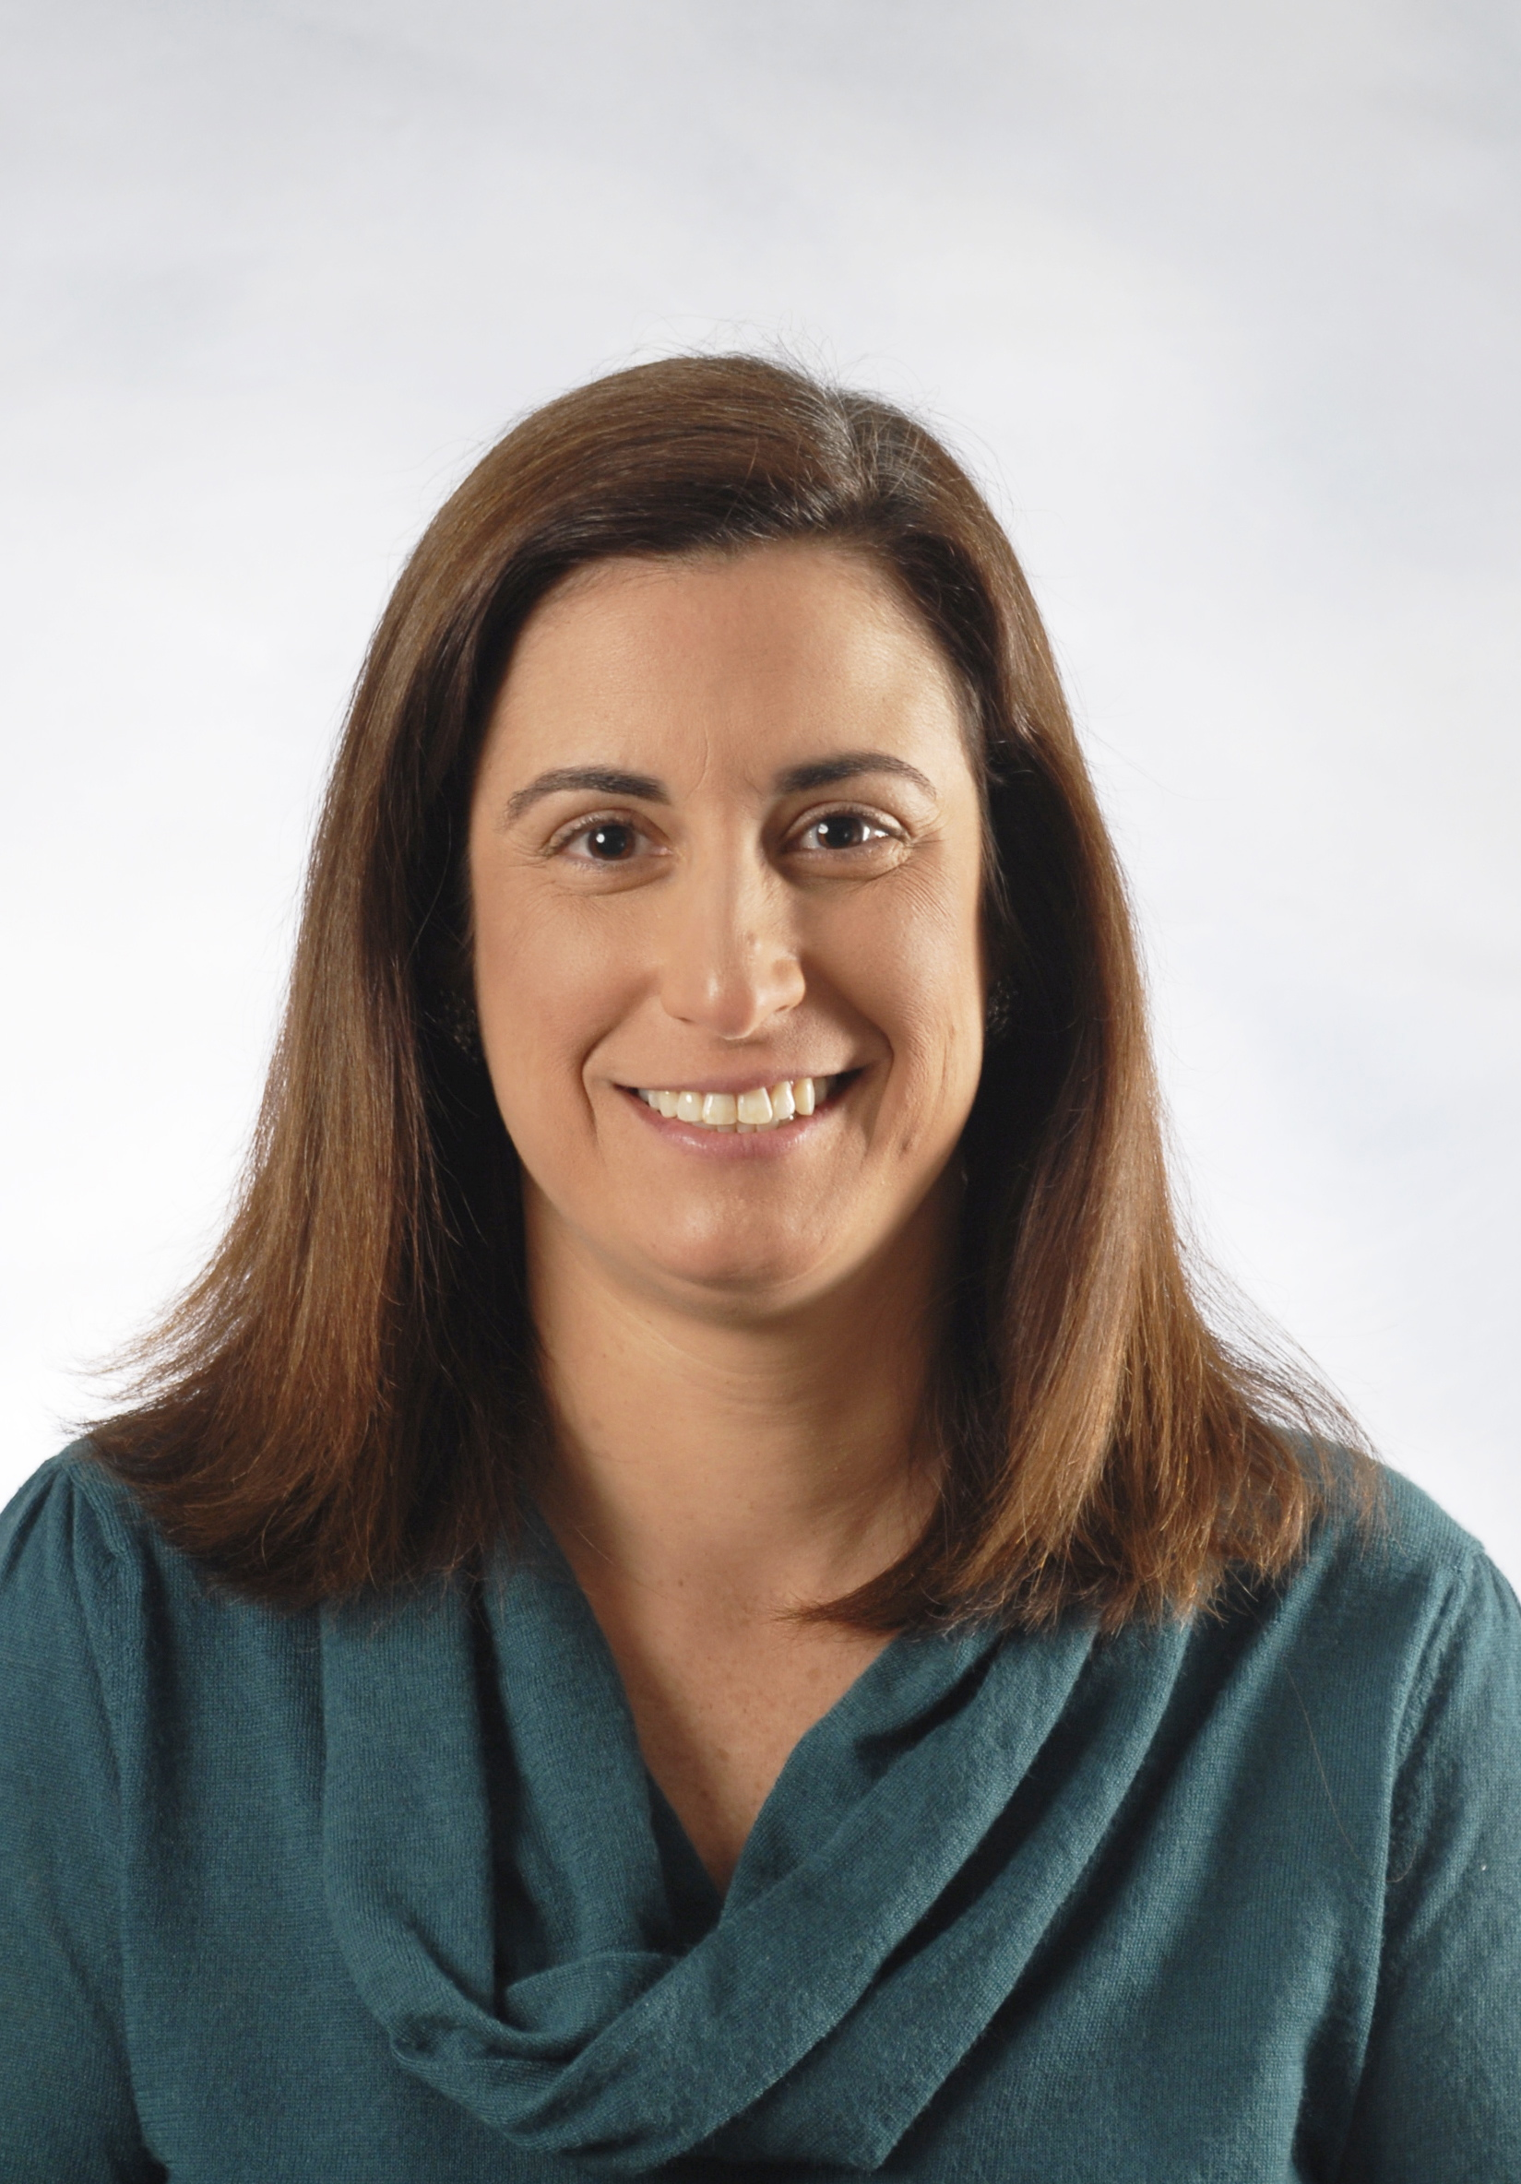
Melissa R. Gische
Melissa is the Physical Scientist (Technical Leader) for the Latent Print Units at the Federal Bureau of Investigation Laboratory in Quantico, VA. She has been with the FBI since 2000 and has testified as an expert witness in federal and state court. Melissa is a certified latent print examiner through the International Association for Identification. Melissa served as chair of the Scientific Working Group on Friction Ridge Analysis, Study and Technology from 2012 to 2014 and as chair of the Organization of Scientific Area Committees (OSAC) Friction Ridge Subcommittee from 2014 to 2017 before being appointed to her current position as chair of the OSAC Physics/Pattern SAC. Melissa received a Bachelor of Science degree in Psychobiology from the University of California, Los Angeles and a Master of Forensic Sciences degree in Forensic Science from The George Washington University.

Danielle Gruttadaurio
Danielle Gruttadaurio is a full-time Forensic Artist / Graphic Technician with the Suffolk County, New York, Police Department. Before joining the Suffolk County Police Department, in 2009, she was a full-time K-12 New York State certified art teacher for five years. Danielle earned a Masters Degree in Art Education from the University of Stony Brook in 2008 and also studied at Southampton University and the Fashion Institute of Technology. She is an active member of the International Association of Identification and has continued her education with highly specialized Forensic Art training in Composite Imaging, 2D & 3D Postmortem Reconstruction/Approximation and Age Progression as well as with advanced level black and white and color photography and Photoshop training.

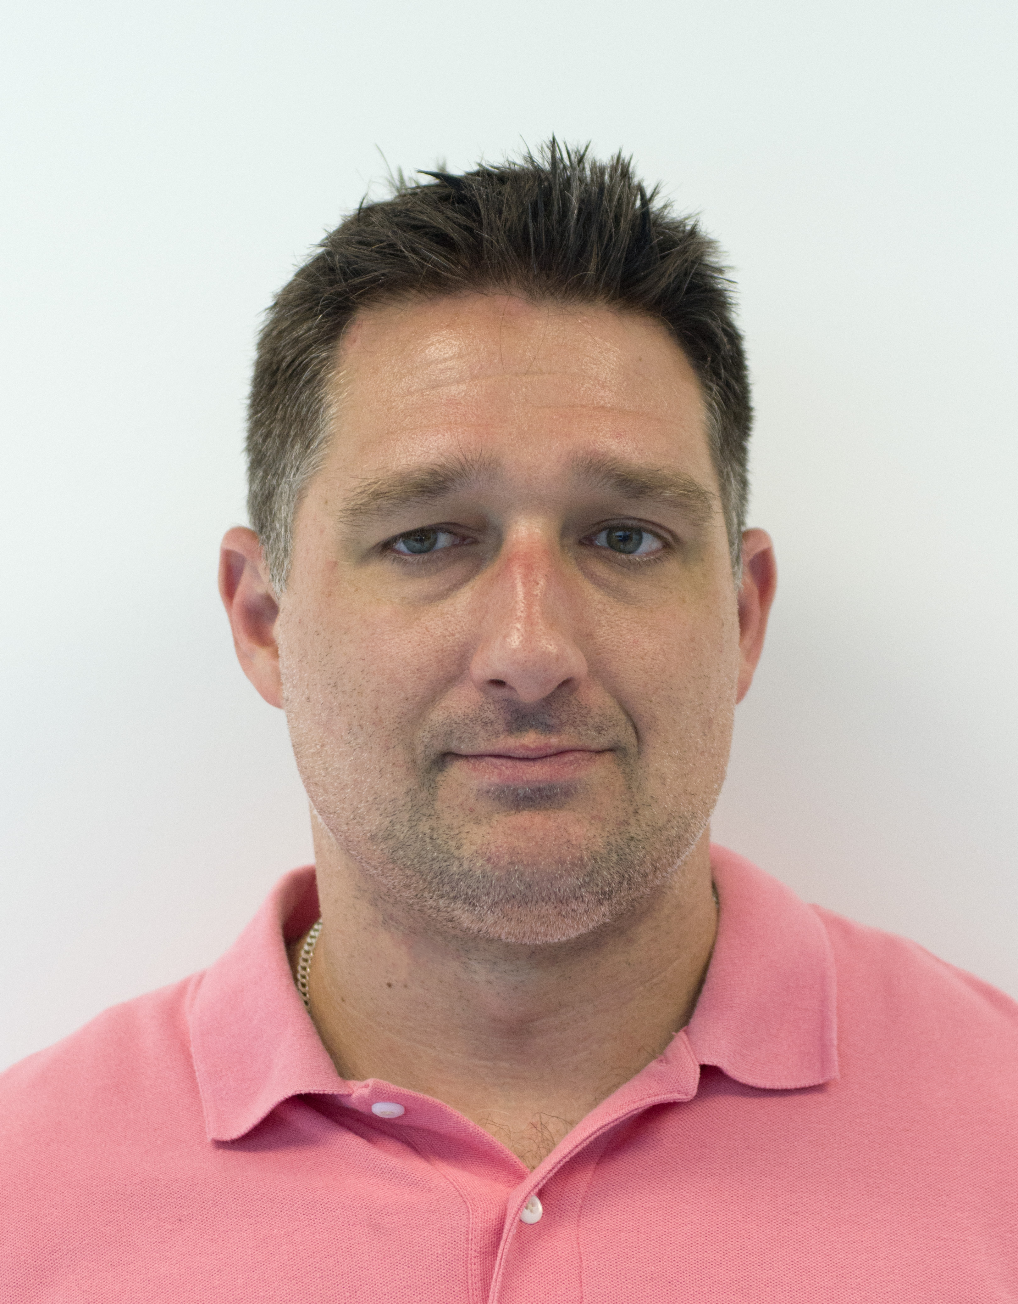
Walter Hiller
Walter Hiller- is an employee of the SPEX Forensics Division of Horiba Instruments Inc. of Edison, New Jersey. Walter has worked with law enforcement agencies since 2006 and has trained many departments, at all levels of government, in the use of Forensic Light Sources, RUVIS and basic photography. Walter has held numerous lectures and workshops on the subjects of Forensic Light Sources and RUVIS at regional IAI meetings and International conferences. Walter has acquired an extensive sales and public speaking background throughout his career and is a graduate from Montclair State University.
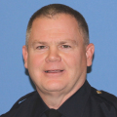
Tim Kelly
Police Experience: 1991-Present
- Police Officer : Patrol (1992-1995)
- Police Officer : DARE Instructor (1996-2002)
- Police Officer : Crime Scene Investigator (2002-2008)
- Detective : General Services (02/2008 – 09/2008)
- Detective : Identification Section (09/2008 – Present)
_________________________________________________________________________________
Education:
- Suffolk County Police Academy : 1991
- Suffolk County Community College : A.A.S. Criminal Justice : 1997
_________________________________________________________________________________________________________

Training:
- NY DCJS Motor Vehicle Investigation : 2002
- Nikon Photography : 2004
- Weapons of Mass Destruction Operations for Investigators : 2004
- DEA Hidden Compartments ; 2005
- Prevention and Response to Suicide Bombing Incidents : 2005
- FBI Law Enforcement Officers Training School : Basic Crime Scene Investigators Course : 2005
- The Reid Technique of Interviewing and Interrogation : 2006
- Henry C. Lee Institute of Forensic Science : Evidence Recognition, Documentation & Collection : 2006
- NY DCJS Instructor Development : 2006
- Courtroom Testimony / Counter-Drug : 2007
- NY Train the Trainer DNA Evidence Identification, Collection & Preservation for Law Enforcement : 2007
- FBI Digital Photography for Crime Scene : 2007
- ACI Courtroom Testimony : 2008
- NY DCJS DNA Evidence Recognition Collection & Preservation : 2009
- Advanced Palm Print Comparison Techniques : 2009
- NY DCJS Latent Print Processing Course – Level II : 2009
- Introduction to Forensic Digital Image Processing : 2010
- NY DCJS Certified SAFIS Latent Print Examiner Course – Level III : 2010
- Analysis of Distortion in Latent Prints : 2011
- NY DCJS Homicide and Non-Fatal Shootings : 2011
- NY DCJS Aquatic Death / Homicide Drowning Investigation : 2012
- NYC OCME Medicolegal Investigation of Death : 2013
- NYC OCME Blood Stain Pattern Analysis : 2014
- IAI Complex Latent Prints : 2015
- IAI Florida Conference : 2017
- IAI Western States Joint Conference : 2018
Andrew McNeill
Andrew McNeill is the Director of Forensic Education for L-Tron Corporation in Victor, NY. He recently retired from the Monroe County Sheriff’s Office after a 20-year career, during which he spent 18 years as a crime scene investigator. His responsibilities included crime scene investigation, collision reconstruction, latent fingerprint examination, forensic video analysis, and training. He has testified as an expert witness at the local, county, and state court levels and has provided technical and consulting assistance to other law enforcement agencies on a variety of cases.
Andy assisted the NYS Division of Criminal Justice Services with developing its Basic Investigative Photography and Police Crime Scene and Evidence Specialist courses. He maintains certification as a General Topics police instructor and still teaches at Monroe Community College’s Public Safety Training Facility. He is also an Academy/Regional State Fire Instructor who teaches Fire Investigative Photography.
Andy has presented various topics related to crime scene investigation and forensic photography at recent NYSTARS and STEPEMS educational seminars, as well as at several Rochester-area colleges and the George Eastman Museum. He holds a Master of Forensic Sciences degree from The George Washington University and a Bachelor of Arts degree from the University at Buffalo. He is an ACTAR-accredited collision reconstructionist and is certified as a Senior Crime Scene Analyst by the International Association for Identification.
Andy joined the L-Tron team informally in 2017 as a beta tester for the OSCR360 spherical photography solution. After seeing the success of OSCR in forensic casework, he accepted a position with the company upon retirement in May 2018. He now concentrates on developing and delivering a variety of forensic training courses, as well as serving as a liaison and resource for law enforcement OSCR users.

Lisa Ragaza
Lisa Ragaza has a bachelor’s degree in Archaeology and Geological Sciences from Tufts University and a master’s degree in Forensic Science from the University of New Haven. From April 2006 until May, 2008 she worked as a Crime Scene Technician for the Waterbury Police Department. During those two years she processed hundreds of crime scenes including burglaries, robberies, stabbings, shootings, assaults, motor vehicle accidents, suicides, and homicides. From May, 2008 to March, 2010 she worked at the State of Connecticut Toxicology and Controlled Substances Laboratory in Hartford as an Evidence Control Officer. In March, 2010 she was promoted to Forensic Science Examiner 1 and currently works at the State of Connecticut Division of Scientific Services as a footwear and tire track examiner and a questioned document examiner. Lisa Ragaza is also an Associate Professor at Post University and teaches Introduction to Forensic Science both on campus and online. She is the current President of the Connecticut Chapter of the International Association for Identification, and is a member of the International Association for Identification, the American Academy of Forensic Sciences, and the Northeastern Association of Forensic Scientists. She is also a certified footwear examiner through the International Association for Identification

Michelle Reznicek
Michelle Reznicek is a Supervisory Physical Scientist/Forensic Examiner with the Latent Print Unit of the Federal Bureau of Investigation Laboratory in Quantico, VA. Michelle received her Bachelor of Science degree in Ecology from the University of Illinois Urbana/Champaign and her Masters of Science degree in Environmental Science from the Florida Institute of Technology. In addition to her supervisory duties, Michelle reviews cases and assist with training. She is a member of her agency’s Hazardous Evidence Analysis Team and the Fingerprint Legal Advisory Group. She assisted in the development of the ACE module for the FBIOs Latent Print Unit Training Program and currently teaches the Uniqueness and Persistency lectures.

Eric Ray
Ray Forensics
Eric Ray has been employed as a Forensic Scientist since 2017 and is a Certified Latent Print Examiner. He earned a BS in Biochemistry and Molecular & Cellular Biology from the University of Arizona in 2000. As a member of the IAI, Eric is on the Editorial Board of the JFI. As the President of Ray Forensics, Eric has published and presented extensively on the exclusion decision in latent fingerprint comparisons and is developing new extensions to customize Photoshop for latent print examiner use. In his spare time he also co-host the Double Loop Podcast, a weekly show on fingerprint topics.

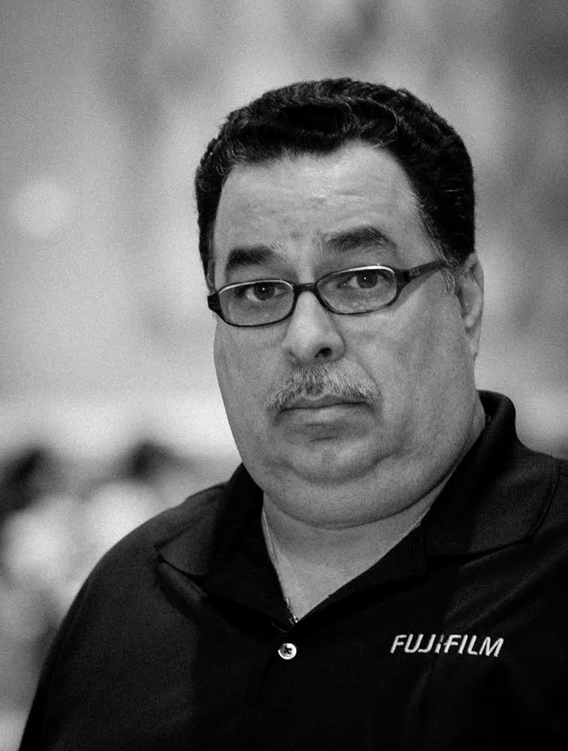
Julio Sosa
Julio Sosa is a professional photographer & forensic consultant for Fujifilm, with over 25 years of Commercial and 15 years of Digital Forensic Photography. Julio has extensive experience in Ultraviolet and Infrared Photography. Past Beta Tester for Adobe. Julio has worked with agencies that includes the U.S. Secret Service, NASA, U.S. Navy and the U.S. Army and has been called as an expert witness. Currently Julio travels for Fujifilm giving seminars and demonstrating the advantages of UV/IR Photography.

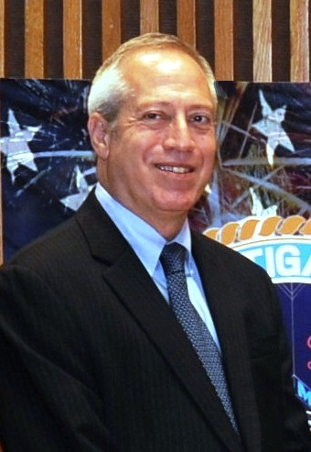
Eliot Springer
Eliot Springer is presently the Deputy Director of the NYPD Police Laboratory, one of the largest and busiest forensic laboratories in the US. Before that, he served for thirty years in the Israel National Police, Division of Identification and Forensic Science, where he retired as a Lt. Colonel. During that time, he dealt with many areas of forensic science, in the fight against crime and terror. Throughout his career, he has also been actively engaged in research and development. He has been serving as an IAI Board of Directors member and has been on various committees for the last few years.

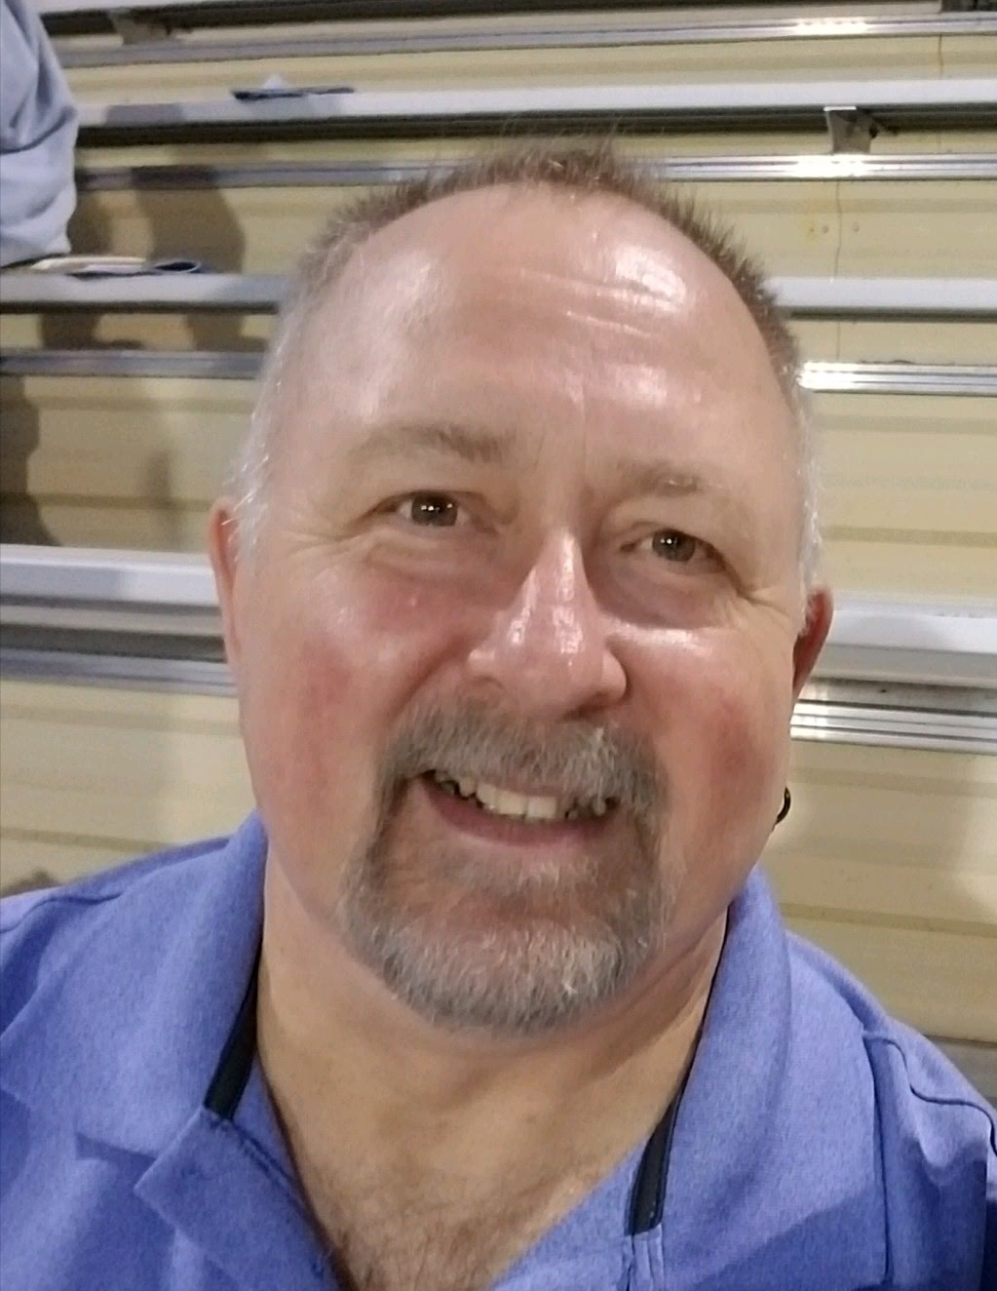
David Witzke
Vice President, Program Management, Foray Technologies
With more than 25 years of AFIS and forensic digital imaging experience, David Witzke (better known as Ski), is considered to be one of the foremost experts in forensic digital imaging technologies. Ski is an associate member of the International Association for Identification (IAI) as well as the European and regional divisions of the IAI, is a member of the Canadian Identification Society (CIS), and is an Associate Member of the European Network of Forensic Science Institutes Fingerprint Working Group (ENFSI FWG). In addition, Ski was elected to the ENFSI FWG Steering Committee at the organization’s 2017 annual meeting in Cergy, France. And, Ski recently was named as the chairperson for the Digital Evidence Subcommittee for the IAI.

Ski has been invited to speak at hundreds of regional, national and international IAI conferences; AFIS user group meetings; and the ENFSI FWG meetings in Split, Croatia; Taormina, Italy; and Barcelona, Spain. Ski was also the guest instructor of the Digital Imaging of Evidentiary Photography training program at the FBI Academy in Quantico, Virginia for more than seven years, and was the instructor for the Forensic Digital Image Processing program at the British Columbia Institute of Technology (BCIT) in Vancouver, BC for more than six years. He also provided digital imaging training for the Automatic Fingerprint Recognition systems (AFR) Consortium at police agencies throughout the United Kingdom, and for the Federal Department of Justice and Police AFIS/DNA Services in Berne, Switzerland.

Ski is a contributing writer for three well-known forensic books: Crime Scene Photography (Third Edition, Published 2016 by Academic Press), Introduction to Crime Scene Photography (Published 2012 by Academic Press) and Footwear, The Missed Evidence (Third Edition, Published 2013 by Staggs Publishing). (Crime Scene Photography has been chosen by the IAI certification committees for the Certified Crime Scene Investigator (CCSI) Certification Test, the Certified Crime Scene Analyst (CCSA) Certification Test, the Certified Senior Crime Scene Analyst (CSCSA) Certification Test, and the Forensic Photography Certification Test.) Ski is also working on a fourth book on forensic digital imaging; the book is currently scheduled to be published in the second half of 2019.

