**Mt. Zion Methodist Church of Laurel Grove**

**Second Annual Car Show**

**27108 Mt. Zion Church Rd., Mechanicsville MD 20659**

**(just passed Apple Basket on Route 235 - North Bound Lane)**

**SHOW DATE: SEPTEMBER 6, 2014**

**RAIN DATE: SEPTEMBER 13, 2014**

**SHOW HOURS: 2:00 PM – 7:00 PM ADULT Spectator Fee: $3.00 Donation Children 12 and under FREE**

**(Proceeds benefit United Methodist Men’s** Group **Charity Donations)**

**TROPHIES FOR THE TOP 30 AND 5 SPECIALTY AWARDS**

**(Vehicle must be registered by 4:00pm to be judged)**

**AWARDS WILL BE PRESENTED AT 6PM)**

**T-SHIRTS TO THE FIRST 20 CARS, TRUCKS, OR MOTORCYCLES THRU THE GATE, AND DASH PLAQUES TO ALL, DOOR PRIZES, DJ, MUSIC, BLESSING OF THE CARS, VENDORS, FOOD AND MORE….**

**REGISTRATION FEE IS $20.00 AT THE GATE AND PRE-REGISTATION IS $15.00**

**Pre-registration form must be postmarked by August 23, 2014.**

**For further information contact: TOM KELLER AT 301-481-6388, OR JIMMY HERRIMAN AT 301-481-0360**

**For vendor information contact: TOM KELLER AT 301-481-6388**

**VENDORS MUST BE PRE-REGISTERED/APPROVED**

**VISIT US AT:** [**www.mtzionmech.org**](http://www.mtzionmech.org) **for forms and rain information**

**---------------------------------------------------------------------------------------------------------------------------------------------- Please Print:**

**Name: Address:**

**City/State/Zip: E-mail Address:**

**Club Affiliation: Vehicle Make:**

**Model: Year:**

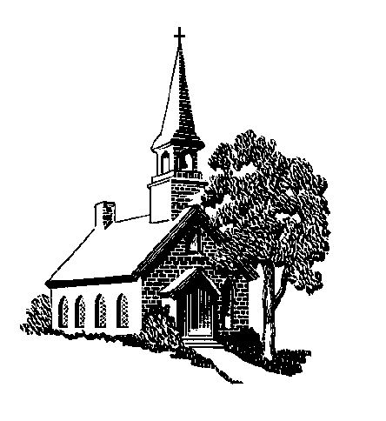In consideration of the acceptance of the right to participate, entrants and participants, by execution of this entry form hereby release and discharge any cause of action against the Mt. Zion United Methodist Church of Laurel Grove and its employees, members, clubs, and any other entity connected with the management and/or presentation of this car show for any and all known or unknown damages, injuries, losses, and/or claims whatsoever, that may be suffered by an entrant and/or participant or his/her property with respect to participation in this show. I further ensure that my party will observe and obey all safety and traffic regulations, fire ordinances, and will maintain conduct befitting a representative of the Street Roding Sport.

**Make Checks Payable to: Mt. Zion United Methodist Men Signature:** __________________________________________

C:\Users\Admin\AppData\Local\Microsoft\Windows\Temporary Internet Files\Content.IE5\ANFW7XRO\MC900188297[1].wmf**And mail all pre-registration forms and payments to:**

**Mt. Zion United Methodist Men (Car Show)**

**27108 Mt. Zion Church Road Mechanicsville, MD 20659**