GENEFORCE EMERGENCY POWER SYSTEM | 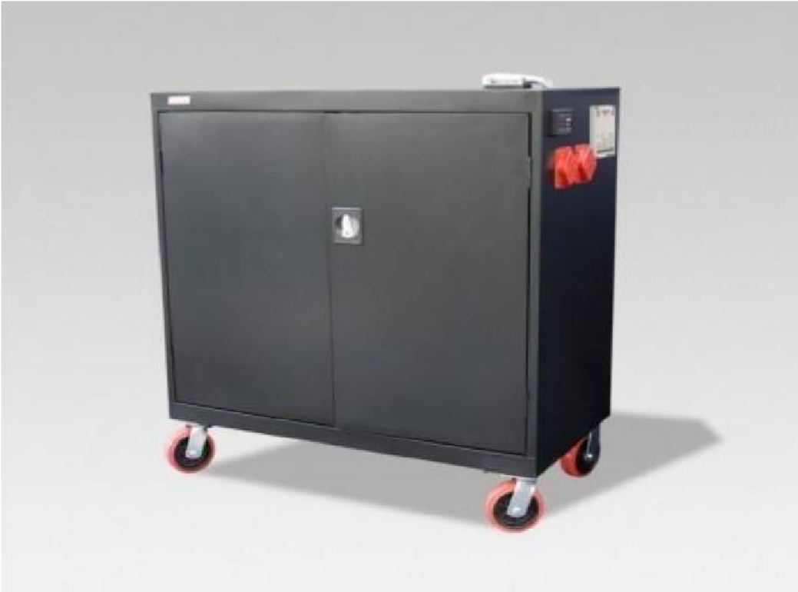
GEN-840H 4000 W – (120V/240V) - 10 kW – 16 Yr.
Product Features
Silent operation; Safe for indoors; No gas or emissions; No Maintenance or permits required; Automatic & one-touch start; Remote monitoring & configuration.
Advanced System Control Panel with Graphical 128 x 64-pixel, backlit LCD display that allows for setup and monitor of entire system including multiple solar charge controllers and auxiliary battery banks. Panel displays power reserves, amp hours consumed, fault conditions, solar panel output, charging, power consumption.
Dual AC inputs with capability to work with two-wire and three-wire generator starting systems
May be used with a solar panel array to recharge 12V DC
True sine wave and Built-in voltage regulation system provides clean output for sensitive electronics.
Electrical Specifications | (GEN-840H) 120V/240V
Output power (continuous) at 25°C | 3800 W
Output power (30 min) at 25°C | 4400 W
Output power (5 sec) at 25°C | 7000 W
Peak current | 41 A
Output frequency | 50 / 60 Hz selectable
Output voltage | 120 / 240 Vac
Output wave form | True sine wave
Optimal efficiency | 94%
Idle consumption search mode | <11 W
Input DC voltage range | 40 - 68 Vdc
AC connections | Single / Split phase
Charger
Output current | 45 A
Nominal output voltage | 48 Vdc
Output voltage range | 24 - 64 Vdc
Charge control | 2 or 3 stage
Charge temperature compensation | Battery temperature sensor included
Optimal efficiency | 92%
AC input power factor | > 0.98
Input current | 12 A
Input AC voltage | 120 / 240 Vac split phase
Input AC voltage range line to neutral | 95 - 135 Vac single phase; 170 - 270 Vac
Dead battery charge | Yes
Battery bank reserve power | 10,080 W
Battery service life | 12-16 years on float
General Specifications
Transfer relay rating | 30A
Transfer time (AC to inverter and inverter to AC) < | <1 cycle (16.7ms)
Optimal operating temperature range | -20°C to 60°C (-4°F to 140°F)
Storage ambient temperature range | -40°C to 85°C (-40°F to 185°F)
Humidity Operation / storage | < 95% RH, non-condensing
Ingress protection rating | Indoor only, IP20
Altitude (operating) | 2000 m (6562 ft)
System network and remote monitoring | Available
Part number | GEN-840-4000-120240-16
Product/shipping weight | 393.0 kg (865.0 lb)
Product dimensions (H x W x D) | (36” x 36” x 18”); Heavy steel - includes casters
Shipping dimensions (H x W x D) | 40” x 48” x 36” standard pallet
Warranty (depending on the country of installation) | 5 yr. warranty-components; 4 yr. warranty-batteries
Features
System monitoring and network communications | Available
Regulatory approval
Safety | Components are (CSA) us mark CSA C22.2, No. 107.1-01  UL1741 Ed.2
EMC directive | FCC Part 15 Class B
Warranty | 2-5 years on components; 4 years on batteries.
Price | $11,279
Geneforce Incorporated www.geneforcepower.com Tel: (305) 215-5443 email: sales@geneforcepower.com

