SPECIAL MEETING
OCTOBER 31, 2019

Three (3) Public Hearings and a Special Meeting of the Town Board of the Town of Hampton, County of Washington and the State of New York was held at the Town Hall, 2629 State Route 22A, Hampton, New York on the 31st day of October 2019.

PRESENT: David K. O’Brien------------Supervisor
Tamme Taran----------------Councilwoman-came at 7:12pm
Donald Sady-----------------Councilman
Andrea Sweeney------------Councilwoman
Roger Weeden---------------Councilman
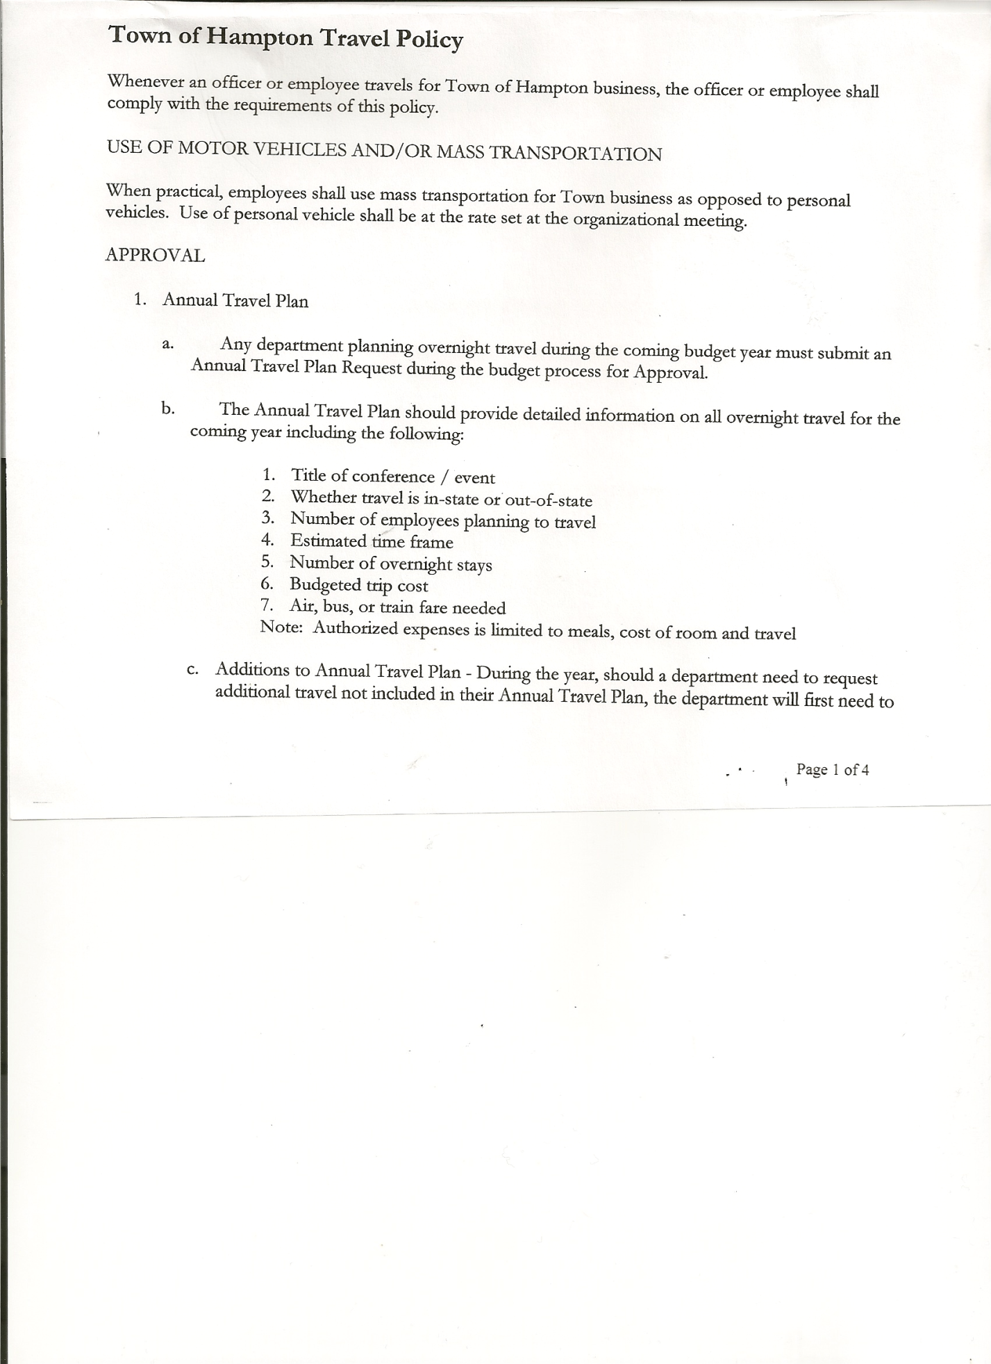
Rebecca Jones---------------Town Clerk
Camilla Shaw----------------Tax Collector/Deputy Town Clerk
Herbert Sady, Jr.-------------Highway Superintendent
Kim Perry---------------------Budget Officer/Bookkeeper

Planning Board Member(s): Steve Fernett and Matthew Pratt

Also present: Matthew Sears, Hampton Fire Company Chief; Kenneth Peterson, Artie Pratt and Leonard Reed

The FIRST Public Hearing was called to order by Supervisor O’Brien at 7:00pm

Town Clerk Jones read the Legal Notice of Public Hearing (copy attached), which was published in the Manchester Newspapers, to discuss the proposed contract with Hampton Fire Protection District 1.

Contract has an increase of $832.00 ($41,616.00 in 2019) for a total of $42,448.00 for 2020.

All persons desiring to be heard, having been heard, the Public Hearing was closed at 7:01pm.

The SECOND Public Hearing was called to order by Supervisor O’Brien at 7:05pm

Town Clerk Jones read the Legal Notice of Public Hearing (copy attached), which was published in the Manchester Newspapers, to discuss the proposed contract with Hampton Fire Protection District 2.

Contract has an increase of $2244.00 ($7,756.00 in 2019) for a total of $10,000.00 for 2020.

All persons desiring to be heard, having been heard, the Public Hearing was closed at 7:06pm.

The THIRD Public Hearing was called to order by Supervisor O’Brien at 7:11pm

Town Clerk Jones read the Legal Notice of Public Hearing (copy attached), which was published in the Manchester Newspapers, for the Preliminary Budget for 2020.

Steve Fernett asked about the State programs for the Highway. Supervisor O’Brien explained that there are two state funded programs in jeopardy of being lost. (PAVE NY and the Emergency Winter Road Fund).

All persons desiring to be heard, having been heard, the Public Hearing was closed at 7:20pm.
TOWN BOARD MEETING
OCTOBER 31, 2019 PAGE 2

SPECIAL MEETING
The Special Meeting was called to order by Supervisor O’Brien at 7:20pm, followed by the Pledge of Allegiance. Location of Fire Exits were given. Quorum of board members present.

RESOLUTION NO. 106-2019
APPROVAL OF THE 2020 BUDGET
On a motion of Councilman Weeden, seconded by Councilwoman Sweeney, the following resolution was ADOPTED:
BY ROLL CALL VOTE: Supervisor O’Brien AYE
Councilwoman Taran AYE
Councilman Sady AYE
Councilwoman Sweeney AYE
Councilman Weeden AYE
RESOLVED, that the 2020 Town Budget for the Town of Hampton is adopted.

RESOLUTION NO. 107-2019
HAMPTON FIRE DISTRICT #1
On a motion of Councilwoman Taran, seconded by Councilman Sady, the following resolution was ADOPTED Ayes 5 O’Brien, Taran, Sady, Weeden, Sweeney
Nays 0
RESOLVED, to approve Hampton Fire District #1 Contract for 2020 in the amount of
$42,448.00.

RESOLUTION NO. 108-2019
HAMPTON FIRE DISTRICT #2
On a motion of Councilwoman Taran, seconded by Councilman Sady, the following resolution was ADOPTED Ayes 5 O’Brien, Taran, Sady, Weeden, Sweeney
Nays 0
RESOLVED, to approve Hampton Fire District #2 Contract for 2020 in the amount of
$10,000.00.

Suggestion was made to consider combining Fire District #1 and #2 in the future.

Supervisor O’Brien noted that there is no requirement for Roll Call Votes. Following a brief discussion the following Resolution was introduced.
RESOLUTION NO. 109 -2019
ROLL CALL VOTES
On a motion of Councilman Sady, seconded by Councilwoman Taran, the following resolution was ADOPTED Ayes 5 O’Brien, Taran, Sady, Weeden, Sweeney
Nays 0
RESOLVED, to continue doing Roll Call Votes on money matters.

PUBLIC COMMENTS/COUNCIL COMMENTS
Lenny Reed asked if the Sand and Salt was put up for the winter yet.
Highway Superintendent Herb Sady replied that the salt was set, but working on getting the sand. Herb also noted that the paperwork for the CHIPS money is done and sent in.

On a motion of Councilman Sady, seconded by Councilman Weeden, the meeting adjourned at 7:35pm. All in favor Aye.

Respectfully submitted,
Rebecca S. Jones, RMC/Town Clerk

