

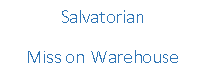

Summer 2016

**“Go and set everyone afire! Oh, that all may become truly zealous Apostles!”** *Fr. Francis Jordan, Salvatorian Founder*

Dear Friends,

How wonderful is the Holy Spirit! And how blessed are we here at the Salvatorian Mission Warehouse. It is only through God’s divine providence that we are able to continue a tremendous ministry and set afire all the hearts of the missions we reach. As summer is set to begin, let me briefly describe how we have set afire the world through your generosity.

Since the beginning of January 2016, the warehouse has shipped out 24 containers to nine different countries serving 17 missions. Besides the usual assorted food products, clothes, and blankets; we have sent out over 300 bicycles and 200 cases of personal hygiene products such as soap, toothpaste, and shampoo. These additional items are a result of us requesting them last summer and you have responded with great joy! Thank you all for these great gifts and donations. I continue to seek your support in donating bars of soap, shampoo, toothbrushes/paste and bicycles. As one mission priest bluntly said, “We have wonderful roads but we also have many dirt paths that are hard to travel and create much dust and dirt.” Getting a bike and getting soap is simply one of the greatest gifts we can provide.

As always, your financial contributions have allowed the Salvatorian Mission Warehouse the ability to ship all these containers. Since January 2016, we have received $138,500 to help cover the cost of the $144,800 needed for shipping. Hearts were set afire because an incredible 47% of donated money since January has come directly from personal donations! We continue to seek your financial support. To celebrate the unbelievable generosity from people like you, we are having a special open house on June 18th followed by a Mass at 4PM. This event will be held at the Salvatorian Mission Warehouse as a simple gesture to honor everyone who has ever donated. If you have not yet RSVP’d, there is still time to let us know you can come and see the ministry you support. Please email me at [dholton@salvatorians.com](mailto:dholton@salvatorians.com)

The Holy Spirit has set the Salvatorian Mission Warehouse afire… it is alive and thriving! As always, visit our website [www.salvatorianmissionwarehouse.org](http://www.salvatorianmissionwarehouse.org) and our facebook page <https://www.facebook.com/salvatorianmissionwarehouse/> to see the many emails and pictures we receive from the missions. God bless you all!

Peace in Christ,

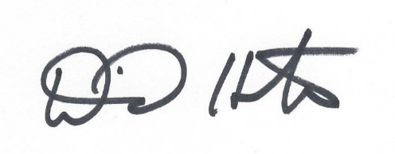

David Holton

Dear Dave,

With this letter, I wish to express my profound gratitude to you and all the wonderful volunteers and donors of the Salvatorian Mission Warehouse. Your kindness and generosity helped put endless smiles on the faces of the children at the St. Therese Youth Development Center in the village of Kaluri in northern Ghana.

Some of the candies were distributed to the children while I was at the Center and they very much enjoyed it. It is a source of energy and nourishment for the kids and they are very thankful for your generosity.

On behalf of the Theresian Fathers and the children at the St. Therese Youth Center, I wish to thank you once again for your enormous support. May God’s choicest blessing come upon you and remain with you always.

Yours in Christ,

*Rev. Paul Kala, Founder & Superior*

*Missionary Society of Saint Theresa*

**Some of the Many Letters of *THANKS!***

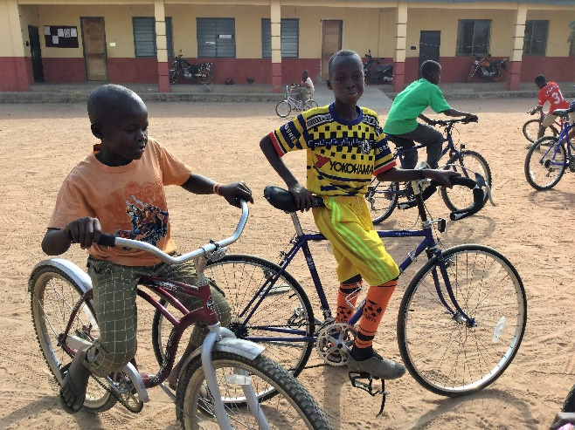

The Peace of the Lord!

Thank God that the containers arrived safely. We have started distributing. The people we minister to are so delighted, likewise our Sisters. May the good Lord continue to bless you and all at the warehouse including your generous benefactors.

I pray that the Lord will continue to touch the hearts of more  
benefactors so that we also can be blessed by the goods sent to us.

Please find attached two single parents with their children who got the rice and they were so overjoyed. Once again we all thank you for helping us in our ministry.

God bless you,  
*Sr. Faustina, SIJ*

*Ghana*

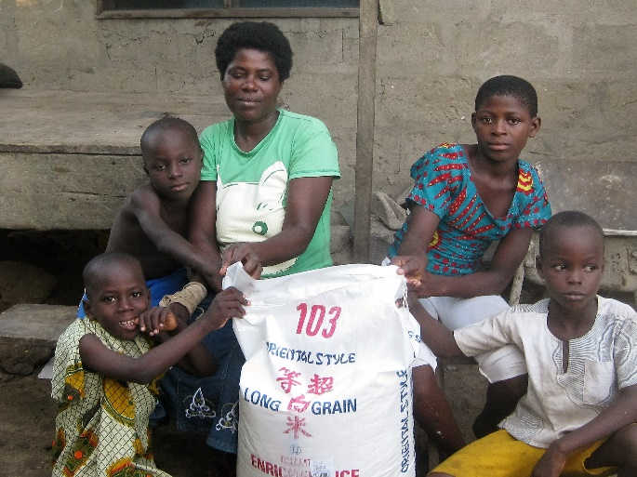

Hi Dave,

I really want express deep gratitude to you for sending us the two containers. The rice was of a great help to us since the climatic change really affected our stable food. The only available food was rice. So you can imagine the gratitude on faces of so many people. The pictures are from Koforidua School for the Deaf who received rice and candies.

Once again I am grateful to you and pray for all your staff who do the hard work of packing items at your center.

Your brother in Christ,

*Monsignor Alex Bobby Benson*

*Ghana*

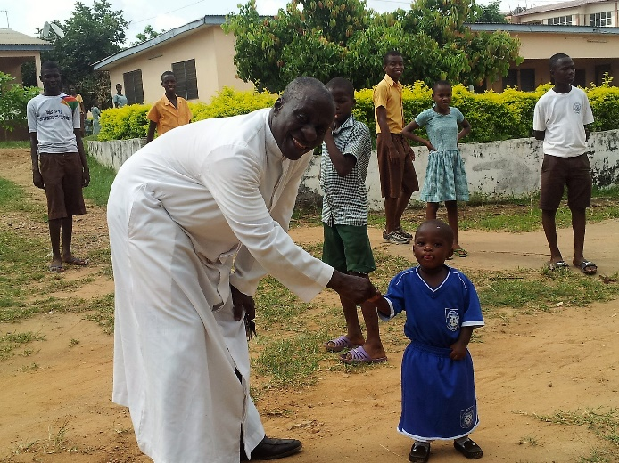

**Shipments January – May, 2016**

**Relief Goods – Total of 300,011 lbs.**

* 7 to Ghana, Africa
* 1 Honduras, Central America
* 2 Guatemala, Central America (1 new mission – Franciscan orphanage)
* 1 Chile, Central America
* 1 Congo, Africa
* 2 Paraguay, South America
* 1 Tanzania, Africa
* 1 Chuuk, Micronesia

**Rice Shipments (40,000 lbs. each) – 7 Total**

* + - 6 Ghana
    - 1 Tanzania
    - Average shipping and rice purchase cost - $14,000 per 40 foot container. One container will sustain a village for one year.

**Other News & Special Requests**

* Please consider donating bars of soap or shampoo. Even the little ones from hotels work great!

* New notebooks, folders, crayons or markers are loved in the orphanages.

* If you or someone you know could help us secure bulk, non-expired food items, such as rice or oatmeal, this would be a huge help.

* We have saved .34 per letter by going to postcards. Help us continue to help shave costs by utilizing on-line services. Financial donors will receive an end of the year report stating financial donations for the entire year.

* Special thanks to Jerome Geiser for creating our chapel and painting the entire inside of the Salvatorian Mission Warehouse!

**Donor Celebration**

We’d like to honor and thank all of the people and businesses that have financially supported the Warehouse. Your support has allowed us to bring JOY to thousands of people around the world!

**Saturday, June 18th, 2016**

Warehouse Open House 1pm – 3:30pm, Mass at 4pm

If you have not already RSVP’d that you ARE COMING, please do so by calling 920-898-5898

or email [dholton@salvatorians.com](mailto:dholton@salvatorians.com) so we can plan accordingly.

**If you are not able to join us, no response is necessary.**

**Thank you for your continued support!**

**Attention ALL Warehouse Volunteers:**

**Annual Volunteer Celebration**

Date: Sunday, August 28th, 2016 *(rain or shine)*

Time: 10:15am Outdoor Mass, followed by lunch provided by Altona Supper Club

Location: Salvatorian Mission Warehouse *(outside – backyard)*

1303 Milwaukee Drive, New Holstein, WI

Bring: Lawn chairs or blankets for sitting No need to RSVP

***\*Special recognition for years of service Marian Schweitzer & Larry Bay***



Donor Name (s)

Mailing Address

City State Zip

Phone ( ) Email

Please accept my gift of $

Salvatorian Mission Warehouse

1303 Milwaukee Dr., New Holstein, WI 53061

***Donations also accepted through PayPal at*** [***www.salvatorianmissionwarehouse.org***](http://www.salvatorianmissionwarehouse.org)