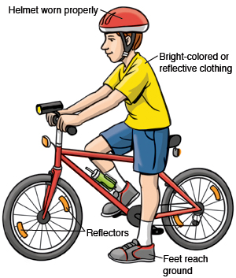
Hey Kids…
Get On Your Bikes
and Join the Riding School Bus!
Monday, May 11th-Thursday, May 14th
Win Prizes!!
Bicycle Safety:
1. Wear a helmet.
Even adults!
2. Ride with traffic,
not against it.
3. Establish eye contact with drivers.
4. Do not ride more than two abreast.
5. Ride predictably and be visible.
6. Use hand signals
when turning.
7. Use lights at night.
8. Obey all traffic signals, signs, and laws.

2 Meeting Locations: 1st St.& Boardwalk or 34th St. & Haven Ave. Parking Lot
Meet at 7am at the North or South location
and a Police Escort, Volunteers and “Surprise Teachers” will ride along to the Intermediate School with the “Riding School Bus”.
Return trips depart 10 minutes after dismissal time.
Parent Volunteers are welcome!
PLEASE NOTE:
All Students MUST wear a helmet and have turned in a registration form with parent’s permission.

Please complete form and register prior to the event by dropping off
at the Ocean City Intermediate School office.

Student(s)Name________________________________________________________Grade__________
Parents Name_________________________________________________________________________
Parents Signature______________________________________________________________________
Emergency Contact Number_____________________________________________________________
**Please complete waiver on reverse**
For more information call 525-9301
Event coordinated by the Ocean City Council on Physical Fitness & Sports
with support from the Ocean City Police and Recreation Divisions.

