SPECIAL MEETING
SEPTEMBER 30, 2021

A Public Hearing and a Special Meeting of the Town Board of the Town of Hampton, County of Washington and the State of New York was held at the Town Hall, 2629 State Route 22A, Hampton, New York, also via Zoom and live streaming on the You Tube Channel for “Town of Hampton New York” on the 30th day of September 2021.

Due to the Corona Virus, occupancy inside the Town Hall is limited at this time. Supervisor O’Brien did provide a link to join the Zoom meeting.

PRESENT: David K. O’Brien------------Supervisor
Tamme Taran----------------Councilwoman came at 7:23pm
Donald Sady-----------------Councilman
Andrea Sweeney------------Councilwoman
Michael Pietryka------------Councilman
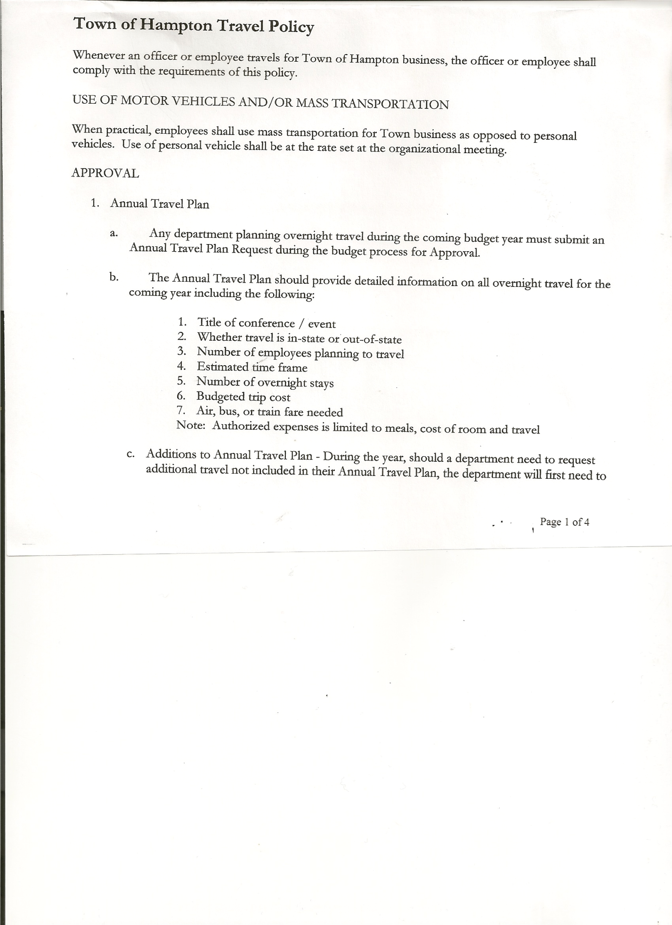
Rebecca Jones---------------Town Clerk
Camilla Shaw----------------Tax Collector/Deputy Town Clerk
Herbert Sady, Jr.-------------Highway Superintendent
Kim Perry---------------------Budget Officer

Planning Board Member(s): Bonnie Hawley, Chair and Ginny Kinsey

Also present: See attached list

The Public Hearing was called to order by Supervisor O’Brien at 7:15pm

Town Clerk Rebecca Jones read the Legal Notice of Public Hearing (copy attached), which was published in The Post-Star on 9/21/2021 to discuss a proposed Local Law requesting that the New York Cannabis Control Board prohibit the establishment of any on-site consumption licenses.

Supervisor and Board Members explained what this proposed Local Law entailed. The Town Board has previously okayed Retail Dispensary licenses but are looking to Opt Out of On-Site Consumption Licenses.

All persons desiring to be heard, having been heard, the Public Hearing was closed at 7:26pm.

Everyone present at the Town Hall joined in and sang Happy Birthday to Lenny!!!

SPECIAL MEETING
The Special Meeting was called to order by Supervisor O’Brien at 7:27pm, followed by the Pledge of Allegiance. Location of Fire Exits were given. Quorum of board members present.

RESOLUTION NO. 90-2021

MOTION BY: Councilman Michael Pietryka
SECONDED BY: Councilman Donald Sady

RESOLUTION ADOPTING LOCAL LAW B OF 2021 REQUESTING THAT THE CANNABIS CONTROL BOARD OF THE STATE OF NEW YORK PROHIBIT ON-SITE CONSUMPTION LICENSES IN THE TOWN OF HAMPTON, COUNTY OF WASHINGTON, STATE OF NEW YORK

TOWN BOARD MEETING
SEPTEMBER 30, 2021 PAGE 2

WHEREAS, New York’s recently adopted Cannabis Law of the State of New York provides, at Section 131 of the Cannabis Law, that a municipality may request that the New York State Cannabis Control Board prohibit on-site consumption licenses in the municipality, which
TOWN BOARD MEETING
SEPTEMBER 30, 2021 PAGE 2

request must be in the form of a local law adopted by the municipal board subject to permissive referendum; and

WHEREAS, the Town Board of the Town of Hampton previously introduced a local law requesting that the New York State Cannabis Control Board prohibit -site consumption licenses in the Town of Hampton pursuant to Cannabis Law Section 131; and

WHEREAS, the Town scheduled a public hearing to be held before the Town Board on September 30, 2021 at 7:15p.m. at the Town of Hampton Town Hall to hear all interested parties on the proposed Local Law; and

WHEREAS, notice of said public hearing was duly posted and then published in the
Post Star the official newspaper of the Town, pursuant to and in conformance with Section 20 of the Municipal Home Rule Law; and

WHEREAS, said public hearing was duly held and all parties in attendance were permitted an opportunity to speak on behalf of or in opposition to the proposed Local Law.

NOW, THEREFORE, BE IT

RESOLVED, the Town Board, upon due deliberation of the proposed Local Law and the comments presented at the public hearing, finds that the adoption of the same shall be in the best interests of the Town; and be it further

RESOLVED, the Proposed Local Law B of 2021 law requesting that the Cannabis Control Board of the State of New York prohibit any on-site consumption licenses in the Town of Hampton pursuant to Cannabis Law Section 131, a copy of which is attached to and made a part of this resolution, is hereby adopted subject to permissive referendum as provided for in Section 131 of the Cannabis Law of the State of New York, and shall take effect as provided for in said Local Law; and be it further

RESOLVED, this resolution shall take effect immediately.

DATED: September 30, 2021 Supervisor O’Brien NAY
Councilman Sady AYE
Councilwoman Taran AYE
Councilwoman Sweeney AYE
Councilman Pietryka AYE

Stimulus Fund……modify to include Defibrillators & extra pads for Fire Department and Town Hall.

TOWN BOARD MEETING
SEPTEMBER 30, 2021 PAGE 3

Discussed, reviewed, and modified Tentative Budget.

RESOLUTION NO. 91-2020
PUBLIC HEARING ON HAMPTON FIRE DISTRICT NUMBER 1
On a motion of Councilman Sady, seconded by Councilman Pietryka, the following resolution was ADOPTED: AYES 5 O’Brien, Sady, Taran, Sweeney, Pietryka
NAYS 0
RESOLVED, to set the Public Hearing to discuss the proposed contract between the Town on behalf of the Town of Hampton Fire Protection District Number 1 and the Hampton Volunteer Fire Company for October 21st, 2021 at 7:15pm.

RESOLUTION NO. 92-2021
PUBLIC HEARING ON HAMPTON FIRE DISTRICT NUMBER 2
On a motion of Councilman Sady, seconded by Councilman Pietryka, the following resolution was ADOPTED: AYES 5 O’Brien, Sady, Taran, Sweeney, Pietryka
NAYS 0
RESOLVED, to set the Public Hearing to discuss the proposed contract between the Town on behalf of the Town of Hampton Fire Protection District Number 2 and the Hampton Volunteer Fire Company for October 21st, 2021 at 7:17pm.

RESOLUTION 93-2021
MOTION BY: Councilman Donald Sady
SECONDED BY: Councilwoman Andrea Sweeney

RESOLUTION INTRODUCING PROPOSED LOCAL LAW
TO OVERRIDE THE TAX LEVY LIMIT ESTABLISHED IN GENERAL MUNICIPAL LAW SECTION 3-c

WHEREAS, pursuant to Section 10 of Municipal Home Rule Law, the Town Board of the Town of Hampton (the “Town”) has the authority to adopt local laws; and

WHEREAS, pursuant to General Municipal Law Section 3-c, the Town Board of the Town of Hampton has the authority to adopt a budget that requires a tax levy that is greater than the tax levy limit for the coming fiscal year by adopting a local law by a vote of sixty percent (60%) of the total voting power of the Town Board of the Town to override such limit for such coming fiscal year only; and

WHEREAS, a proposed Local Law has been prepared by the Town Attorney, a copy of which is attached hereto; and

WHEREAS, the Town Board is desirous of proceeding with the review and consideration of this proposed Local Law.

NOW, THEREFORE BE IT RESOLVED that the proposed Local Law is hereby accepted for introduction to the Town Board. A public hearing shall be scheduled for the consideration of the proposed Local Law to be held by the Town Board on October 21, 2021 at 7:20p.m. at the Town Hall located at 2629 State Route 22A, Hampton, New York. Copies of the Local Law shall be available at the Town Clerk’s office for review; and be it further

RESOLVED, that the Town Clerk is directed to post and publish a notice of said public hearing in the Manchester Newspapers (The Granville Sentinel/The Whitehall Times) at least five (5) days before the hearing; and be it further

TOWN BOARD MEETING
SEPTEMBER 30, 2021 PAGE 4

RESOLVED, that the consideration and proposed adoption of this Local Law is an action under the New York State Environmental Quality Review Act (SEQRA). The Town Board hereby declares that this action is a Type II action pursuant to 6 NYCRR 617.5(20) and (27) and declares that the action does not have a significant impact on the environment and the action is hereby precluded from further environmental review; and be it further

RESOLVED, that this resolution shall take effect immediately.

DATED: September 30, 2021 Supervisor O’Brien AYE
Councilman Sady AYE
Councilwoman Taran AYE
Councilwoman Sweeney AYE
Councilman Pietryka AYE

RESOLUTION NO. 94-2020
PUBLIC HEARING-PROPOSED LOCAL LAW TO OVERRIDE TAX CAP
On a motion of Councilwoman Taran, seconded by Councilman Sady, the following resolution was ADOPTED: AYES 5 O’Brien, Sady, Taran, Sweeney, Pietryka
NAYS 0
RESOLVED, to set a Public Hearing for October 21st, 2021 at 7:20pm on the proposed Local Law regarding overriding the Tax Cap.

RESOLUTION NO. 95-2020
ADOPTION OF TENTATIVE BUDGET
On a motion of Councilman Sady, seconded by Councilwoman Sweeney, the following resolution was ADOPTED:
By Roll Call Vote: Supervisor O’Brien AYE
Councilman Sady AYE
Councilwoman Taran AYE
Councilwoman Sweeney AYE
Councilman Pietryka AYE
RESOLVED, that the 2022 Tentative Budget be adopted and becomes the 2022 Preliminary
Budget for the Town of Hampton.

RESOLUTION NO. 96-2020
PUBLIC HEARING ON PRELIMINARY BUDGET FOR 2022
On a motion of Councilwoman Sweeney, seconded by Councilman Sady, the following resolution was ADOPTED: AYES 5 O’Brien, Sady, Taran, Sweeney, Pietryka
NAYS 0
RESOLVED, to set the Public Hearing on the Preliminary Budget for 2022 for October 21st, 2021 at 7:25pm.

RESOLUTION NO. 97-2021
MEETING ADJOURNED
On a motion of Councilman Sady, seconded by Councilwoman Taran, the following resolution was ADOPTED: AYES 5 O’Brien, Sady, Taran, Sweeney, Pietryka
NAYS 0
RESOLVED that the meeting adjourned at 8:46pm.

Respectfully submitted,

Rebecca S. Jones, RMC/Town Clerk

