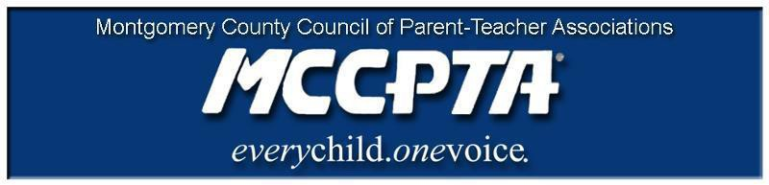
DELEGATES’ ASSEMBLY MEETING AGENDA
Tuesday, March 26, 2019
7:30 PM JA Auditorium – Thomas Edison HS of Technology

Welcome and Introduction of Officers

MISSION OF PTA
To make every child's potential a reality by engaging and empowering families and communities to advocate for all children.
Hacer una realidad el potencial de cada niño al comprometer y apoderar las
familias
y comunidades para que intercedan por todos los niños.
Approval of Agenda and Minutes

MCCPTA Minute
- Student Minute – SMOB candidates
- First Community Minute – Local Accountability Model Focus Groups
- Second Community Minute – Safety Patrol Camp, Family Justice Center “Expect Respect” Healthy Teen Relationship workshop

Special Presentation – Maryland “Safe to Learn” Act and School Safety Evaluations in MCPS
(Mike Harting, MCPS Acting School Safety Supervisor)

Old Business
- Nominating Committee Update
- National PTA Dues Increase
- Pedestrian Safety

New Business
- Increasing Recess in ES - (Lauren Zolkiewicz)
- Racism 101 Events - (Bruce Adelson, Charisse Scott)
- MCCPTA Performing Arts Festival - (Uttam Gupta)
- National PTA Dues Increase (Frances Frost)
- MCCPTA Budget Amendments (Khristy Kartsakalis)
- Operating Budget Hearings – County Council (Laura Mitchell)
- Annapolis Update (Laura Stewart)
- Family Engagement Survey (Tracie Potts)
- Role Montgomery College can play in family strategies for the post-secondary launch (Cynthia Simonson)

Officer Reports Committee Updates Announcements Adjourn

