5 Pieces of Marketing Magic from Disneyland

Today marks the 59th anniversary of the day Disneyland opened its doors in Anaheim, CA in 1955. There are now two “Disneylands” in the US (California and Florida with its Disney World, Epcot Center, Animal Kingdom, water park), Tokyo Disneyland, Disney Paris, Hong Kong Disneyland, and the recently opened Disneyland in China.
The Disney World park’s massive overhead ($100 million in reported annual maintenance alone) puts a lot of pressure on marketing to continually attract visitors and capitalize on every spending opportunity. Despite this massive pressure, Disney’s marketing department has been delivering on this mandate ever since the gates first opened. So what makes their marketing so magical? Below, we explore five ways the theme parks continue to drive exceptional results.
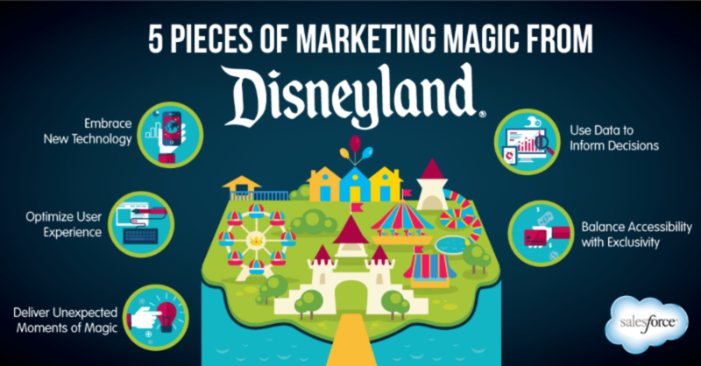

Embrace New Technology
Throughout its history, Disneyland had never shied away from new technology. The park has always been quick to embrace technological advantages, like launching an app to keep visitors informed, or their new MagicBands wearables. The MagicBands store tickets, hotel keys, debit and credit card information and can be used anywhere just by tapping a sensor, dramatically streamlining the park experience for guests.
The marketing magic: Where it offers an advantage over the competition, technology should be embraced wholly and quickly.

Use Data to Inform Decisions
Another upshot of the new MagicBand initiative is that it provides tracking data on all of the park’s guests. This allows the park to monitor traffic flows, check queue lengths, and pinpoint where and when purchases are made. All of this data allows Disneyland to optimize everything from staffing to the location of a food vendor.
The marketing magic: Marketing departments can no longer fumble in the dark, using intuition as their business case for new initiatives. Data should be a big part of your planning process and be used to support major decisions.

Optimize User Experience
Any UX designer can tell you that products live or die by how usable and seamless they are for their users. While Disneyland spans 160 acres, it is still a product, and the marketing team is meticulous when it comes to creating a uniquely enjoyable experience for every user. Nearly every aspect of a guest’s day is optimized, from the purchase process to the infamous "stroller guy," whose full time job is to park your stroller while you take your kids on a ride.
The marketing magic: You must always consider your customer experience and work to streamline the process of purchasing, using, and servicing your product.

Balance Accessibility with Exclusivity
While Walt Disney opened the park in 1955 to bring the Disney magic to the masses, there has always been an exclusive experience reserved for those willing to pay more. In the early days, this was a speakeasy-style lounge hidden in the New Orleans area, reserved for those willing to pay steep membership dues. Today, it takes the form of a tiered pricing structure that offers features like skipping lines at higher price points.
The marketing magic: Exclusivity will always appeal to your customers. Design a way to make your customers feel special, and they will respond with customer loyalty.

Deliver Unexpected Moments of Magic
One of Disneyland's greatest assets is its least tangible: the Disney magic. Disney carries an immense amount of brand affinity and brand loyalty with its visitors. Disneyland capitalizes on this affinity with live characters, surprise performances, parades, and exceptional customer service.
The marketing magic: While most marketers don’t have the luxury of capitalizing on childhood nostalgia, making an effort to surprise and delight your customers at every turn will always pay dividends.
_________________________________
Source: Sales Force / July 17, 2014
Author: Matt Wesson
Retrieved from: https://www.salesforce.com/blog/2014/07/5-pieces-of-marketing-magic-from-disneyland.html

