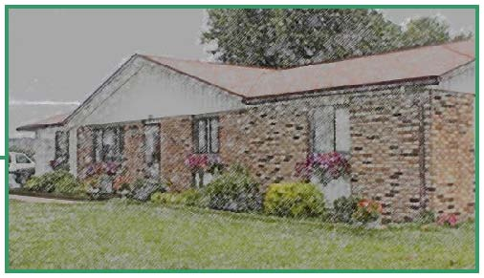

416 E. Walnut Street, Brownstown, IN 47220 (812) 358-5180 • Fax (812) 358-5846

juvenilehome@juvenilehome.com
Application Package

Placement from ___________________ ☐ DCS ☐ Probation
(County)
Name: ________________________________ Date of Birth: ____________

Anticipated date of admission: ______________

Reason for Placement ______________________________________________________________________________

______________________________________________________________________________

______________________________________________________________________________
(DCS requires a reason as to why a less restrictive option is not viable, please list specific behaviors)

Current School: _________________________________ Is this person planning to remain at current school? ☐Yes ☐No

Current Medications:
Medication | Prescribed for

Psychological Assessment (attach) → Current Diagnosis ______________________ Date of Diagnosis __________

Any previous diagnosis?: __________________________________________

Please Attach:
☐ Case Plan with Goals (Required)
☐ Permanency Plan (Required)
☐ Placement History (Required)
☐ Recent reports from current placement (Required if currently in an institutional setting)
☐ Criminal History (Required on probation cases)

☐ Any Assessment of any kind is very helpful in making placement decisions.
☐ Social/Family History
☐ Trauma History
☐ IEP if the child has special school needs
☐ Any Academic or IQ testing done by school

Is there anything we should know, or that needs to be done for this child? (i.e. if they were still living at his current location, they would need such as clothing haircut, tutor, acute illness, behavioral, psychological, educational, etc) . . .

________________________________________________________________________________________

________________________________________________________________________________________

________________________________________________________________________________________

________________________________________________________________________________________

________________________________________________________________________________________

________________________________________________________________________________________

________________________________________________________________________________________

________________________________________________________________________________________

________________________________________________________________________________________

________________________________________________________________________________________

________________________________________________________________________________________

________________________________________________________________________________________

________________________________________________________________________________________

________________________________________________________________________________________

________________________________________________________________________________________

________________________________________________________________________________________

________________________________________________________________________________________

