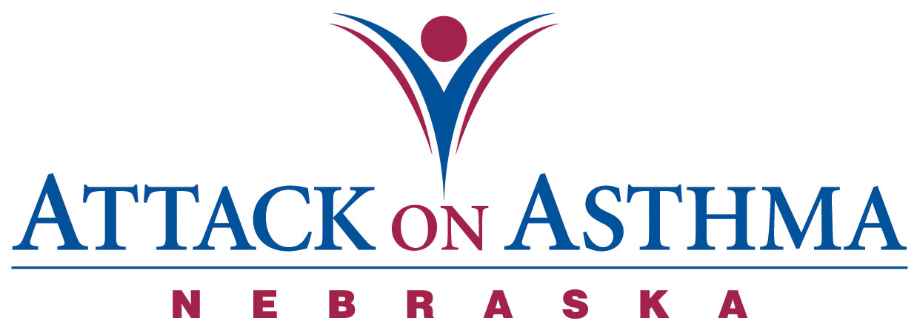

Characteristics of Individuals and Protocol Use in Nebraska Schools
2008-09

Data was voluntarily reported to Attack On Asthma Nebraska (AOAN) during and following the 2008-2009 school year. During this period of time there were 42 reported incidents of the Emergency Response to Life-Threatening Asthma or Systemic Allergic Reaction (Anaphylaxis) protocol being implemented. Schools submit data using a standardized form.

- Almost half the incidents occurred during the months of August, September, October, November (47%).

- Protocol administration was split almost evenly between male (55%) and females (45%).

- More Elementary school students (38%) were administered the protocol than Middle School (22%) and High School (33%) students. There was three staff incidents (7%) reported.

- The greatest percentage of incidents was reported in conjunction with activity; PE class and recess (41%). Classroom (36%) incidents as a location followed.

- The majority of the incidents were with an individual with a history of asthma (52%). Thirteen reported no history of either asthma or anaphylaxis (31%) and only seven individuals reporting a history of anaphylaxis (17%).

- Slightly over two-thirds (69%) received epinephrine as a correct usage of the protocol.

- Fourteen individuals (17%) with no history of asthma returned to school with an action plan.

- Out of six individuals with a history of asthma and no action plan on file, just over one-quarter (27%) returned to school with an action plan after protocol administration.

- Of the twenty-two individuals with a history of asthma, sixteen (73%) had an action plan on file.

- Three (43%) of the individuals with a history of anaphylaxis did not have an action plan on file at school. All three (100%) individuals returned to school with an action plan.

- No one required the administration of CPR.

- There was one incident (2%) in which albuterol only was administered.

- Emergency Medical Services (EMS) was summoned 93% of the time. Three incidents (7%) do not document this statistic.

- Thirty-four individuals (81%) were transported to a medical facility via the Emergency Medical System. Three individuals (7%) were transported to a physician’s office or medical facility by a parent or were signed off by a parent and five (12%) incidents did not document this statistic.

- Twelve school districts reported the 42 incidents.

- Each school district had access to or has a school nurse.

NOTE: Action plans on file at school may or may not include prescribed medication(s).

