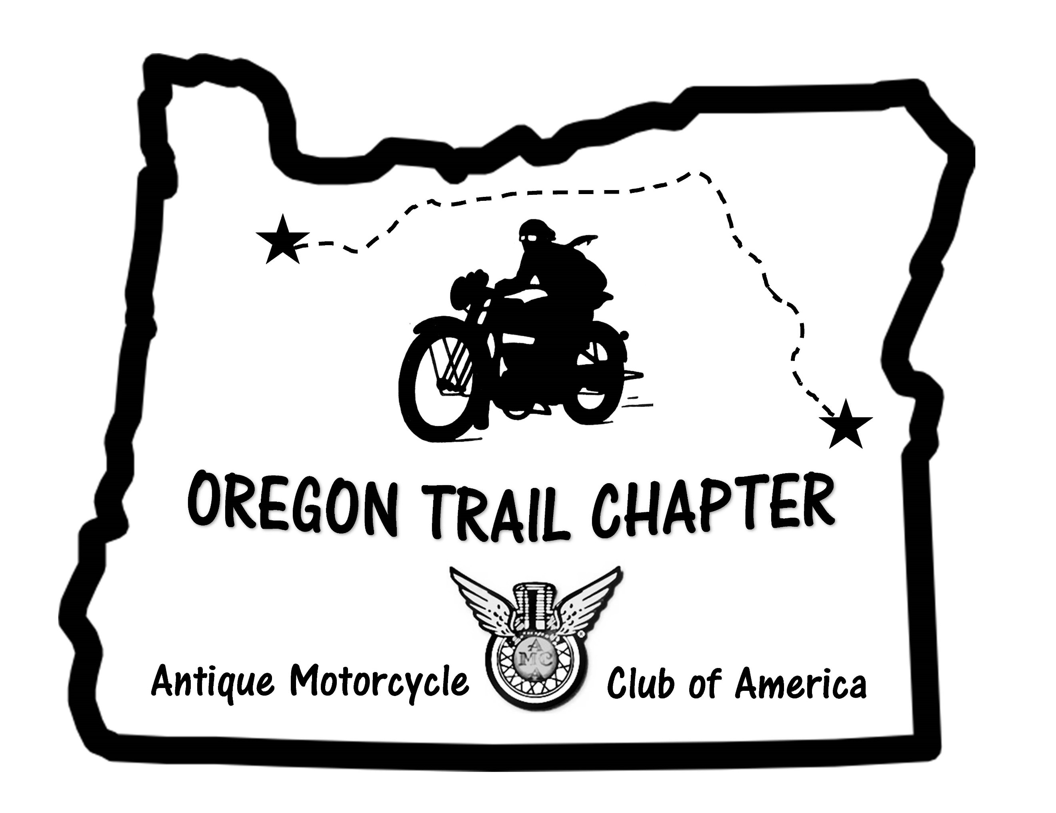

Oregon Trail Chapter of the AMCA Membership Application

Name

_______________________________ Spouse:

Address: City, State, Zip:

AMCA # (required ) :
____________________________ Phone:____________________________

Email address:

We'd like to know more about our members. (Pictures are also appreciated!)
First motorcycle, make/model?

Who introduced you to riding?

First/early riding experiences

Current motorcycles

Motorcycle reports (long trips, memorable rides)

Competition experiences

Why did you join the Oregon Trail Chapter?

You can join/ renew online at http:// www.antiguemotorcycleoregon..com or send this completed form and $15 (individual) or $30 (couple) dues to:
John Davey, OTC Treasurer, 2165 Norwood St, Eugene, OR 97401 john@riverroofing.com

