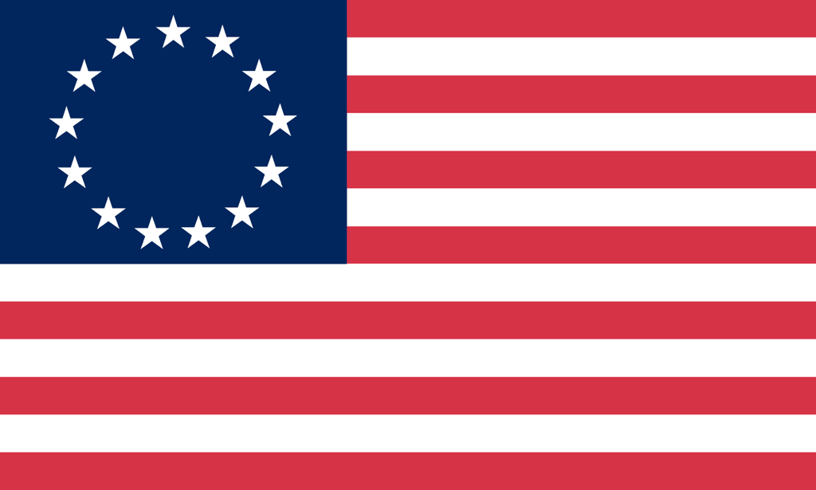U.S. History with Mr. Brown Name _______________________________ Period _____
Articles of Confederation and Constitutional Convention Book Preview ch8

Directions: Find the answers to the following questions throughout Ch 8 starting on page 202.

1) What was the name of the road that Daniel Boone and 30 woodsmen built over the Appalachian Mountains into Kentucky?
2) The colonies now being free and independent states needed to write state constitutions. Some things they did was to divide power into different ___________ and include a Bill of __________________.
3) Why did the national Government have few powers under the Articles of Confederation?
4) The Articles of Confederation left the most important powers to _____________.
5) Why did some small states refuse to ratify the Articles of Confederation?
6) What law passed by the Confederation Congress divided up the land of the Northwest Territory into six mile square plots?
7) According to the Northwest Ordinance, how many people had to live in a territory before it could apply for statehood?
8) What were the farmers participating in Shay’s Rebellion angry about?
9) How was Shay’s Rebellion finally stopped?
10) A constitutional convention was called in the Summer of 1787 due to the fear that rebellions like the one in Massachusetts might spread. 12 out of 13 states sent representatives to Philadelphia for the Convention. Which state did not?
11) Which Constitutional Convention delegate read more than a hundred books on government to prepare for the convention?
12) What did Patrick Henry say about the convention in Philadelphia?
13) The challenge that face the Constitutional Convention was how to build a strong but ____________________ federal government.
14) Who was unanimously elected the leader of the Constitutional Convention?
15) Why did the convention decide to keep their discussions secret?
17) The Virginia Plan proposed a government that would have three _________________.
18) The Virginia Plan also proposed a legislature that would have ____________ houses.
19) Why did smaller states oppose the Virginia Plan?
20) How did the Great Compromise change the Virginia plan to satisfy smaller states?
21) Southerners wanted to count ___________________ toward their population for reasons of representation but not for taxation.
22) What was the Three-Fifths Compromise?
23) Southerners succeeded in banning congress from taxing __________________ because their economies depended on them.
24) Federalists vs Anti-Federalists
 | Federalists | Anti-Federalists
Supported or against the Constitution?
Name two leaders

25) What was the goal of the Federalist Papers?
26) What did the Anti-Federalists believe needed to be added to the Constitution n to protect people’s rights?
27) What year was the Constitution ratified?
28) What year was the Bill of Rights ratified?
29) Would our country have survived and thrived without a Bill of Rights?

