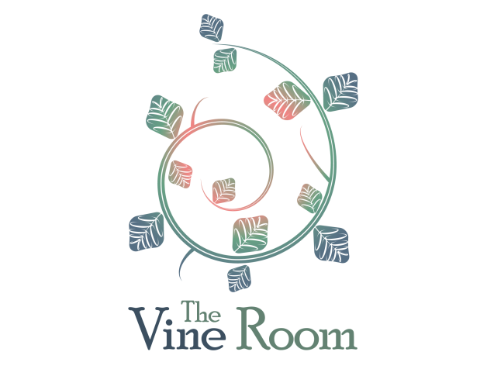

Brunch Buffet Presentation
-$13.95 per person-
Add our Build Your Own Mimosa Bar featuring Tropical Juices and Fruits or Bloody Mary Bar for an additional $7

Small Plates (apps) (Choice of Two)
Smoked Salmon Spread* Spinach and Artichoke Dip
Fruit and Cheese Boards *Anti Pasta Skewers
Eggs Etc. (Choice of Two)
Build Your Own Benedicts
Top your Crostini with Poached Eggs and your choice of Fried Prosciutto, Canadian Bacon and our house made Hollandaise Sauce.
Frittatas
Eggs baked with Gourmet Cheeses, Roasted Vegetables
and assorted Meats and Hams
Build your Focaccia Biscuits
Choose from Italian Sausage Gravy, Jalapeno Cheese Sauce
Fried Prosciutto and Scrambled Eggs
Diablo Shrimp with Parmesan and Asiago Grits
Gulf Shrimp sautéed with Spices tossed in House Made Rustic Marinara

Included on the Buffet
Breakfast Pizza Tastes
Savory Tastes of Infused Oil, Spinach and Goat Cheese
Sweet Tastes of Blueberry, Strawberries and Powdered Sugar
Spinach Salad with our Signature Champagne Dressing

Beverages included-Coffee, Tea and Soft Drink
7% Tax and 18% gratuity will be added. Room Fee $200

