THE MOST HOLY TRINITY
MAY 26 & 27, 2018
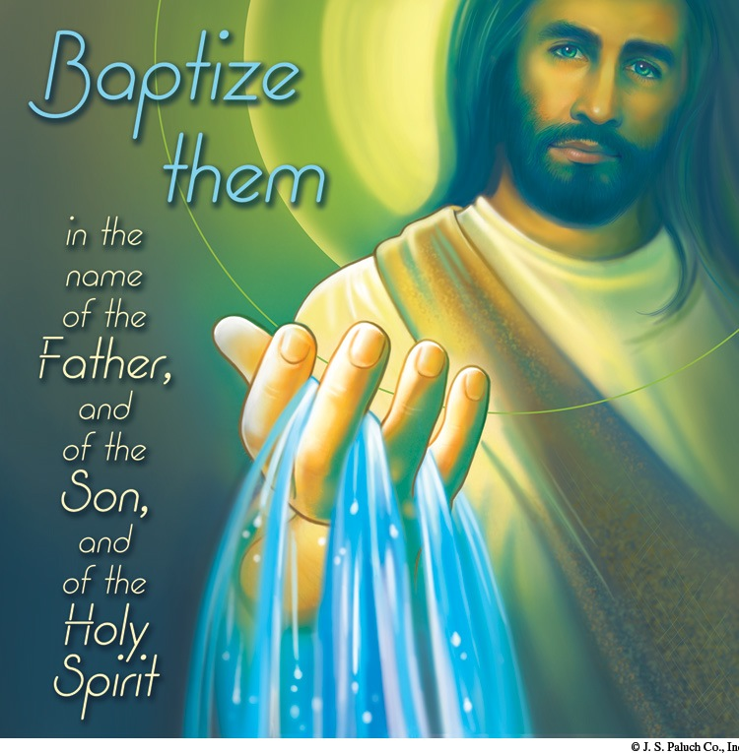
PASTORAL RUMINATIONS
By Fr. Andrés Querijero

At our Pentecost celebration, I mentioned “Service: Social Justice” along with Prayer, Morality, and Tenderness of Heart as the pillars or areas of the spiritual life wherein we undergo ongoing inner formation by the Holy Spirit. If our faith is to grow and bear much fruit for ourselves and for the greater good of our faith community, the optics of our spiritual formation as disciples of Christ should be holistic, and not compartmentalized; and the dynamics should involve all sectors of our parish moving towards common goals to achieve our vision for OLGC.
The first five years of my pastoral ministry had been geared towards: uniting the parish given our diverse backgrounds through liturgy, music, including fundraising activities that promote relationship-building; and, providing solid faith formation and catechetical instructions to our children and youth. A good number of our parishioners have committed themselves to sharing their time, talents, and treasure in order to accomplish these goals.
This year, we intend to focus on infrastructure. Our buildings are beginning to show signs of aging and slow deterioration. For this reason, I seek your commitment to help me (1) Form a Building, Construction and Maintenance Committee, a think-tank group, that would inspect, inventory, and recommend actions plans to redesign, remodel, restore and/or repair existing structures (Church— interior and exterior, Parish Hall, and CCD Classrooms); (2) Prioritize projects according to our funds capability; and, (3) Establish a Fundraising Committee to ensure that our projects are executed in a well-thought-out and orderly way.
I, therefore, need volunteers from among you, my dear parishioners, who are willing and ready to concretely express their faith in action through charity and actual service in our community.
“None of us works for or by themselves, but rather in the name of Christ who has shown us the way of service. It would be a contradiction to live charity apart from one another! I invite you, therefore, to strengthen every possible means of working together” (Pope Francis, On Charity and Communion).

MARRIAGE HUMOR
By Dennis Tavares

Marriage, ancient and predating government, dates back to the first couple in the Garden of Eden. It was an arranged marriage. God had to put Adam to sleep to take a rib from him to give to Eve, possibly because Adam was having marriage jitters. Adam, being a normal guy, but with infused knowledge about a lot of things, might have worried if there was enough fruit in the garden for a family. This operation was definitely the first recorded with anesthesia and transplanting. And God didn’t just select Eve out of the available hominid females, but rather knit her up out of Adam’s stuff to insure compatibility. They were rudimentary reproducers, but nonetheless had a primal pair bonding instinct and went to work on the ancient command to fill the Earth. They were successful as evidenced by our existence. The question now is what’s next.
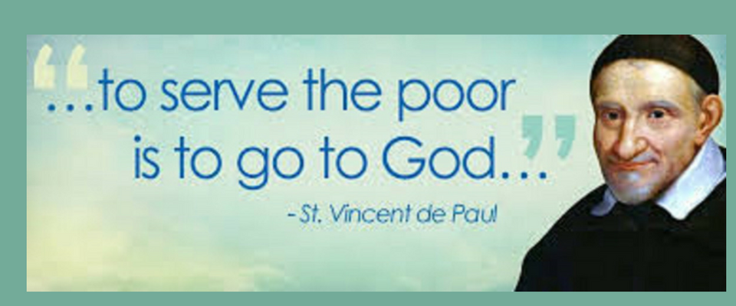
400 YEARS OF ACTION
By Jane Vartanian & Julie Edwards

A boy called Vincent was born (April 24, 1581) into a poor farm family in France. He worked on the farm, but showed interest in books and study, so his father took him to the Franciscans to be formally educated. He had to sell some oxen to pay for it, and later Vincent was able to tutor younger students and earn his own way.
He was ordained in 1600 and was sent to Rome for further studies. He was kidnapped by pirates and sold into slavery for several years. He escaped and returned to Paris where he stayed until his death on September 27, 1660.
Because of his roots, he especially wanted to help the poor, and he found he had the skills to organize people to do this.
Up until this time, nuns lived only in cloisters. He founded the Order of The Sisters of Charity in 1633, who worked directly in serving the poor and relieving their pain. He established foundling hospitals as well as other hospitals and homes for the infirm and aged. His work was a completely new and organized approach to age-old problems of poverty.
The current St. Vincent de Paul society was formally founded in 1833, but the work has been going on since 1617 when he established his first effort to help the poor, so we celebrate 400 years of concerted effort to serve the poor. The motto of the organization is “End Poverty Through Systemic Change.”
In 2016 in the US, there were nearly 100,000 volunteers providing 17,500,000 hours of volunteer service amounting to a value of one billion dollars.
OLGC, as a responsible member of the Fort Bragg community, is starting a chapter of the St. Vincent de Paul Society. By doing this, we will be able to meet the challenges of helping our local poor (following the Vincentian Spirituality) in a responsible and organized manner. SVDP representatives will guide us in all the steps needed to get started.
“We help ourselves by helping others,” say these volunteers. “We see Jesus in everyone.”
Call our office at 964-0229, (10:00am to 2:00pm, Monday through Friday) to place your name on a list of people interested in this endeavor. If you find it interesting and doable, then get involved.
Jesus said, in both Mark and Mathew, “The poor you shall always have with you,” so He is giving us the opportunity to follow His example in helping others.

ATTENTION
THE PARISH OFFICE WILL BE CLOSED
ON MONDAY, MAY 28, 2018.
KNIGHTS OF COLUMBUS FATHER’S DAY WEEKEND
TRI-TIP ROAST SALE

WILL BE ON SATURDAY, JUNE 16, 2018. PAINSTAKINGLY PREPRARED FOR YOU.
THE ROASTS ARE MARINATED AND BARBECUED, READY TO TAKE
HOME AND EAT.
THE PRICE IS $25.00 EACH.
PLACE YOUR ORDER TODAY WITH ANY COUNCIL MEMBER OR
BY PHONE AT 480-4614.
PROCEEDS ARE TO SUPPORT OUR ON-GOING EDUCATIONAL GRANT PROGRAM.

WEEKLY READINGS
Monday: 1 Pt 1: 3-9; Ps 111: 1-2, 5-6, 9-10c; Mk 10: 17-27
Tuesday: 1 Pt 1: 10-16; Ps 98: 1-4; Mk 10: 28-31
Wednesday: 1 Pt 1: 18-25; Ps 147: 12-15, 19-20; Mk 10: 32-45
Thursday: Zep 3: 14-18a or Rom 12: 9-16; Is 12: 2-3,
4 bcd-6; Lk 1: 39-56
Friday: 1 Pt 4: 7-13; Ps 96: 10-13; Mk 11: 11-26
Saturday: Jude 17, 20b-25; Ps 63: 2-6; Mk 11: 27-33
Sunday: Ex 24: 3-8; Ps 116: 12-13, 15-18; Heb 9: 11-15;
Mk 14: 12-16, 22-26

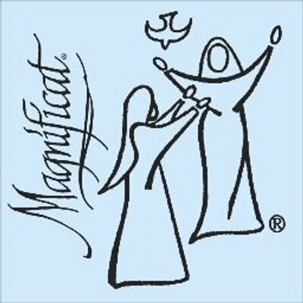
OLGC Magnificat Days
Marian Summer Camp
Date: June 26-28. Time: 9:00am-2:00pm
For children in grades 1-8

Come join us for fun activities and crafts, games, prayer and Mass as we learn about the Communion of Saints. Lunch and snacks will be provided. Sponsored by the OLGC Don Bosco Youth Group.
The Marian Sisters of Santa Rosa will be joining on Thursday
to help with the fun.‬
Register Now. Cost: $20/student or $30/family‬.
Scholarships Available - Just contact the office at 964-0229.

Registration forms are available in the back of the church or
from the office. Please return forms to one of
the CCD teachers or the office.

High School Students & Young Adults:
We need your help. Contact Mrs. Kasperson if you are available to help with activities for all or part of Magnificat Days.

In addition, donations of shoe boxes are needed for the crafts activities. Donations of snacks for each of the three days would also be greatly appreciated!
Please bring donations to the office
anytime prior to June 26.
Thank you & God bless,
The OLGC Don Bosco Youth Group

WEEKLY COLLECTION
MAY 19 & 20, 2018……$2,007.00
YOUTH MINISTRY……..$879.00

THIS WEEKEND’S SECOND COLLECTION:
ANNUAL MINISTRY APPEAL
NEXT WEEKEND’S SECOND COLLECTION:
LIABILITY INSURANCE
THANK YOU FOR YOUR SUPPORT &
CHRISTIAN GENEROSITY

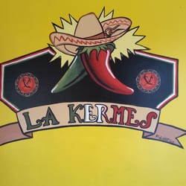
THE HISPANIC COMMITTEE OF OUR LADY OF GOOD COUNSEL
WOULD LIKE TO INVITE OUR COMMUNITY TO
“A KERMES”
(MEXICAN FOOD SALE & GAMES)
THAT WILL TAKE PLACE ON THE SCHOOL PATIO,
ON SUNDAY, JUNE 24TH
FROM NOON UNTIL 5PM.

WE ALSO NEED DONATIONS OF SODAS AND BOTTLED WATER.
YOU CAN BRING THEM TO THE OFFICE FROM 10AM – 2PM.

ALL BENEFITS WILL GO TOWARDS RETREATS AND/OR FESTIVITIES THROUGHOUT THE YEAR.
FOR MORE INFORMATION, CALL THE OFFICE AT 964-0229.

MASS INTENTIONS
MAY 28 – JUNE 3, 2018
Monday (28)  Tuesday (29)  Wednesday (30)  Thursday (31)  Friday (01)  Saturday (02)  Sunday (03) | 11:45am  12:05pm  12:05pm  12:05pm  6:00pm  9:00am  5:00pm  6:30pm  8:00am  10:00am | Communion Service  Communion Service  Luigia Romeri †  Gina Murada †  Guadalupe Sánchez Tejeda †  Crisanto Del Rosario †  OLGC’s Mass  Fred & Clara White †  Ruth Cimolino †  Antonia Yáñez (b-day)  Louis & Janet Andreani †  Bob & Lola Balassi †

PLEASE PRAY FOR OUR SICK PARISHIONERS
Tarcicio Garía, Sofía García, María de Jesús Mendoza, Ana García, Antonio Cazares, Evelyn Costa, Ryan Moore, Eileen Seeman, Marianne Brannan, Lilia Parrish, Nancy Smith, Peter Lopez, Julián Palomar, Luisa Martínez, Jennifer Vera, John Braet, Graciela Morales, Ana María López, Kim Koskinen, Margaret Valencia, Matthew Marcoulier, Dennis Tavares, Jose Freitas, Alfredo Sousa, Joel Morales, Manuel Muñoz Mendoza, Juana Arreguín, Aron Yasskin, Victoria Walzer, Fidela Yáñez Jara, Erika Ramos, Bill Gibson, Carla Tomas, Erasmo Yáñez, Memo Soria, Patricia Vargas, Fidela Yáñez, Rogelia Serrano, Elvia Flores, Camila Blanco-Cherrez, Yonel Ruíz, Angie Freitas, Russel Bryant, Derrick Heater, Luis Angel, Juan Barrera-Terán, Gabriel Hurtado, Gerald Butler, Helen Reynolds, Toni Clark, Ann Gallagher, Brianna Lopez, Margaret Milliken, Gina Pivirotto, Nick Quin, Mary Servis, Denis Sousa, Victor Venegas, Matty Walker, Charles Lorenz, Rebecca Lorenz, Ofelia Ibarra, Leonardo Naal, Gina Leal.

WEEKLY READINGS
Monday: 1 Pt 1: 3-9; Ps 111: 1-2, 5-6, 9-10c; Mk 10: 17-27
Tuesday: 1 Pt 1: 10-16; Ps 98: 1-4; Mk 10: 28-31
Wednesday: 1 Pt 1: 18-25; Ps 147: 12-15, 19-20; Mk 10: 32-45
Thursday: Zep 3: 14-18a or Rom 12: 9-16; Is 12: 2-3,
4 bcd-6; Lk 1: 39-56
Friday: 1 Pt 4: 7-13; Ps 96: 10-13; Mk 11: 11-26
Saturday: Jude 17, 20b-25; Ps 63: 2-6; Mk 11: 27-33
Sunday: Ex 24: 3-8; Ps 116: 12-13, 15-18; Heb 9: 11-15;
Mk 14: 12-16, 22-26

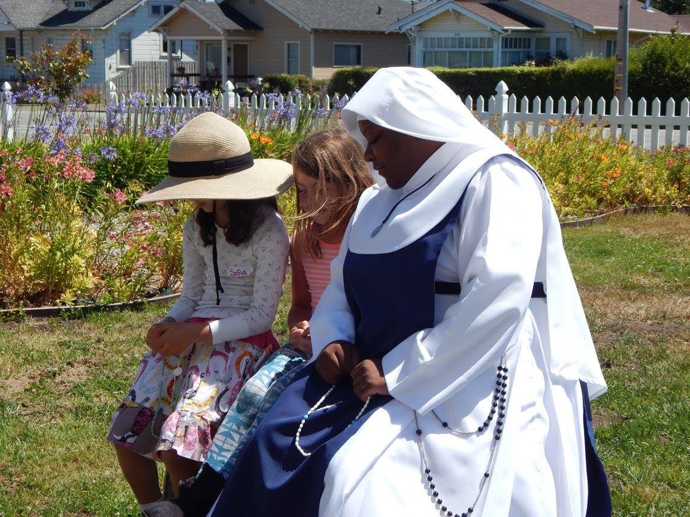

MARIAN SISTER AND TWO GIRLS PRAYING THE ROSARY
AT LAST YEAR’S MAGNIFICAT DAYS.

UNA DE LAS HERMANAS MARIANAS JUNTO CON DOS JOVENCITAS REZANDO EL ROSARIO DURANTES LOS DIAS DE LA MAGNIFICAT DEL AÑO PASADO.

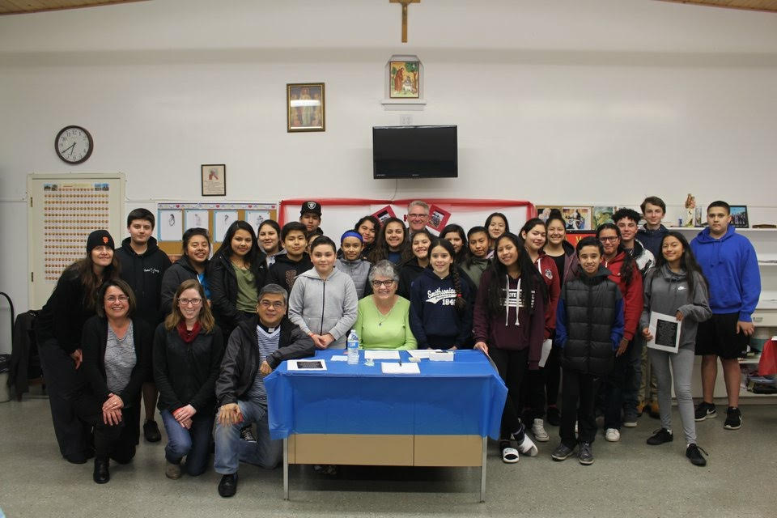
CONFIRMATION GROUP 2018

AFTER PRESENTING THEIR SAINT TO A FOUR MEMBER PANEL AND THEY WERE PRESENTED TO THE CHURCH AT THE FOLLOWING 10AM MASS.

GRUPO DE CONFIRMACION DE 2018, DESPUES DE HABER PRESENTADO EL NOMBRE DEL SANTO ESCOGIDO POR ELLOS A UN PANEL DE CUATRO PERSONAS Y AL DIA SIGUIENTE DURANTE LA MISA DE 10AM, EL PADRE ANDRES LOS PRESENTO A LA CONGREGACION.

NET MINISTRIES

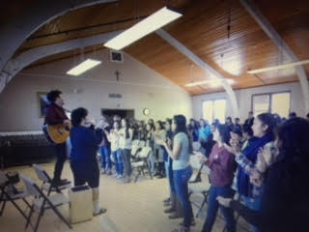

ON SUNDAY, MARCH 4TH, 12 YOUNG ADULTS (SOME FRESH OUT OF HIGH SCHOOL) FROM ALL OVER THE UNITED STATES AND EVEN THE WORLD CAME TO OLGC TO SHARE THEIR FAITH WITH THE YOUNG PEOPLE OF OUR PARISH.

EL DOMINGO 4 DE MARZO, 12 ADULTOS (ALGUNOS ACABADOS DE SALIR DE LA PREPARATORIOA (HIGH SCHOOL) DE TODO EL PAIS Y VARIAS PARTES DEL MUNDO) VINIERON A ESTA PARROQUIA PARA COMPARTIR SU FE Y SUS ENSENANZAS CON NUESTRA JUVENTUD.

