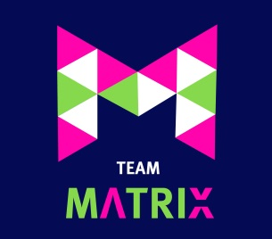

TEAM MATRIX NETBALL CLUB
CODE OF CONDUCT FOR UMPIRES

As an Umpire I will:

- Be affiliated to EN and comply with all rules, regulations and requirements of the sport including any leagues and competitions.

- Respect the rights, dignity and worth of all people involved in netball

- Not abuse or misuse any relationship of trust or position of power or influence held by me within my club.

- Conduct myself in an appropriate manner.

- Exercise self-control: I understand that verbal, emotional and physical abuse of coaches, spectators, athletes or other officials is not acceptable.

- Treat all officials with respect.

- Umpire consistently, independently and with complete impartiality and exercise reasonable care and skill to enforce the rules of the game, to apply them fairly and to effect control of the game so as to ensure the safety of the players at all times.

- Ensure that I will maintain the level of knowledge required by attending appropriate and approved EN Courses.

- Conform to the appropriate standard of mental and physical fitness defined by EN which will enable me to effectively control matches.

- Be Appropriately dressed whenever I umpire

- Abide by any disciplinary sanctions that might be imposed on me

- Abide by the “safeguarding best practice guidelines” for children and young people.

- Promote this code of conduct to other umpires and officials.

I will not:

- Consume alcoholic drinks or illegal substances or smoke around athletes.

- Wager on any match or at any event where I am umpiring

- Coach during any match at which I am umpiring

- Use social media technology to bring the game into disrepute or make an inappropriate comment about a fellow official, coach, athlete, volunteer or the NGB.

I have fully read and understood the above Conduct of Conduct for Umpires and will ensure that my conduct and practice reflects the above points.
Signed: Dated:
NAME:

