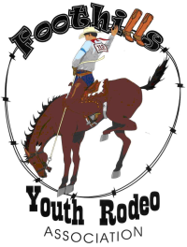
FOOTHILLS YOUTH RODEO ASSOC.
QUEEN/PRINCESS CONTEST
CONTESTANT BIOGRAPHY

PLEASE TYPE! USE THIS OFFICIAL FORM ONLY, NO OTHER RESUME, COMPUTER ALTERED BIOGRAPHY OR ADDITIONAL PAGES WILL BE ACCEPTED. Call for e-mail word version!

HOME STATE:

FULL NAME: AGE:

CURRENT GRADE LEVEL: HOMETOWN:

PARENT’S NAMES:

SCHOOL NAME:

RODEO EVENTS:

HOW MANY YEARS IN FYRA RODEO? HORSE’S NAMES:

SPEECH TITLE/TOPIC:

ADDITIONAL INFORMATION TO BE USED BY THE JUDGES:

ACADEMIC ACHIEVEMENTS:

OTHER ACTIVITIES:

IF YOU HAD ONE WISH TO COME TRUE, WHAT WOULD IT BE?

FUTURE PLANS AFTER FYRA RODEO:

ANY OTHER COMMENTS ABOUT YOURSELF, SCHOOL, OR FYRA RODEO:

