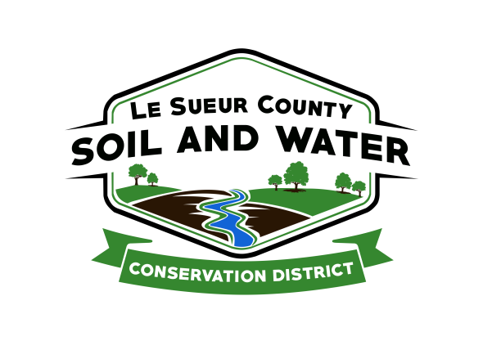

Le Sueur County Soil & Water Conservation District

Le Sueur County SWCD Tel. (507) 419-0365
181 W Minnesota St Website: www.lesueurswcd.org
Le Center, MN 56057

Minutes from March 8, 2022 regular meeting of the Le Sueur County SWCD Board of Supervisors. Le Sueur County Justice Center, Le Center, MN.

Meeting was called to order by Chairman Struck at 9:00 am.

Members present: Chairman, Jim Struck
Vice-Chairman, Greg Entinger
Secretary, Earle Traxler
Treasurer, Cletus Gregor
PR&I, Glendon Braun

Others present: District Manager, Mike Schultz
District Technician, Joe Jirik
Ditch Specialist, Nik Kadel
Resource Technician, Karl Schmidtke
District Conservationist, Steve Breaker
Program Specialist, Sue Prchal
County Commission, Steve Rohlfing

The Pledge of Allegiance was recited.

Secretary’s report from February 8, 2022 was read and approved.

Treasurer’s report for January 31, 2022 was read. Motion by Entinger, second by Traxler to approve as read.
Affirmative: All
Opposed: None
Motion carried

Secretary’s report for February 28, 2022 was read. Motion by Traxler, second by Braun to approve as read and to pay bills.
Affirmative: All
Opposed: None
Motion carried

Mike updated the board on the following: employee benefits
bids for tables, chairs and a tv for the back room
drainage steering committee
county ditch meetings coming up to discuss repairs
1W1P Cannon – projects will be starting soon.
1W1P Lower MN – MOA agreement to be adopted

Motion by Gregor, second by Entinger to purchase furniture and tv needed for the back room in the SWCD building.
Affirmative: All
Opposed: None
Motion carried

The board was given notice of the following upcoming meetings/trainings:

Legislative Days – March 9/10, briefing on the 9th at the Radisson Hotel, St Paul and
on the 10th virtual meetings with legislators

Growing Healthy Soils - March 16 @ Ridges of Sand Creek, Jordan
Shoreland Regulations & Requirements – March 16
1W1P Lower MN policy meeting – March 17
SWCD Manager Meeting – March 30-31, Brainerd
1W1P Cannon – policy meeting April 6
HR training – April 6-7, St. Cloud
Area 6 Meeting – April 6, New Ulm
Water testing clinic – April 28, Environmental Services

The 2021 SWCD annual report was handed out and discussed.

Motion by Gregor, second by Entinger to encumber $4000.00 for Steve Biehn/Jim Struck cost-share contract #Wash-4 for sediment basins where 25% or $1,000 will come from Lake Washington Improvement Association and 75% or $3,000 from the Lake Washington Grant.
Affirmative: Entinger, Traxler, Gregor, Braun
Abstained: Struck
Opposed: None
Motion carried

Motion by Traxler, second by Gregor to encumber $3900.00 for Teresa Mulvehill/Jim Struck cost-share contract #Wash-5 for sediment basins where 25% or $975 will come from Lake Washington Improvement Association and 75% or $2,925 from the Lake Washington Grant.
Affirmative: Entinger, Traxler, Gregor, Braun
Abstained: Struck
Opposed: None
Motion carried

Mike informed the board of the new Water Storage Grant available through BWSR. The SWCD will be submitting an application for the Lake Washington Watershed.

Steve went over the Civil Rights policy with the board and the MOA between the SWCD and NRCS. He discussed posters and statements regarding discrimination, that are displayed at the office. He discussed SWCD board diversification also.

Commissioner Rohlfing discussed updates at the courthouse such as remodeling, remote working and commented that any new building permits in Le Sueur County will need to have a septic inspection beginning April 1, 2022 if there is a current septic system on the building site.

There being no further business, meeting adjourned at 10:45 am.

The board and staff will be meeting for lunch and a strategic planning session.

______________________ ___________________________________________
Date District Secretary

