World War II enemies become friends 70 years later
Lauren Abdel-Razzaq, The Detroit News September 24, 2014
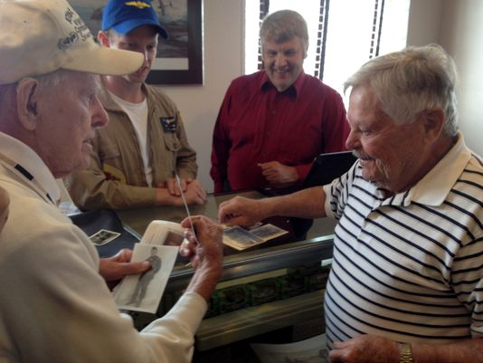Buy Photo
(Photo: Lauren Abdel-Razzaq, The Detroit News)

St. Clair Shores — Exactly 70 years ago to the day, Arno Whitbread and Josef Hoettel were fighting against each other in a war that would change the framework of the world.
On Saturday, they shook hands and met each other for the first time.

Whitbread, 94, was a glider infantryman in the U.S. Army during World War II, among the first troops to invade Normandy. He continued on with Allied forces through the rest of France and into the Netherlands and Germany during the rest of the war in Europe.
Josef Hoettel, 90, was drafted into the German Army on his 18th birthday and served in Italy for most of the war before being taken prisoner by the Americans.

"We were big enemies," said Hoettel. "Now we are friends."

"Small world," added Whitbread.

The two St. Clair Shores residents shared war stories during a 70th anniversary commemoration of Operation Market Garden at the Detroit Arsenal of Democracy Museum.

Market Garden was the largest airborne offensive of the war to that point, and it was a huge failure for the British, who were leading the mission. Whitbread was one of the men who were dropped in from above that day to fight.

"It was kind of rough," said Whitbread. "We didn't know if we were going to make it to the next day."

Seven decades later, he swapped photos with Hoettel, who escaped from East Germany after the war and eventually made his way to Canada before immigrating to the U.S. in 1968.

The pair's meeting was a surprise to museum staff, including director and founder John Lind.

The day included a discussion about the offensive from Sept. 17-25, 1944, on the border between Germany and the Netherlands. The Allies' goal was to end the war by Christmas that year. But the mission was a failure.

"The difference between Normandy and Market Garden was that this time, they had secured the sky 100 percent," Lind told a group of about two dozen at the museum. "They thought it would be a walk in the park. The British ended up losing 8,000 soldiers."

Lind also gave a talk about the 1977 movie "A Bridge Too Far," which depicted the Market Garden offensive. Lind said he wanted to hold a commemoration for Operation Market Garden because it was an important battle in the war.

"It basically decimated the First British airborne division," said Lind. "I do it because there are veterans here who were in it and I want to honor them as best as I can."

Story Highlights
Operation Market Garden took place Sept. 17-25, 1944 on the German/Netherlands border.
Nearly 8,000 Allied soldiers were killed in the failed mission.
Arno Whitbread, 94, of St. Clair Shores, was a glider in the offensive 70 years ago.

