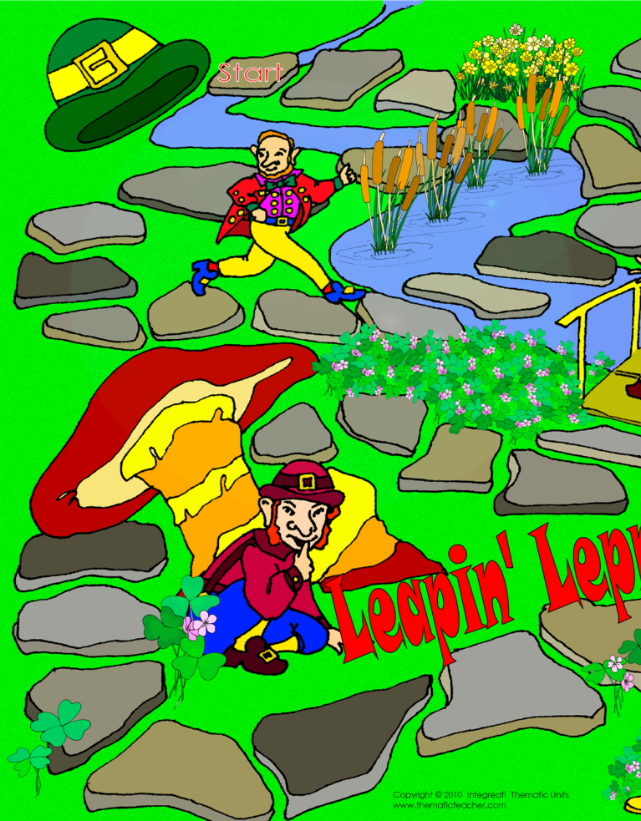

Type your words or questions here.
Type your words or questions here.
Type your words or questions here.
Type your words or questions here.
Type your words or questions here.
Type your words or questions here.
Type your words or questions here.
Type your words or questions here.
Type your words or questions here.
Type your words or questions here.
Type your words or questions here.
Type your words or questions here.
Type your words or questions here.
Type your words or questions here.
Type your words or questions here.
Type your words or questions here.

Type your words or questions here.
Type your words or questions here.
Type your words or questions here.
Type your words or questions here.

Type your words or questions here.
Type your words or questions here.
Type your words or questions here.
Type your words or questions here.
Type your words or questions here.
Type your words or questions here.
Type your words or questions here.
Type your words or questions here.
Type your words or questions here.
Type your words or questions here.
Type your words or questions here.
Type your words or questions here.
Type your words or questions here.
Type your words or questions here.
Type your words or questions here.
Type your words or questions here.

Leapin’ Leprechauns
Tips and Suggestions

You can use this game board with any set of flashcards, or lists of questions and answers that you want the children to practice. With emergent and beginning readers, you may give them a book you want them to practice, and after reading a page they may then take their turn. Turn your standardized test practice sheets into individual flashcards and have the kids play to practice. You may also use the mini game cards to produce your own set of cards to practice. If you have access to Microsoft ™ Word, all you have to do is type your own sight words, spelling words, vocabulary words, math facts, formulas, science, or social studies facts into the space. It is easy to change the font size to fit more or less in the small space.
Run off the game materials on 8.5x11 white construction paper or cover stock. Trim the inside space on the game board sections, tape it together on the back, and laminate. You will need to supply one die and a couple of small manipulatives (counters, colored beans, chips, etc.) to use as markers. Store these with the flashcards in a zipper baggie and you’ll have a fun activity to add to your classroom centers. If you have access to a large format printer, you can print the 11x17 version directly onto a piece of ledger sized paper, or take it to a copy center. Make enough boards for several groups to play at once.
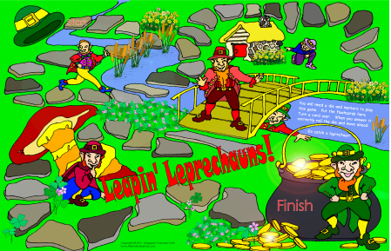

Copyright © 2010 by Integreat! Thematic Units All rights reserved.
Permission to reproduce these classroom materials is given to educators for use with their own students or clients in their classroom. They may change the publication to make it more suitable for their own personal use. It may not be redistributed for any reason without written authorization from the author.

Credits: Game board drawn by Sallie Ehrlich, Watercolor Artist.
www.thematicteacher.com

