RSAI Position Paper
School Choice and the Priority of Public Schools

Current Reality: Iowa has a wide range of school choice for parents and students, including:
- A neighborhood public school or a public school in another neighborhood within the school district (transfers regulated by local school board).
- Open enrollment to another school district (with application filed by the March 1 deadline the year prior to enrollment) in 328 school districts, with a total of 31,369 students exercising this option in the 2016-17 school year.
- Open enrollment to another school district if request meets the criteria set by the local school board in the remaining five districts with voluntary diversity plans (total of over 2,500 students open enrolled out of those five districts in the 2016-17 school year).
- Open enrollment in an Iowa public virtual academy (CAM/Anita & Clayton Ridge).
- Strong nonpublic schools, with 34,226 students enrolled in private schools in 2016-17. Private schools and parents are supported by millions of state tax dollars for school tuition organization scholarships, tuition and textbook tax credits, transportation and textbook funds to private schools, public school and AEA support for special education in private schools, and public/private partnerships for private preschool tuition in the statewide voluntary preschool program. Worthy of note: according to State Tax Subsidies for Private K-12 Education by the Institute for Taxation and Economic Policy, Oct. 2016, of the 17 states that have either private school scholarships or private school tuition/expenses tax credit, Iowa is one of only five that have both (AL, IA, IN, LA, SC).
- Home school assistance (competent private instruction) or independent private instruction.
- All told, over $53 million in state tax dollars support the education of Iowa students in private and home school settings.
Vouchers or Education Savings Accounts Costs Outweigh Benefits: Further Iowa public investment in private schools will not add the benefits often touted and will negatively impact public school students:
- Voucher proponents suggest that competition will improve outcomes for students. First, in Iowa, there is already enough competition to pressure schools to preform, if competition really does provide positive pressure. But according to the Economic Policy Institute Report, Feb. 28, 2017, School vouchers are not a proven strategy for improving student achievement. “Research does not show that vouchers significantly improve student achievement.”
- They also conclude that there are more effective ways than vouchers to increase graduation and college attendance rates, that vouchers programs have hidden costs, including shrinking the pipeline into teaching, and that supports for privatization detract from more proven methods of improving student learning.
- Iowa’s current budget situation does not provide adequate resources for public schools. If an increasing part of a very small pie is carved out for vouchers, there will be less available for public schools. According to the Institute on Taxation and Economic Policy, State Tax Subsidies for Private K-12 Education, Oct. 2016, “30 neovouchers across 20 states are draining over $1 billion in public revenues from state coffers every year. Every dollar of revenue diverted toward private schools is revenue that cannot be invested in the public education system. Allowing certain taxpayers to opt out of funding an institution as fundamentally important as the nation’s public school system erodes the public’s level of investment in that institution – both literally and figuratively.”

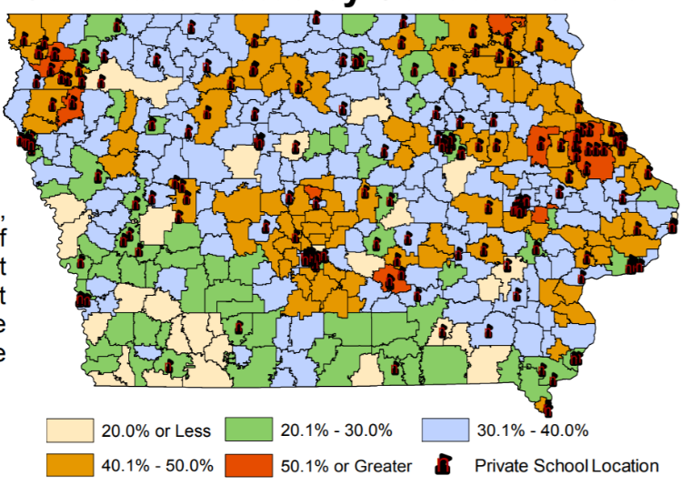
- Statewide complications occur: the survival of rural schools depends on adequate state funding, yet there are few private schools available for their parents to choose as an alternative. This map from the Department of Revenue presentation to the Tax Expenditure Committee measuring participation in Iowa’s Tuition and Textbook Tax Credit, November 2017, shows the gaps in private school geography. According to the National Rural Education Association, investing in vouchers reduces resources to rural schools and saves money for parents in urban centers. Meanwhile, student poverty and minority concentration in the inner cities is exacerbated when families with means are encouraged to leave the public school for a private program, increasing the challenge of urban districts while decreasing resources.
- The Institute also finds insufficient budgetary oversight of voucher programs. There is no publicly elected school board or Department of Education regulating and reporting allowable expenditures. The public does not have access to records or public meetings. Good stewardship of tax dollars requires transparency and clearly articulated expectations.
- Public schools are accountable to taxpayers, parents, communities, i.e., the public and serve all students. Public schools cannot jettison students that are not meeting expectations or refuse enrollment based on specific student needs, such as disabilities, or students who are non-English-speaking, minority or low income. If additional state dollars are used to fund vouchers, it is only fair that the private schools receiving those tax dollars also comply with testing, reporting, and service requirements.

The Rural School Advocates of Iowa call on legislators and our governor to invest in Iowa’s public schools who educate 96% of Iowa students before creating even more private school and home school options.
Margaret Buckton, RSAI Professional Advocate margaret@iowaschoolfinance.com

