2015
Hunter Education
Kern County - Frazier Park

Hunter Education Courses for Men, Women, and Youths is now being offered. This
1-day course will be held at Chuchupate FS Ranger Station in Frazier Park.
34580 Lockwood Valley Rd., Frazier Park, Ca 93225

Class cost $ 20.00 per student. Minimum 10 students to hold class.

July 11

Print Clearly

Students Name: Date of Birth:

Address: City: Zip:

Phone: Work:

Email Address:

Disabilities or Special Needs:

CASH (no C.O.D’s)
CHECK (make payable to DF-Hunter Education)

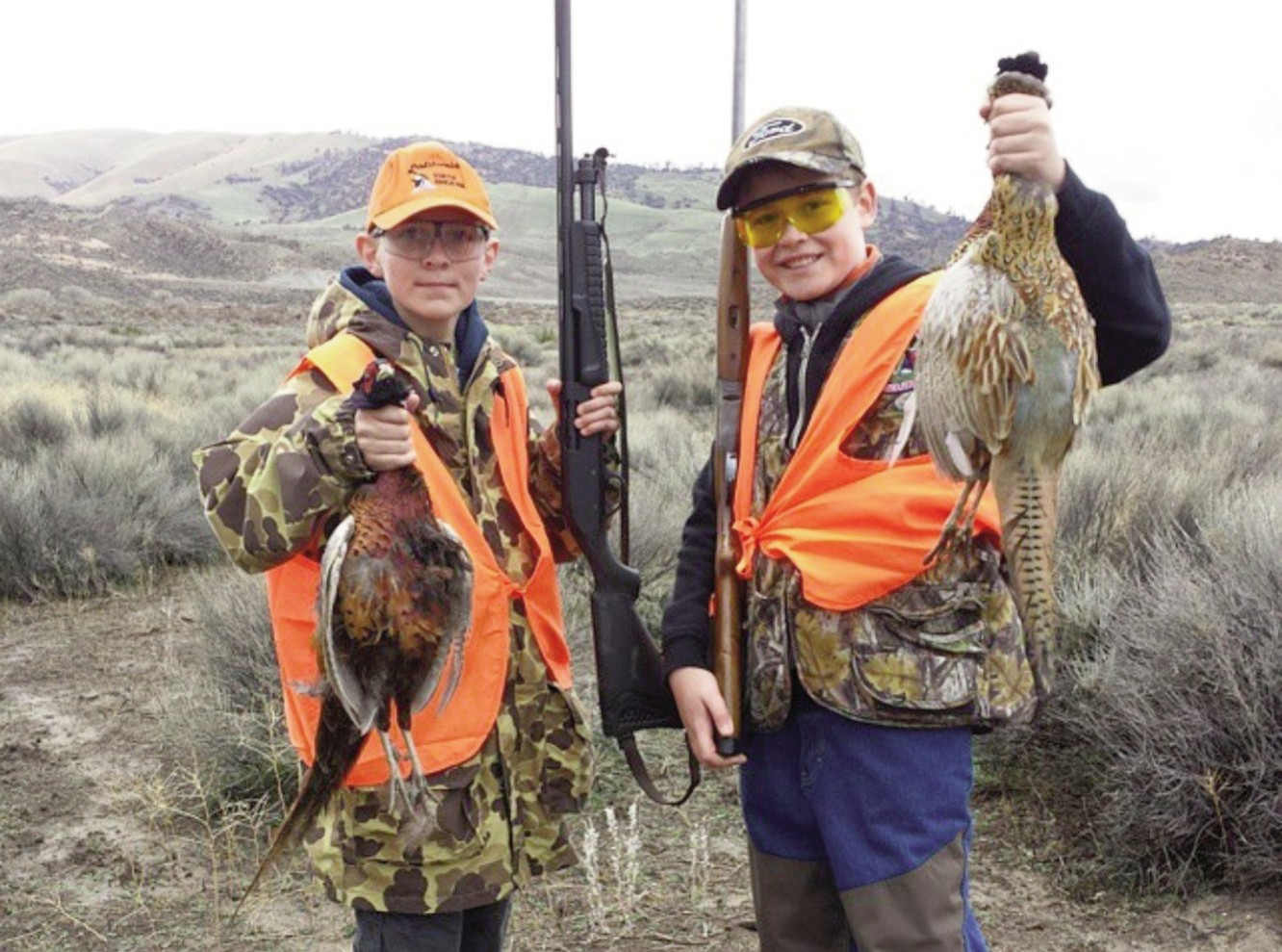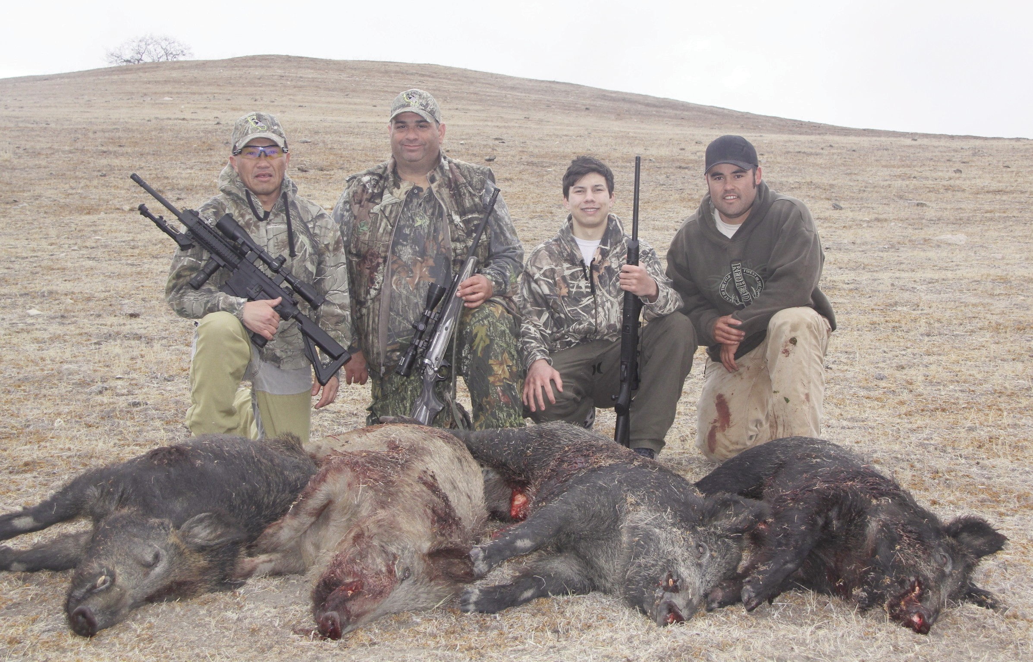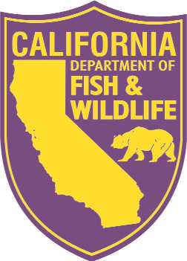
HunterEdClass@HunterEdClass.com

CREDIT CARD NUMBER: EXP. DATE: CARD HOLDER NAME: 3 digit code (back of card)
Billing Address:

Signature:

Information Only: Call (661) 297-0876 or Email: HunterEdClass@HunterEdClass.com - www.HunterEdClass.com
CLASS COST | $ 20.00
TOTAL

Mail Registration Form & Deposits To: Hunter Education, P.O. Box 802738, Santa Clarita, California 91380-2738
Email Registration Form To: HunterEdClass@HunterEdClass.com
Minimum $ 10.00 Deposit required with all registrations if not paying in full. Payment IS NOT refundable for non-attendees.
A $ 25.00 charge will be added to any returned Checks or cancelled Credit Card Payments and Hunter Education Certificates will be VOIDED in lieu of payment.

