Saving a Google Form or Spreadsheet to Your Taskbar
1. Open the google form or spreadsheet in Chrome. In the upper right corner of the window (next to the address bar), click the 3 vertical dots. Choose “More Tools” and then “Create shortcut.”
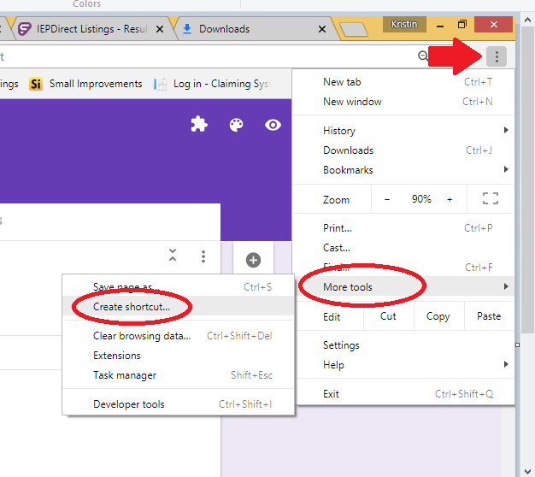

2. You can adjust the name of your shortcut, if you wish, then click “Create.”

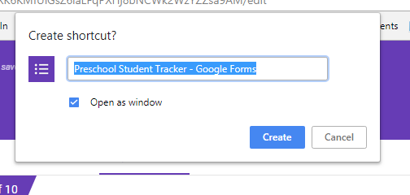

3. Find the new shortcut icon on your desktop (it will be purple for a Form, green for a Spreadsheet.) Right-click the shortcut and then choose “Pin to Taskbar.”
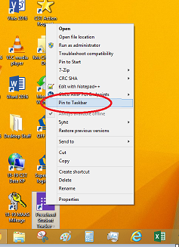

4. Now your form or spreadsheet will always be at the bottom of your screen for quick access.
