March 2017 At a glance
Full descriptions of activities in bulletin.

Sun | Mon | Tues | Wed | Thurs | Fri | Sat
5  Zero Waste Sunday  1 Lent  Worship  11:15  Communion | 6  AA 7:30 pm  Meditation  7 pm | 7  Cards  9:30  TOPS  6:30 | 8  Soup Supper  6 pm  Lent  Service  7 pm  Faith Exploration 7:30 | 9  Russell away – family funeral | 10 | 11  Women’s Breakfast  8 am
12  Worship  11:15  Open Hearts Jar  Farewell for Pastor Carla 2 pm  Russell away | 13  AA 7:30 pm  Meditation  7 pm | 14  Cards  9:30  TOPS  6:30 | 15  Lent  Service  7 pm  Faith Expl. 7:30 pm | 16  Craft/Study  1:30  Buddhist Meditation 7 pm w Faith Expl. | 17  Film & Faith | 18  Russell away
19  Worship  11:15  Russell away - Skylight | 20  AA 7:30 pm  Meditation  7 pm | 21  Cards  9:30  TOPS  6:30  Godly Play Training  6:30 pm | 22  Lent  Service  7 pm | 23  Craft/Study  1:30 | 24 | 25  Russell away  IMCF Breakfast  9 am
26  Worship  11:15  Potluck  Cong. Care  Speaker  Russell away - Arizona | 27  AA 7:30 pm  Meditation  7 pm | 28  Cards  9:30  TOPS  6:30 | 29  Lent  Service  7 pm | 30  Craft/Study  1:30 | 31 | 1

TOPS = Take Off Pounds Sensibly
AA = Alcoholics Anonymous

We are excited to have Christine Lwanga joining us to deliver the reflection today in celebration of a slightly extended Black History Month! Christine emigrated from Uganda about 20 years ago and she is well-known in Regina for her involvement in a variety of social movements, including support for women, refugees, African-Canadians, and other equity-seeking groups. She was a commissioner on the Saskatchewan Human Rights Commission for ten years and recipient of a Saskatchewan Centennial Medal for community service and a YWCA Woman of Distinction award.
ANNOUNCEMENTS
March 5, 2017

306-761-0556 eastsideunited@sasktel.net
Like us on facebook (Eastside United Church)
Follow us on Twitter @Eastside_united
www.eastsideunited.ca

W
elcome to Eastside United. May our opportunities of ministry offer you rest, challenge and peace on your Christian journey.
Ministers:
Minister: Russell Mitchell-Walker with Christine Lwanga
Greeting: Sheri Nupdal, Marg and Leif Riesach
Congregational Care Greeter: Linda Fowler
Prayers: Doug Scheurwater
PowerPoint: Taylor Balfour
Piano: Michelle Dickie
sunday
Attendance last week:

Russell’s e-mail address: russell.eastside@sasktel.net

Office Hours:
Tuesday, Wednesday and Thursday from 8:30 am to 3:30 pm

Russell is in the office Tuesday through Thursday from 9 am to 4:30 pm, working from home on Friday. He will be away March 9 through 12 for a family funeral and March 18 through 21 at Skylight Planning meetings.

Brewed Awakening Office Hours, Wednesday afternoons from 2 to 4:30 pm. At U of R Campion College for the month of March. NO Coffee Shop hours March 8.

Scripture Reading: Luke 10: 25-42

Songs:
All Who are Thirsty MV #4
O Beautiful Gaia MV #41 vs2
Sow Seeds
Let us Talents and Tongues Employ VU #468
Called by Earth and Sky MV #135 chorus
We Have This Ministry VU #510
Spirit Song

Arcola East Senior Bridge Club: Looking for a fun way to get out and socialize with other seniors? The Arcola East Senior Bridge Club gathers for social bridge each Monday at 1 pm at the Living Spirit Centre (3018 Doan Drive). No prize money; weekly fee is $1. For more information, please contact Bill Jeske at 306-789-2430 or Alma Pockrandt at 306-789-5981 or apockra@yahoo.ca.
Join us for Easter
Worship

April 9 Palm Sunday
A Walk through Holy Week All Ages Service
11:15 am

April 13 Maundy Thursday
Teaching Seder with Bread of Life
7 pm

April 14 Good Friday
Memorial Wake with IMCF
Featuring Creator’s Sacrifice Paintings
7 pm

April 15 Easter Vigil
At St. Paul’s Anglican Cathedral
with St. Philip Anglican
10 pm

April 16 Easter Sunday
Sunrise Service 5:45 am
Easter Worship 11:15 am

LSC Meditation Group: The Meditation Group gathers at 7 pm Monday evenings in the East Sanctuary. Feel free to bring a friend, and dress comfortably.

St. Philip Senior Ministry Outreach card playing program, Tuesday mornings at 9:30 am in the East Sanctuary at the Living Spirit Centre. Whist and lessons to those that would like to learn. Come out and enjoy fellowship, coffee and card playing. If you need a ride call Rod 306-789-1388. Everyone is welcome.

Eastside’s Craft/Study Group Thursdays at 1:30 pm in the Multipurpose Room! Join us as we share in discussion, handiwork and coffee time following. We will soon begin Grounded by Diana Butler Bass and will be placing a book order shortly. If you haven't been involved in this group in the past but would like to, please contact the office and we'll set you up! Current members will have the chance to sign up at your next gathering. This is a fun time of study, crafting, and refreshments following.
We’d love you to join our family! We are planning a Transfer of Membership service Sunday, March 12. If you are interested in being included or have questions, please let Russell know.
Understanding World Religions: Leaders from four of the large world religions will talk about their faith including origins, customs, and belief systems. A different religion will be featured each week – Islam, Hinduism, Buddhism and Sikhism. Thursdays, March 2, 9, 16, 23 from 10 to 11:30 am at 2151 Scarth Street, Room 109. These presentations are FREE and everyone is invited to attend. Space is limited so call 306-585-5748 to reserve your seat today! Drop-ins also welcome if space permits. This is a program of the University of Regina’s Lifelong Learning Centre.

JOIN US FOR LENTEN SOUP: Wednesday, March 8 at 6 pm, Munch Café and Catering is again providing a simple soup meal prior to our evening Lenten worship. Vegetarian and meaty soup options and bread will be served. RSVP to eastsideunited@sasktel.net. $5 per person.

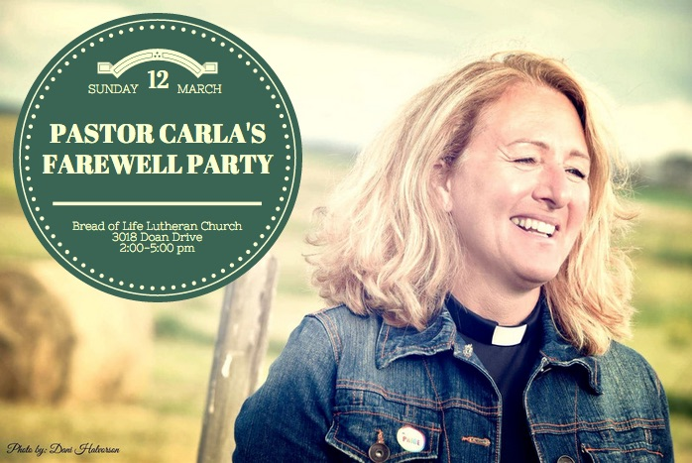
Sunday School will be offering Godly Play! We will hear the story during Theme Time and need volunteers to supervise the kids’ creative play downstairs. Our training session has been rescheduled to Tuesday, March 21 at 6:30 pm. Please let Russell know if you’d like to work with our kids in this way! Children will remain in worship until this workshop and we need volunteers.
Easter is Coming!
We are beginning to prepare for our Easter Egg Hunt, our gift to the community. If you wish to help with the planning, let Russell or Terri Lynn Frederickson know. We also need egg cartons, so please bring them to the church. Thanks!

LSC Women’s Spirituality Breakfast, Saturday, March 11 from 8 to 10 am. This month’s special guest is Sandra Fowler. Sandra will be sharing about a recent Canadian Food Grains Study Tour to Nicaragua in which she took part. This tour included meeting with rural communities who explained their child nutrition programs, conservation agriculture and land bank programs; a visit to a United Church Mission and Service partner in Managua; and learning from academics and Oxfam workers about the history and political situation in the country; but the true joy was getting to know Nicaraguans and learning how, with the help of the Food Grains Bank, they are improving their lives and the lives of their children. Sandra is a United Church lay worship leader who lives near Eyebrow where she and her husband and daughter have a cattle and sheep operation (and is Sarah Tkachuk’s mom, too!). All women are welcome to attend – please bring a toonie to help with breakfast costs.

A Night for St. Andrew’s Gala Dinner and Fundraiser, Tuesday, April 18, 2017 at the Wascana Country Club, 6500 Wascana Parkway. Gathering 5 pm, dinner 6:15 pm. Tickets $110 (partial tax receipt), ticket deadline April 10. See Leona Martin or contact the church office if interested. This year’s fundraiser includes an address by Right Reverend Jordan Cantwell, UCC Moderator, and music by Lori Erhardt and Corinne Groff!

TIME OUT FOR BLESSINGS: A Christ-centred yoga retreat presented by Connie Moker Wernikowski of Big Fish Yoga. Friday, April 28 at 6 pm to Saturday April 29 at 5 pm. At the living Skies Retreat Centre in Lumsden, SK. This retreat will offer both active and restorative yoga; meditation; some free time for walking, resting, visiting; Christian chanting; and an intro to the First Ignation Spiritual Exercise. Cost is $193. Please complete a registration form found on any of the LSC bulletin boards, or by emailing mokerw@sasktel.net.

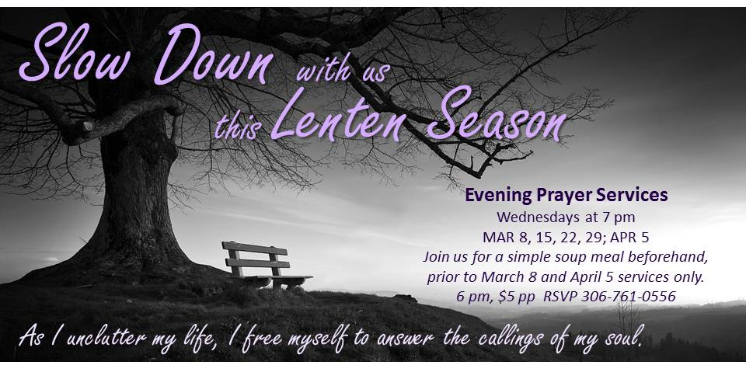

Sunday School will be offering Godly Play! We will hear the story during Theme Time and need volunteers to supervise the kids’ creative play downstairs. Our training session has been rescheduled to Tuesday, March 21 at 6:30 pm. Please let Russell know if you’d like to work with our kids in this way! Children will remain in worship until this workshop and we need volunteers.
Easter is Coming!
We are beginning to prepare for our Easter Egg Hunt, our gift to the community. If you wish to help with the planning, let Russell or Terri Lynn Frederickson know. We also need egg cartons, so please bring them to the church. Thanks!

LSC Women’s Spirituality Breakfast, Saturday, March 11 from 8 to 10 am. This month’s special guest is Sandra Fowler. Sandra will be sharing about a recent Canadian Food Grains Study Tour to Nicaragua in which she took part. This tour included meeting with rural communities who explained their child nutrition programs, conservation agriculture and land bank programs; a visit to a United Church Mission and Service partner in Managua; and learning from academics and Oxfam workers about the history and political situation in the country; but the true joy was getting to know Nicaraguans and learning how, with the help of the Food Grains Bank, they are improving their lives and the lives of their children. Sandra is a United Church lay worship leader who lives near Eyebrow where she and her husband and daughter have a cattle and sheep operation (and is Sarah Tkachuk’s mom, too!). All women are welcome to attend – please bring a toonie to help with breakfast costs.

A Night for St. Andrew’s Gala Dinner and Fundraiser, Tuesday, April 18, 2017 at the Wascana Country Club, 6500 Wascana Parkway. Gathering 5 pm, dinner 6:15 pm. Tickets $110 (partial tax receipt), ticket deadline April 10. See Leona Martin or contact the church office if interested. This year’s fundraiser includes an address by Right Reverend Jordan Cantwell, UCC Moderator, and music by Lori Erhardt and Corinne Groff!

TIME OUT FOR BLESSINGS: A Christ-centred yoga retreat presented by Connie Moker Wernikowski of Big Fish Yoga. Friday, April 28 at 6 pm to Saturday April 29 at 5 pm. At the living Skies Retreat Centre in Lumsden, SK. This retreat will offer both active and restorative yoga; meditation; some free time for walking, resting, visiting; Christian chanting; and an intro to the First Ignation Spiritual Exercise. Cost is $193. Please complete a registration form found on any of the LSC bulletin boards, or by emailing mokerw@sasktel.net.

