April 2017 At a glance
Full descriptions of activities in bulletin.

Sun | Mon | Tues | Wed | Thurs | Fri | Sat
2  Worship  11:15  Communion  Special education for kids re communion  Remits pres | 3  AA 7:30 pm  Meditation  7 pm | 4  Cards  9:30  TOPS  6:30 | 5  Soup Supper  6 pm  Lent  Service  7 pm  Faith Expl. 7:30 pm | 6  Craft/Study  1:30  Family Dinner  6 pm  Faith Formation 7:30 pm | 7  Hindu Temple  7 pm | 8  Women’s Breakfast  8 am  Easter Egg Hunt! 1 pm
9  Worship  11:15  Open Hearts Jar | 10  AA 7:30 pm  Meditation  7 pm | 11  Cards  9:30  TOPS  6:30 | 12  Community Study Night  8 pm | 13  Teaching Seder at LSC 7 pm | 14  Good Friday Memorial Wake  7 pm | 15  Easter Vigil at St. Paul’s Cathedral 10 pm
16  Sunrise Service and potluck breakfast  5:45 am Worship  11:15 | 17  AA 7:30 pm  Meditation  7 pm | 18  Cards  9:30  TOPS  6:30 | 19  Faith Expl. 7:30 pm | 20  Craft/Study  1:30  LT Meeting  7 pm | 21  Film and Faith | 22  IMCF Breakfast  9 am to 12
23  Worship  11:15  Transfer of Membership  POTLUCK  Cong. Care  Speaker | 24  AA 7:30 pm  Meditation  7 pm | 25  Cards  9:30  TOPS  6:30  Russell at Inhabit Conference | 26 | 27  Craft/Study  1:30 | 28 | 29
30  Worship  11:15 | 1  AA 7:30 pm  Meditation  7 pm | 2  Cards  9:30  TOPS  6:30 | 3  Faith Expl. 7:30 pm | 4  Cong. Care  10 am  Craft/Study  1:30  Prayer Writing Workshop  7 pm | 5 | 6

TOPS = Take Off Pounds Sensibly
AA = Alcoholics Anonymous

ANNOUNCEMENTS
April 2, 2017

306-761-0556 eastsideunited@sasktel.net
Like us on facebook (Eastside United Church)
Follow us on Twitter @Eastside_united
www.eastsideunited.ca

W
elcome to Eastside United. May our opportunities of ministry offer you rest, challenge and peace on your Christian journey.

Ministers:
Minister: Russell Mitchell-Walker
Greeting: Linda and Larry Fowler
Congregational Care Greeter: Sheri Nupdal
Prayers: Mavis Olesen
PowerPoint: Steph Banks
Piano:Josh Hendricksen
Attendance last week:73

Russell’s e-mail address: russell.eastside@sasktel.net

Office Hours:
Tuesday through Friday from 8:30 am to 3:30 pm
Brewed Awakening Office Hours, Wednesday afternoons from 2 to 4:30 pm. At Woodhams Drive location for the month of April.

Scripture Reading: Luke 18:31-19:10

Songs:
All Who are Thirsty MV #4
O Beautiful Gaia MV #41 vs 1
Jesus Christ is Waiting VU #117
Called by Earth and Sky MV #135 chorus
The Church is Wherever God’s People VU #579
Spirit Song

JOIN US FOR LENTEN SOUP: Wednesday, April 5 at 6 pm, Munch Café and Catering is again providing a simple soup meal prior to our evening Lenten worship. Vegetarian and meaty soup options and bread will be served. RSVP to eastsideunited@sasktel.net. $5 per person.

Arcola East Senior Bridge Club: Looking for a fun way to get out and socialize with other seniors? The Arcola East Senior Bridge Club gathers for social bridge each Monday at 1 pm at the Living Spirit Centre (3018 Doan Drive). No prize money; weekly fee is $1. For more information, please contact Bill Jeske at 306-789-2430 or Alma Pockrandt at 306-789-5981 or apockra@yahoo.ca.
Join us for Easter
Worship

April 9 Palm Sunday
A Walk through Holy Week All Ages Service
11:15 am

April 13 Maundy Thursday
Teaching Seder with Bread of Life
7 pm

April 14 Good Friday
Memorial Wake with IMCF
Featuring Creator’s Sacrifice Paintings
7 pm

April 15 Easter Vigil
At St. Paul’s Anglican Cathedral
with St. Philip Anglican
10 pm

April 16 Easter Sunday
Sunrise Service 5:45 am at LSC
Easter Worship 11:15 am

LSC Meditation Group: The Meditation Group gathers at 7 pm Monday evenings in the East Sanctuary. Feel free to bring a friend, and dress comfortably.

St. Philip Senior Ministry Outreach card playing program, Tuesday mornings at 9:30 am in the East Sanctuary at the Living Spirit Centre. Whist and lessons to those that would like to learn. Come out and enjoy fellowship, coffee and card playing. If you need a ride call Rod 306-789-1388. Everyone is welcome.

Eastside’s Craft/Study Group Thursdays at 1:30 pm in the Multipurpose Room! Join us as we share in discussion, handiwork and coffee time following. We are reading Grounded by Diana Butler Bass. This is a fun time of study, crafting, and refreshments following.

Join us for our weekly Lenten service Wednesday evenings at 7 pm. These short services take place in the East Sanctuary. All are welcome!

All are welcome to join the Faith Exploration group as we visit the holy places of other faith traditions: Friday, April 7 at 7 pm, Hindu Temple at 3307 Pasqua Street.

Community Easter Egg Hunt, Saturday, April 8, 2017.
Last year's Easter Egg Hunt was a huge success and we are excited to offer this event to our community again this year. We still need lots of volunteers to donate chocolate and to help in a variety of roles the day of: to hide eggs and help with the Easter Egg Hunt; to take registrations and explain the event to participants upon arrival; to hand out candy bags; and to help with the refreshment area. Let's work together to ensure this unique and popular event continues as a gift to our neighbourhood families! Let Russell know if you can help.

LSC Women’s Spirituality Breakfast, Saturday, April 8 from 8 to 10 am. Our guest speaker this month will be Sheila Fahlman on the topic of Grandmothers for Grandmothers (G4G) Regina. G4G Regina raises awareness and fundraises for the Stephen Lewis Foundation to support African grandmothers who are raising a generation of children orphaned by AIDS. All women are welcome to join us – please bring two toonies to help cover the costs of breakfast and speaker honorarium.

Community Study Night, Wednesday, April 12, from 8 to 11 pm. Coffee, tea and snacks supplied! Come for a quiet space to get some studying and homework done. Plug-ins for laptops available! See Taylor Balfour if interested and follow our Facebook event page:
https://www.facebook.com/events/157007284815470/

A Night for St. Andrew’s Gala Dinner and Fundraiser, Tuesday, April 18, 2017 at the Wascana Country Club, 6500 Wascana Parkway. Gathering 5 pm, dinner 6:15 pm. Tickets $110 (partial tax receipt), ticket deadline April 10. See Leona Martin or contact the church office if interested. This year’s fundraiser includes an address by Right Reverend Jordan Cantwell, UCC Moderator, and music by Lori Erhardt and Corinne Groff!
We’d love you to join our family! We are planning a Transfer of Membership service Sunday, April 23. If you are interested in being included or have questions, please let Russell know.

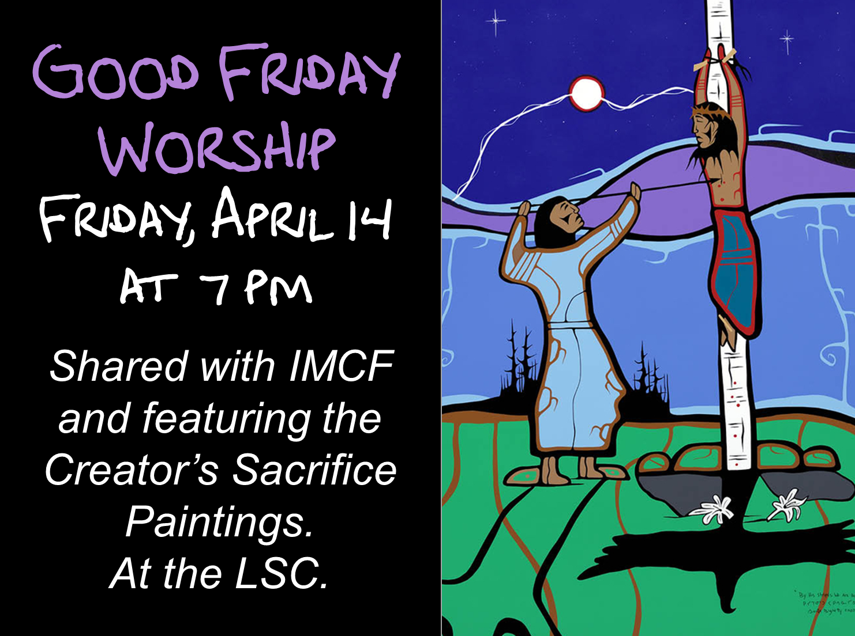
TIME OUT FOR BLESSINGS: A Christ-centred yoga retreat presented by Connie Moker Wernikowski of Big Fish Yoga. Friday, April 28 at 6 pm to Saturday April 29 at 5 pm. At the living Skies Retreat Centre in Lumsden, SK. This retreat will offer both active and restorative yoga; meditation; some free time for walking, resting, visiting; Christian chanting; and an intro to the First Ignation Spiritual Exercise. Cost is $193. Please complete a registration form found on any of the LSC bulletin boards, or by emailing mokerw@sasktel.net.

Prayer Writing Workshop, Thursday, May 4 at 7 pm: Join us as we reflect on the power of prayer in worship and in devotional practices, and explore the benefits that writing a prayer can offer as a path to mindful and compassionate living. Workshop facilitator, Ray McGinnis, offers tips for helping anyone who is asked spontaneously to lead a group in prayer. Drawing on a splendid range of examples of prayer from scripture and recent prayers written by adults and children, Ray helpfully provides a step-by-step template for you to write opening prayers, prayers of thanksgiving and intercessory prayers. There is time for discussion and time for prayer and reflection on how praying together can strengthen the church and help us be there for each other when it counts. No previous writing experience needed. Older children, youth and adults all welcome! Suggested donation to attend is $20. To register, call 306-761-0556.
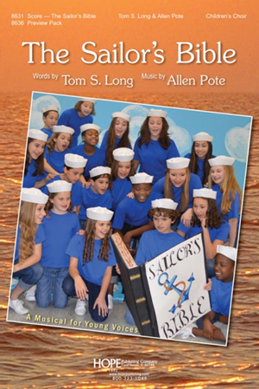
Since 1999, Ray McGinnis is has taught a range of writing workshops to over 15,000 participants across Canada and internationally. From 1986-95 he served as national staff for Youth and Young Adult Ministries with the United Church of Canada. He is author of Writing the Sacred: A Psalm-inspired Path to Appreciating and Writing Sacred Poetry. For more information on Ray visit www.writetotheheart.com.
Maundy Thursday Service with Rabbi Jeremy Parnes. April 13 at 7 pm at the LSC
Join us for another LBC Musical
Cast members needed! May gathering intro with fall
rehearsals and performance before December.
Let Russell know if interested!
St. James United Church Players are holding their Annual Dinner and
Maundy Thursday Service with Rabbi Jeremy Parnes. April 13 at 7 pm at the LSC
Dessert Theatre, "Honestly, Now!" a comedy by Jack Sharkey. March 24, 25, 30, 31, April 1, 7, 8. Doors open at 5:30 pm, performance at 6 pm. Tickets $35, includes dinner. Dessert Theatre dates are March 26 and April 9. Doors open at 1:30 pm, performance at 2 pm. Tickets $20. Reserve your tickets by calling St. James United Church office at 306-543-2626.
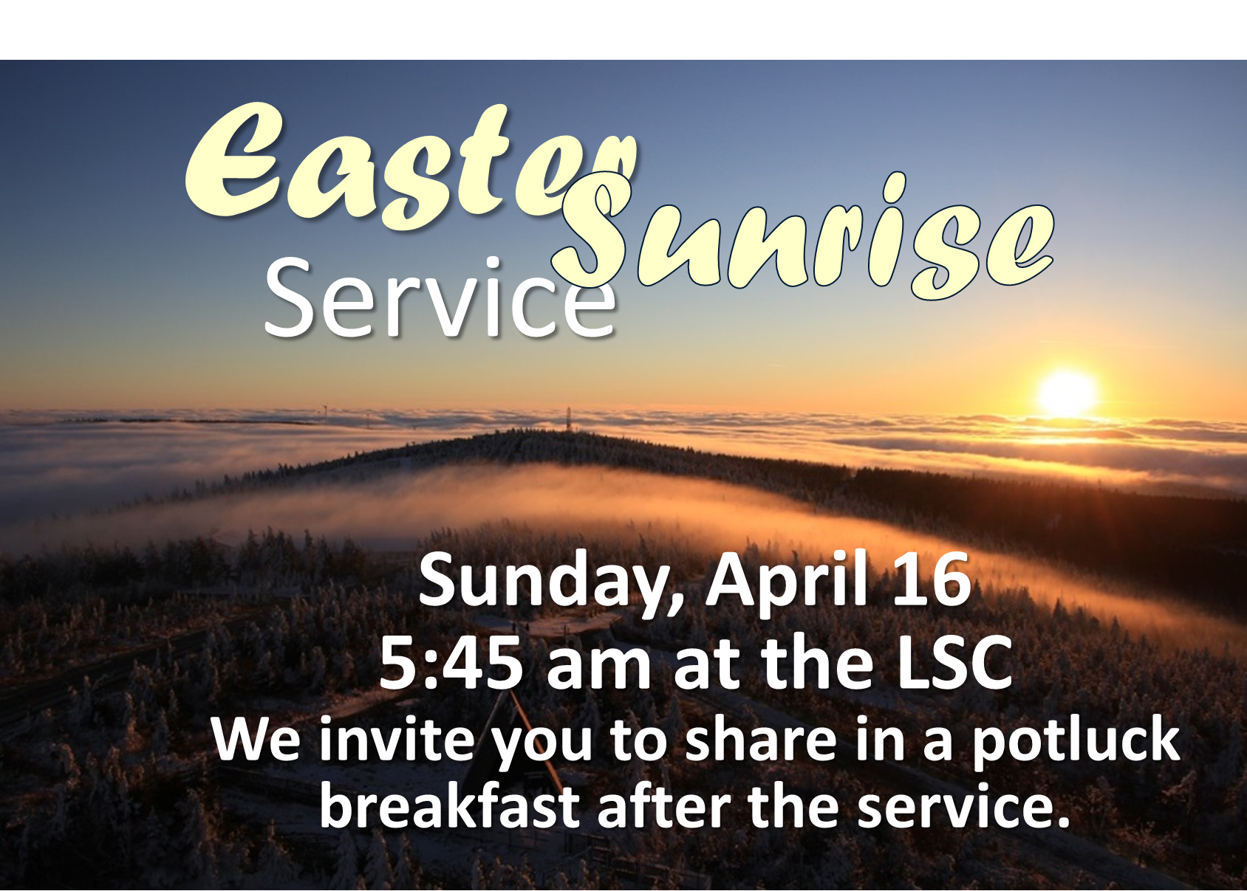

Community Study Night, Wednesday, April 12, from 8 to 11 pm. Coffee, tea and snacks supplied! Come for a quiet space to get some studying and homework done. Plug-ins for laptops available! See Taylor Balfour if interested and follow our Facebook event page:
https://www.facebook.com/events/157007284815470/

A Night for St. Andrew’s Gala Dinner and Fundraiser, Tuesday, April 18, 2017 at the Wascana Country Club, 6500 Wascana Parkway. Gathering 5 pm, dinner 6:15 pm. Tickets $110 (partial tax receipt), ticket deadline April 10. See Leona Martin or contact the church office if interested. This year’s fundraiser includes an address by Right Reverend Jordan Cantwell, UCC Moderator, and music by Lori Erhardt and Corinne Groff!
We’d love you to join our family! We are planning a Transfer of Membership service Sunday, April 23. If you are interested in being included or have questions, please let Russell know.

TIME OUT FOR BLESSINGS: A Christ-centred yoga retreat presented by Connie Moker Wernikowski of Big Fish Yoga. Friday, April 28 at 6 pm to Saturday April 29 at 5 pm. At the living Skies Retreat Centre in Lumsden, SK. This retreat will offer both active and restorative yoga; meditation; some free time for walking, resting, visiting; Christian chanting; and an intro to the First Ignation Spiritual Exercise. Cost is $193. Please complete a registration form found on any of the LSC bulletin boards, or by emailing mokerw@sasktel.net.

Prayer Writing Workshop, Thursday, May 4 at 7 pm: Join us as we reflect on the power of prayer in worship and in devotional practices, and explore the benefits that writing a prayer can offer as a path to mindful and compassionate living. Workshop facilitator, Ray McGinnis, offers tips for helping anyone who is asked spontaneously to lead a group in prayer. Drawing on a splendid range of examples of prayer from scripture and recent prayers written by adults and children, Ray helpfully provides a step-by-step template for you to write opening prayers, prayers of thanksgiving and intercessory prayers. There is time for discussion and time for prayer and reflection on how praying together can strengthen the church and help us be there for each other when it counts. No previous writing experience needed. Older children, youth and adults all welcome! Suggested donation to attend is $20. To register, call 306-761-0556.
Since 1999, Ray McGinnis is has taught a range of writing workshops to over 15,000 participants across Canada and internationally. From 1986-95 he served as national staff for Youth and Young Adult Ministries with the United Church of Canada. He is author of Writing the Sacred: A Psalm-inspired Path to Appreciating and Writing Sacred Poetry. For more information on Ray visit www.writetotheheart.com.
Maundy Thursday Service with Rabbi Jeremy Parnes. April 13 at 7 pm at the LSC
Join us for another LBC Musical
Cast members needed! May gathering intro with fall
rehearsals and performance before December.
Let Russell know if interested!
St. James United Church Players are holding their Annual Dinner and
Dessert Theatre, "Honestly, Now!" a comedy by Jack Sharkey. March 24, 25, 30, 31, April 1, 7, 8. Doors open at 5:30 pm, performance at 6 pm. Tickets $35, includes dinner. Dessert Theatre dates are March 26 and April 9. Doors open at 1:30 pm, performance at 2 pm. Tickets $20. Reserve your tickets by calling St. James United Church office at 306-543-2626.

