Our suite is located on the lower level, backside of the building facing the woods.
From Crabtree Valley Mall, Bandford Way is the 6th light North. The American Red Cross is on our corner. Turn right at that light onto Bandford Way and stay straight. Turn right at the mailboxes marked "Lower Level" and we're on the left.

If coming from Strickland Rd, enter our complex at the Jared Drive entrance and just come down the hill to find us!
Our suite is the lowest-possible section, in the very-back, by the trees.
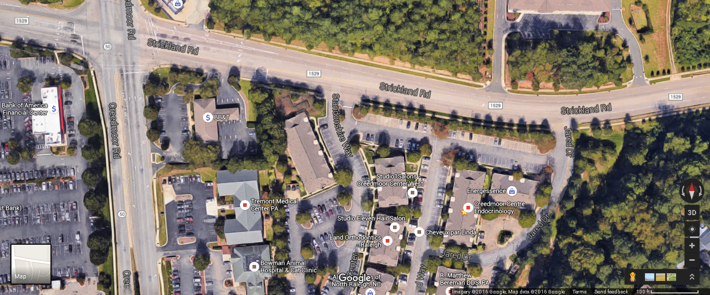
Creedmoor
Strickland

Jared
Office Address: 8340 Bandford Way
Suite 001
Raleigh, NC 27615

