|  |  |  |
| --- | --- | --- |
|  |  |  |
|  |  |  |

**STUFF WE *SHOULD* KNOW**

**COLONEL WILLIAM TODD ROBINS - was born November 22nd, 1835, King and Queen County, VA. He rode with the 24th Virginia Cavalry and was the father of Brig. Gen. Augustine Warner Robins, for whom Robins Air Force Base and the City of Warner Robins, GA are named. Husband of author Sally Nelson Robins. Related to George Washington, Robins died October 26, 1906 in Richmond and was buried in** [**Ware Episcopal Church Cemetery**](http://www.findagrave.com/cgi-bin/fg.cgi?page=cr&GRid=8271550&CRid=641547&)**, Gloucester Co., VA. Sec. W, Lot 124B.**

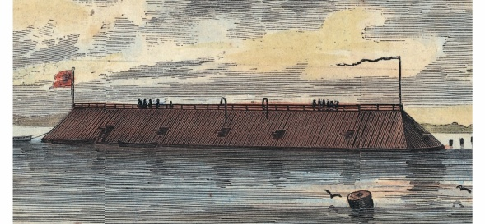**CSS GEORGIA BROUGHT TO SURFACE - By Phil Gast, CNN / November 14, 2013**

**The CSS Georgia "didn't have enough power to maneuver and effectively trade artillery rounds with enemy vessels in the swift Savannah River. Instead, the Confederate ironclad produced for the Confederacy, became a stationary floating battery, bristling with artillery pieces. She did her job. The Yankees, intent on taking Savannah, Georgia, refused to take on the CSS Georgia or other nearby defense obstructions. It was scuttled in December 1864 shortly before Union forces took Savannah and has rested in the murky river ever since, rarely disturbed and having weathered the indignity of being hit during dredging a couple of times over the years. U.S. Navy divers, working with archaeologists for the Army Corps of Engineers, recently retrieved a 64-square-foot section of the ironclad. More recovery is planned.**

**MACON LEADS IN PRESERVATION - By Phillip Ramati/Macon.com / November 16, 2013**

**2013-11-17T04:14:21ZFor years, Savannah , Georgia has been synonymous with historic preservation, but that may be changing. In the past year, historic preservation projects in Macon outnumbered efforts of every other city in the State. Of the 112 historic preservation applications and certifications filed with the state in the fiscal year that ended in July, Macon was involved with more than a third of them.**

**MACON'S NAMESAKE IN A NOVEL - By Woody Marshall / Macon.com - November 27, 2013 "No one should live within earshot of a neighbor’s barking dog." That advice seems strange coming from the namesake of one of Georgia’s largest cities.**

**Nathaniel Macon’s philosophy of country living wasn’t the reason he was honored in the naming of the county seat of Bibb, or the county by the same name about 40 miles to the southwest. There’s a Macon County in six states. “He was just an incredibly respected man,” said author Will Ferrell, who recently published a historical novel (The Secrets of Sterling Shearin: The Noblest Cause) featuring Macon as a main character. “He’s unique in that he was a very honest and reluctant politician who never solicited any man to vote for him, or hinted that he wished them to. Thomas Jefferson complimented Macon as “the last of the Romans,” as a model of a selfless patriot and a man of principle.**

**BEFORE THE PILGRIMS AND ABE - It is odd how we were taught that the Pilgrims originated the tradition of Thanksgiving. On September 16, 1619, 38 English colonists headed by Captain John Woodlief sailed from England aboard a ship called "The Margaret." They documented: "*We ordained that the day of our ships arrival … in the land of Virginia shall be yearly and perpetually kept holy as a day of thanksgiving to Almighty God."* These *SOUTHERN* colonists held a thanksgiving observance on December 4, 1619 - a year before the Pilgrims arrived at Plymouth. Surely Woodlief and his followers were as grateful as the renowned Puritans. In 1861 and 1862 President Jefferson Davis declared Thanksgiving Day for the Confederate States; first, not Abraham Lincoln.**

**-13-**

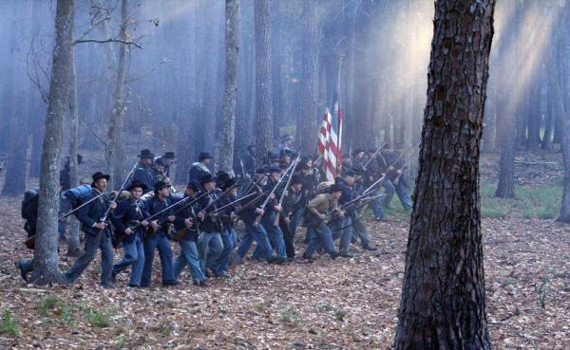**Georgia's Alamo**

**Like the vastly outnumbered Texans’ at the Alamo, and similar to Colonel William Lamb’s vastly outnumbered and outgunned North Carolinians at Fort Fisher the following month, Fort McAllister’s garrison was fighting an enemy seventeen times their own strength.  As is common today, Southern defenders are often termed as merely “Confederates” rather than identified as mostly local men defending their homes, farms, families and State.  At Fort McAllister were the First Regiment, Georgia Reserve Companies D and E under Captains George N. Hendry and Angus Morrison, respectively; the Emmet Rifles under Captain George A. Nicoll; and Captain Nicholas Clinch’s Light Battery of artillery.  All were defending their country to the last extremity. “The sporadic crackle of musketry echoed through the woods and marshes as Union patrols probed the defenses of Fort McAllister on Tuesday, December 13, 1864. The attack was launched shortly after 4PM.  Ragged musketry and cannon fire dropped some of the Yankees as they neared the breastworks.  Other explosions ripped gaps in the blue line as it swarmed onto the embankments to engage the Rebels in hand to hand combat. The Southerners only succumbed as each man was individually overpowered, an enemy commander reported.  The fort was never surrendered; It was captured by overwhelming numbers at 4:30PM, the assault lasting but fifteen minutes.**

**(Civil War Savannah, Derek Smith; pp. 173-178)**

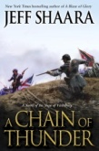**A FEW GOOD BOOKS**

**A Chain of Thunder: A Novel of the Siege of Vicksburg by** [**Jeff Shaara**](http://www.goodreads.com/author/show/14655.Jeff_Shaara) **$19.99 A Chain of Thunder: A Novel of the Siege of VicksburgContinuing the series that began with *A Blaze of Glory,* Jeff Shaara returns to chronicle another decisive chapter in America’s long and bloody War. The action shifts to the city of Vicksburg, Mississippi and reminds us of an outcome that echoes 150 years later.**

**Civil War Northern Virginia 1861 By William S. Connery $19.99   
In the mid-nineteenth century, Arlington was an eleven-hundred-acre estate managed by U.S. Colonel and Mrs. Robert E. Lee; Fairfax, Prince William and Loudoun Counties consisted of rolling farmland and tiny villages. This peaceful region was thrown into chaos with the advent of War. The "invasion" of Northern Virginia on May 24, 1861, created a no-man's land between Yankee and Rebel armies. Some citizens joined Confederate forces, while others stayed to face uncertainty. William S. Connery offers new insights into this most important time.**

**The Quotable Nathan Bedford Forrest: Selections From the Writings and Speeches of the Confederacy's Most Brilliant Cavalryman $12.95   
Though Nathan Bedford Forrest was not a writer, had little formal education, and was not a professional speaker, he did leave us with a number of witty comments, profound words, and sublime statements. Forrest scholar Lochlainn Seabrook has gathered together some of the more memorable ones into a fascinating work.  
  -14-**

**Private Ethan Bloodworth, 16th GA, Co. G writes: "I heard the poem *For What Died the Sons of Róisín* by Luke Kelly and decided to create a version relating to the Confederacy."**

**For What Died the Sons of Dixie**

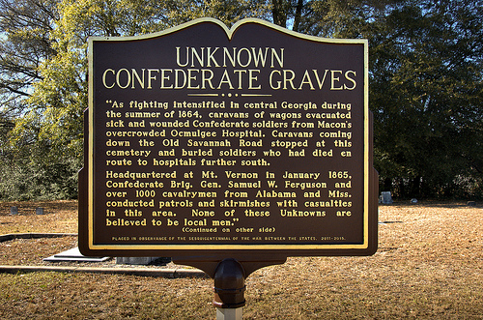  
**For what died the Sons of Dixie, was it fame?  
For what died the Sons of Dixie, was it fame?  
For what flowed Southerners' blood as Georgia burned in flame,  
The flow that did not cease and has not ceased, with the   
surrender of General Lee.  
For what died the Sons of Dixie, was it fame.**  **the old McMillan Burial Ground**

**from *Vanishing South Georgia* by Brian Brown**

**For what died the Sons of Dixie, was it greed?  
For what died the Sons of Dixie, was it greed?  
Was it greed that drove thousands from their families to fight,  
to Stand for the cause they knew was right,  
And to die alone and forgotten by those blind to the light.  
For what died the Sons of Dixie, was it greed.  
  
To whom do we owe our allegiance today?  
To whom do we owe our allegiance today?  
To the thousands who fought and died,  
So Dixie could retain independence and pride,  
So that their families could live in peace,  
So that their children could be raised away from enemies,  
Or to the faceless elected who for fame and dollar,  
Doth sell truth and freedom to the highest bidder?  
To whom do we owe our allegiance today.  
  
For what suffer our patriots today?  
For what suffer our patriots today?  
We have a political correctness problem so they say.  
For we fly our flag and honor our dead,  
While they continually twist what our ancestors did and said.  
They claim equality and tolerance,  
But where is historical truth's acceptance?  
For what suffer our patriots today?**

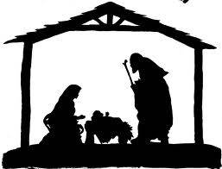

**-15-**

**Brigadier General Alfred Iverson, Jr. - born in Clinton, Georgia**

[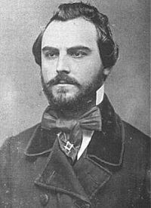](http://en.wikipedia.org/wiki/File:AlfredIverson.jpg) 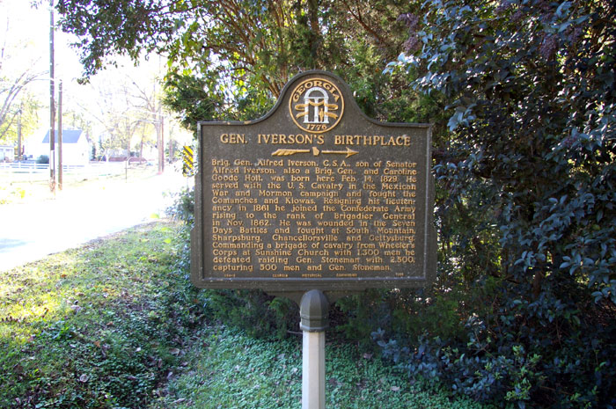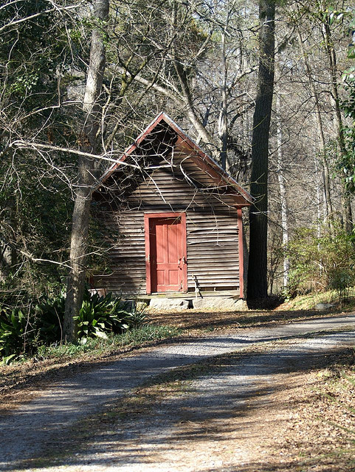

**Birth Place and Early Career**

**Alfred Iverson, Jr. was born in Clinton, Jones County, Georgia on February 14, 1829. He was the son of Alfred Iverson, Sr. (United States Senator for Georgia and a fierce proponent of secession) and Caroline Goode Holt. The senator decided on a military career for his son and enrolled him in the Tuskegee Military Institute. Alfred Jr.'s career as a soldier began at the age of 17, when the Mexican-American War began. His father raised and equipped a regiment of Georgia volunteers and young Iverson left Tuskegee to become a second lieutenant in the regiment. He left the service, in July 1848, to become a lawyer and contractor. In 1855, his Mexican-American War experience (in which he saw no combat and spent eight of eleven months in the Army on sick leave, gained him 1st Lt. in the 1st U.S. Cavalry regiment. The picture above is 1858. There are none known of him in uniform.**

**At the start of the War Between the States, Iverson resigned from the U.S. Army and received a commission from his father's old friend,** [**Jefferson Davis**](http://en.wikipedia.org/wiki/Jefferson_Davis)**, as Colonel of the 20th North Carolina Infantry, a unit he played a strong role in recruiting. His regiment was initially stationed in North Carolina, but was called to the** [**Virginia Peninsula**](http://en.wikipedia.org/wiki/Virginia_Peninsula) **in June 1862, for the** [**Seven Days Battles**](http://en.wikipedia.org/wiki/Seven_Days_Battles)**. He distinguished himself at Gaines' Mill,** [**Major General**](http://en.wikipedia.org/wiki/Major_General_(CSA)) [**D.H. Hill**](http://en.wikipedia.org/wiki/D.H._Hill)'s **division, by leading the only successful regiment of the five that were assigned to capture a Union artillery battery. Iverson was severely wounded in the charge and his regiment took heavy casualties. Unfortunately for Iverson and the Confederacy, this battle would turn out to be the high point of his military career.**

**Iverson, Jr. rejoined the** [**Army of Northern Virginia**](http://en.wikipedia.org/wiki/Army_of_Northern_Virginia) **in the** [**Maryland Campaign**](http://en.wikipedia.org/wiki/Maryland_Campaign)**. At South Mountain, his entire brigade was forced to retreat after, Brigadier General** [**Samuel Garland**](http://en.wikipedia.org/wiki/Samuel_Garland)**, was mortally wounded. Iverson's regiment ran away at** [**Antietam**](http://en.wikipedia.org/wiki/Battle_of_Antietam) **a few days later, although he was able to rally them to return to the battle. After that battle, Iverson was promoted to brigadier general on November 1, 1862, causing the more senior colonel who had been in temporary command to resign from the Army. The promotion had the recommendation of both General "Stonewall" Jackson and General Robert E. Lee, but camp gossip hinted that it was due to his father's political influence. His first assignment commanding his new brigade was at the Battle of Fredericksburg, but he was assigned to the reserve and saw no action. Conflict soon resulted, however. When he attempted to name a**

**-16-**

**new colonel for the 20th North Carolina, a personal friend from outside of the regiment, 26 of his field officers signed a letter of protest against the action. Iverson attempted to arrest all 26 officers, but eventually cooled off. His friend was not placed as the new colonel, but Iverson refused all winter to promote any of the other candidates. In February 1863, he threatened to resign if not granted a furlough but General Jackson called his bluff, saying he would rather accept Iverson's resignation than grant the leave. At** [**Chancellorsville**](http://en.wikipedia.org/wiki/Battle_of_Chancellorsville)**, Iverson's brigade participated in** [**"Stonewall" Jackson**](http://en.wikipedia.org/wiki/Stonewall_Jackson)**'s famous flanking march, suffering heavy casualties (including Iverson himself, wounded in the groin by a spent shell), and walked away from his hard-pressed brigade to "procure reinforcements" and never returned. Many of his officers concluded that he was shirking. By now, his performance at Gaines's Mill was forgotten and rumors swirled that he got his command only by family political influence. A pattern of unfitness was emerging.**

**At Gettysburg**

**On November 1, 1862, when Iverson took command of the recently killed General Garland’s Brigade of North Carolina troops, he had successfully commanded the brigade at Fredericksburg and Chancellorsville but was constantly at odds with many other Confederate commanders, including General Jackson. Then came Gettysburg …..**

**At first dawn on July 2nd, 1863, cannoneers and drivers of Captain Thomas J. Kirkpatrick’s Amherst (Virginia) Artillery began to stir from their night’s encampment along Oak Ridge, northwest of Gettysburg. Having arrived too late the previous evening to participate in that day’s brutal engagement, the awakening soldiers found themselves numbed by a grisly panorama being slowly unveiled by the rising sun. As one young Virginian sorrowfully recalled:**

***“This morning on getting up, I saw a sight which was perfectly sickening and heart rending in the extreme. It would have satiated the most blood-thirsty and cruel man on God’s earth. There were, within a few feet of us, by actual count, seventy-nine North Carolinians laying dead in a straight line. I stood on their right and looked down their line. It was perfectly dressed. Three had fallen to the front, the rest had fallen backward; yet the feet of all these men were in a perfectly straight line . . . They had evidently been killed by one volley of musketry and they had fallen in their tracks without a single struggle . . . I turned from this sight with a sickened heart and tried to eat my breakfast, but had to return it to my haversack untouched.”***

**This memorable scene of carnage was located in a broad field just south of the Mummasburg Road, on the eastern edge of the John Forney farm. There, on July 1st, the veteran North Carolina brigade of General Alfred Iverson, Jr. fell prey to a nearly perfectly executed Union ambush. In just a few short minutes Iverson’s command lost over 900 men (about 500 killed outright in action) and suffered one of the highest percent casualty rates of any Confederate brigade at Gettysburg. Said one witness plainly:*“They died as if on dress parade.”*A Tar Heel survivor lamented: *“Unwarned, unled as a brigade, we went to our doom. Deep and long must the orphan children of North Carolina rue the rashness of that hour.”***

**Retribution for that *“rash hour”* came swiftly. Less than a fortnight after battle’s end, Iverson was reassigned from his brigade in the Army of Northern Virginia and was destined for Georgia at the request of Howell Cobb. The details surrounding the slaughter of Iverson’s brigade on July 1st have been told often enough and will not be recounted any further here. While Iverson’s lack of presence on the front line might reasonably be explained by the fact that he was actively seeking support from sister brigades to cover his exposed flanks, the men in the ranks**

**-17-**

**would have none of it. *“Iverson’s part in the heroic struggle of his brigade seems to have begun and ended with the order to move forward and give them hell”* declared a surviving officer in the 23rd North Carolina. Another participant was even more blunt: *“Iverson’s men were uselessly sacrificed,”* wrote Lt. Walter A. Montgomery. Still another observer accused Iverson of hiding in the rear behind a big chestnut log. Unfortunately for the Georgian, he was close enough to the front to make a most grievous and unpardonable error. Seeing his command surprised and nearly decimated by the first Union volley, Iverson was stunned beyond measure. Through the smoke he perceived what looked to be white flags or handkerchiefs being waved at various points along the prostrate Confederate battle line. Iverson’s addled mind conjured the worst. Were his men deserting him *en masse*? Iverson so concluded and, in effect, proceeded to pitch a tantrum. Without an afterthought the overwrought brigadier dispatched a courier to General Rodes wildly saying *“that one of his regiments had raised the white flag and gone over to the enemy.”* It was an obscene indictment of men who were dying by the scores under withering musketry. Such behavior further demonstrated that Iverson had completely lost the ability to exercise sound control on the battlefield. Rodes characterized Iverson’s near-hysterical behavior as *“misconduct.”* Others were less charitable, citing drunkenness and *“the well known cowardly behavior of Iverson.”* With much feeling, the mortally wounded Colonel D. H. Christie of the 23rd North Carolina assured the remaining members of his regiment *“that while he might never live to lead them into battle [again] he would see that ‘The Imbecile Iverson’ never should.”* Iverson later earnestly attempted to exonerate his men from his own slander, claiming that his North Carolinians had indeed *“fought nobly and died without a man running to the rear.”* It was too little too late: The Tar Heels (such as were left) flatly refused to serve under Iverson any longer. Rodes was probably only too willing to exercise a permanent change in brigade leadership, thus neatly deflecting attention away from errors higher up.**

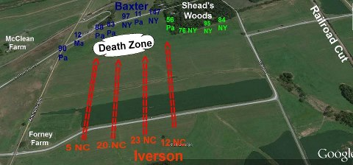**Possibly heavy alcohol use while at Carlisle and dehydration from the summer heat may, in fact, go a long way in explaining Iverson's condition. Some sources indicate that Iverson was immediately relieved of duties, while other testimony say the brigadier retained command until the Army’s return to Virginia. Following Gettysburg, Iverson was damaged goods within the Army of Northern Virginia and his fate with his brigade and hence with the Army of Northern Virginia had been sealed, even though he served in *“a prompt manner”* at Hagerstown. His removal officially came July 10 when Lee relieved him from command. He was directly**

**-18-**

**assigned as provost marshal of Williamsport, Maryland, but no official reason was ever given. Once again political connections providently intervened on his behalf, to the chagrin of many. One staff officer pointedly recalled that while the general *“was relieved at once and sent back [to Richmond] to await trial,”* he eventually *“got off scot free & had a brigade of reserves given him in Georgia.”* Nonetheless, Iverson’s fitness for high command, overall maturity, and personal courage still remained in doubt.**

**Back to Georgia**

|  |
| --- |
| **Following Gettysburg Alfred Iverson was eventually reassigned to Georgia in October 1863 and took command of the state’s forces headquartered in Rome. During Sherman’s Atlanta Campaign, he commanded a brigade of cavalry under General Wheeler. On July 31st, 1864, at the Battle of Sunshine Church, his force of**  **https://lh5.googleusercontent.com/-Y_TN4ptZU74/TYrFZwUDM-I/AAAAAAAAAPA/LrJ9eSognSE/s1600/iverson+old.jpgaround 1,300 men defeated a Union force of about 2,300 under General Stoneman, capturing almost 700 prisoners including Stoneman, himself, the highest ranking Union officer captured during the War. Even though Iverson was born in Clinton, the oft-repeated claims, possibly originating with Wheeler, that he was familiar with the countryside are false. He was barely a year old when his mother died and his father moved from Clinton to Columbus and Iverson,Jr., reportedly, never visited the town again. General Iverson remained with Wheeler’s command as it followed Sherman’s advance into the Carolinas but was eventually put in command of the Confederate garrison at Greensboro and surrendered at that site following General Johnston’s surrender at Durham Station.**  **After the War**  **Iverson returned to Georgia, settling in Macon and eventually moving to Florida in 1877 to become an orange grower. He died in Atlanta on March 31, 1911 and was buried there in Oakland Cemetery. At no time during Iverson’s post-war career did he attempt to seek absolution for his actions at Gettysburg. The best that might be said of the whole unfortunate affair is that Brigadier-General Alfred Iverson, Jr. was the wrong man in the wrong place at the wrong time.** |

**Iverson's Pits**

|  |  |  |
| --- | --- | --- |
| http://www.spiritsocietyofpa.com/sitebuilder/images/Mvc-007f-147x196.jpg**At Gettysburg, a solitary marker is the only thing to suggest something happened on the spot where it stands. The size of the marker is not equal to the significance.  However, it was on this spot on July 1, 1863, the day General Alfred Iverson's North Carolina brigade (5th, 12th, 20th & 23rd NC) was annihilated on July 1, 1863. After a century and a half, much debate has ensued over Iverson's actions and even his state of sobriety that day, but the undeniable fact remains that sending his brigade forward on unfamiliar ground without skirmishers deployed eliminated any advance warning of a hidden enemy position. Smoke from the surrounding fighting may have helped obscure the low stone wall and five Federal Regiments which waited behind it.  The last thing most of Iverson's North Carolinians saw were the hundreds of Yankees rising up to fire, only 80 yards away.  In a matter of seconds, Iverson's Brigade ceased to exist.  Later that night, burial parties dug four long, shallow trenches where about 500 of their comrades' bodies would remain until several years after the war, when they and thousands of others were finally disinterred and sent South. The shallow graves where his men fell in perfect lines became known as “Iverson’s Pits” because the ground sunk.**   **-19-**  C:\Users\od\Documents\EAST MACON.jpg |  |  |

**COMING IN 2014: "*THE BATTLE OF SUNSHINE CHURCH - MINUTE BY MINUTE, HOUR BY HOUR …"***

**Also, at Griswoldville some of us had the pleasure to meet Mr. Joe Byrd, avid 16th GA researcher, who has compiled a data base of information on 147 members of the 16th GA Co. G. We have included a portion of a speech he made in April (see page 20) and hope to publish the entire text in a later issue. Mr. Byrd writes: *"I appreciate the efforts on your organization's behalf to honor the men who served for the South at Griswoldville, and the service you render to numerous organizations, dedications, re-enactments, and related events. The Griswold Memorial Ceremony was well executed and very meaningful."***

*\*\*\*\*\** 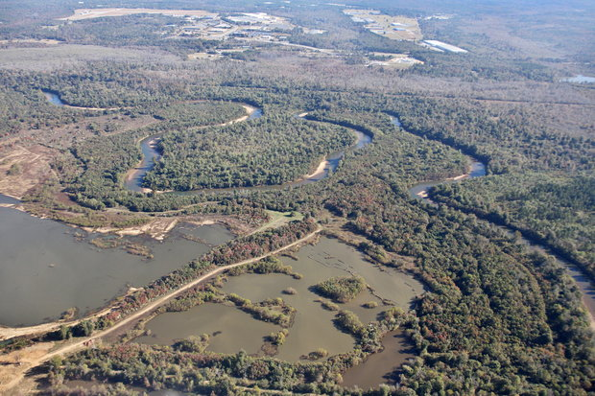

**In November, it was announced that "a land auction would likely result in permanent protection for 679 acres, the largest preservation deal in a pristine area of Bibb County’s river corridor since the creation of Bond Swamp National Wildlife Refuge in 1989. The Ocmulgee National Park and Preserve Initiative, headed by Macon attorney and longtime Ocmulgee River advocate Brian Adams, led the effort to purchase the land, located off Bondsview Road in southeast Bibb County. However, it was actually bought by the Ocmulgee Land Trust, using $815,000 provided by the nonprofit Peyton Anderson Foundation. The property includes almost three miles of riverfront, with a tract completely surrounded by an oxbow of the river. Another tract adjoins Brown’s Mount and is crossed by Stone Creek. Adams said the land is among the most important of the privately owned properties separating Bond Swamp from the Ocmulgee National Monument. His group seeks to protect land in the river corridor between Macon and Hawkinsville, eventually, through helping create the only “national park and preserve” east of the Mississippi River.**

**-20-**

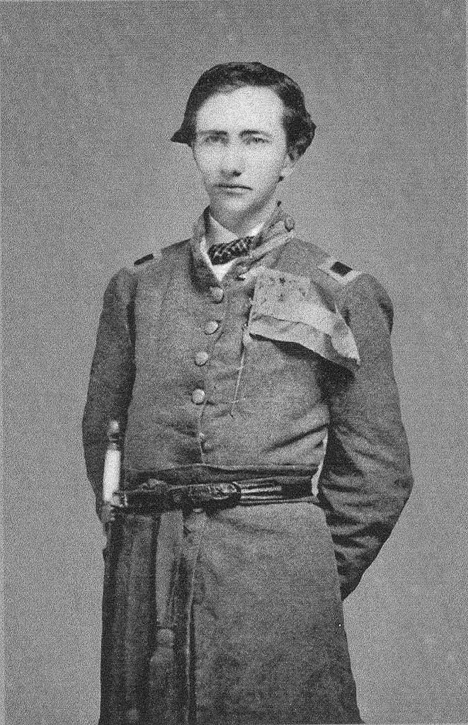**Captain Horatio Goss McMullan  
Company "C", 16th Regiment Georgia Volunteer Infantry, ANV, CSA**

**Horatio Goss McMullan was born in Hart County and was the son of Sinclair and Clarissa Richadson McMullan. He joined the "Hartwell Infantry" in 1861 and was commissioned a 1st Lieutenant when that unit was sworn in to Confederate service as Company "C", 16th Georgia Volunteer Infantry on July 13, 1861.**

**McMullan was promoted to Captain on September 14, 1863 and commanded Company "C" until he was killed in action at the battle of "The Wilderness" on May 6, 1864. He was never married but he has many relatives in the McMullan and related families still living in Hartwell and Hart County.**

**This picture of Captain McMullan was provided by his great-niece, Mrs. Martha Rice Kelley.**

**The Sixteenth Georgia Infantry Regiment**

**After arriving in Richmond around the first of August, the Gwinnett Volunteers were joined by nine other companies, including another Gwinnett County unit, the Flint Hill Greys. The remaining eight companies were from six nearby Georgia counties: Jackson, Madison, Habersham, Walton, Hart, and Columbia.**

**On August 15, 1861, volunteers from the ten companies gathered to elect officers. Howell Cobb was made Regimental Colonel by acclamation. The regiment was designated the 16th Georgia, and the Gwinnett Volunteers became Company I. William Simmons was promoted to First Lieutenant. The other Gwinnett County Company, the Flint Hill Greys, was designated Company H. [*Note: The other eight companies included Company A, Madison County Grays; Company B, Center Hill Guards from Jackson County; Company C, Hartwell Infantry from Hart County; Company D, Danielsville Guards from Madison County; Company E, Cobb Infantry from Habersham County; Company F Walton (County) Volunteers; Company G, Jackson (County) Rifles (AKA Jackson Volunteers; and Company K, Ramsey Volunteers from Columbia County.*]**

**From: A speech entitled, " Major William E. Simmons and the Southern Cause" given at a Confederate Memorial Day Ceremony by Joseph P. Byrd IV, Camp 96 Sons of Confederate Veterans**

**Shadowlawn Cemetery, Lawrenceville, Georgia – April 6, 2013**

**-21-**

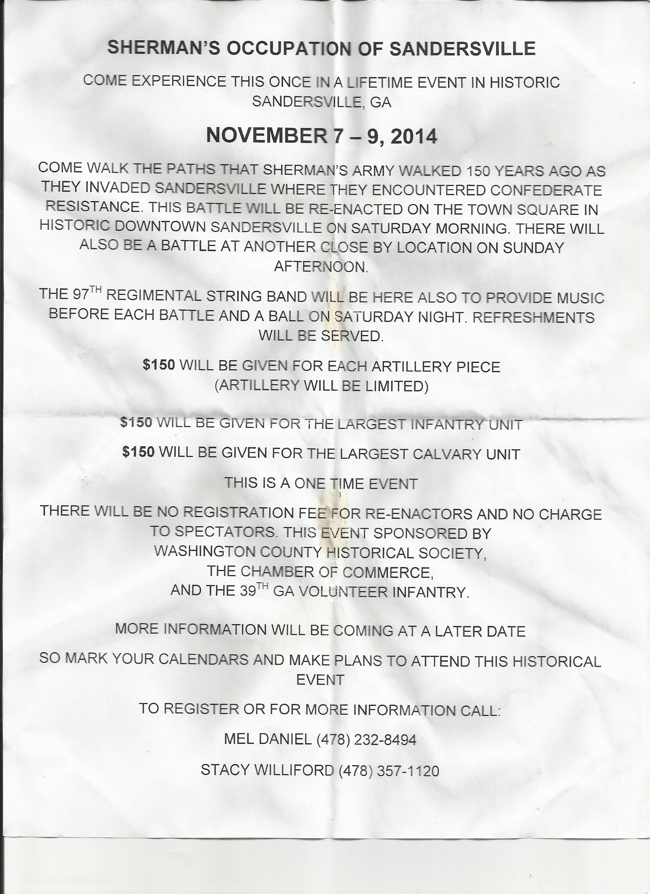



***SWAP SHOP***

**Ryobi ZRRY46501 12 Amp Electric Cultivator - 8-Inch diameter heat treated 4-tooth tines with adjustable cultivating width of 8-Inch to 10-Inch Cultivating depth to 7-3/4-Inch. for excellent mixing and blending. This is a great small job tiller. Comes with two, 100' sections of RIDGID 10/3 extension cords. I used this tiller two seasons and it worked well for breaking new ground but was just too large to cultivate my garden. I would like to sell outright (make offer) or swap for a smaller gasoline tiller like a MANTIS. Call Duke @ 478-731-5531.**

**-22-**

**THE GOODNESS OF THE LORD**

***I had fainted, unless I had believed to see the goodness of the Lord in the land of the living.*** ***Wait on the Lord: be of good courage, and he shall strengthen thine heart: wait, I say, on the Lord. -* Psalm 27: 13-14**

**The Griswoldville Memorial Service and encampment went very well this year due to the grace of the Good Lord and the cohesive team we have become over the years. Like Harry Truman once said, *“It is amazing what you can accomplish if you do not care who gets the credit.”* Humility and diligence gets the job done, every time! Again, thank you to all those who have made in happen for nine years.**

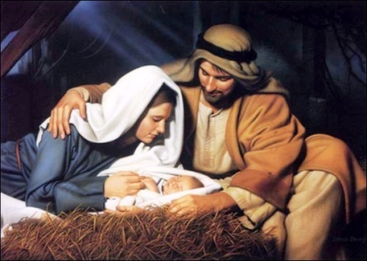 **After we got everything packed up, left Griswoldville and got a bite to eat, about a dozen of us made our way back the familiar old environs of Clinton and spent the cold night in the McCarthy-Pope House. It was a God-appointed time for Chaplain Joel Whitehead, Jr. to bring a devotional appropriate to the Thanksgiving season. After he concluded his message, he asked each of us what we were grateful for. It seems that I was the last to respond and by that time God had given me the kind of answer I always like best - straight from His Word. I said that I was grateful for *"the goodness of the Lord in the land of the living."* To me that sums up Thanksgiving and our life, in general. God supplies us with all the good things we could ever use while we are alive. After death, He can provide then, too, but that is another matter, altogether. Since there is a "land of the living", there must be one where we are no longer alive as we are on earth. It is hard for me to imagine existing any other way or anywhere else, with other people and in a different manner than I do now. It's all I know by experience … by faith, much more…**

**Now, I know what the Bible says about dying and going Heaven (or Hell) but that is sometimes hard to wrap the mind around. You simply have to believe it will be what God says it will be because He said so - that is faith, believing the unseen. You either believe or you don't. Do you believe Him enough to want to go to Heaven (Hell requires no belief) when you die? Lots of people say that they do - even ol' Ted Turner, recently said that he did. The question is, *do you believe God enough to properly prepare for that day?* That is what folks mean by being "SAVED." Salvation does a lot for us in this life but it really pays off in the one to come. Yet, I think many people feel it is just too impossible, or too unbelievable to be real. More than that salvation is often viewed as just too complicated. God's plan of salvation is a simple one, which allows you into Heaven with Him and not in a Hell that was not meant for you anyway (Matthew 25:41)! God made it simple so no one would miss it.**

|  |
| --- |
| **Your joy or your unbearable sorrow for ALL eternity depends upon whether you are saved or not. It is not a matter of how good (or bad) you are, nor even if you are a church member. It is way more important than all that. In the Bible, God says to go to Heaven, you must be born again (John 3:7) God leaves nothing to chance when it comes to you. I mean He came here all the way from Heaven, in the person of the Lord Jesus Christ, (which is what Christmas is all about) died on a cross and rose from the dead (which is what Easter is all about) so you could be safe, happy and with Him when you leave this earth. No one EVER cared about you, planned for you or loved you more than God. Again, I say, His plan is simple! Here is how it goes…..**  **-23-**  **First, you must realize you are a sinner. “For all have sinned, and come short of the glory of God” (Romans 3:23). Don't lean on any of that "well, I'm not so bad" stuff; God says we are all sinners, so that settles it. Because you are a sinner, you are condemned to death - CASE CLOSED. “For the wages [*payment*] of sin is death” (Romans 6:23). This means eternal separation from God in Hell after the physical body is dead and buried on earth.**  **But, God, in His love and mercy made a way out because He loves us so much!**  **[https://encrypted-tbn1.gstatic.com/images?q=tbn:ANd9GcQkpAIxTPXmkGzLGMI8iVX0KfVNkatLCiMRQrGWIG_CF3b3thghgw](http://www.google.com/url?sa=i&rct=j&q=&esrc=s&frm=1&source=images&cd=&cad=rja&docid=eJFL7PSPKzPtwM&tbnid=JiKx5hPkZDrhGM:&ved=0CAUQjRw&url=http://www.impactbiblestudy.com/category/gifts-of-god/salvation-gifts-of-god&ei=85OYUpS2OtfcoATmp4LADw&bvm=bv.57155469,d.cGU&psig=AFQjCNFedpOuhLJxSs7IcF6ua2KuO04Jog&ust=1385817386952400)“ . . . God commendeth His love toward us, in that, while we were yet sinners, Christ died for us” (Romans 5:8). Although we cannot totally understand how, God said my sins and your sins were laid upon Jesus and He died in our place. He became our substitute. It is true. God cannot lie (Hebrews 6:18). Let's use an illustration: What if you were on death row and set to be executed in one hour. Well, I go to your jail cell and am allowed to take your punishment and you go free, with a clean record … they execute me instead. THAT IS WHAT JESUS DID FOR YOU AND ME ! Now, just suppose you are stubborn and independent like Southerners tend to be and you refuse to let me take your place. Well, there is nothing more that can be done for you. You are still on the hook and they will execute you just as surely as the hour comes around. You will perish - but you don't have to. God says, your debt is paid - Jesus paid it for you when He died on the cross. Not only that, but Jesus was the ONLY payment for your sins that God would accept (Hebrews 10:4). Let's just say you are given another chance to reconsider (and we are with each day that we live and breathe) WHAT MUST I DO TO BE SAVED! (Acts 2:37-41) - I am sure glad you asked:**  **YOU MUST REPENT - Turn from your sin unto God, CAUSE He ain't foolin' around with sin. He means business. “God commandeth all men everywhere to repent” (Acts 17:30). Repentance is a change of heart and mind that agrees with God that you are a sinner. It also agrees with what Jesus did as a substitute for us on the Cross. Accept what He has done for you - go on, TAKE IT! It may seem too good to be true; do it anyway - come on, nothing else has worked, has it? GOD CAN'T LIE!**  **YOU MUST RECEIVE -Salvation is a gift of God but no gift does you any good unless you take it. “But as many as received Him, to them gave He power to become the sons of God, *even* to them that believe on His name” (John 1:12). YOU MUST ACCEPT - Suppose I saved all year to buy you a really special Christmas gift. I wrapped it up real nice, put it under the tree and on Christmas Day I smiled from ear to ear because I was giving you the VERY best I had. But you refused my gift even though it was something you truly needed (and wanted); but you just would not take it. Can you imagine how God feels when He sacrificed his "only begotten Son" (John 3:16) for you and me and we don't accept what was done in our behalf. There are no strings attached - God's offer is on the table. We must each do with it as we will. Let's just suppose you reconsidered God's offer and thought you would be foolish not to take it - and let's face it, you would be. How do you take or accept God's gift of salvation.? I mean it is not really some tangible present with ribbons and bows. How do you take what God is offering?**  **YOU JUST ASK - You talk to God a lot like you talk to anyone; he knows what you are thinking anyway - essentially this is prayer… it is the avenue by which we are saved. “For whosoever shall call upon the name of the Lord shall be saved.” (Romans 10:13). *Whosoever* includes you and me. Bad as we have been and as much as we have done wrong. "*Shall be saved"* means not *maybe*, nor *can*, but *SHALL BE saved- guaranteed in writing (the Bible).* So how do you do that prayer?**  **-24-**  **Again, I am sure glad you asked. Now, I am no spiritual authority but I do know enough to read God's Word and take it for what it says. Don't wait, don't think about it anymore, now is the best time!** **"Now is the accepted time; behold, now is the day of salvation." (2 Corinthians 6:2). Find a King James Bible and read these scriptures for yourself. If you have trouble finding them, someone will help.**  **Won't you, please, find time to** **get alone; wherever you are is a good place, just for a few minutes; this won't take long at all. Pray this simple prayer - say these words either out loud or to yourself - God hears real good. God heard, the sinner in Luke 18:13 when he prayed: “God be merciful to me a sinner.” One of the thieves on the cross next to Jesus did not have the time, nor privacy to wait and think about it. He asked and Jesus saved him right then and there. So don't delay another minute, just pray these words: *“God, I know I am a sinner. I believe Jesus was my substitute when He died on the Cross. I believe His shed blood, death, burial, and resurrection were for me. I now receive Him as my Savior. I thank You for the forgiveness of my sins, the gift of salvation and everlasting life, because of Your merciful grace. Amen.”***  **It is Christmas time again. Maybe the last one we all will spend together on earth. I wish I were wealthy enough to buy a fine present for each of you. I cannot but what I do have (which is priceless) I have given you in these words, because I love you and God loves you. Merry Christmas - Duke, Brenda & Kellie**  http://www.jesus-is-savior.com/Basics/gift_of_eternal_life.jpg  **A SCRIPTURE TO THINK ABOUT:**  ***"There is no man that hath power over the spirit to retain the spirit; neither hath he power in the day of death: and there is no discharge in that war; neither shall wickedness deliver those that are given to it."* http://stickygooeycreamychewy.com/wp-content/uploads/2009/07/welcome-sign-1.jpg - Ecclesiastes 8:8**  **\*\*\*\*\***  **Randall and Toni Buchanan, who many of us first met at Chickamauga, joined the 16th GA at Griswoldville. They are**  **from the Buford, GA area and we are glad to have them.** |
|  |  |  |

**-25-**

**16th Georgia Infantry Regiment**

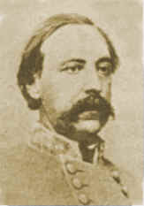[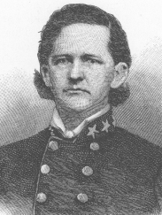](http://2.bp.blogspot.com/-QMUdRLPBHw4/UWV75coOvzI/AAAAAAAAI1Y/NvBIY7zPMZs/s1600/TRRC.png)[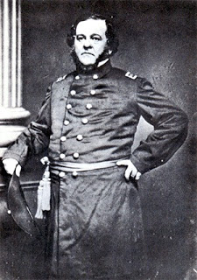](http://4.bp.blogspot.com/-_pSZuoQqFV0/UWVyxsT7_yI/AAAAAAAAI1I/MgUpm77GSRE/s1600/HC.jpg)

**Gen. Howell Cobb Gen. T.R.R. Cobb Col. Goode Bryan**

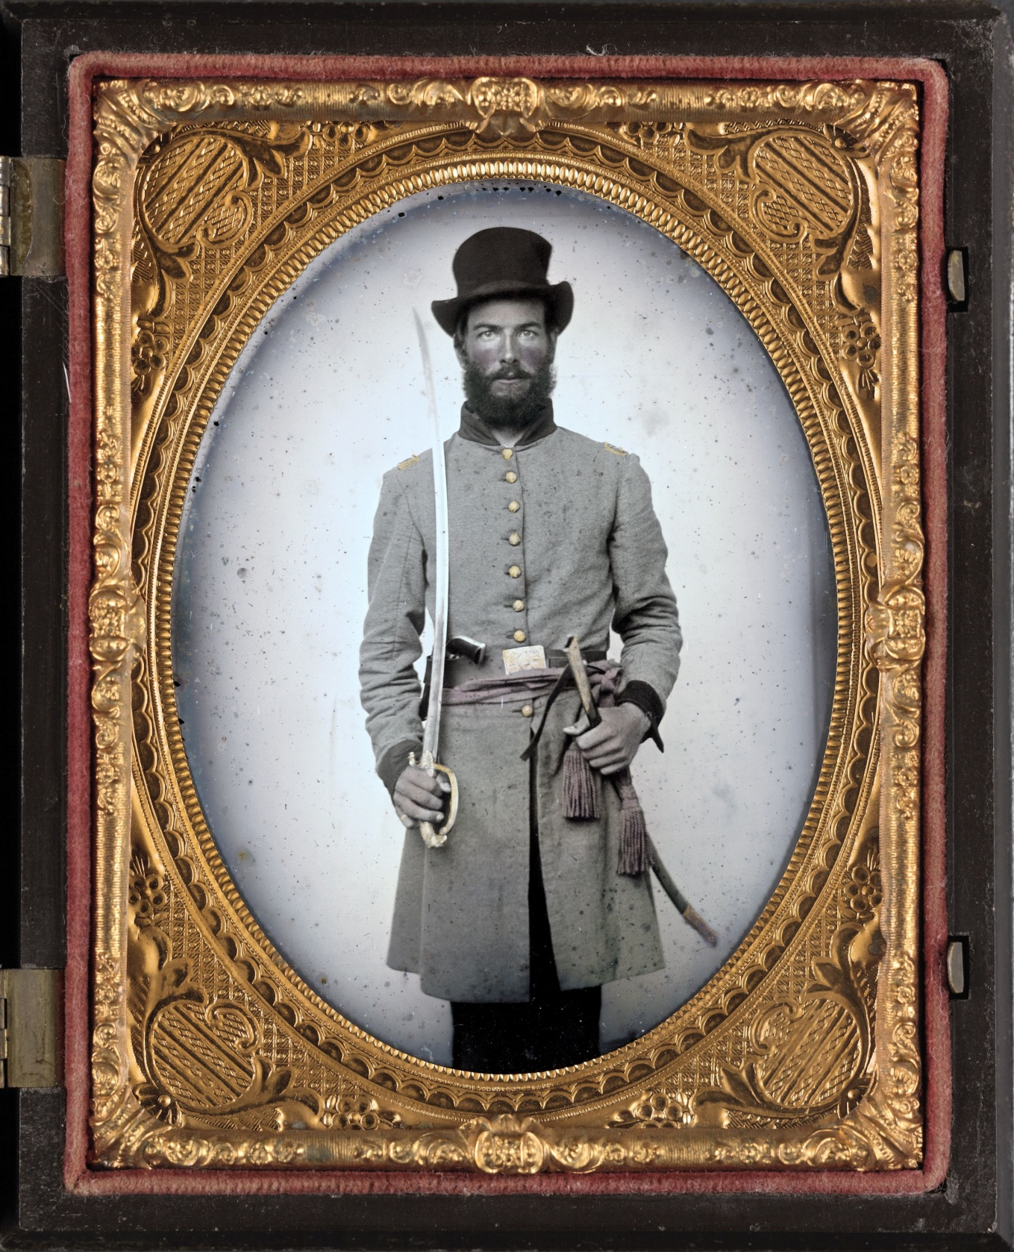[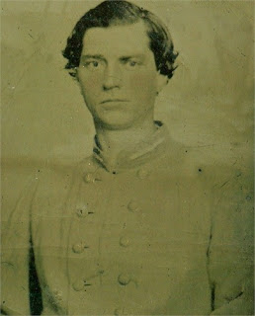](http://3.bp.blogspot.com/-rifbHvcpPqw/UWQT-sVReiI/AAAAAAAAIzo/YwcFc17U4ac/s1600/ESD.jpg)

**Capt. H.G. McMullan,Co.C Capt. A.C. Thompson,Co.G 2nd Lt. E.S. Dyer, Co.C**

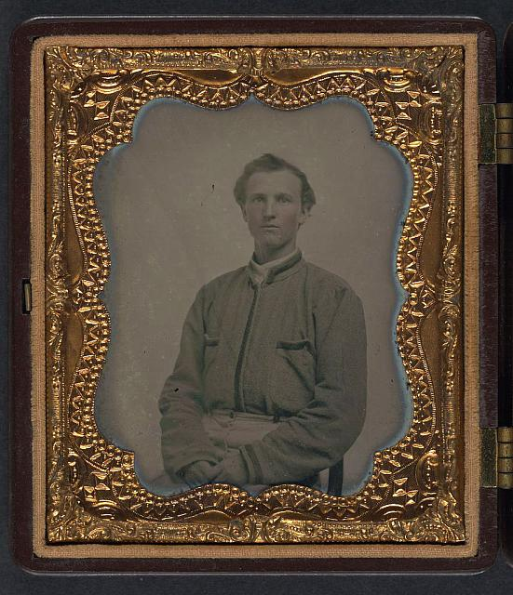

**Lt. H.J. David, Co. B Pvt. E.T. Bray, Co. A**

**-26-**