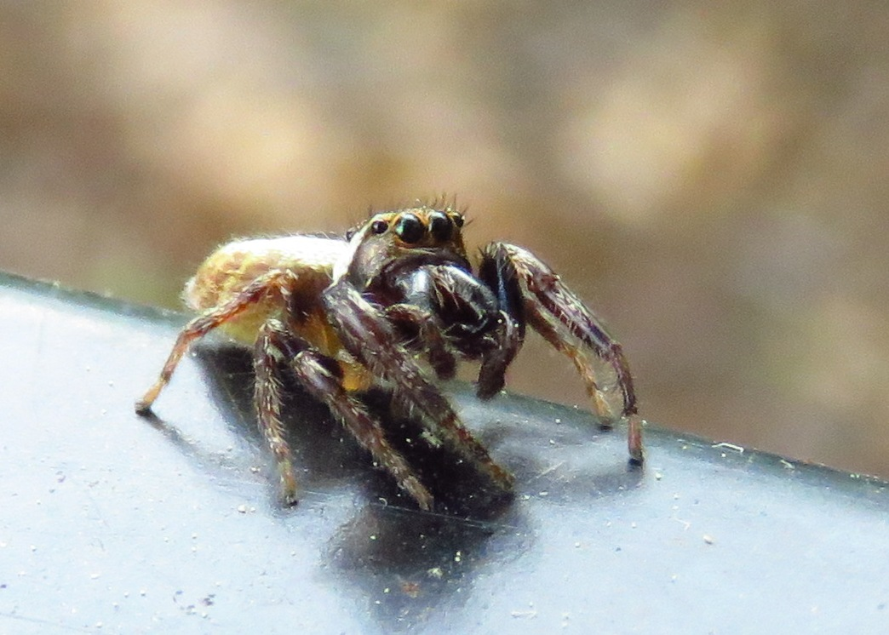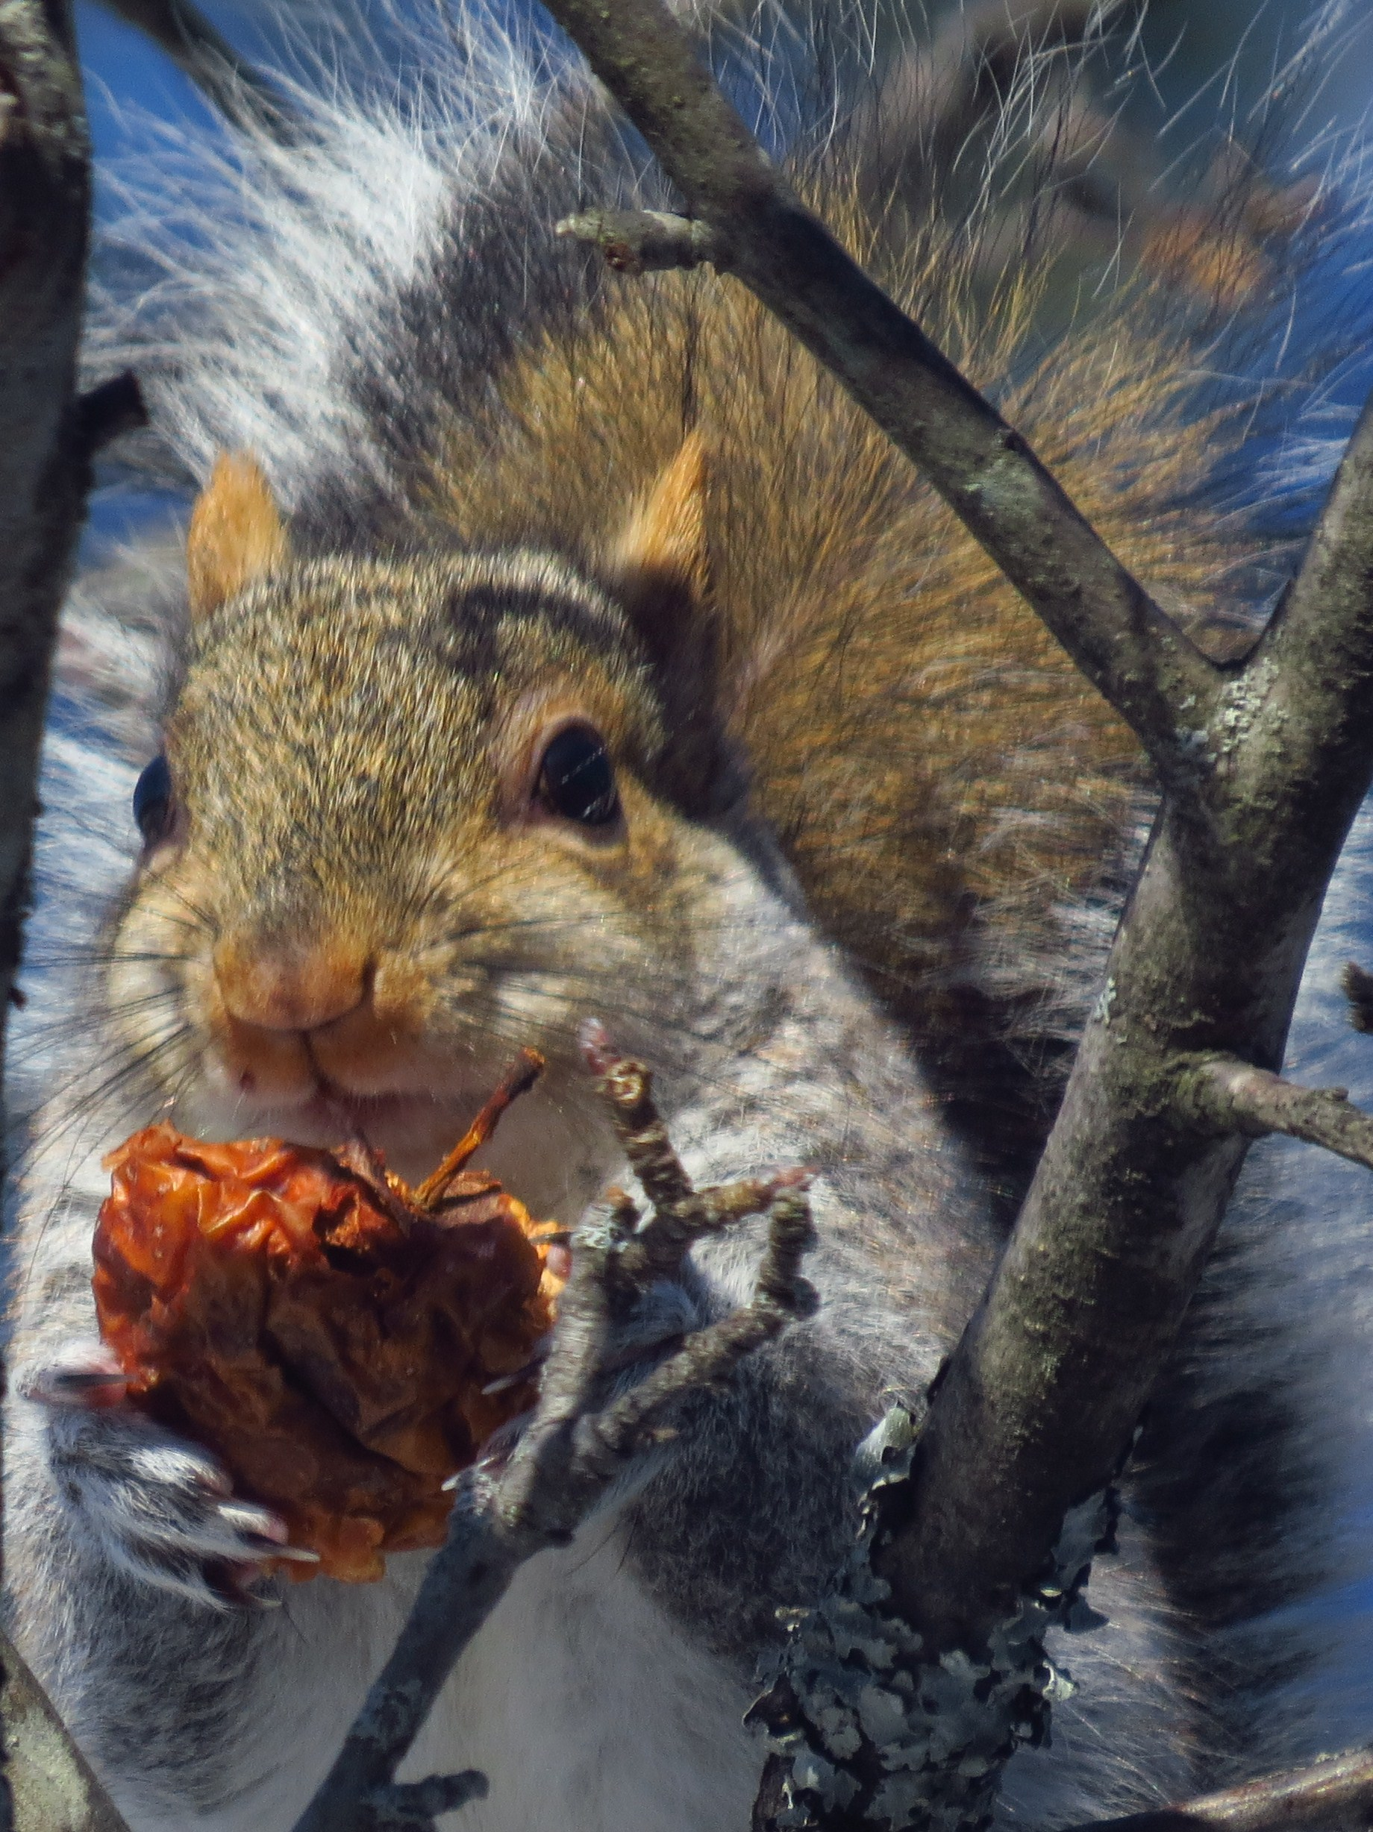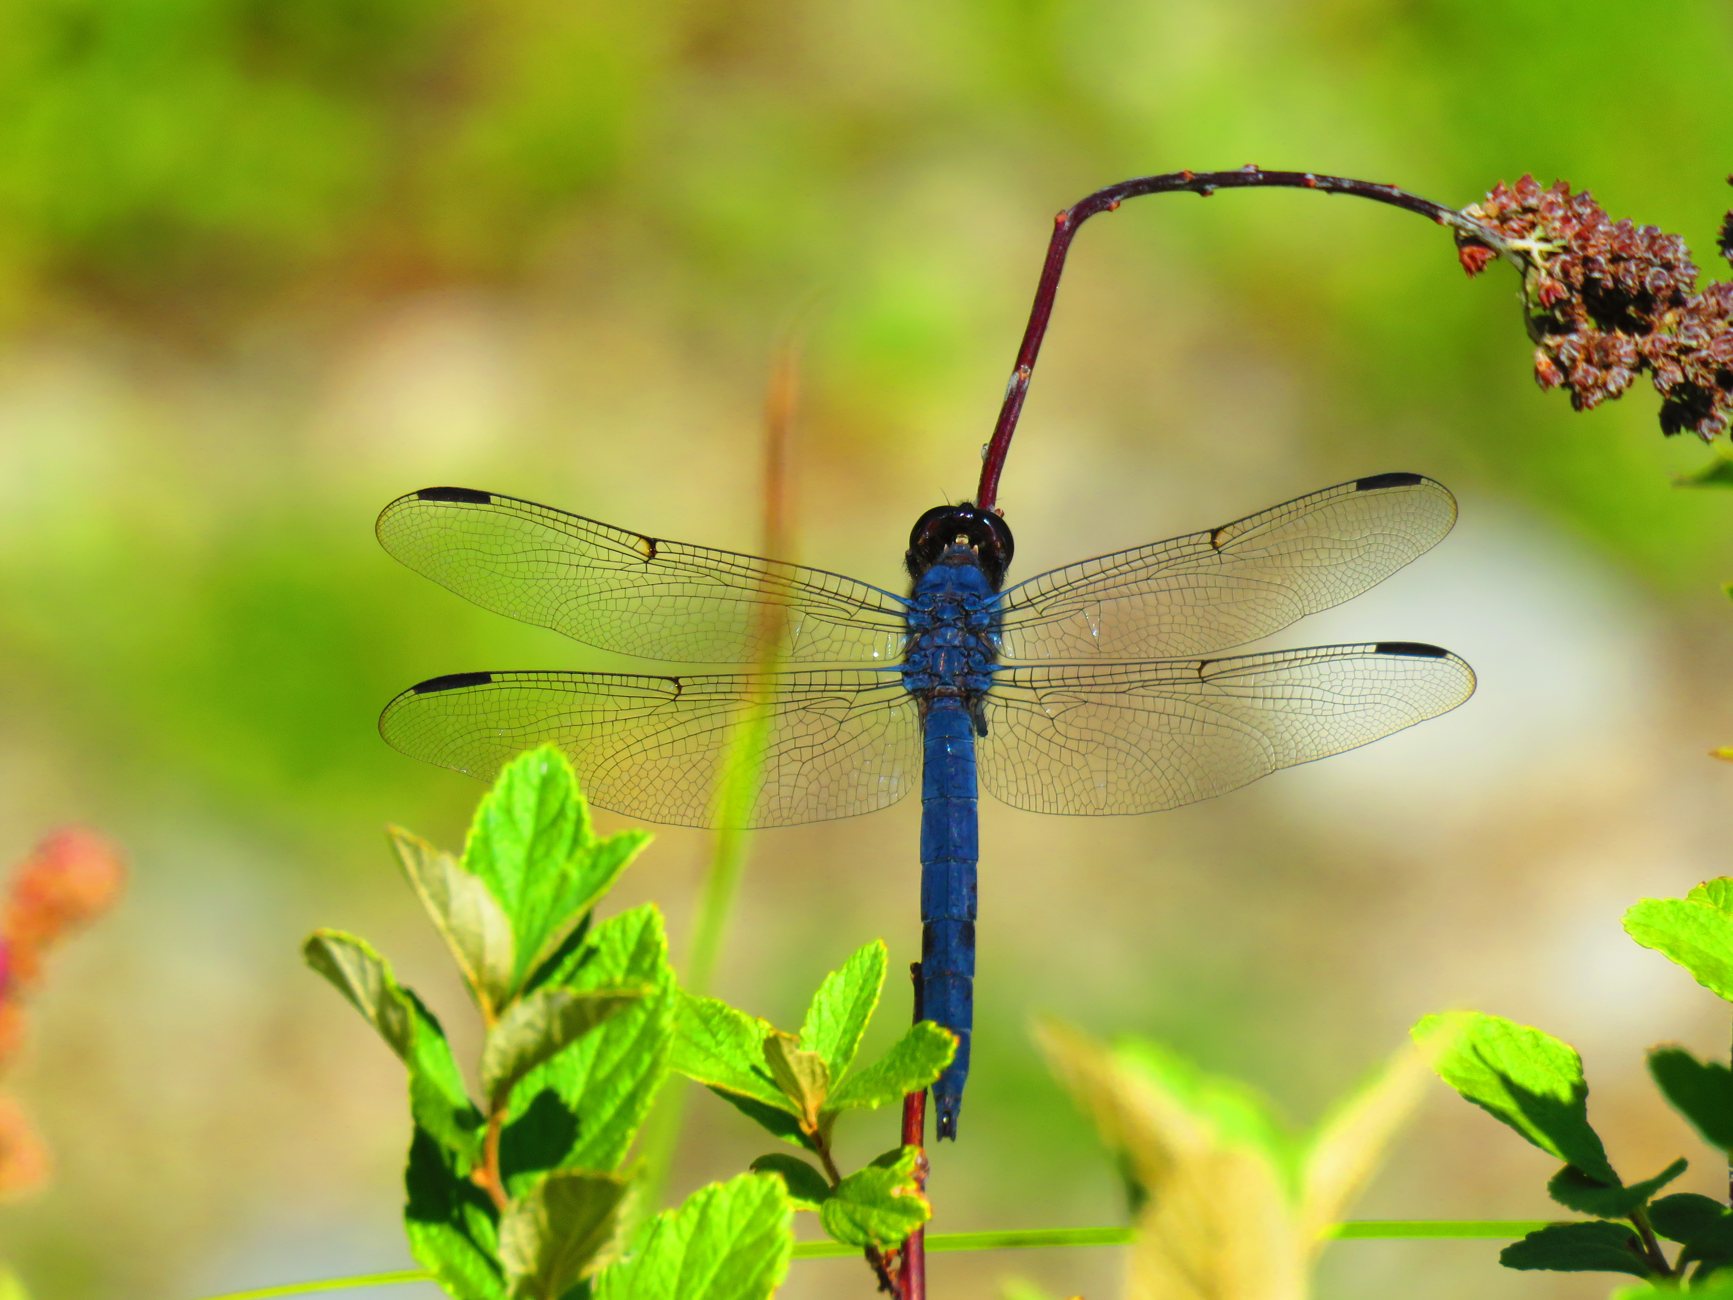

CALL FOR POETRY SUBMISSIONS
The Center For the Arts: Lake Sunapee Region
seeks works from New Hampshire poets
Theme:
WHERE THE WILD THINGS ARE
IN THE KEARSARGE VALLEY

RULES FOR SUBMISSION:
Compose poems about the “wild things” in New Hampshire.
- Poets may submit one (1) original poem (published or unpublished) inspired by the theme.
- Poems should be typed in a 12-pt or larger font.
- Poems should be no longer than one (1) page.
- Poets should submit by mail. Send two (2) copies of your poem: one copy including the poet’s name, address, telephone number and e-mail address.
- The second copy with no identifying information
- The winning poets will be notified (by telephone or e-mail) by March 25th and will be invited to read their poems at the April 1st event.
- Contestants, who want to receive a list of contest winners, should also submit a stamped, self-addressed envelope with their entries. There is no fee for submission.
- Submissions should be mailed by March 15, 2016, to Dianalee Velie, PO Box 290, Newbury, NH 03255, (603) 938-2734, dianaleevelie@aol.com.
- Members of the Center For the Arts’ Literary Arts Guild are not eligible for this contest.
- There will be a winner in each category: Adult, High School, Middle School and Elementary School.

The judge for the contest will be New Hampshire poet Rodger Martin.

Join the winners in a Poetry Month celebration
at
Woodcrest Village, 141 Main Street, New London, NH
Friday, April 1, 2016
5 to 7 p.m.
Refreshments served ~ No charge for Admission ~ Donations Welcome!

“In Wildness is the preservation of the world.”
― Henry David Thoreau, Walking

