**Chosen To Live**

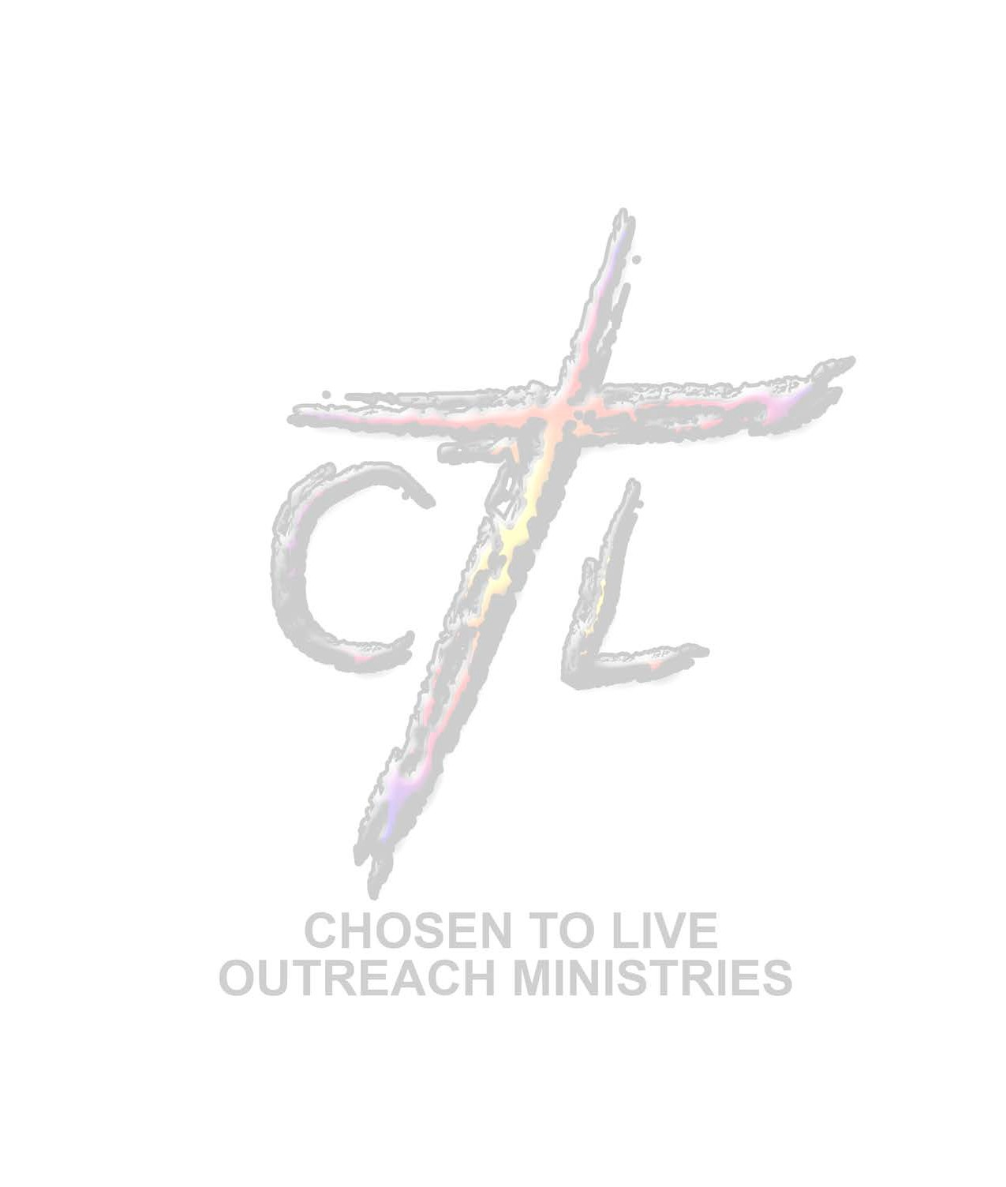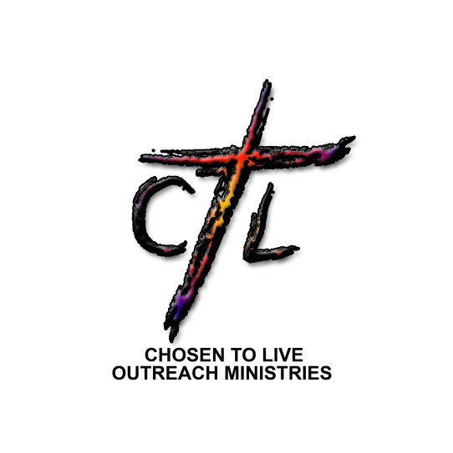

**Fellowship Friday**

**Join Chosen To Live Ministries for our**

**Fellowship Fridays where we are**

**Bringing the Body of Christ Together!!!**

**Enjoy Conversation, Networking, Food and Fun!**

**When: February 20, 2015 @ 7:00pm**

**Where: Our Home - 2217 Harvest Pl. Reynoldsburg 43068**

**Meet new people in a relaxed fun environment!**

**Contact Us @ 614-732-6416 or 614-732-6418**

**Disclaimer: You must be willing to have fun and meet new people that will love you unconditional as God does!**